**ALTERNATING-CURRENT CIRCUITS** 

**Exercises**

**Section 28.1 Alternating Current**

**14.** **Interpret** We're asked to express how the voltage in Europe varies with time.

**Develop**The time-dependence for AC voltage is given by Equation 28.3: 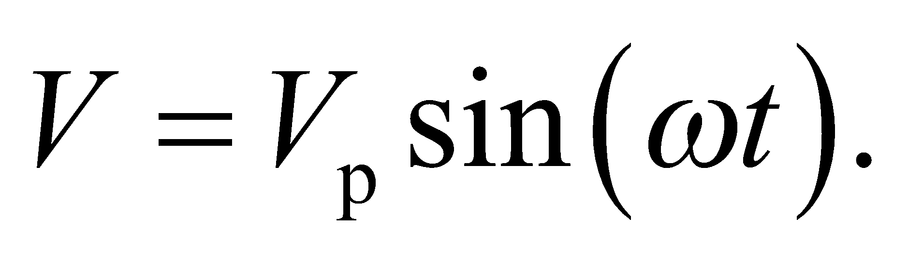 In Europe, the peak voltage and angular frequency are

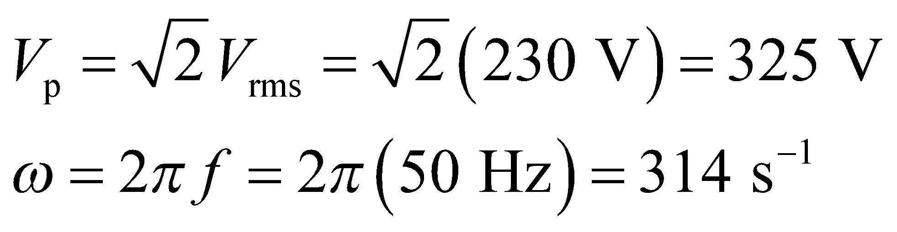

**Evaluate**Plugging the given values into the voltage equation gives

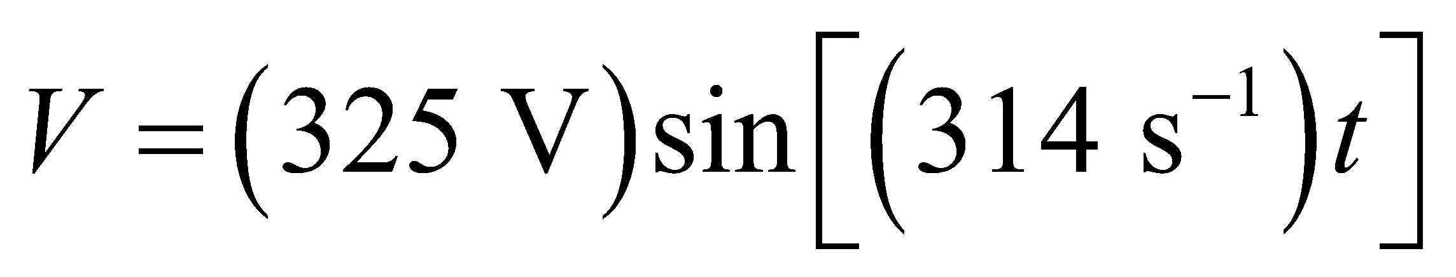

**Assess**The peak voltage and angular frequency are both larger than the rms voltage and frequency.

**15.** **Interpret** We are to convert from rms voltage to peak voltage and from Hz to angular frequency.

**Develop** Apply Equation 28.1 to convert from rms to peak voltage and Equation 28.2 to convert from Hz to angular frequency.

**Evaluate** **(a)** 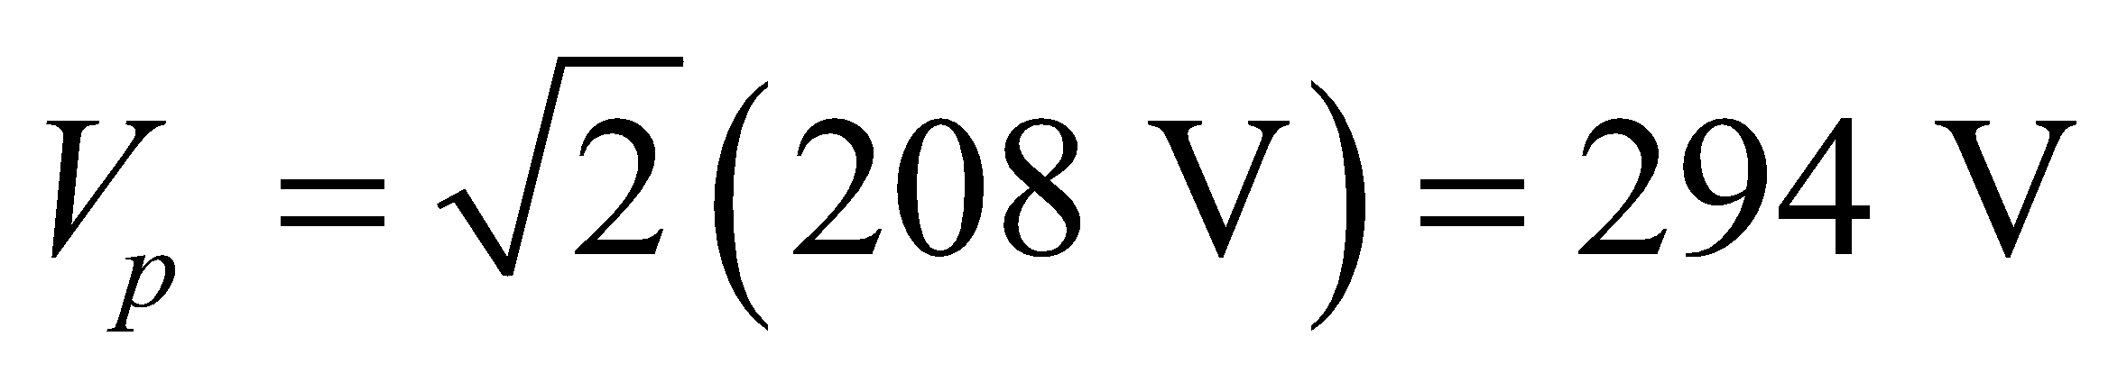 and **(b)** 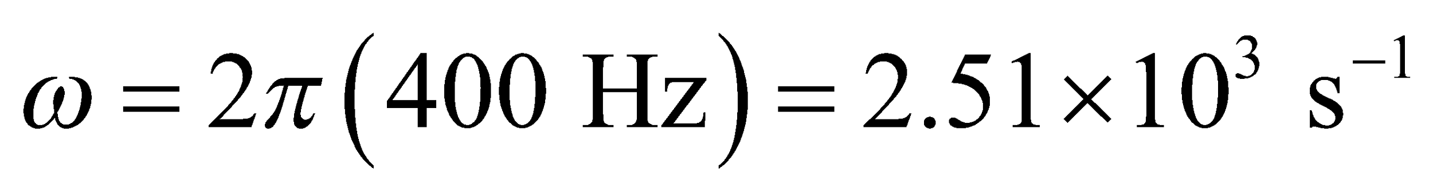.

**Assess** The peak voltage, as its name implies, is greater than the rms voltage.

**16. Interpret** We’re given the AC current in terms of a sinusoidal function, and asked to deduce the rms current and the frequency of the current.

**Develop** As shown in Equation 28.3, the AC current can be written as

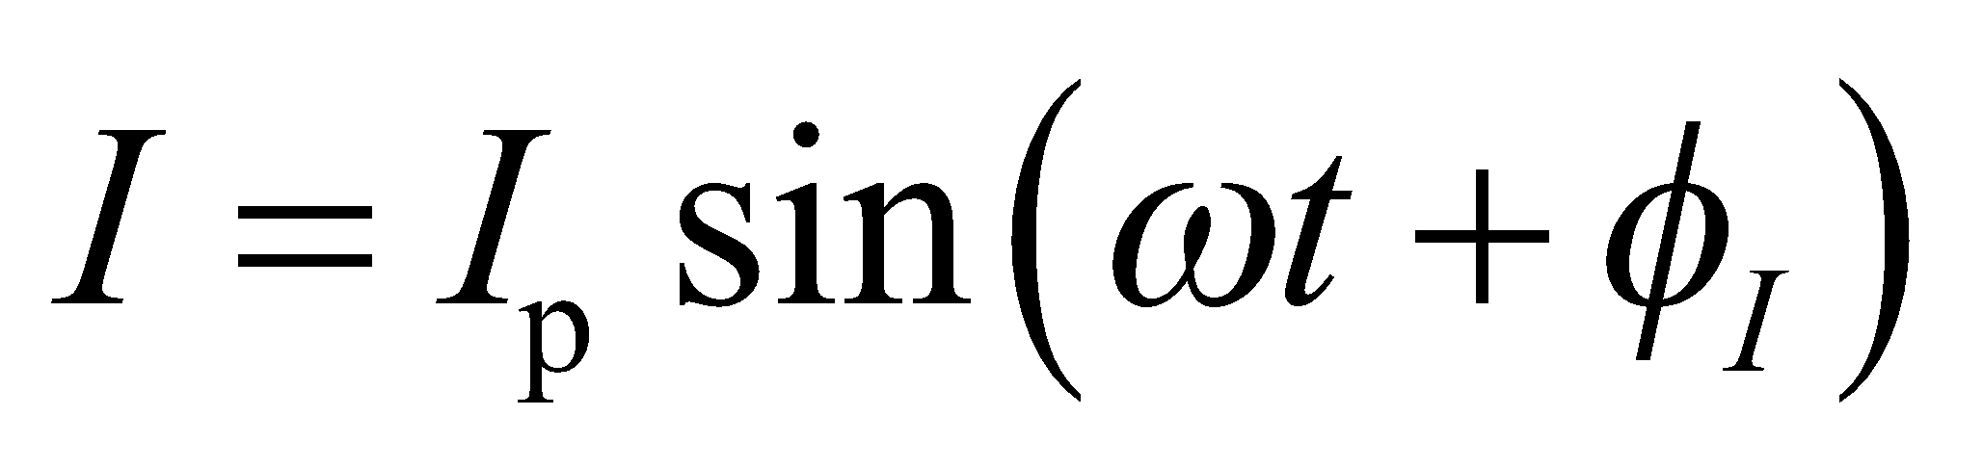

where *I*p is the peak current amplitude, *ω* is the angular frequency, and 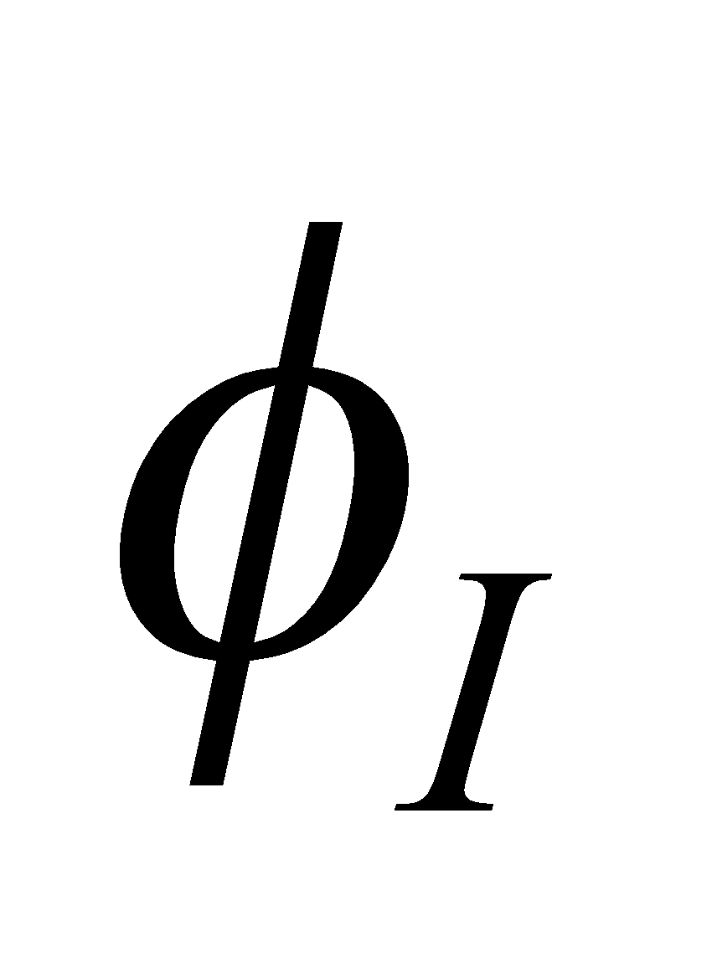 is the phase constant. Comparison of the current with Equation 28.3 shows that its amplitude and angular frequency are 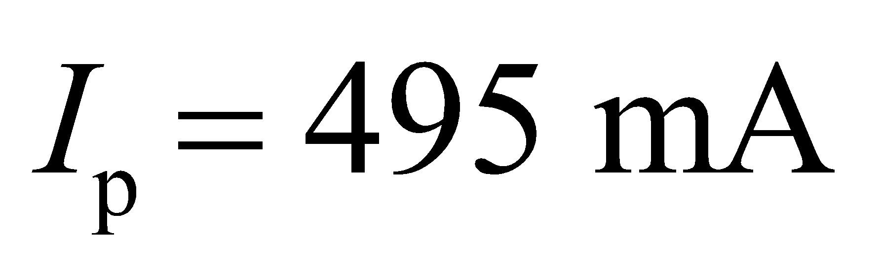 and 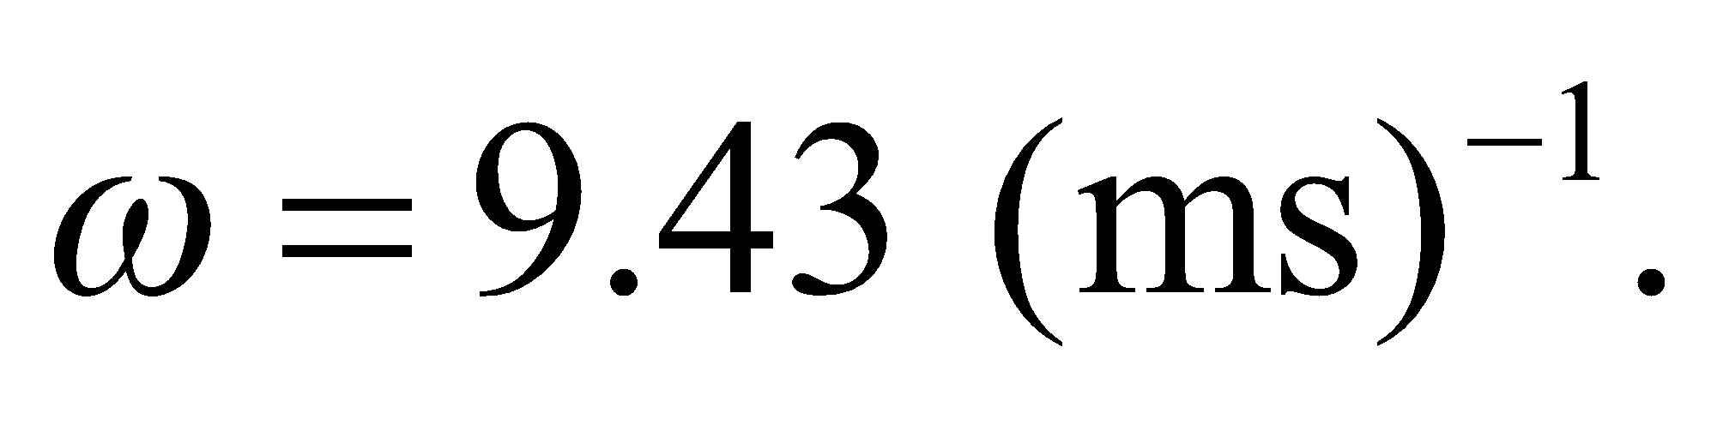

**Evaluate**  **(a)** Applying Equation 28.1 gives 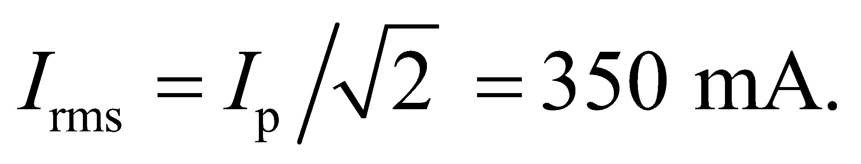

**(b)** Similarly, using Equation 28.2 we have 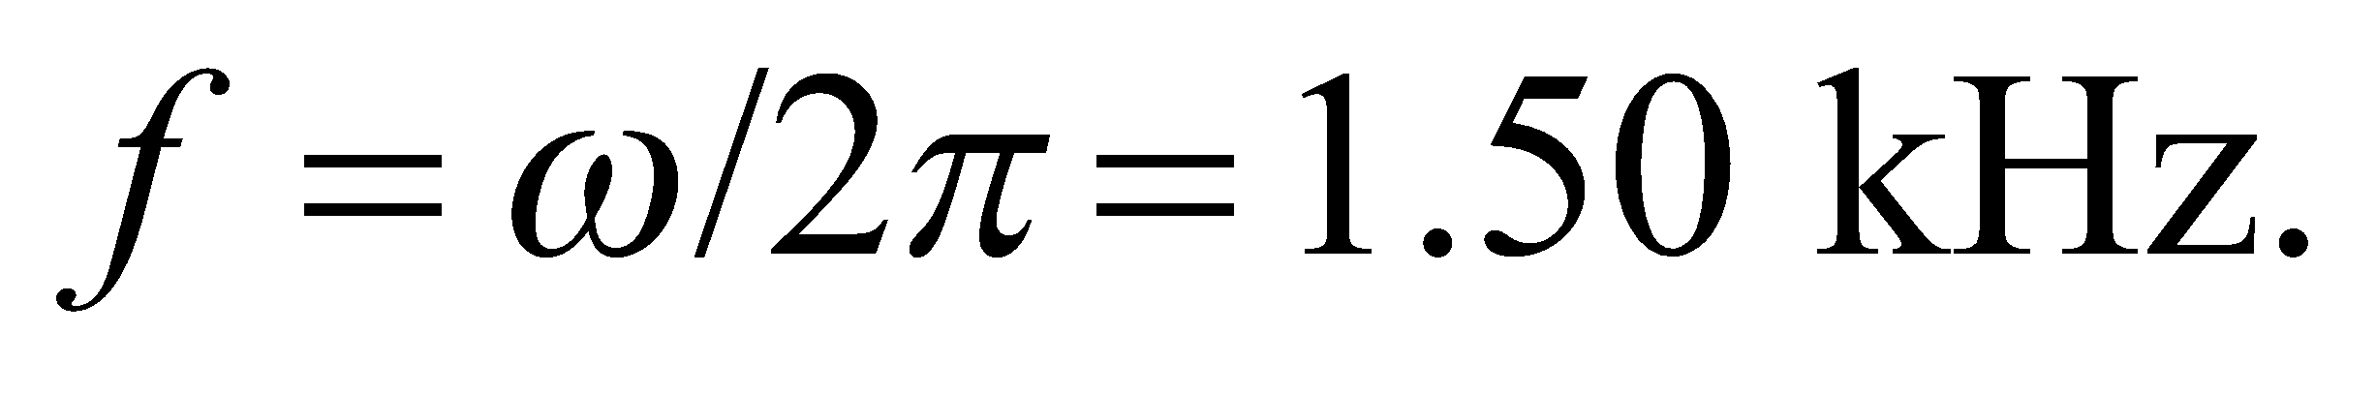

**Assess** The phase  is zero in this problem. Note that since the rms (root-mean-square) current is obtained by squaring the current, taking its time average, and then taking the square root, it is smaller than the peak current by a factor of 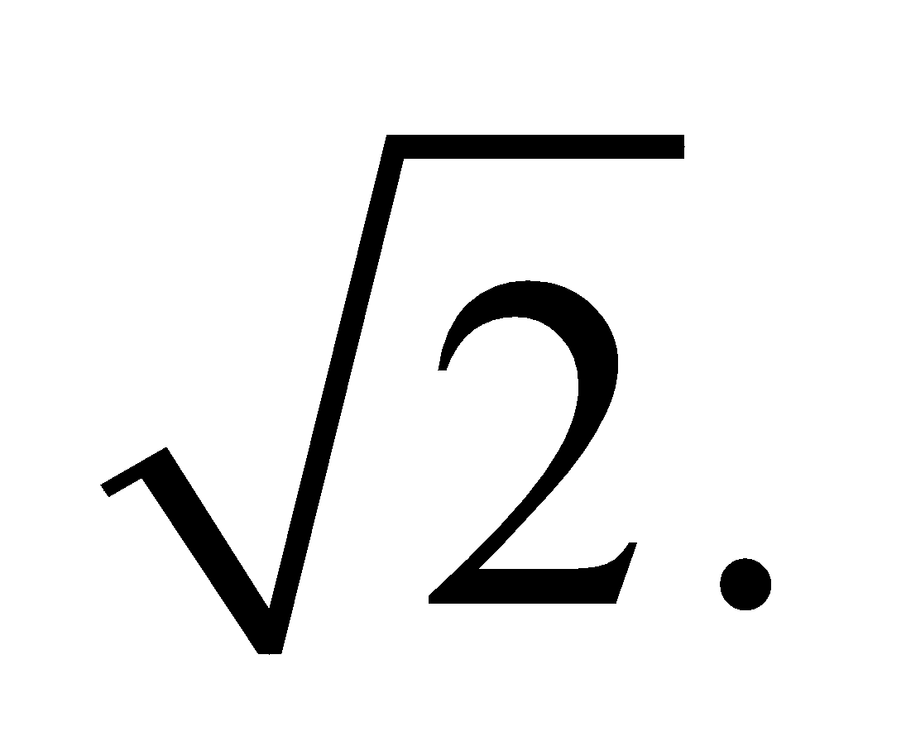

**17.** **Interpret** We are to find the phase constants for a series of signals plotted as voltage versus dimensionless time.

**Develop** The phase constant is a solution of Equation 28.3 for *t* = 0; that is, 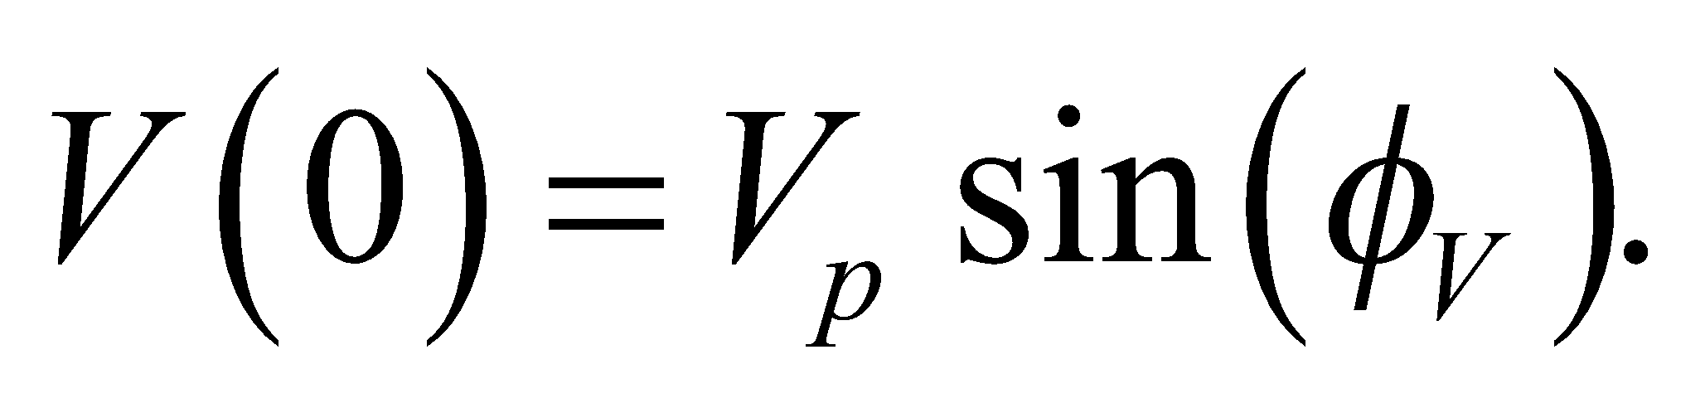 Since 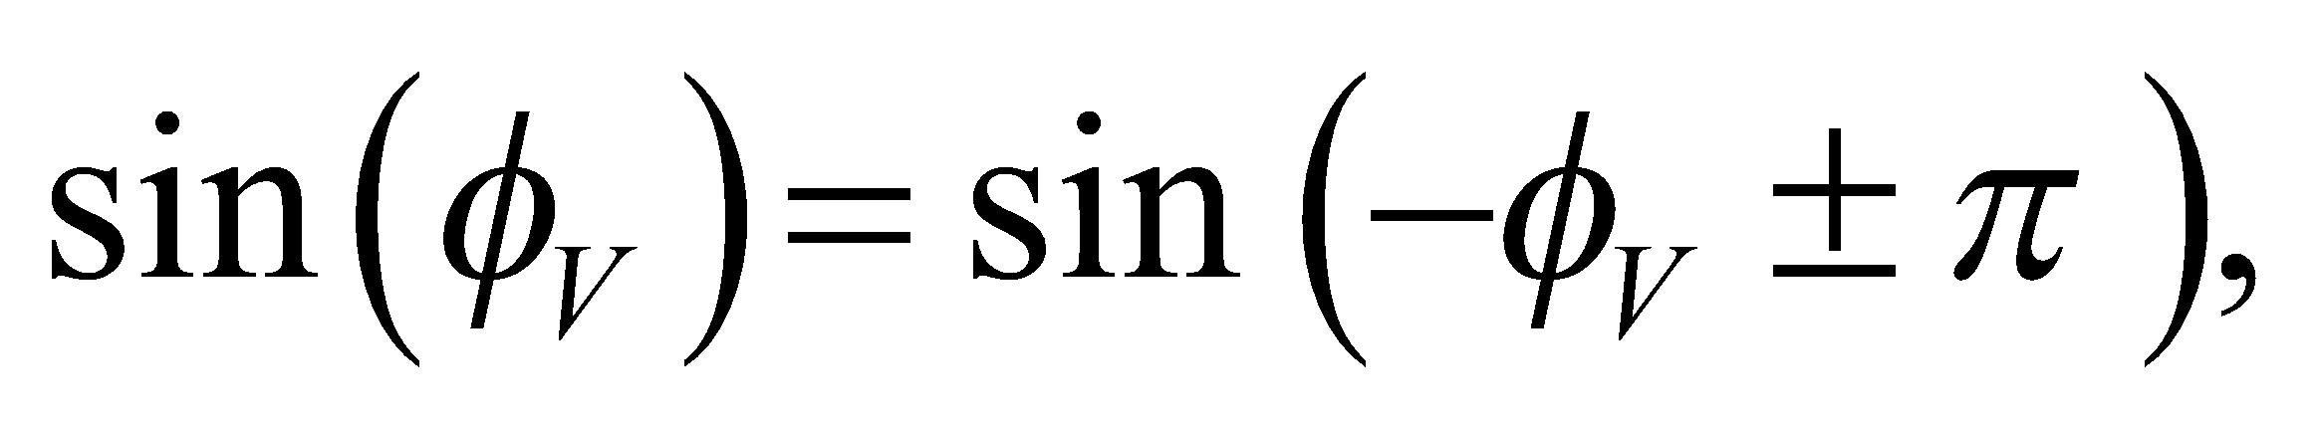 one must also consider the slope of the sinusoidal signal function at *t* = 0. In addition, the conventional range for 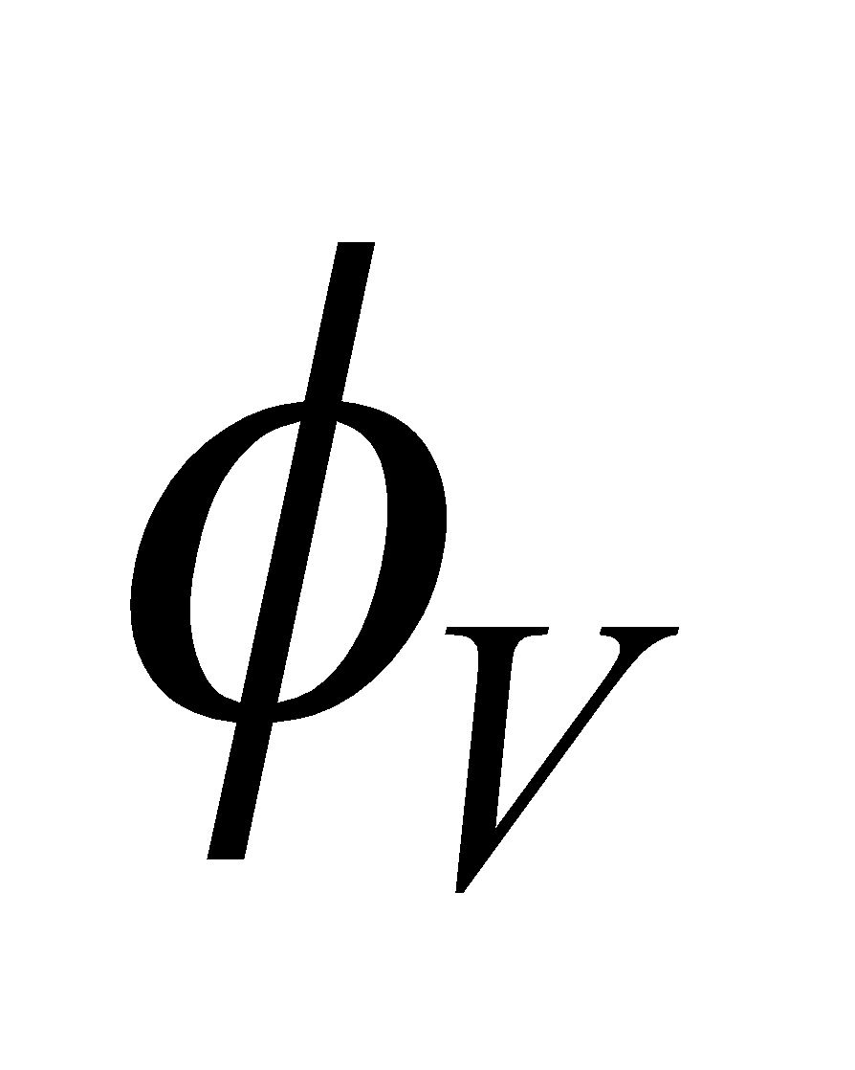 usually runs from −180° to +180°, or 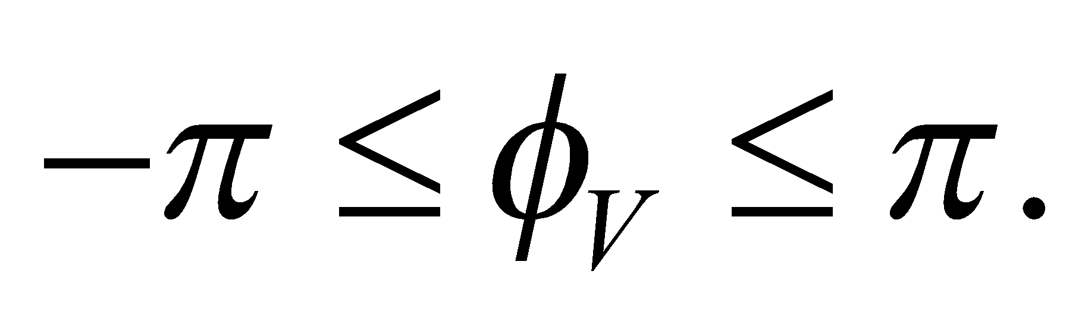 Thus, 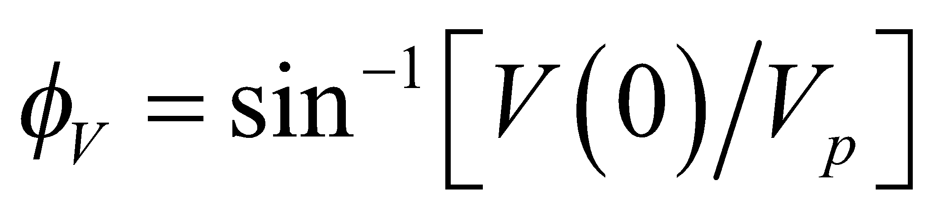 when 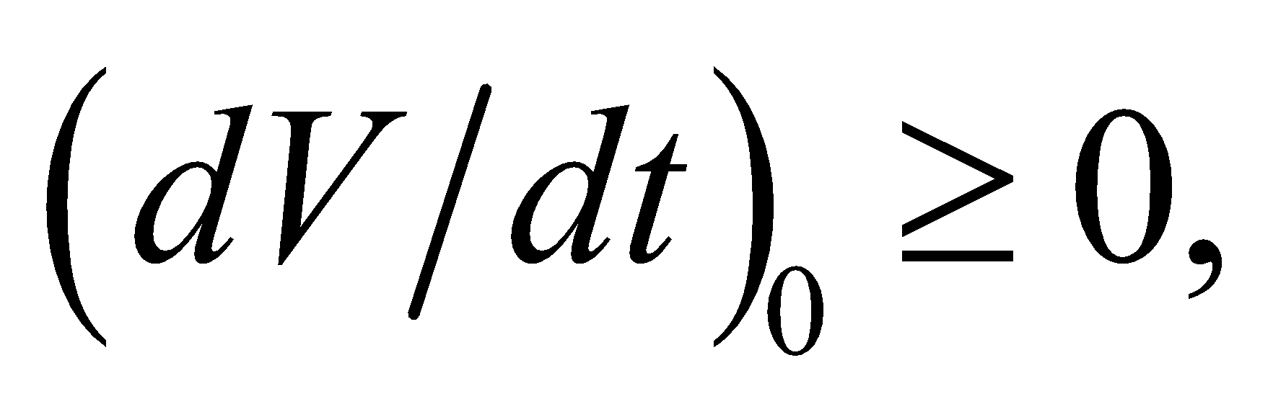 but 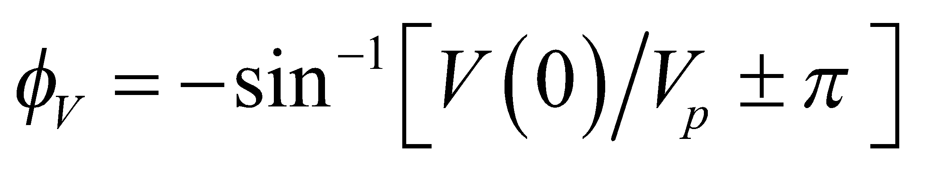 when 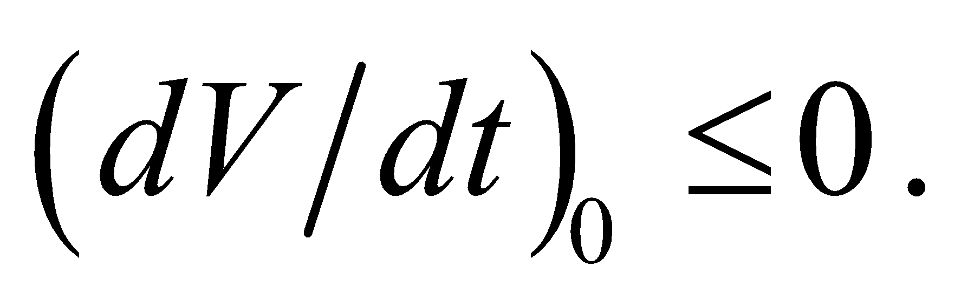

**Evaluate** For signal **(a)** in Figure 28.25, we guess that 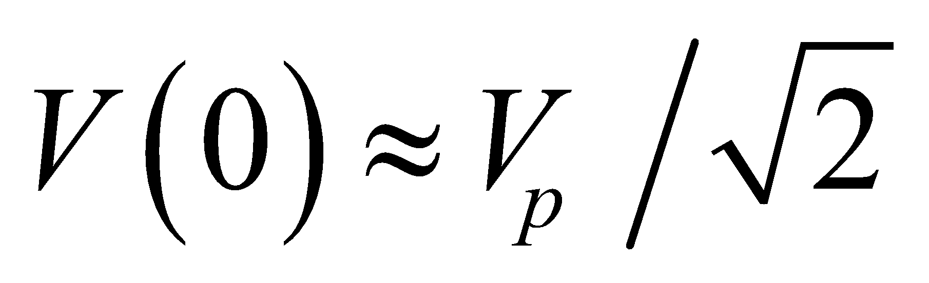 (since that curve next crosses zero about halfway between *π*/2 and *π*) and the slope at zero is positive, so 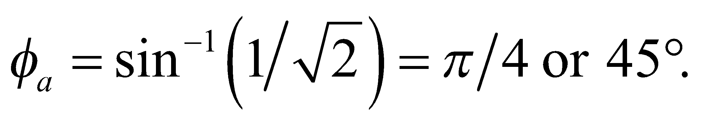 This signal is 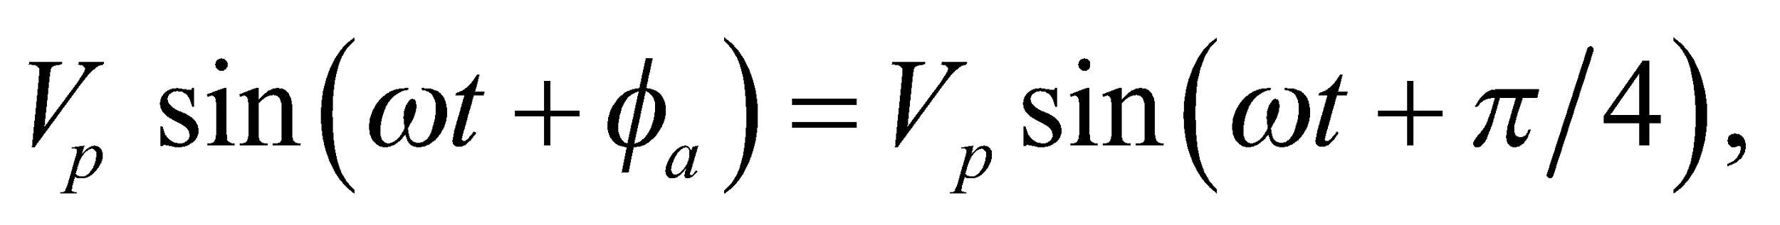 which leads a signal with zero phase constant by 45°. For the other signals,

**(b)** 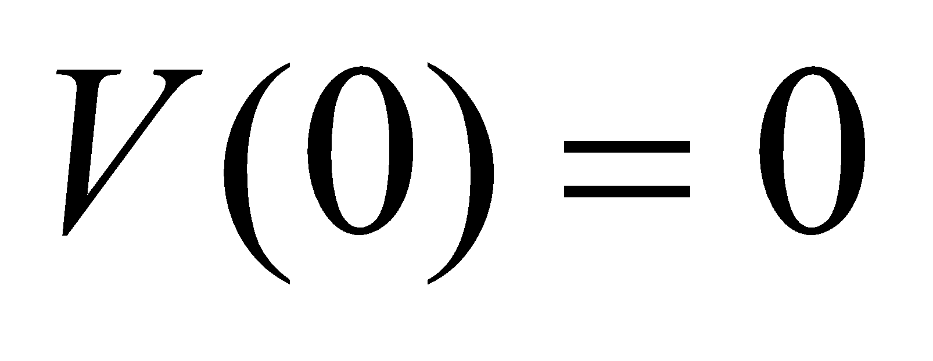 and 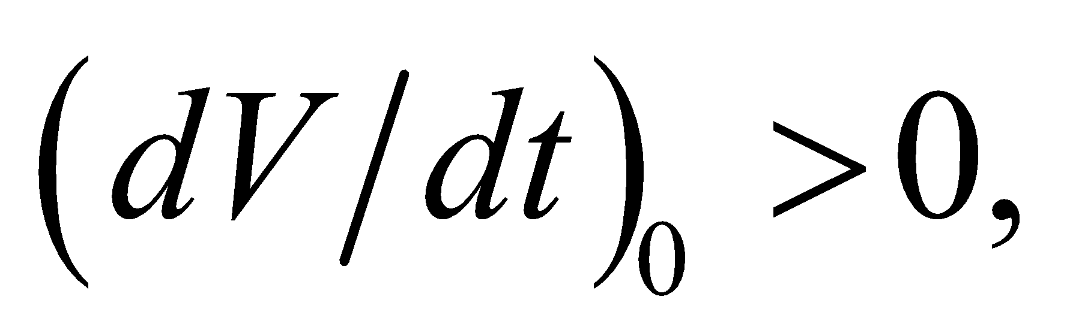so 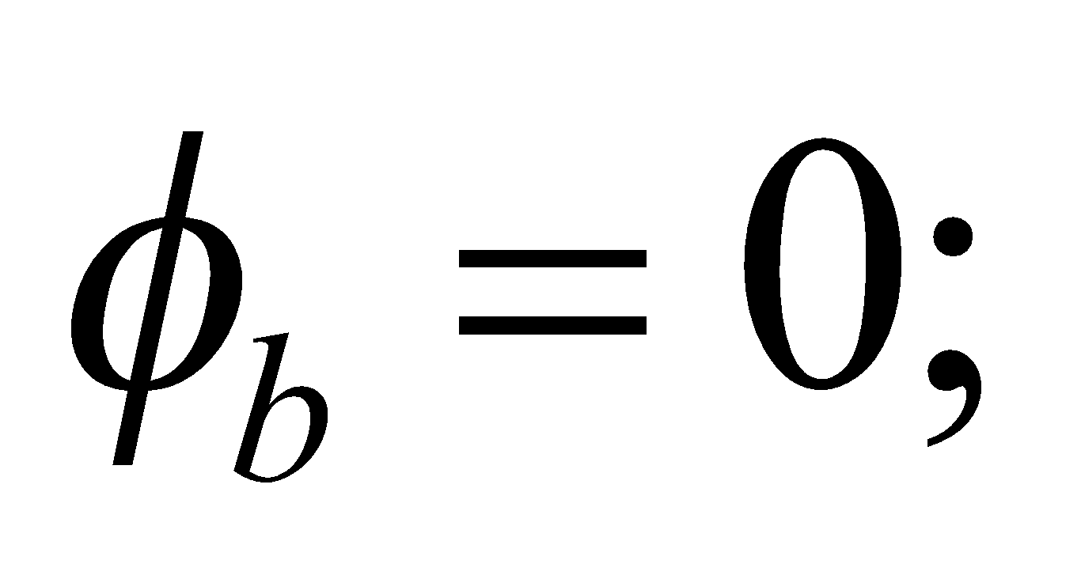

**(c)** 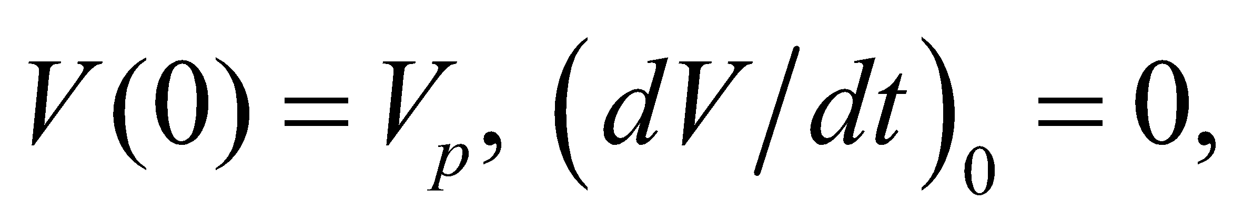 so 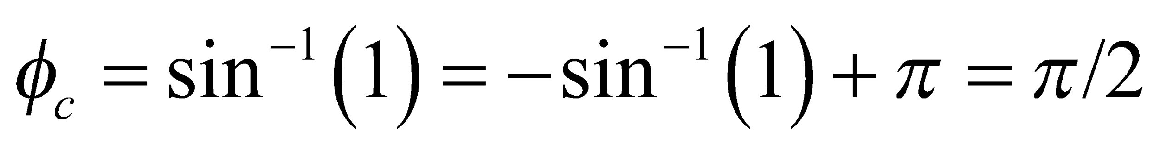 or 90°

**(d)**  and 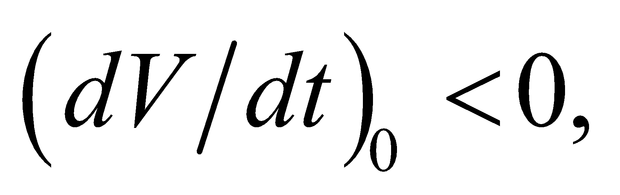 so 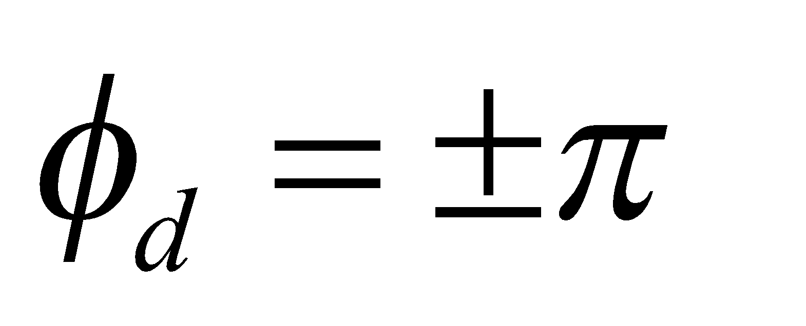 or 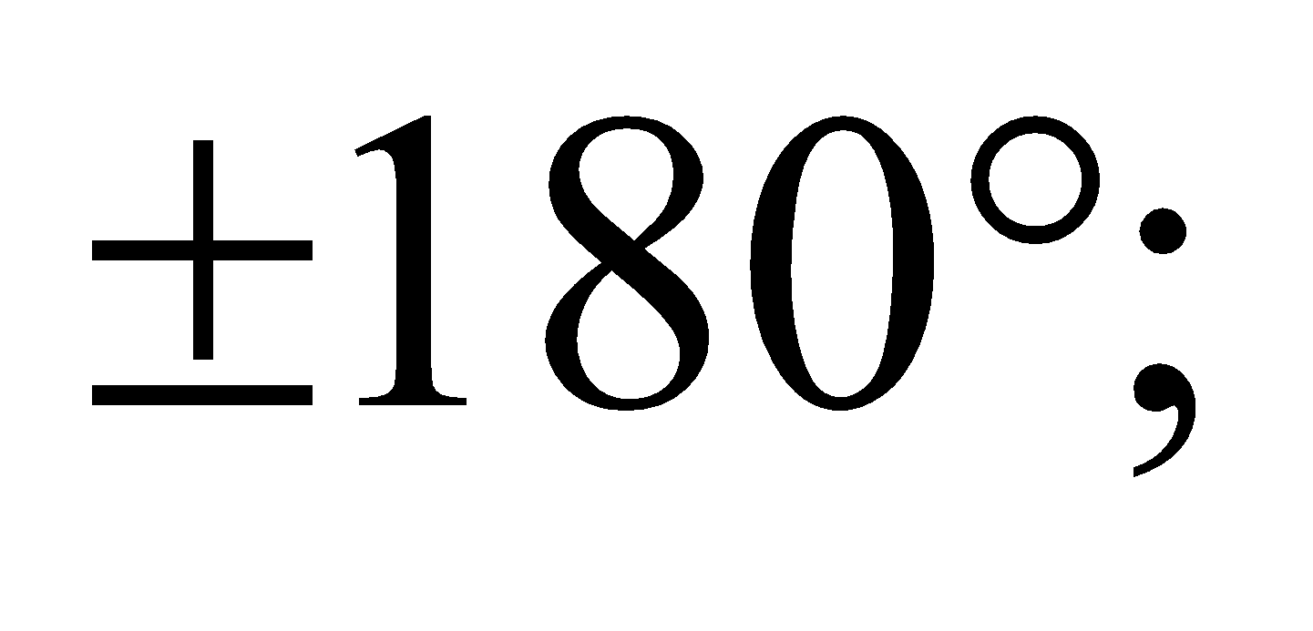 and

**(e)** 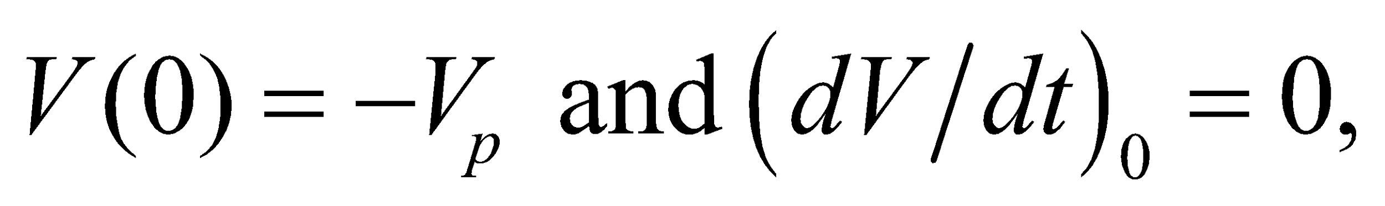 so 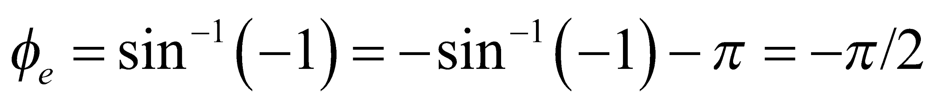 or −90°.

**Assess** We used 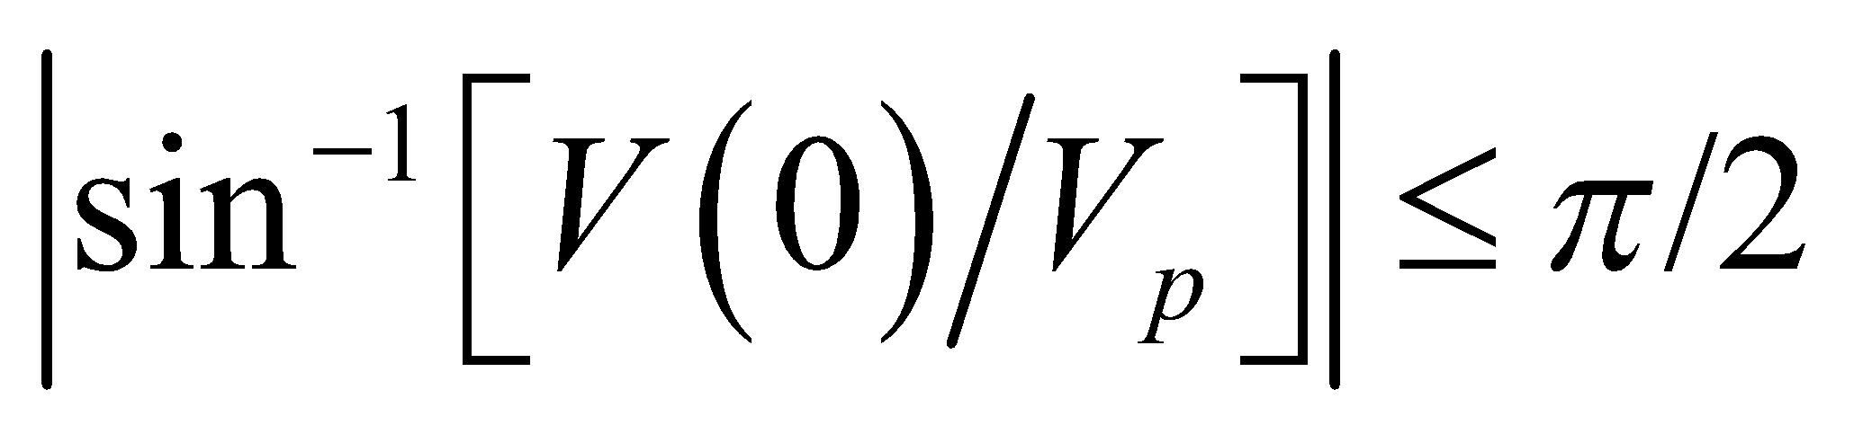 or 90°, as is common on most electronic calculators, since the sine function is one-to-one only in such a restricted range.

**Section 28.2 Circuit Elements in AC Circuits**

**18. Interpret** In this problem, we want to find the rms current in a capacitor connected to an AC power source.

**Develop** The amplitude of the current in a capacitor is given by Equation 28.5:

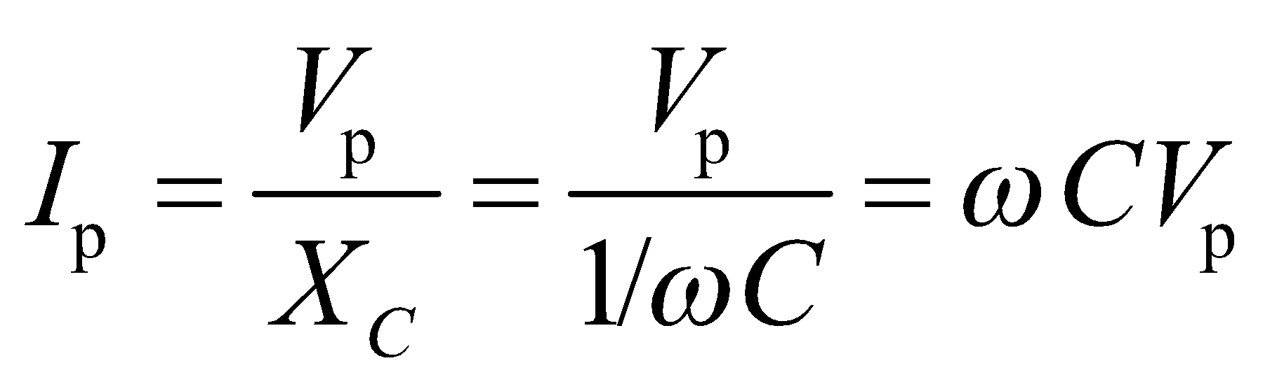

Using Equation 28.1, the corresponding rms current is 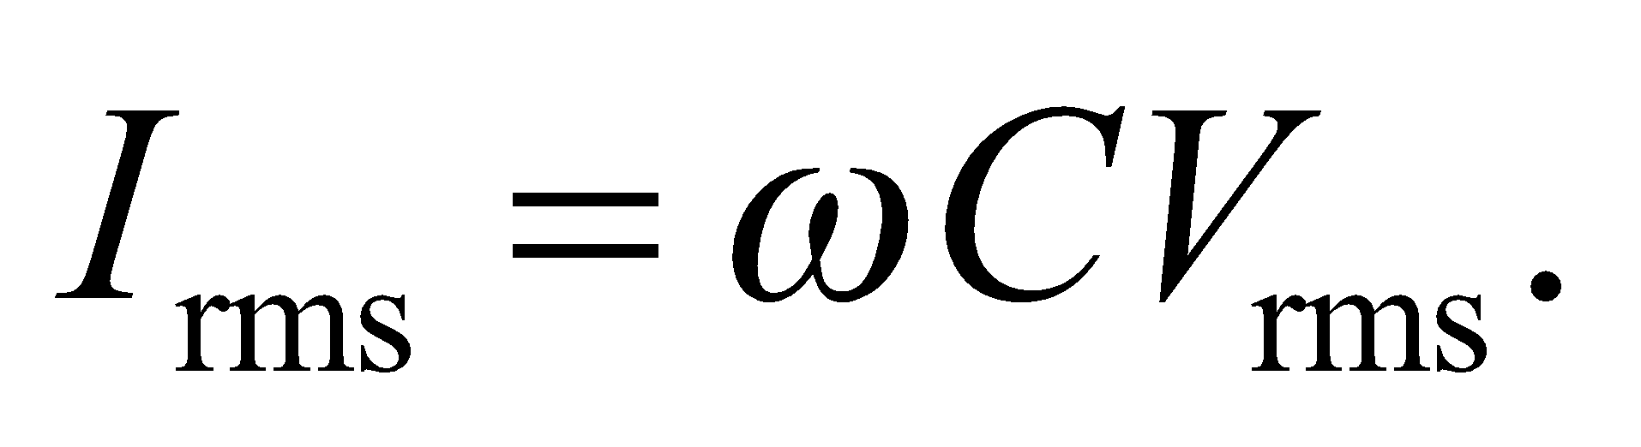

**Evaluate** Substituting the values given in the problem statement, we find the rms current is



**Assess** The capacitive reactance is 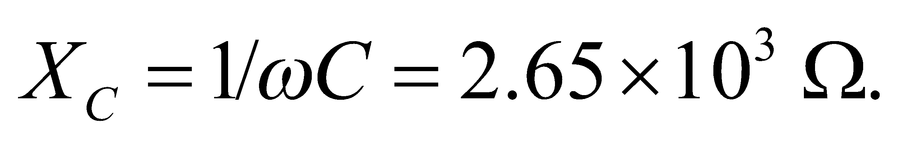 In this circuit, the current in the capacitor leads the voltage across the capacitor by 90°.

**19.** **Interpret** We are to find the rms current in each element of an RLC circuit connected across the given emf source.

**Develop** Apply the equations in Table 28.1 and convert them to rms values using Equations 28.1 and 28.2.

**Evaluate** The equations in Table 28.1 (expressed in rms values) give

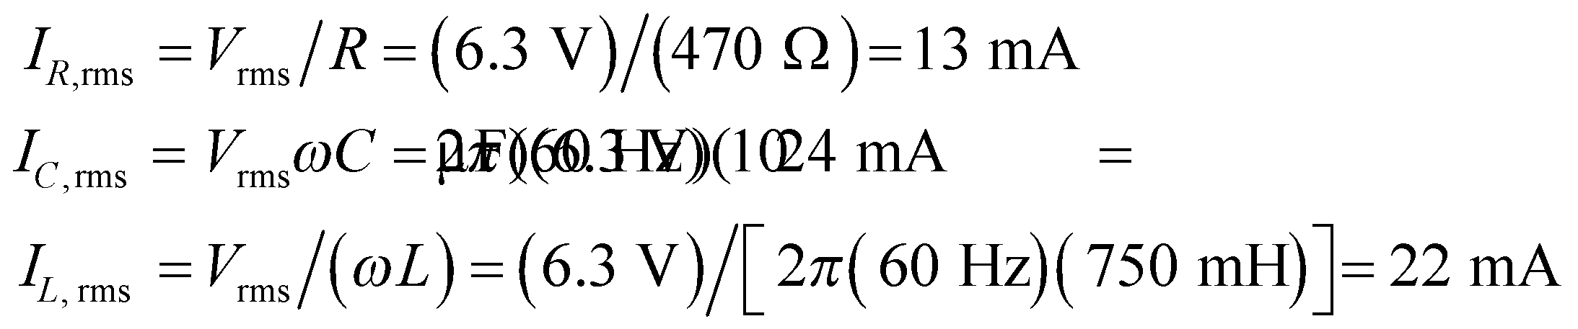

**Assess** These values are realistic for *RLC* circuits.

**20. Interpret** This problem is about the capacitive reactance of the given capacitor at various angular frequencies.

**Develop** From Equation 28.5, we see that the capacitive reactance is

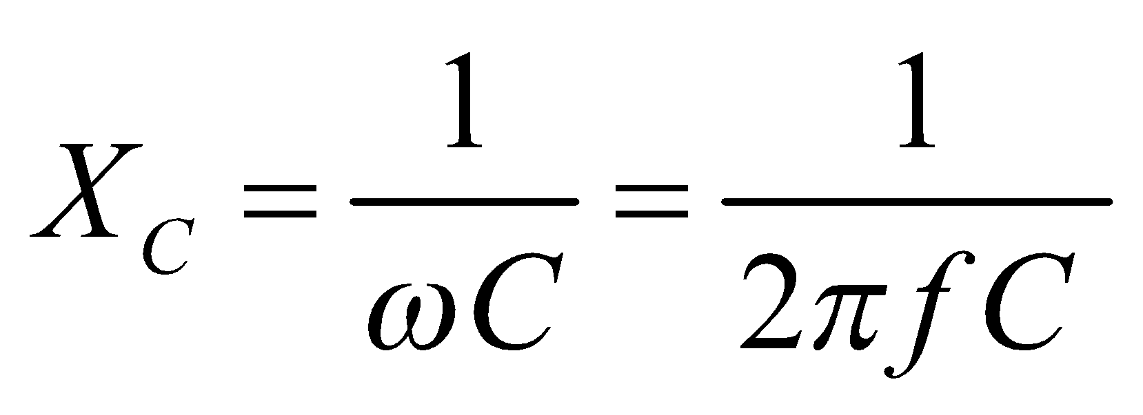

**Evaluate**  **(a)** For *f* = 60 Hz, the capacitive reactance is

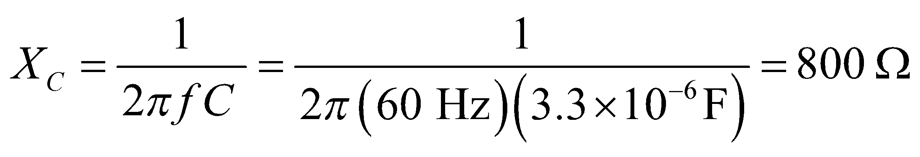

to two significant figures.

**(b)** For 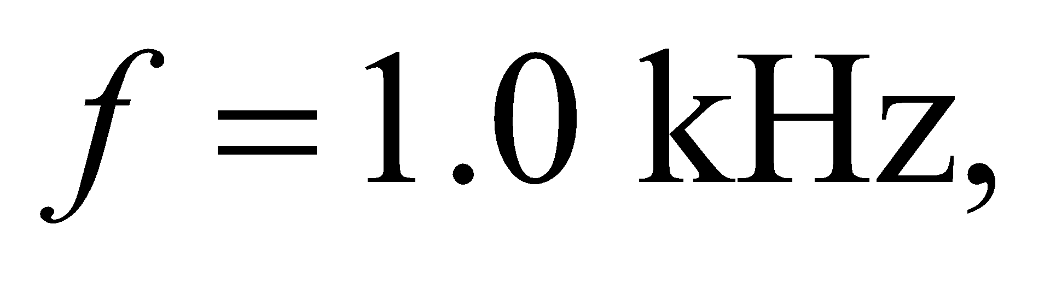 the capacitive reactance is

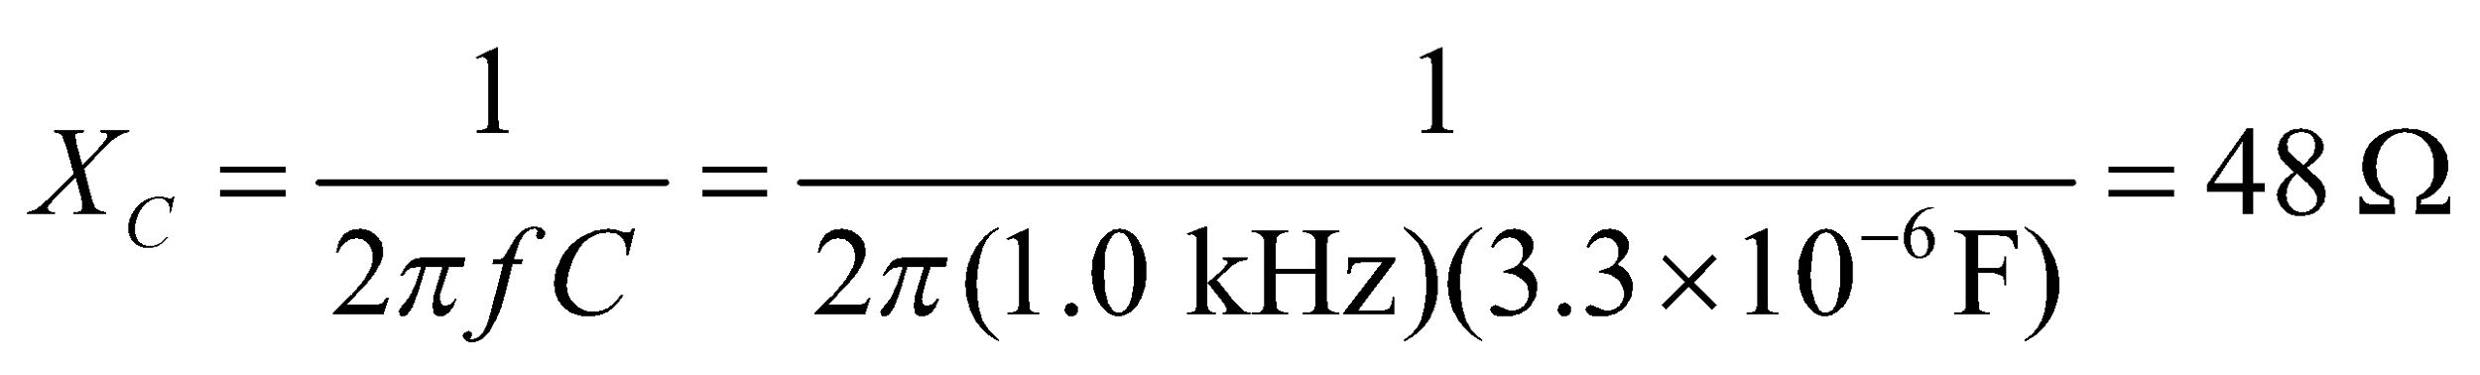

**(c)** Similarly, for 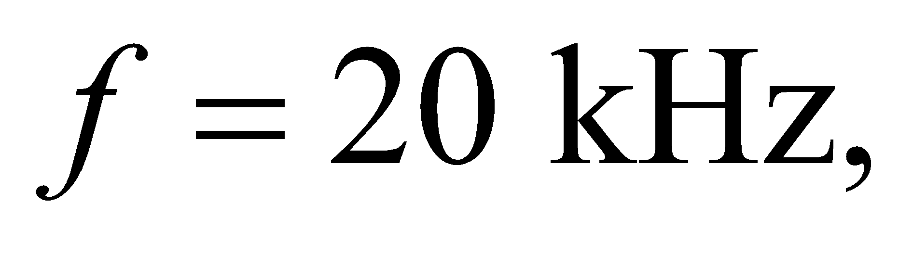 the capacitive reactance is

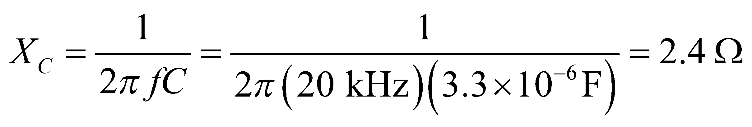

**Assess** One can see that a capacitor has the greatest effect (largest reactance) at low frequency.

**21.** **Interpret** This problem deals with the minimum safety voltage of an capacitive circuit.

**Develop** Take the minimum safe voltage to be equal to the peak voltage, and use Equation 28.5 to find the peak voltage.

**Evaluate** (**a**) For a frequency *f* = 60 Hz, the minimum safe voltage is

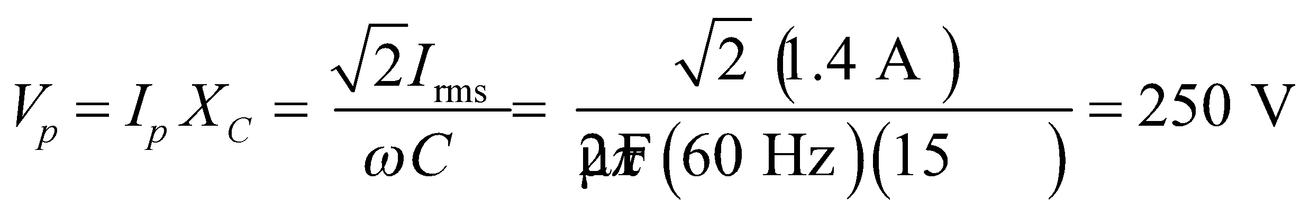

(**b**) For *f* = 1 kHz, the minimum safe voltage is

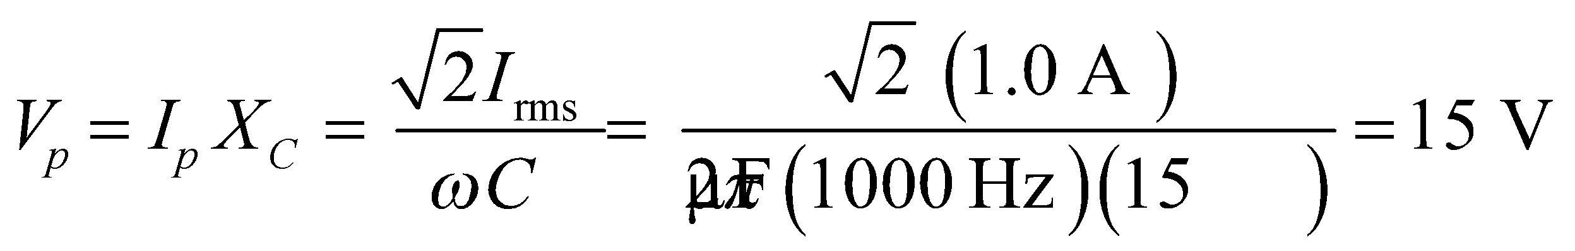

**Assess** The results are given to two significant figures. The safe voltage is based on the peak voltage, which seems reasonable. Notice that the capacitor has the greatest effect (largest reactance) at low frequency.

**22. Interpret** This problem is about the capacitance of a capacitor that’s connected across an AC power source.

**Develop** The fact that the capacitor and the resistor both pass the same current implies that

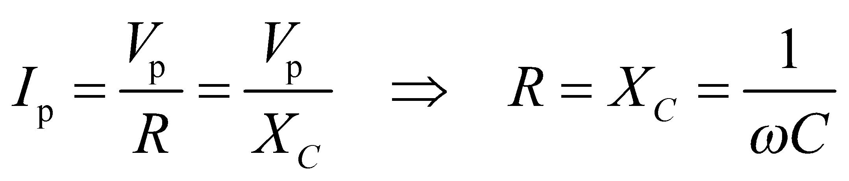

Therefore, the capacitance is 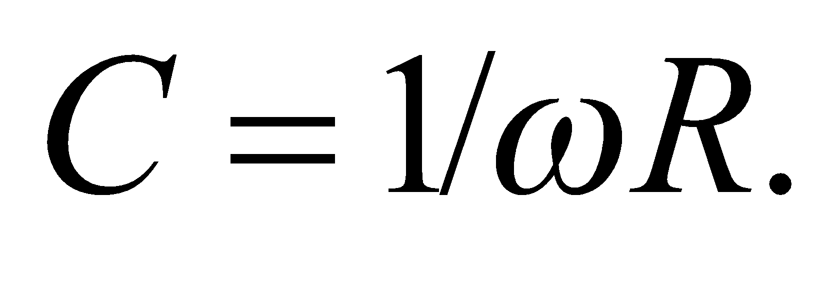

**Evaluate** Inserting the values given, we obtain

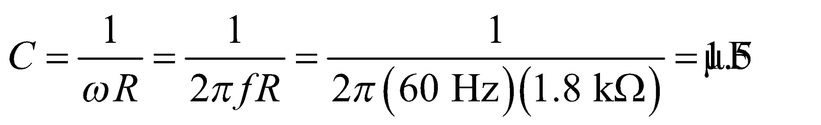

**Assess** Since 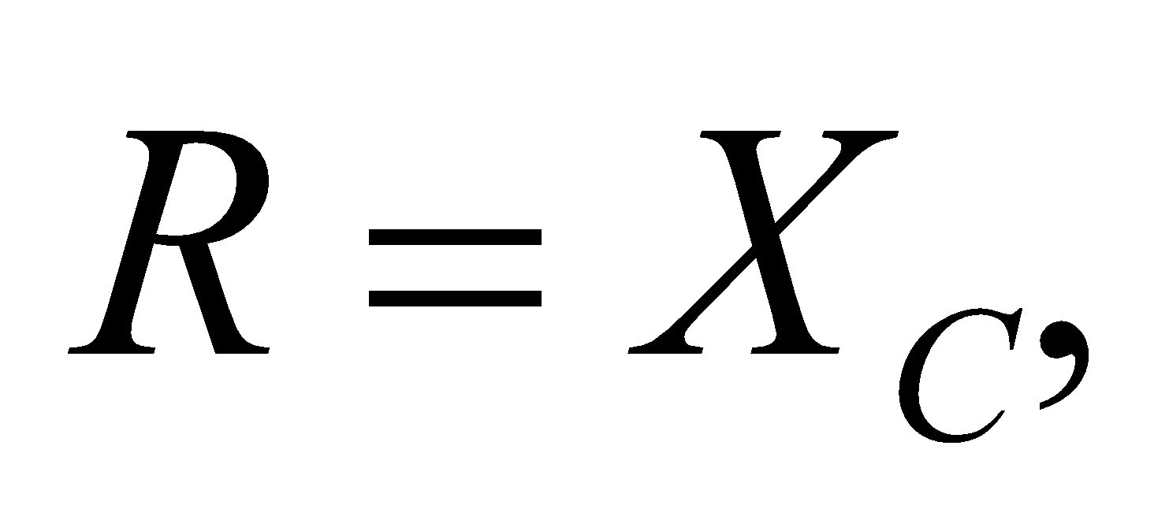 the greater the value of resistance *R*, the greater the capacitive reactance, and thus the smaller the capacitance.

**23.** **Interpret** We are to find the frequency of an inductive circuit given the rms inductance, emf, and current.

**Develop** Apply Equation 28.7, 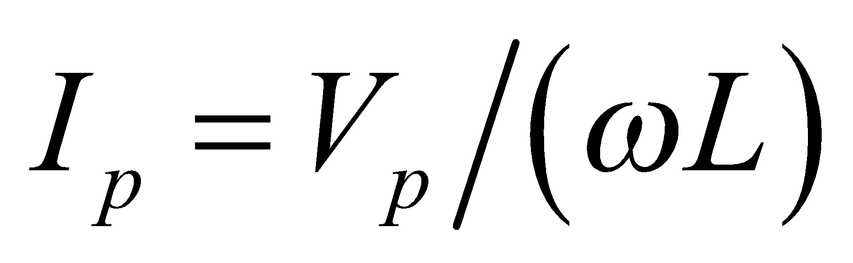 and Equation 28.2, *ω* = 2*πf*. Because

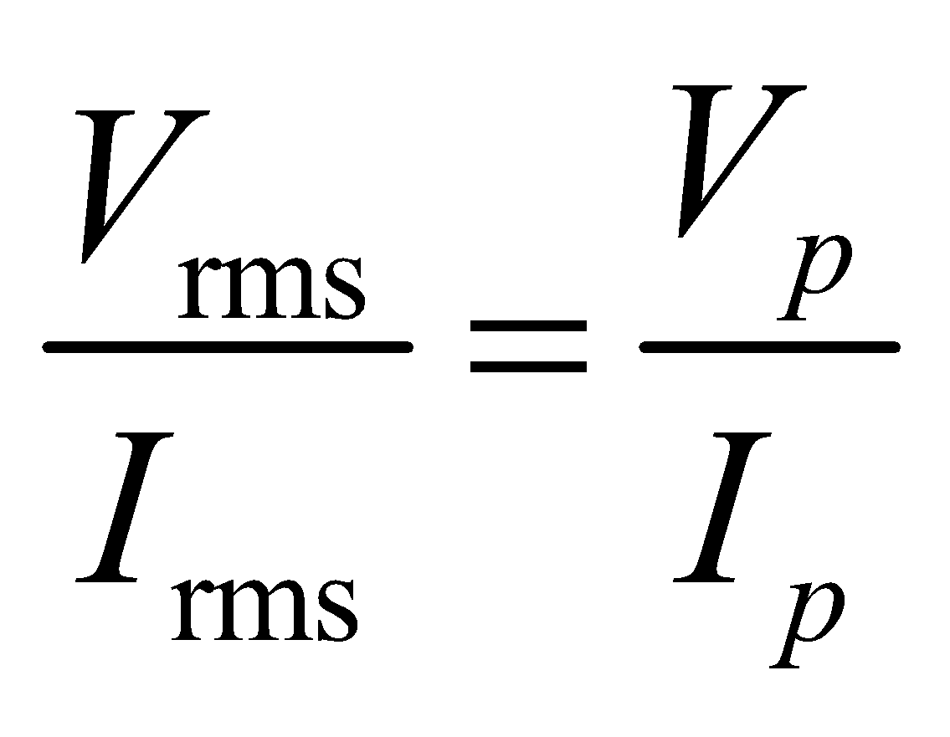

we can use the rms values instead of the peak values in these expressions.

**Evaluate** Combining the expressions above gives

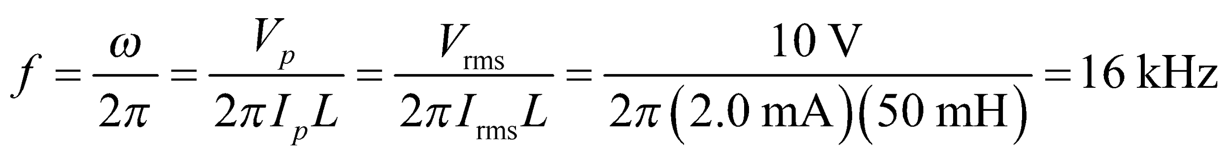

**Assess** The inductance and frequency are inversely proportional.

**Section 28.3 *LC* Circuits**

**24. Interpret** We are to find the resonant frequency of an *LC* circuit.

**Develop** Using Equations 28.2 and 28.10, the resonant frequency can be written as

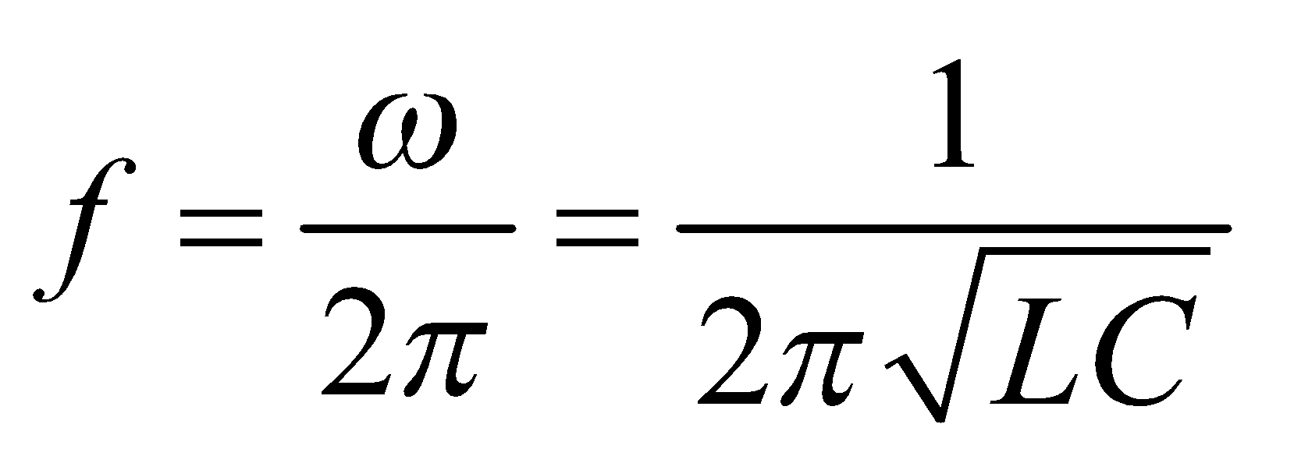

**Evaluate** Substituting the values given for capacitance and inductance, the resonant frequency is

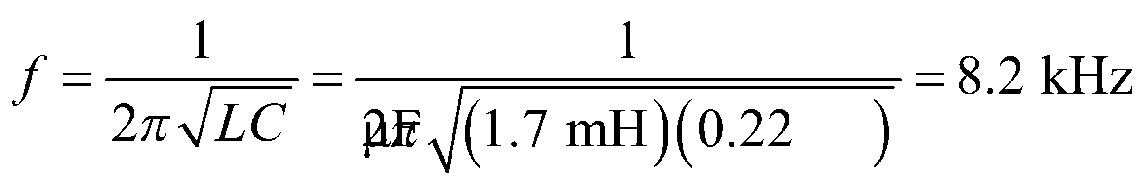

**Assess** The mechanical analog of the *LC* circuit is the mass-spring system whose angular frequency is 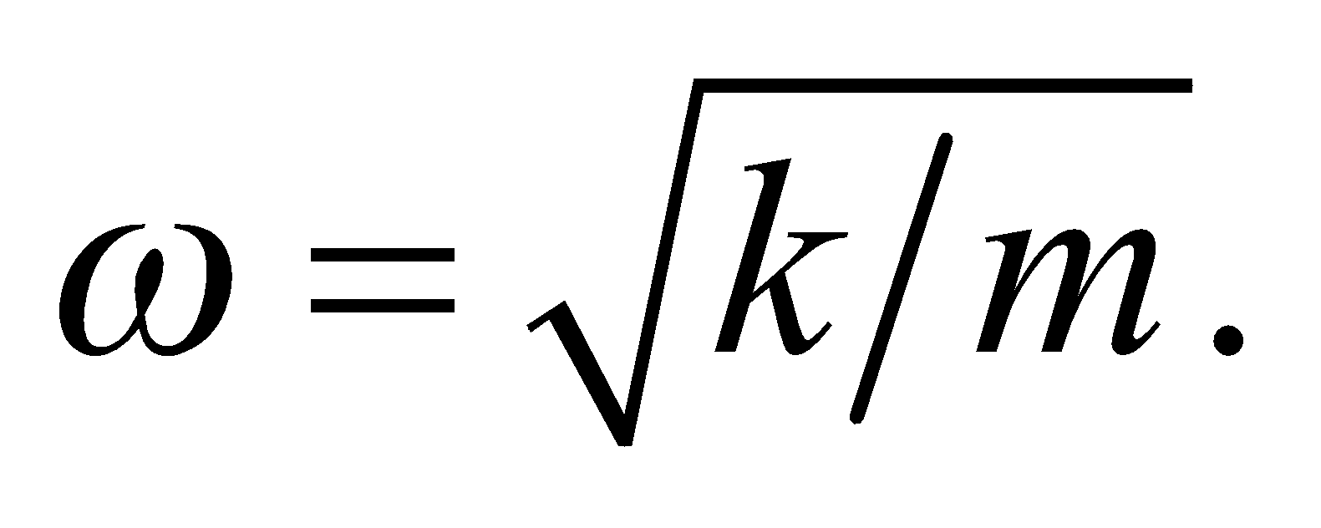 Thus, the correspondence between the two systems is: 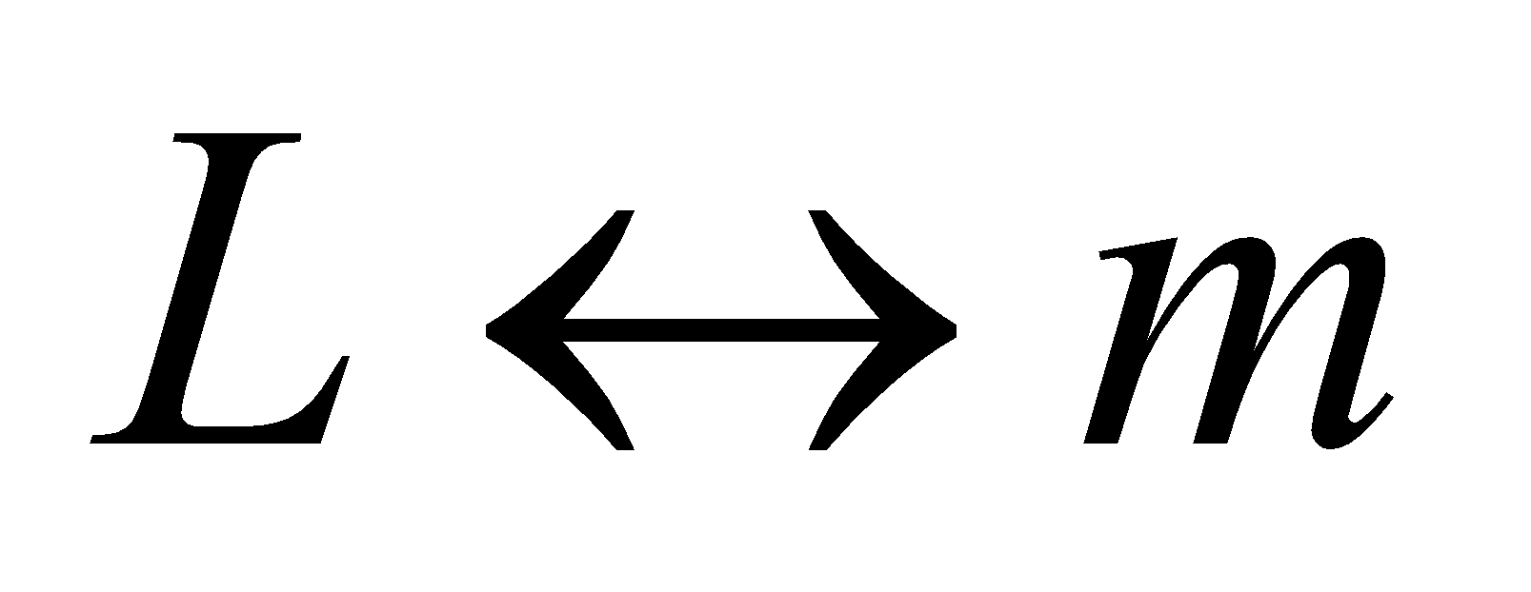 and 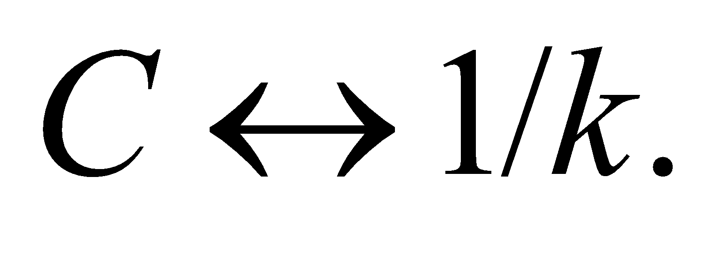

**25.** **Interpret** Given the oscillation period of an LC circuit and its capacitance, we are to find the inductance.

**Develop** The inductance and capacitance are related to the frequency of an LC circuit by Equation 28.10, 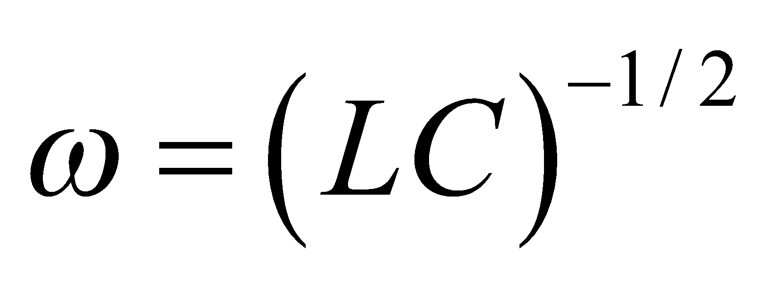. The angular frequency is related to the oscillation period *T* as *ω* = 2*πf* = 2*π*/*T*.

**Evaluate** Solving the expression above for the inductance and inserting the given quantities gives

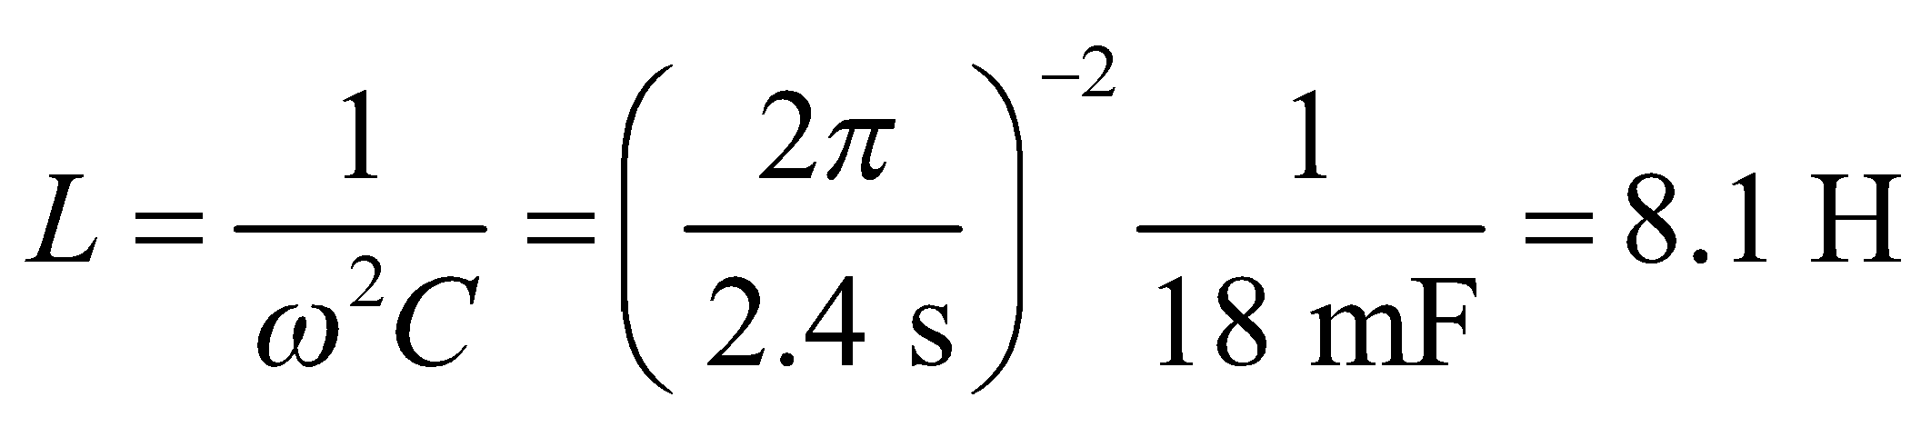

**Assess** The inductance and capacitance are inversely proportional for a given frequency.

**26.** **Interpret** You're helping your sister build her radio and need to determine what variable capacitor to use so as to cover the AM radio band.

**Develop**The frequency of your sister's radio receiver will be set by the *LC* circuit. Recall that the inductor that she wound around the cardboard tube has an inductance of 450 μH. The *LC* circuit oscillates at the angular frequency 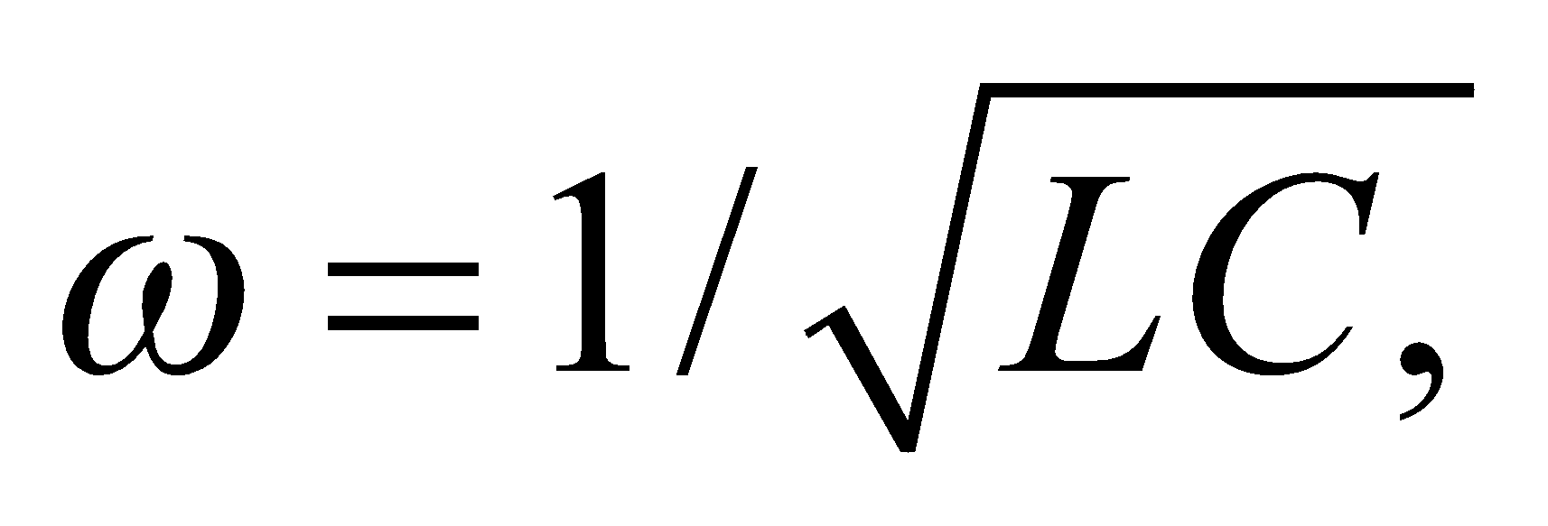 so you need to find the minimum and maximum capacitance in order to cover the minimum and maximum frequencies 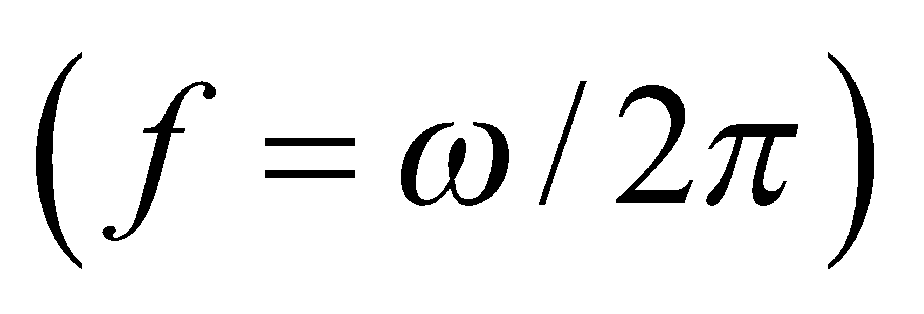of the AM band.

**Evaluate**The minimum frequency is 550 kHz, which corresponds to a capacitance of

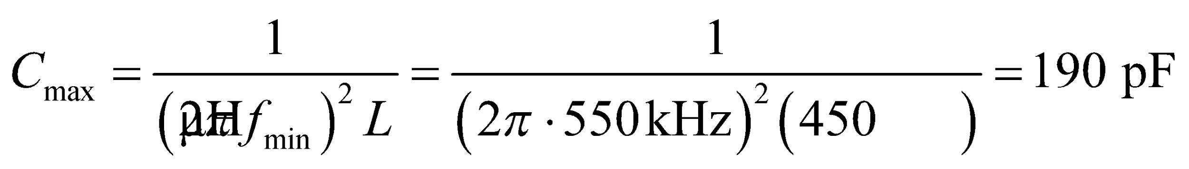

The maximum frequency is 1600 kHz, which corresponds to a capacitance of

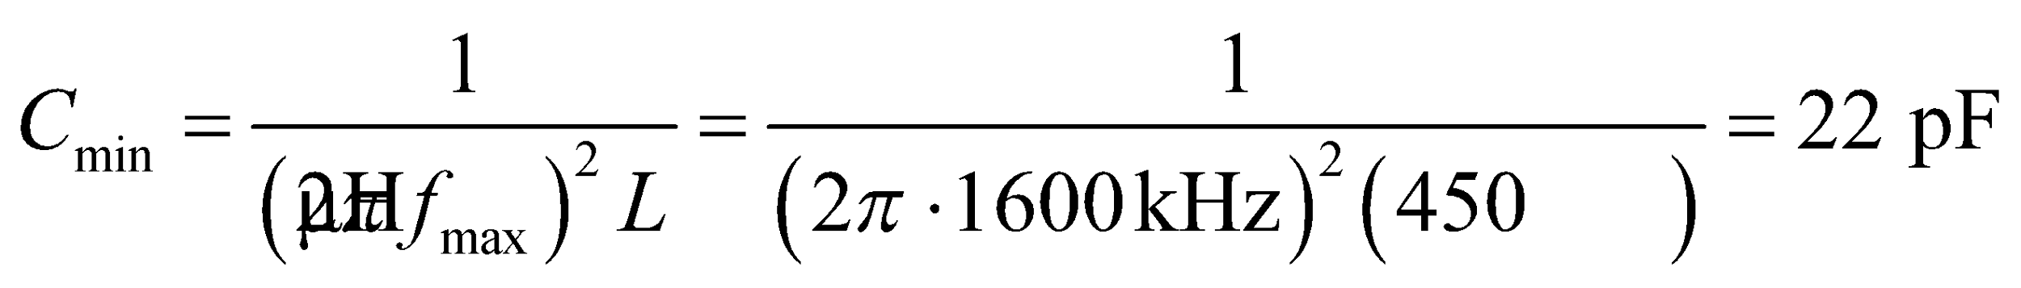

So your sister needs a variable capacitor with a range of 22 to 190 pF.

**Assess**The capacitance is small, but it is typical for small electronic applications.

**27.** **Interpret** We are to find the inductance and peak voltage of an LC circuit given its oscillation period and peak current.

**Develop** Using Equation 28.2, the oscillation frequency is

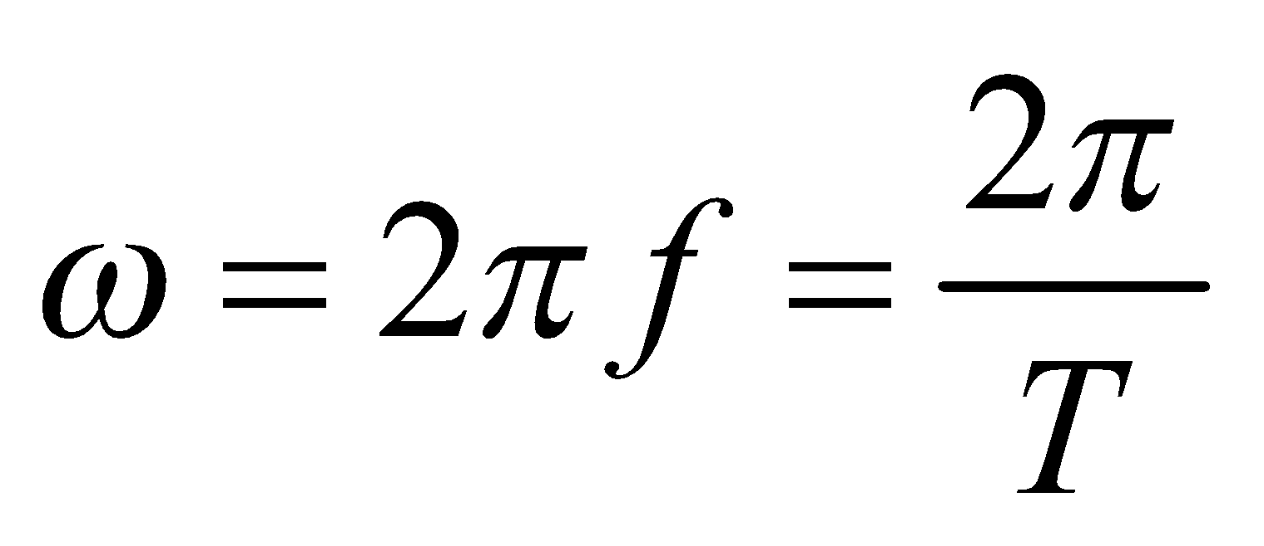

The inductance can be calculated from Equation 28.10: 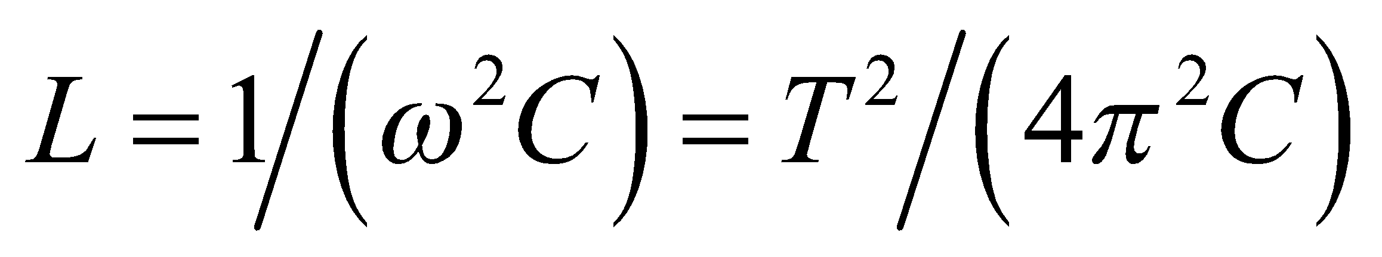

**Evaluate** (a) The inductance is

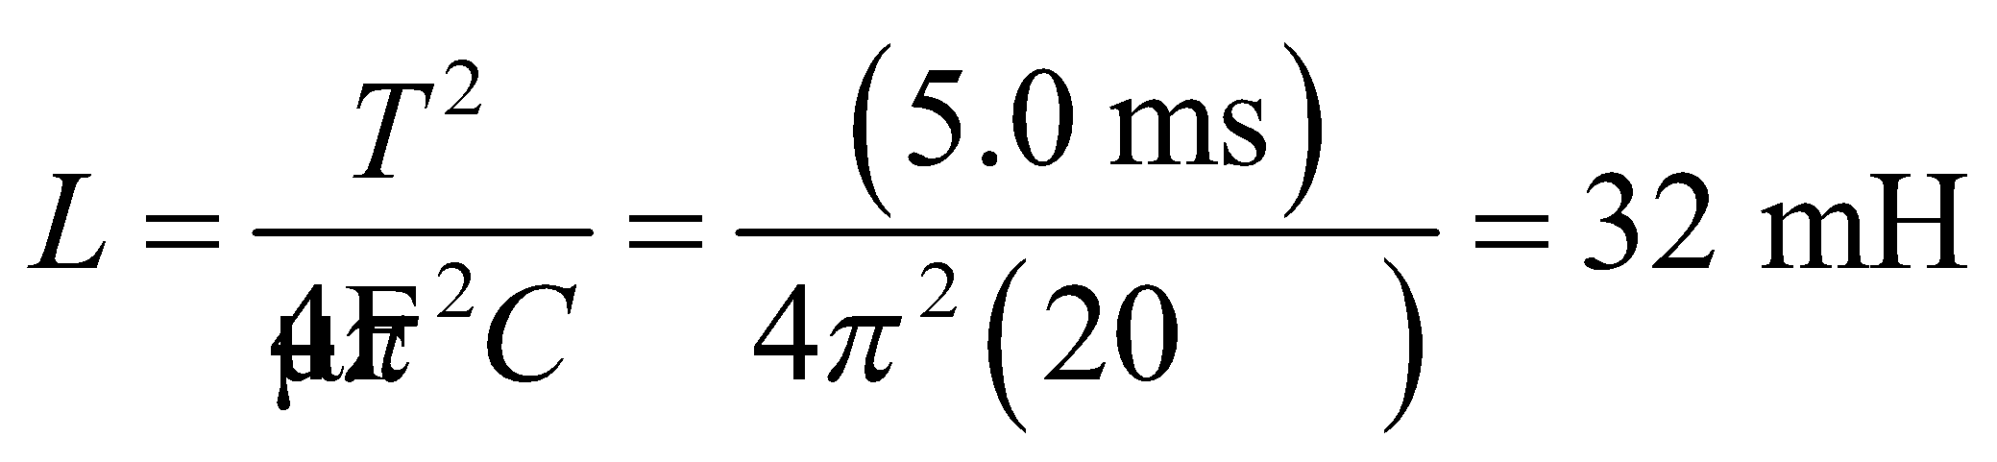

(b) Figure 28.11 and the expressions for the electric and magnetic energies for the *LC* circuit in the text imply that 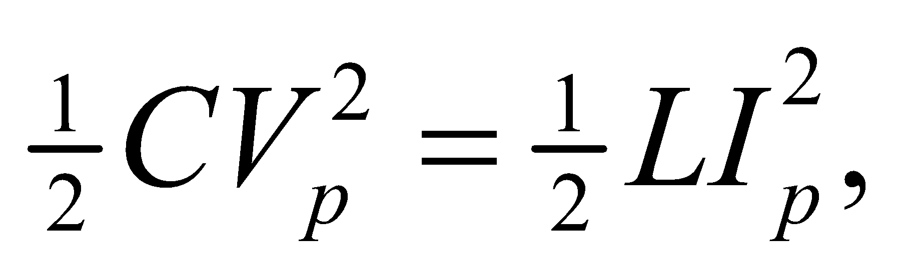 so



**Assess** The results are given to two significant figures, as warranted by the data.

**28. Interpret** We are to find the inductance needed to make an *LC* circuit that has the desired resonance frequency with the given capacitance.

**Develop** The resonance frequency of an *LC* circuit is 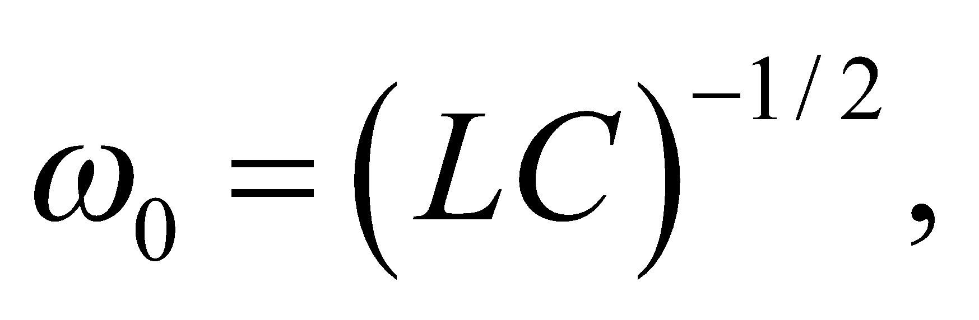 (see Section 28.4) so 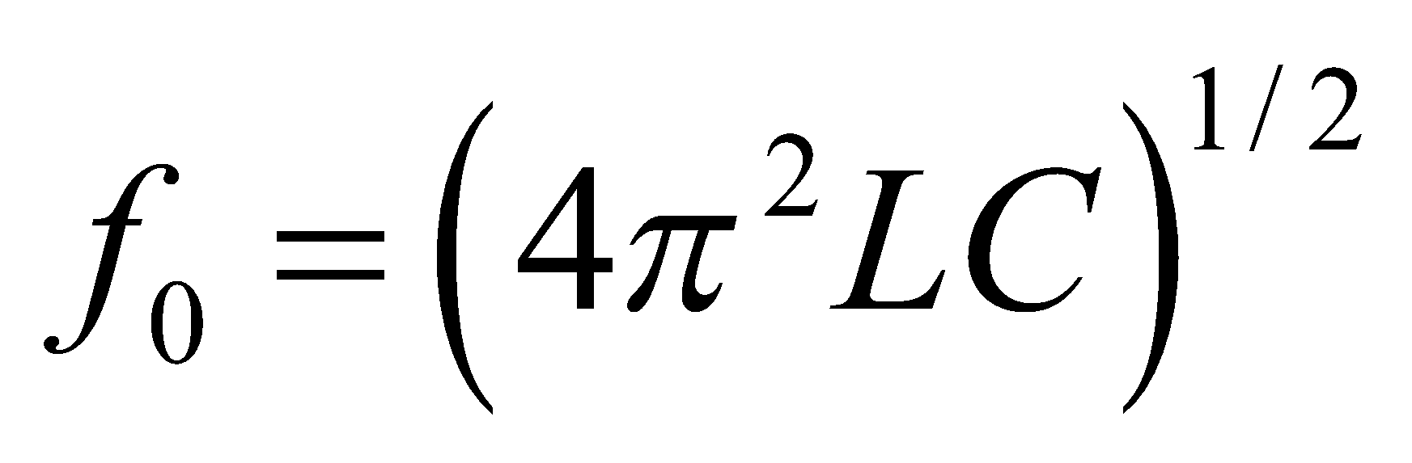 from Equation 28.2. The desired frequency is 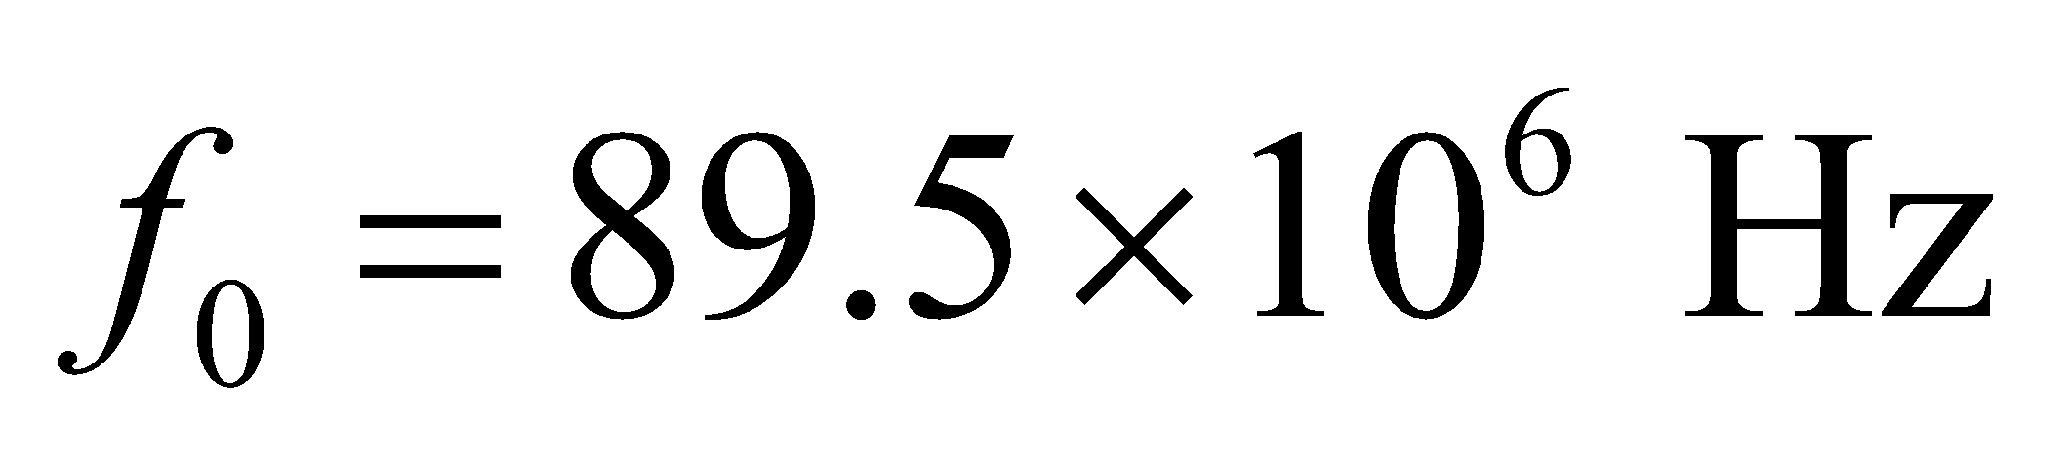 and capacitance is 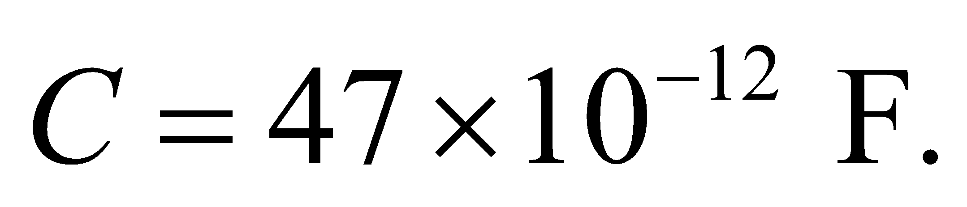

**Evaluate** Solving for *L* gives

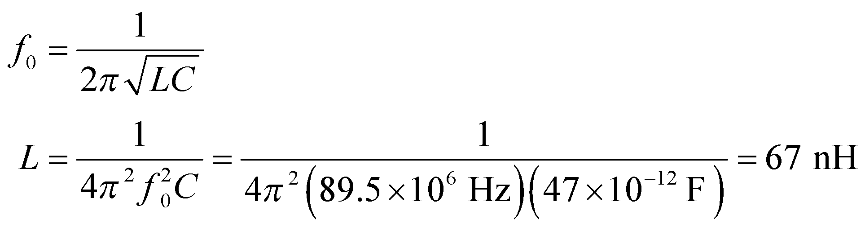

**Assess** This is a very small inductor. At high frequencies, small inductances such as this can have a large effect—so much so that it becomes important to design circuits so as to minimize the inductance of individual lead wires!

**Section 28.4 Driven *RLC* Circuits and Resonance**

**29.** **Interpret** We are to find the capacitance of the given *RLC* circuit, then find its impedance at the two given frequencies.

**Develop** The capacitance can be found from the relation between resonance frequency and the inductance and capacitance:

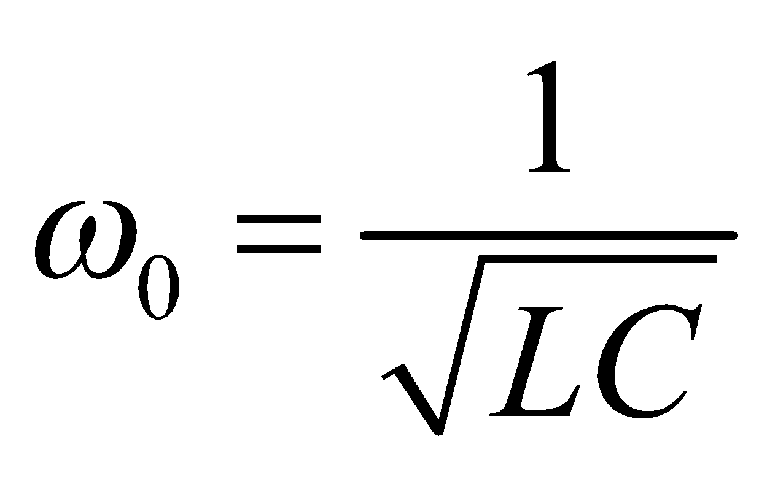

Knowing the capacitance, use Equation 28.12 to find the impedance, using  and 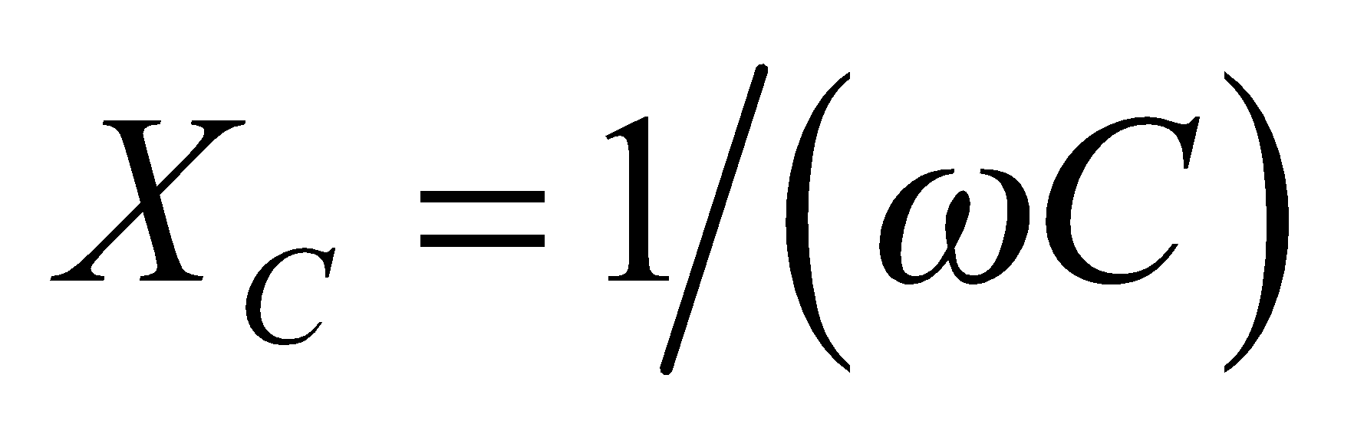.

**Evaluate** **(a)** From the expression for resonance in an *RLC* circuit,

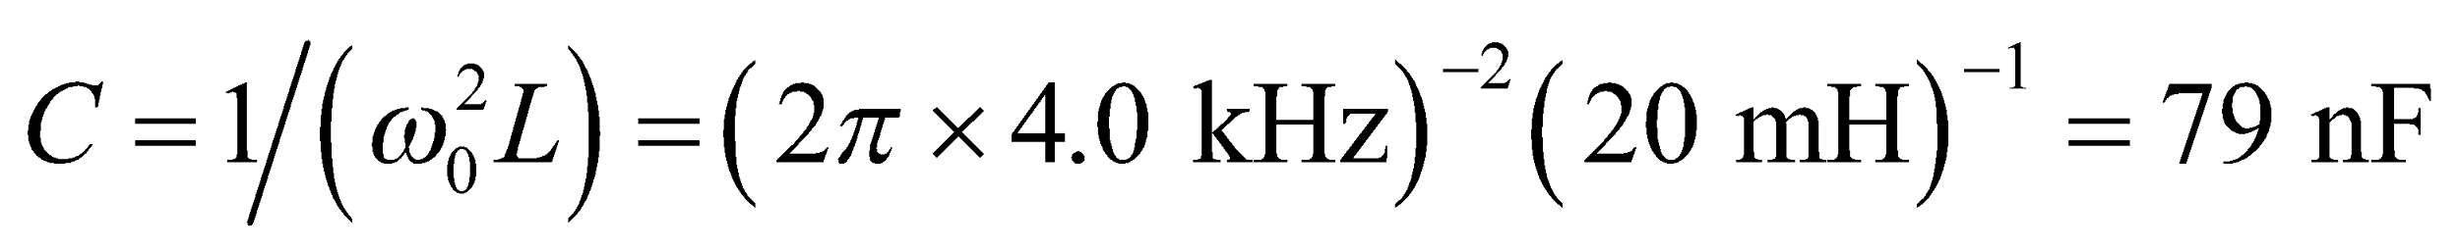

**(b)** At resonance, 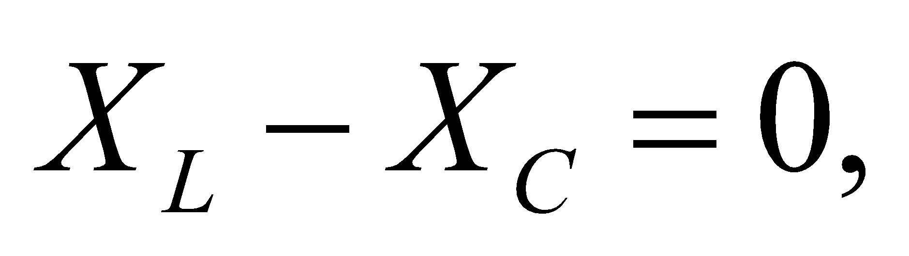 so 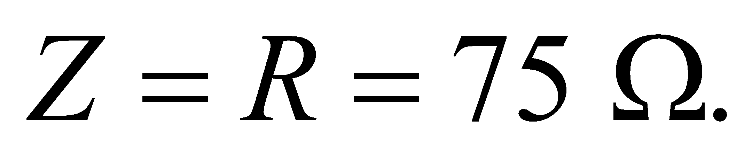

**(c)** At 3 kHz, 

so

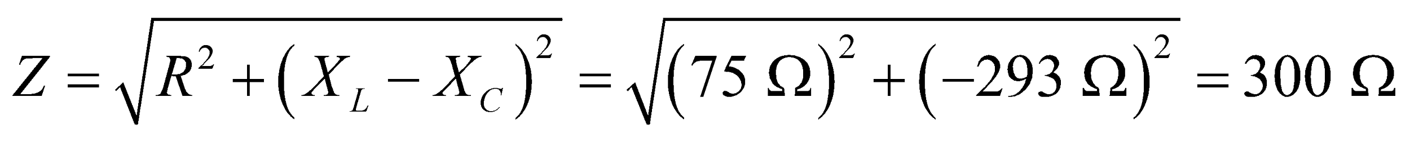

to two significant figures.

**Assess** The impedance is frequency dependent, so its value is different for different frequencies.

**30. Interpret** We are to find the impedance of an *LRC* circuit at a given frequency.

**Develop** From Equation 28.12, we know that 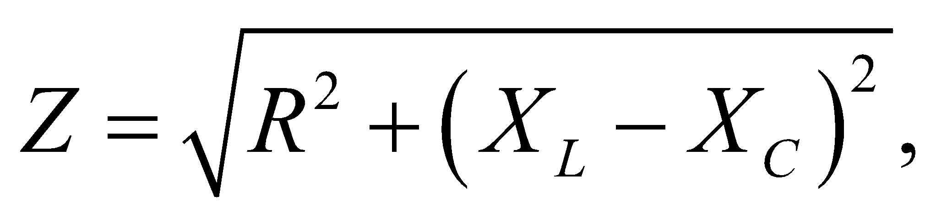 where  and 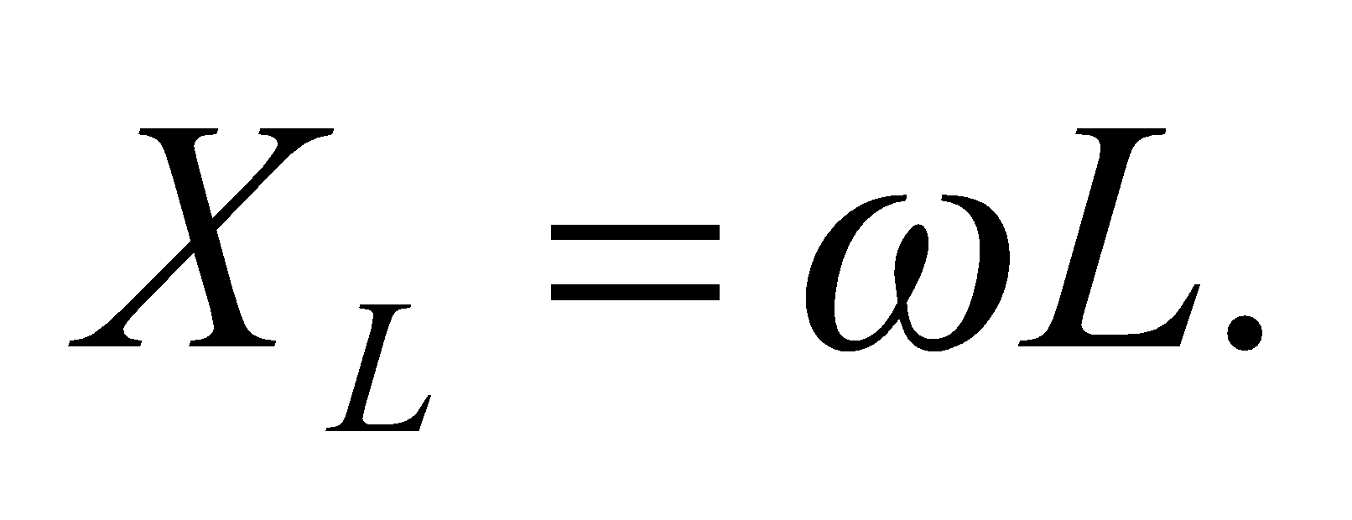 The given frequency is 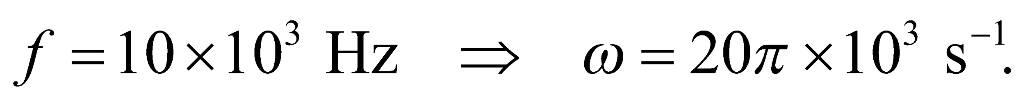 The values of the circuit elements are 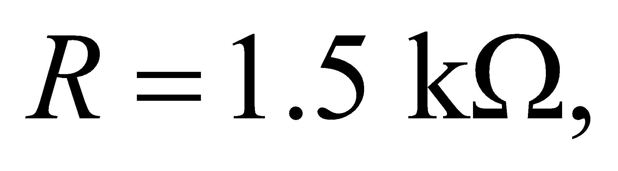 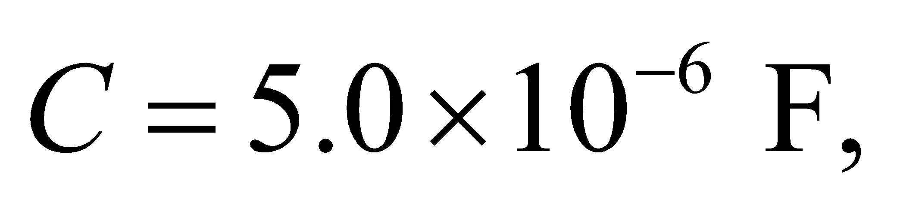 and 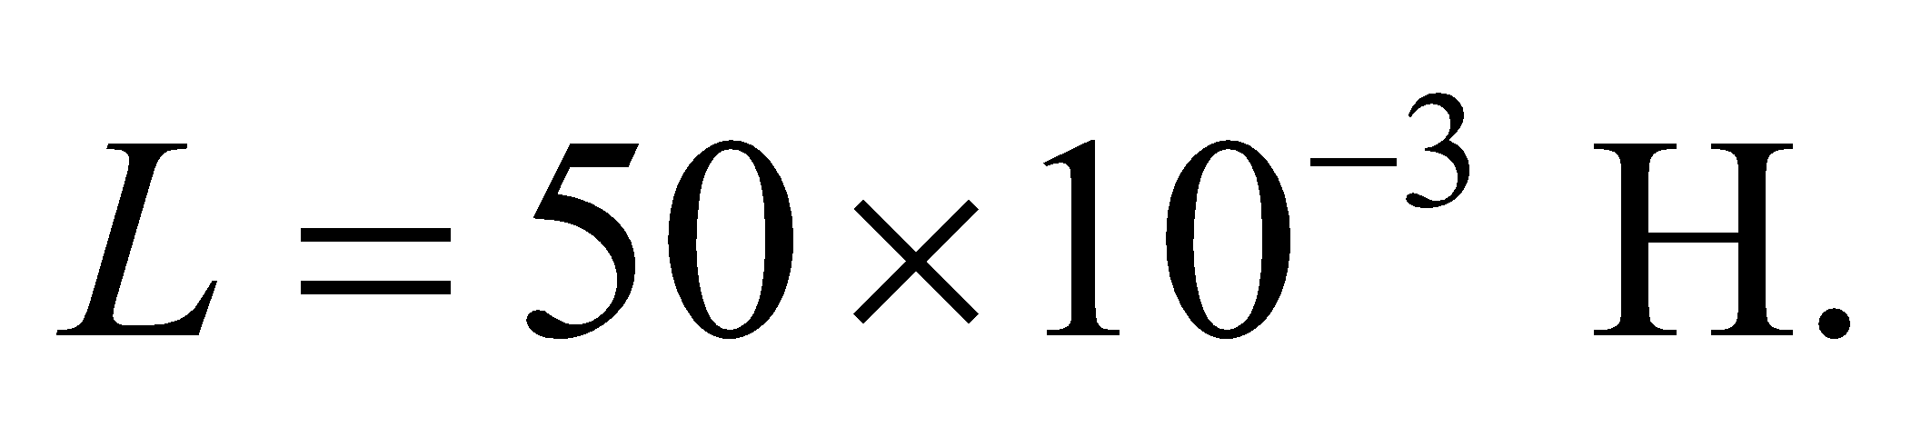

**Evaluate**  Inserting the given values into the expression for the impedance gives

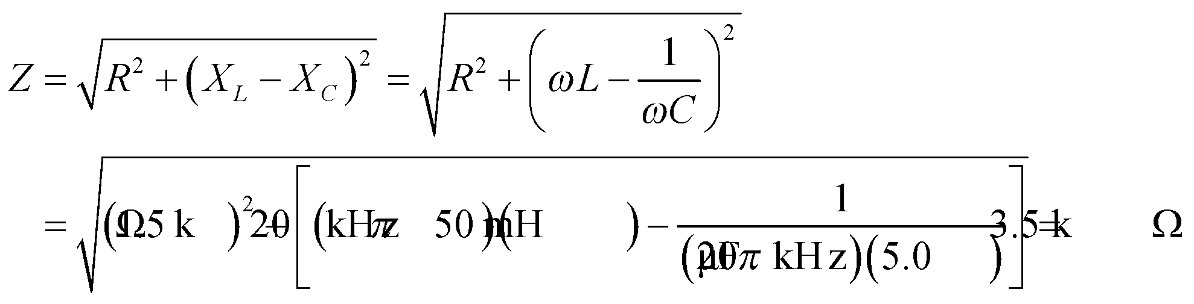

**Assess** Note that, at this frequency, the capacitor has almost no effect compared to the other two circuit elements.

**31. Interpret**  For a series *RLC* circuit, we are to find the frequency at which the impedance is a *minimum* and the value of that impedance.

**Develop** From Equation 28.12, we know that the impedance Z is  where  and  The frequency at which *Z* is minimum will be when 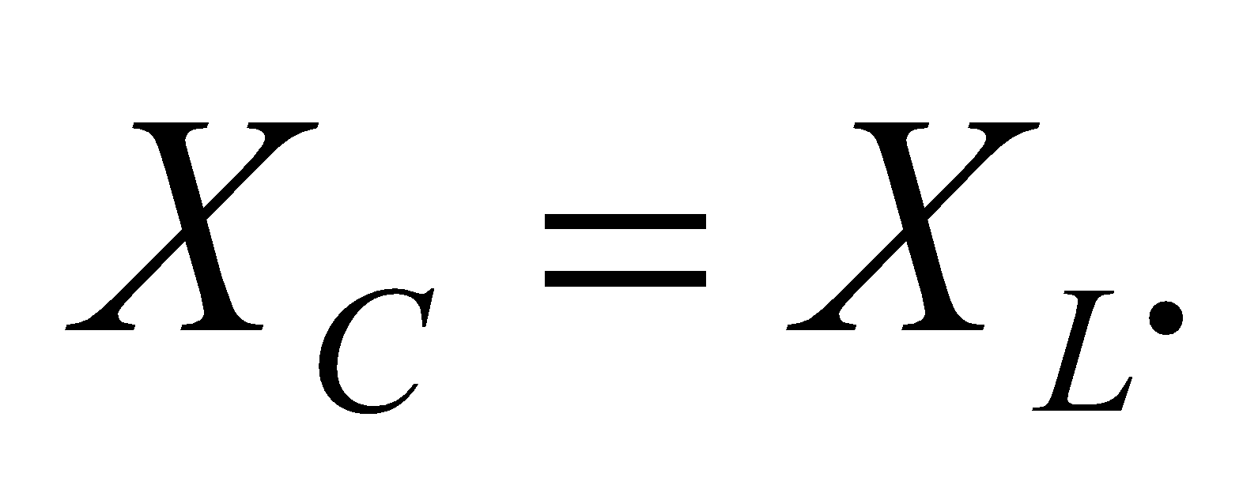 At that resonance frequency, the impedance is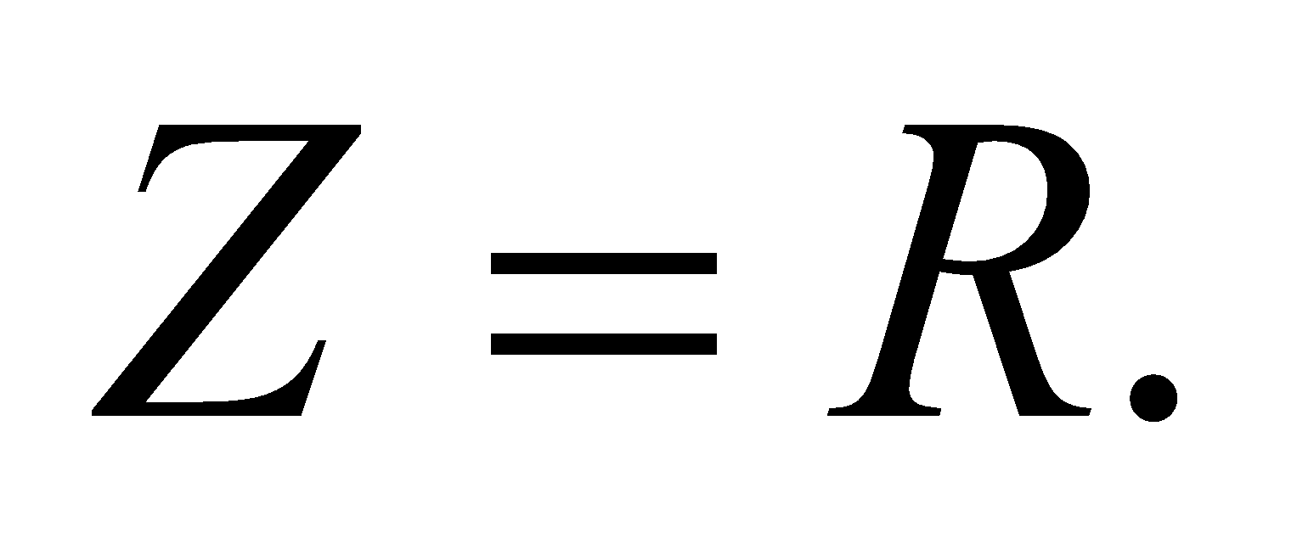 The component values in this circuit are 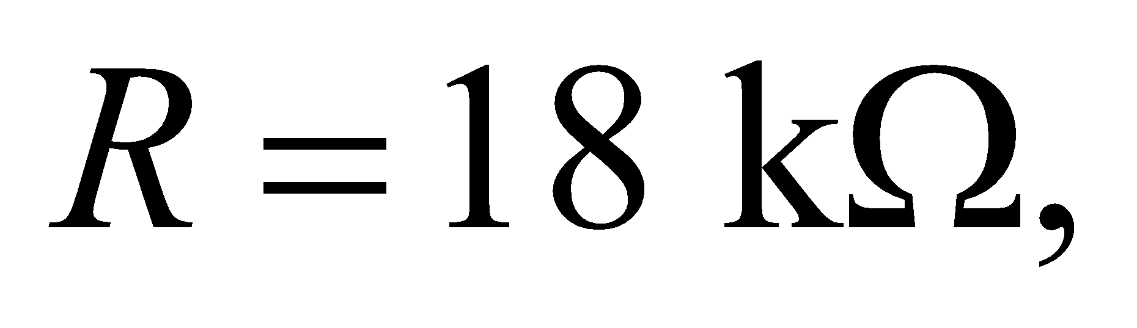 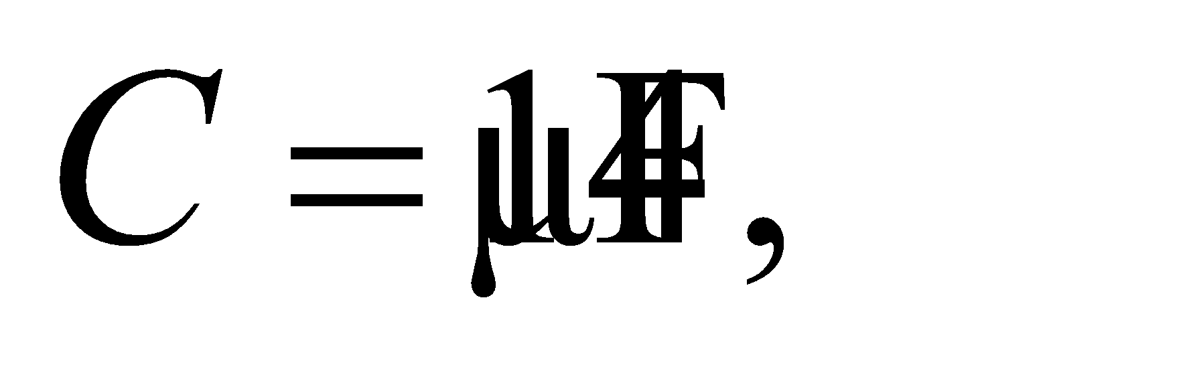 and 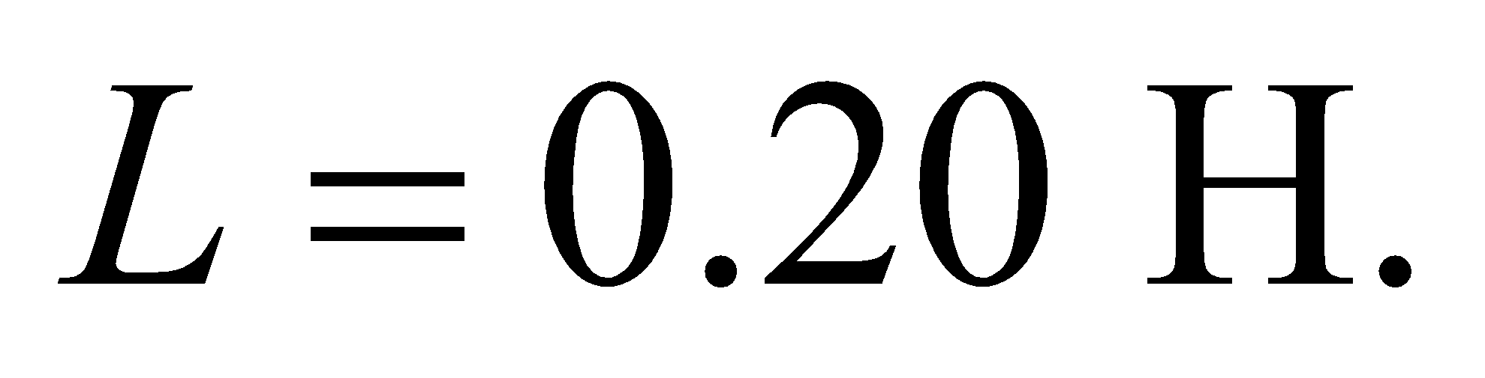

**Evaluate** (**a**) The minimum-impedance frequency is

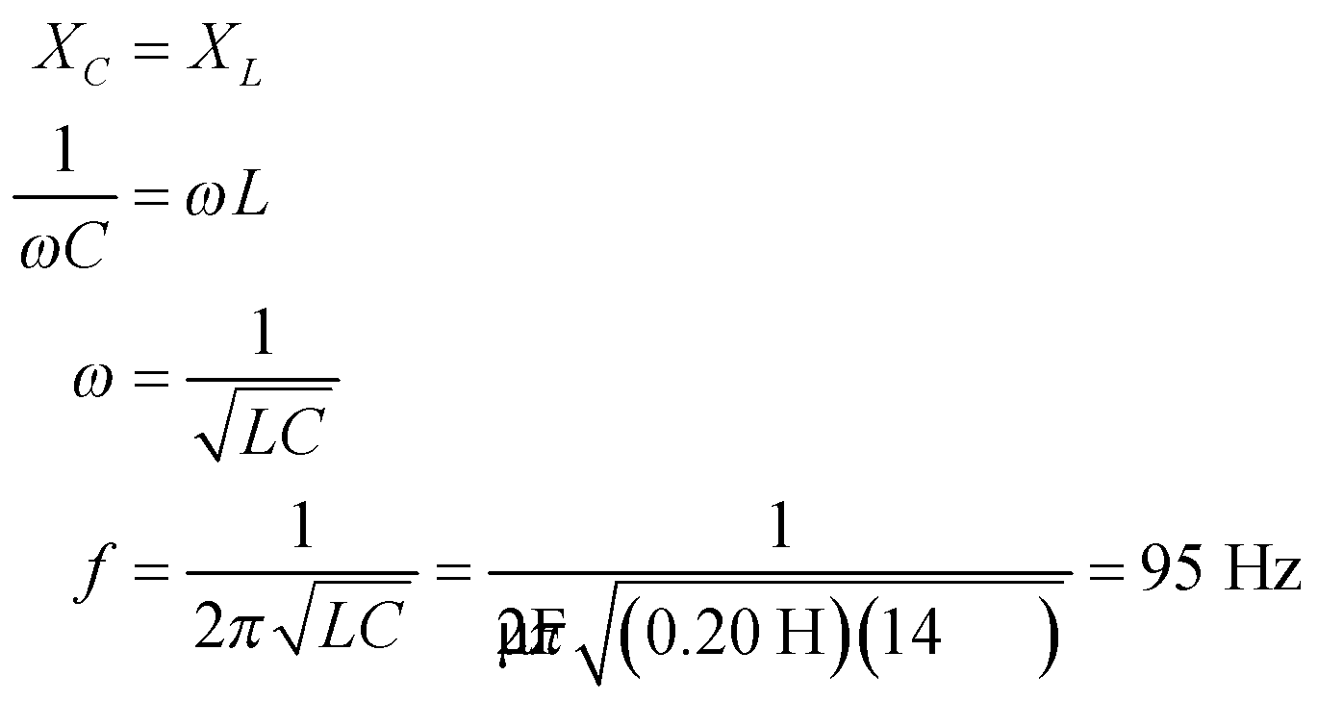

**(b)** At this frequency, the impedance is 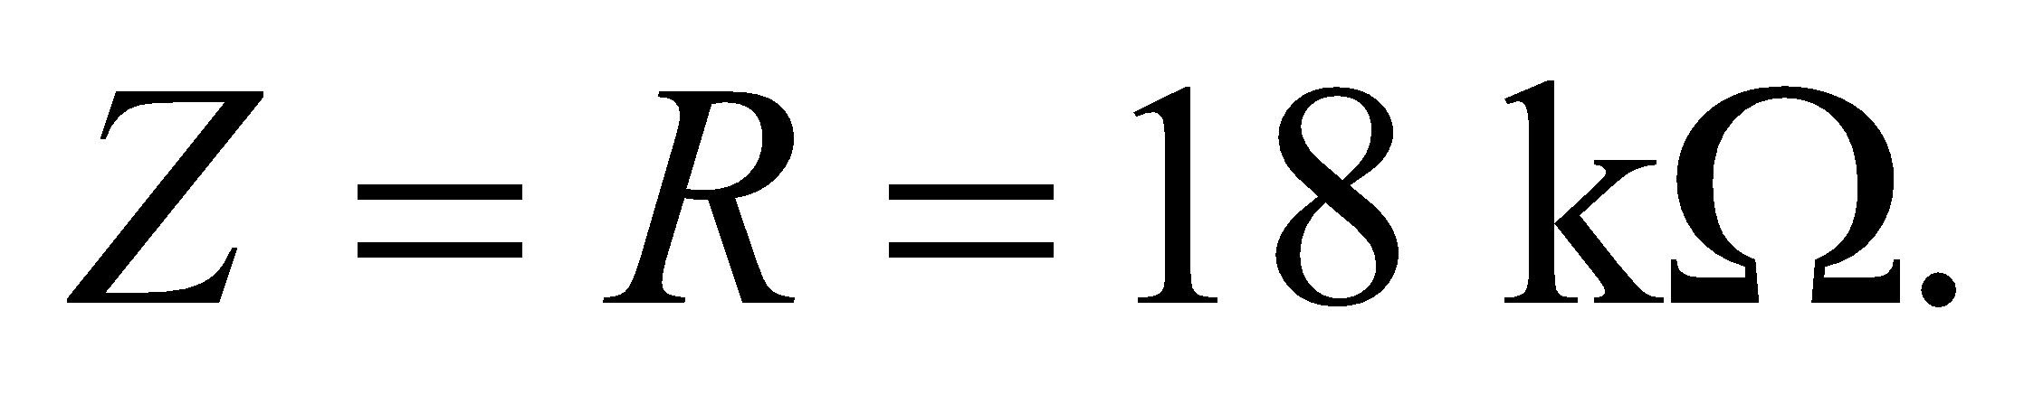

**Assess** At resonance, the effects of the inductor and the capacitor cancel out, leaving only resistance.

**32. Interpret** We are to find the peak current through an *RLC* circuit at resonance, for three values of *R* in the circuit. We shall use the fact that, at resonance, *Z* = *R*.

**Develop** The peak voltage is 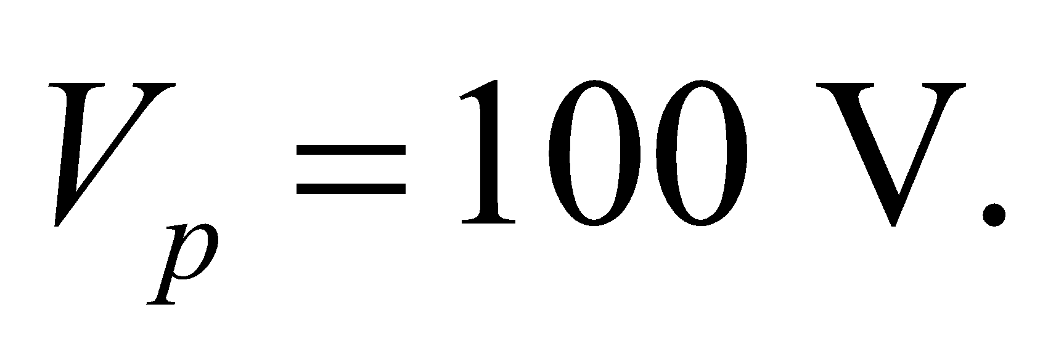 The value of *R* is 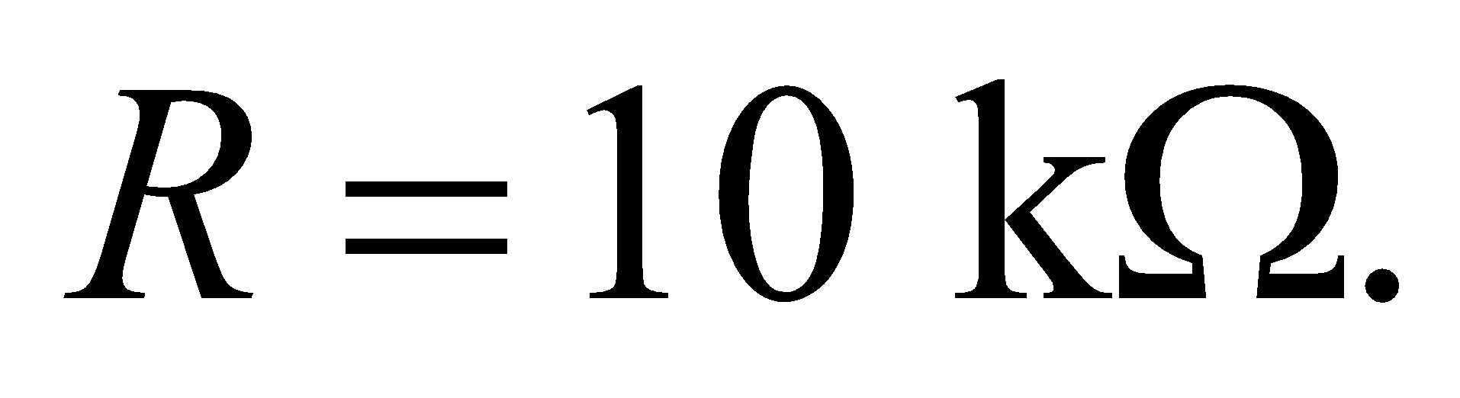 Since *Z* = *R* at resonance, the peak current will be 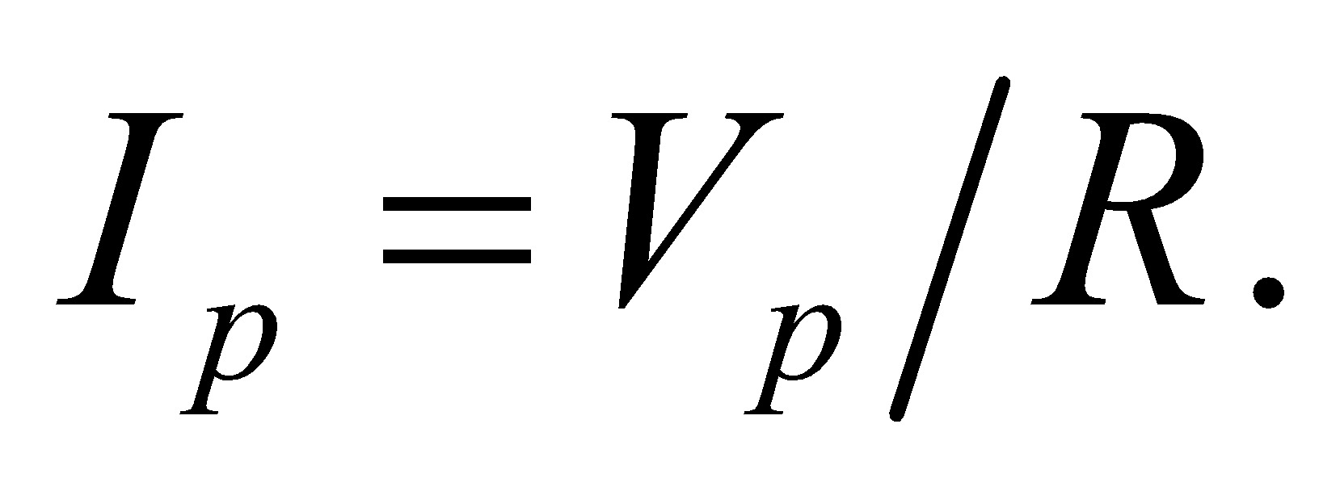

**Evaluate** For resistance  Similarly, for resistance *R*, 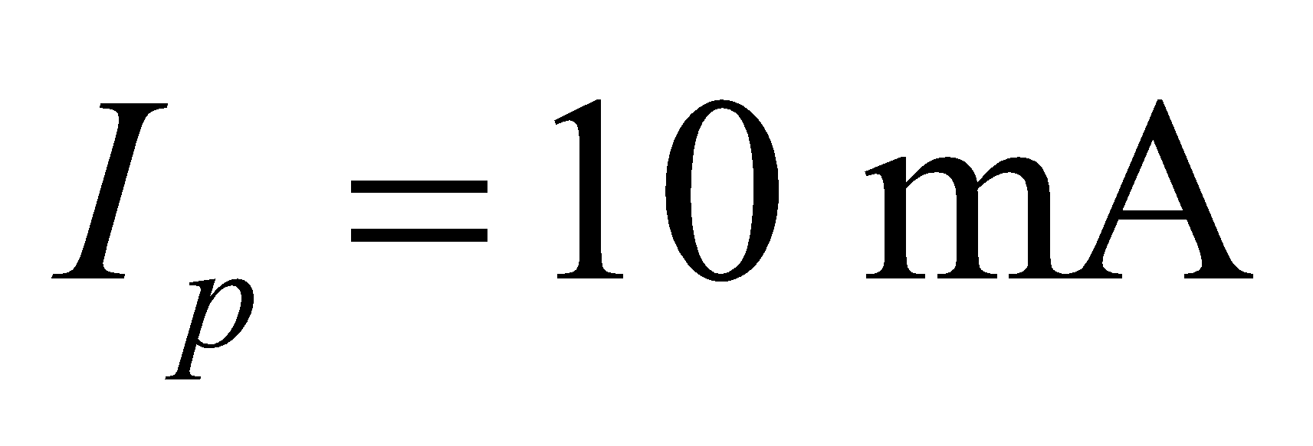 and for resistance 2*R*, 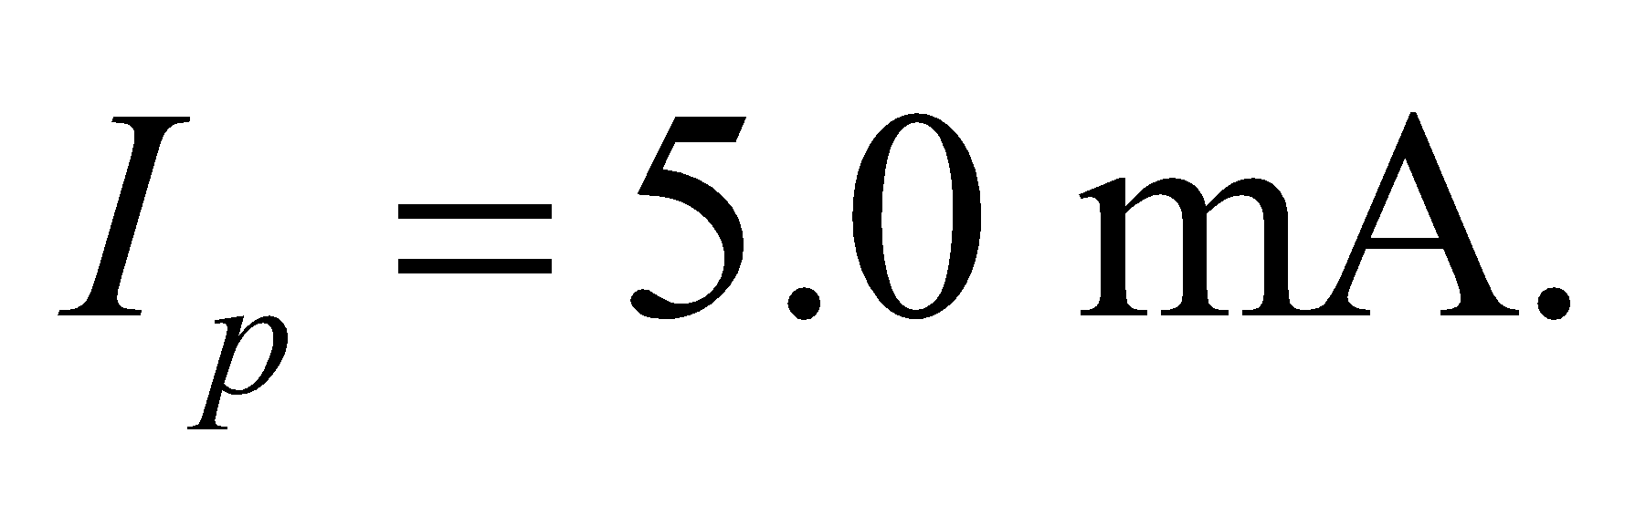

**Assess** At frequencies off the resonance peak, these calculations become somewhat more complicated. But at resonance, *Z* = *R* so everything becomes easy.

**Sections 28.5 Power in AC Circuits and 28.6 Transformers and Power Supplies**

**33.** **Interpret** We are to find the power consumption of a device given its rms current and the current phase.

**Develop** The average power consumed by an AC circuit is given by Equation 28.14, 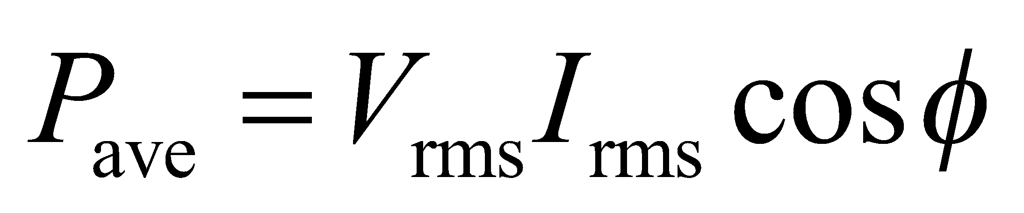.

**Evaluate** Inserting the given values into the expression above gives



**Assess** The maximum power for this would be (120 V)(4.6 A) = 552 W, which would require operating at a different frequency. Thus, at 25° phase, the power is about 90% of its maximum value.

**34. Interpret** We shall use the average power of a lamp, as well as the rms voltage and the power factor, to calculate the rms current that it draws.

**Develop** Use Equation 28.14,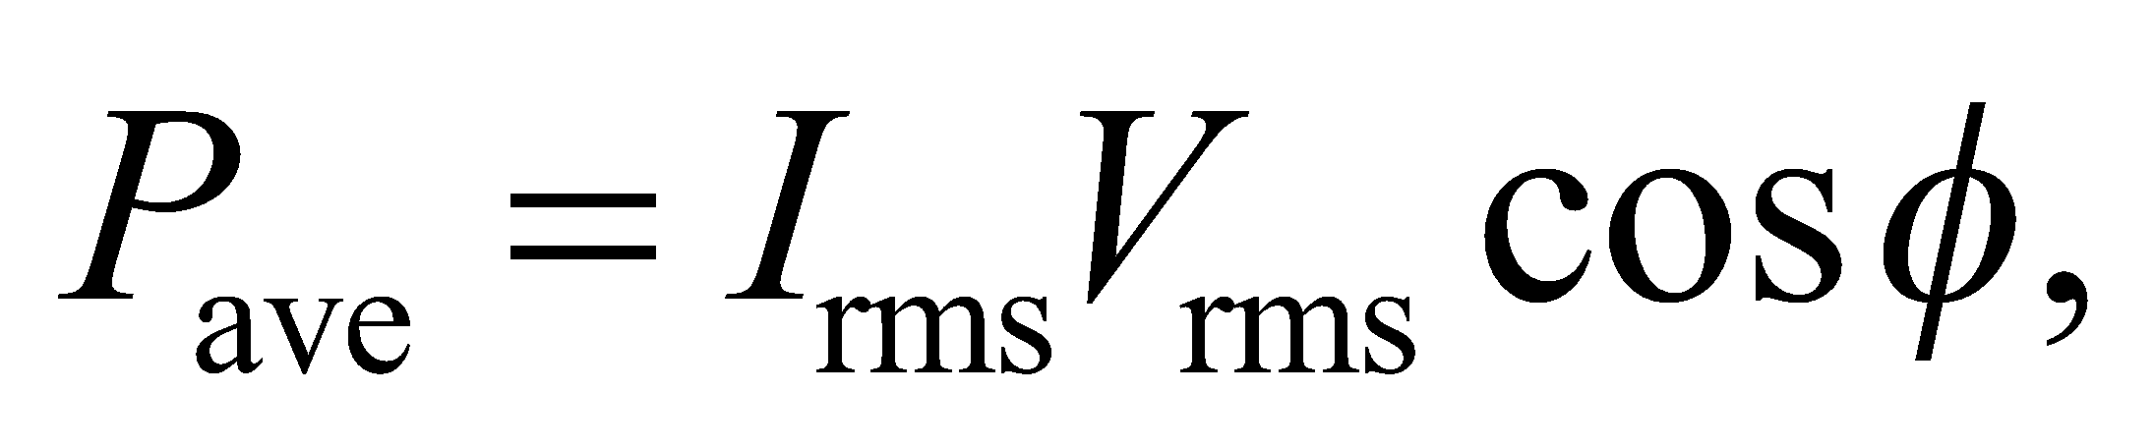 with cos*φ* = 0.85 being the given power factor.  and 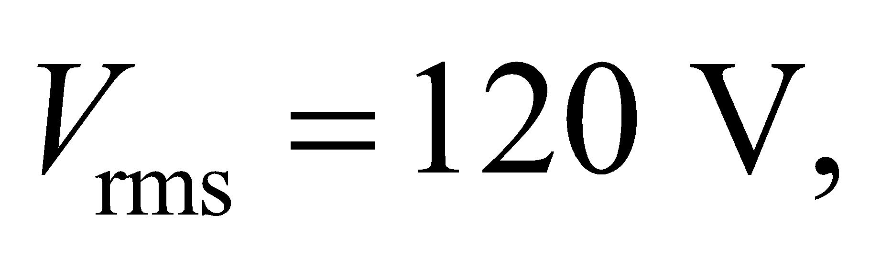 so we simply solve for 

**Evaluate** Solving for the rms currant gives

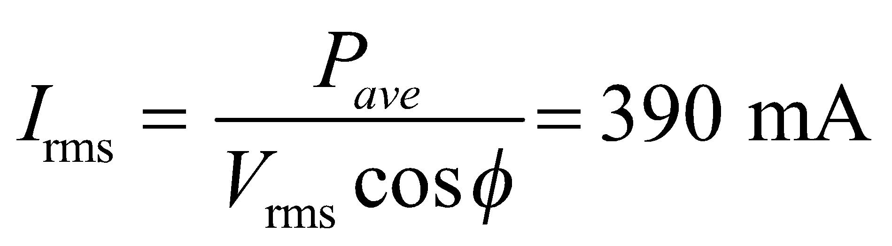

**Assess** The power factor actually matters with fluorescent lamps. With incandescent lamps, the impedance is almost entirely resistive, so the power factor is almost exactly one.

**35. Interpret** We are to compare the power consumption of two circuits that have the same current and voltage; but one that is purely resistive and the other has voltage leading current. The difference in the power usage by these two circuits will be due to the difference in power factors between the two circuits.

**Develop** The average power consumption of a circuit is (Equation 28.14) 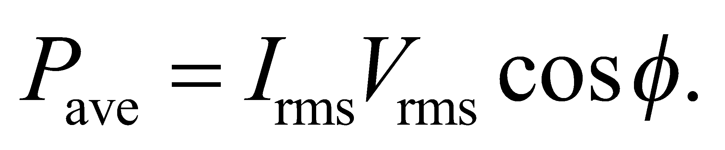 In the first circuit, the power factor is cos*φ* = 1, since the circuit is purely resistive. In the second, *φ* = 20°. In each case, 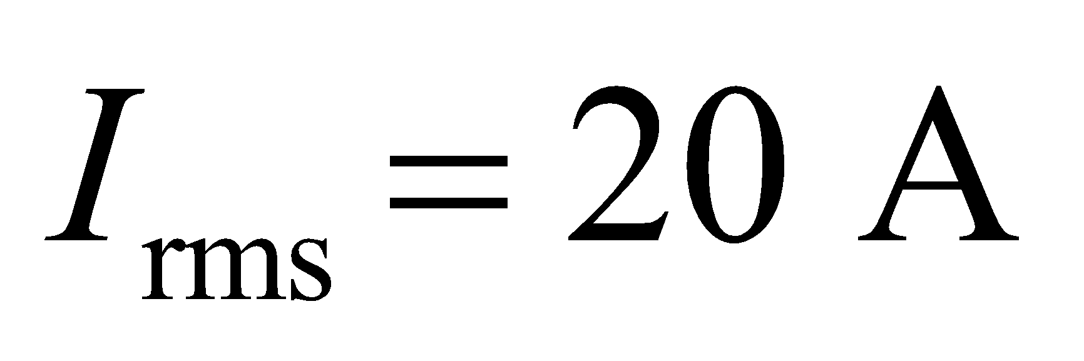 and 

**Evaluate** For the first circuit,



For the second circuit,



**Assess** This is a fairly direct application of a power calculation.

**36.** **Interpret** The problem concerns isolation transformers that are used for safety.

**Develop**The turns ratio is defined in Equation 28.15: 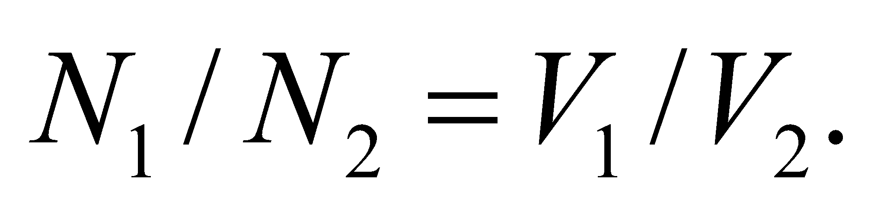

**Evaluate**Since the input and output voltages have the same magnitude, the turns ratio is 1.

**Assess**It might seem like a waste to have a transformer that doesn't "transform," but the isolation transformer can provide an ungrounded power supply separate from the main utility line. An ungrounded power supply is said to be "floating," i.e., the voltage is alternating but the zero of the voltage is not specified, as it is for a grounded power supply. If a patient were to touch a live wire in a medical device connected to an isolation transformer, he or she would provide a "ground." However, since this is the only connection to ground for the medical device, there is no circuit and therefore no current flows through the patient.

**37.** **Interpret** You're trying to determine what transformer you need to run your American-bought stereo in Europe.

**Develop**You need a step-down transformer that goes from Europe's 230 V to the 120 V used by your stereo. The number of turns in the primary and secondary coils are related by Equation 28.15: 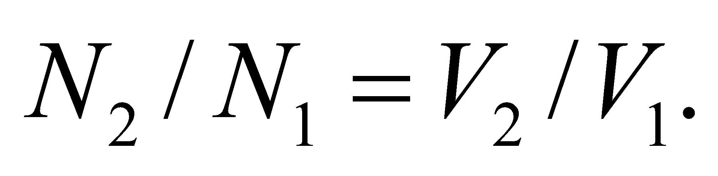 Power, 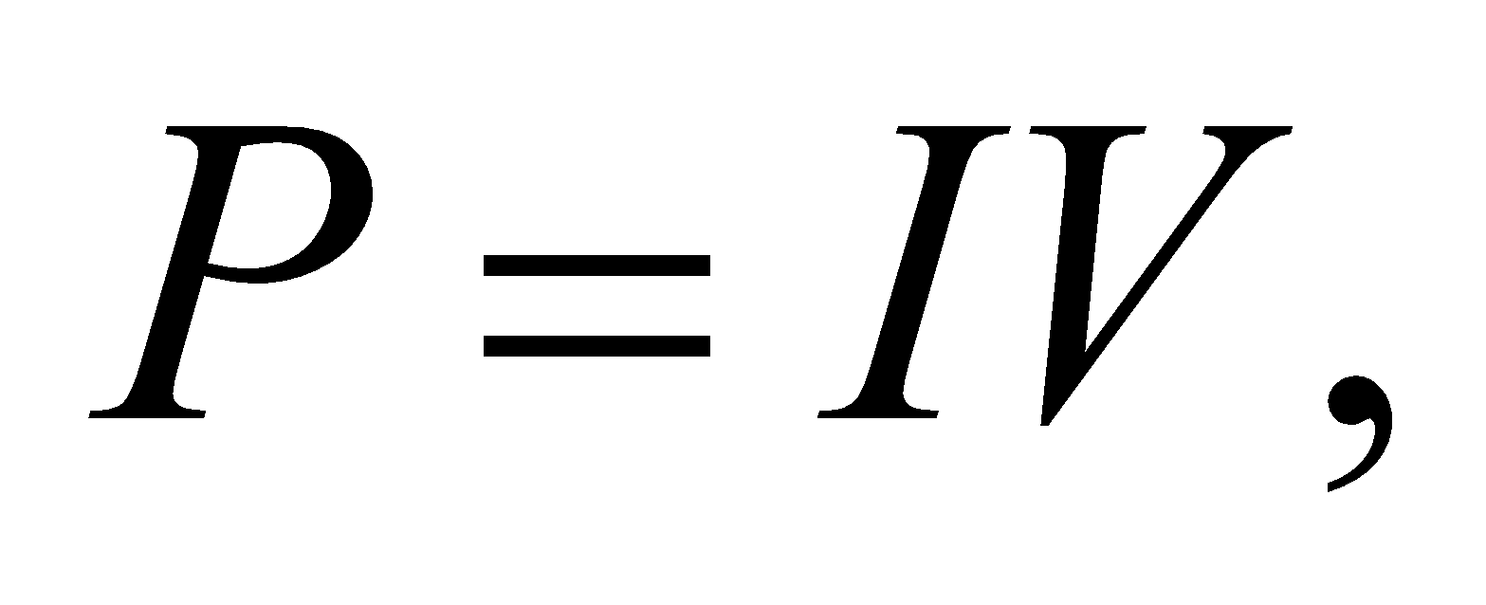is ideally conserved in the transformer, so the currents in the primary and secondary coils should be related by: 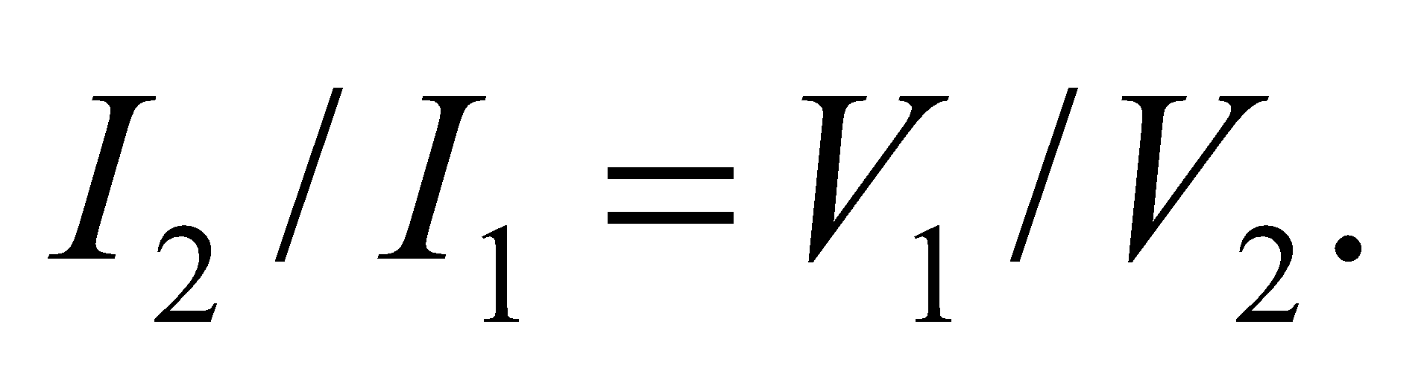

**Evaluate**(a) Given the number of turns in the primary, the number of turns in the secondary is

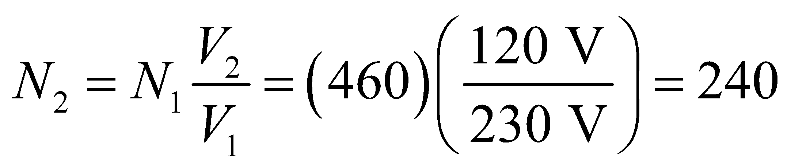

(b) Given the maximum primary current, the maximum secondary current will be

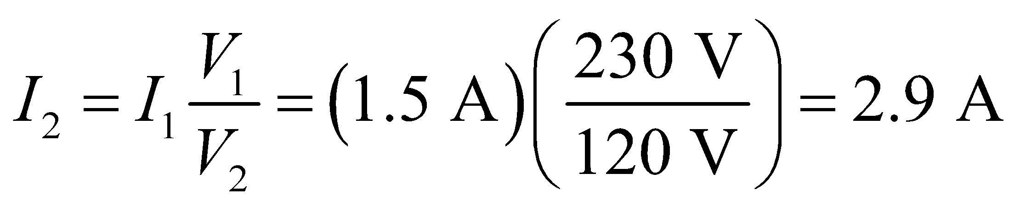

This is below the threshold of your stereo, so the transformer will work.

**Assess**The emf per turn in the secondary is set by the number of turns and the current in the primary. Therefore, to lower the voltage, the secondary should have less turns than the primary, as we have found. By contrast, the reduced voltage of the secondary require more current in order to conserve power. (Of course, some power will be lost in the transformer to resistive heating in the coils.)

**Problems**

**38.** **Interpret** We are to find the rms inductor current for two different reactive circuits.

**Develop** Apply Equation 28.7, 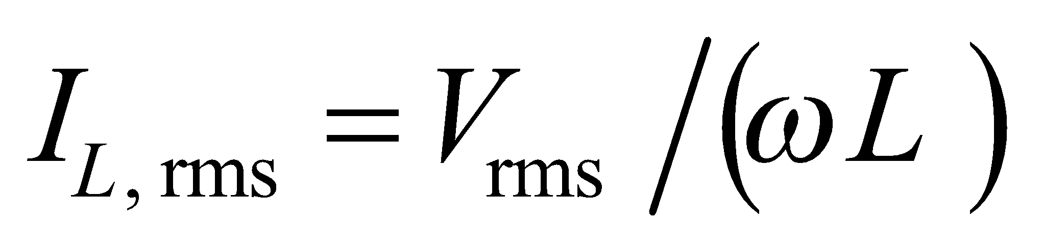

**Evaluate** (**a**) Inserting the given values into the expression for rms current gives

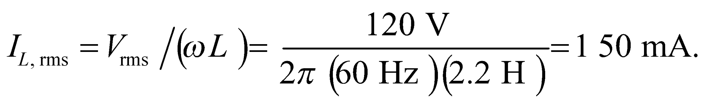

**(b)** A similar calculation with European values gives 330 mA.

**Assess** The result is reported to two significant figures.

**39. Interpret** This problem is about capacitive and inductive reactances, and how they depend on the frequency.

**Develop** From Equations 28.5 and 28.7, the capacitive and inductive reactances are

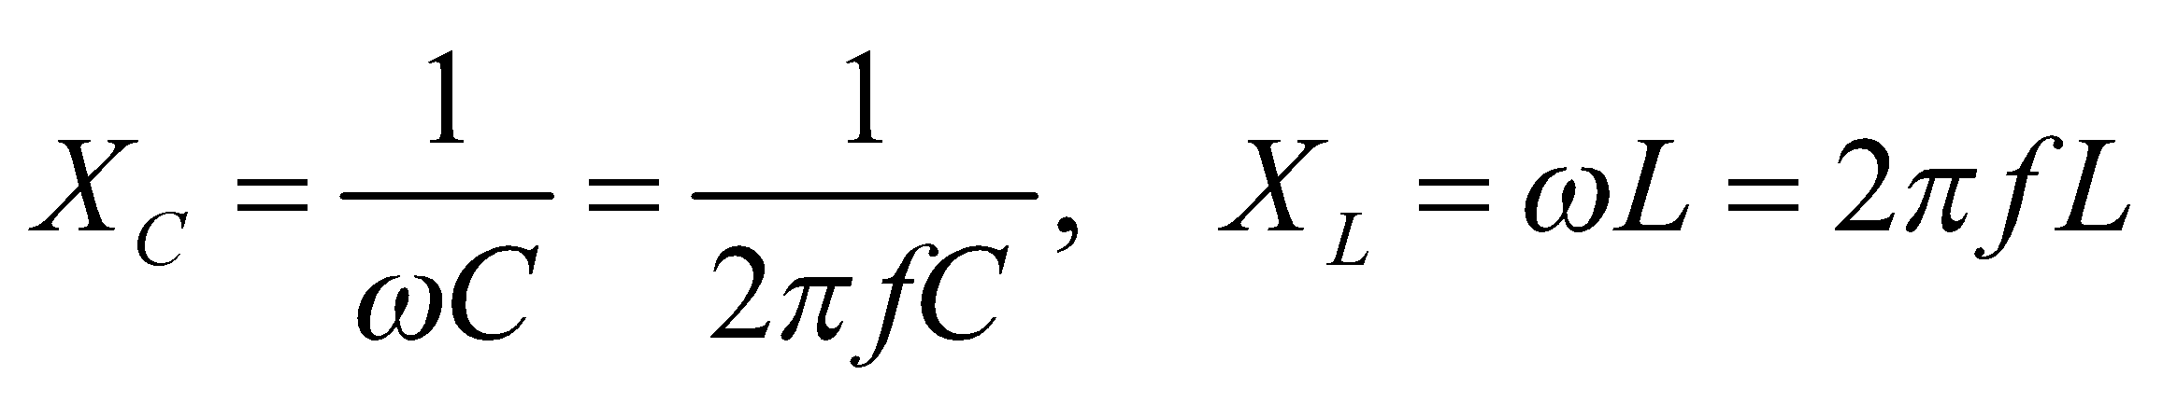

**Evaluate**  **(a)** From the above equation, the frequency of the applied voltage is

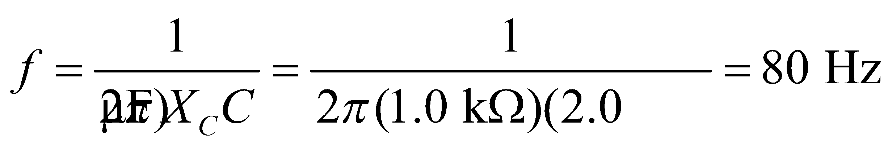

**(b)** Equating 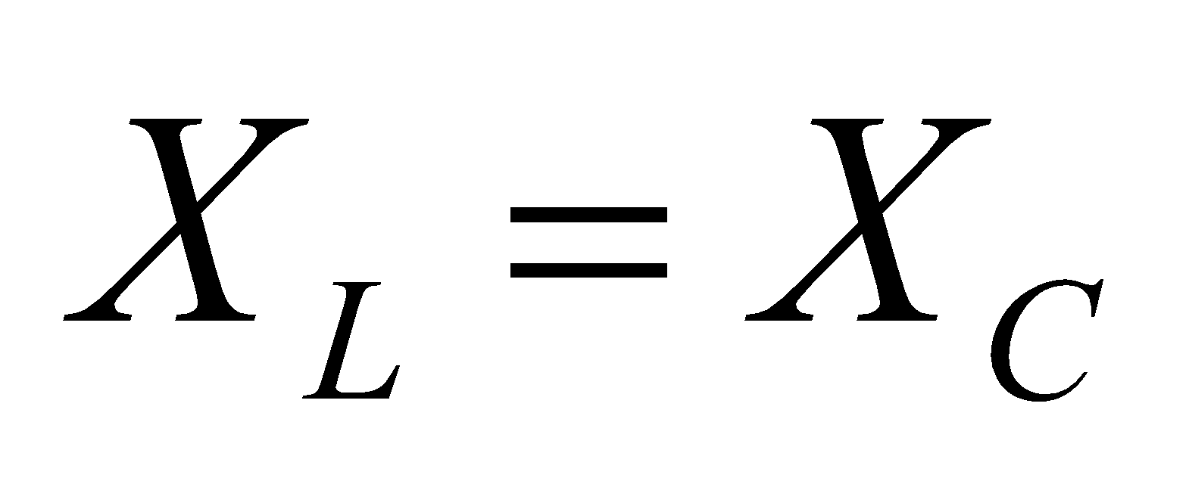 implies

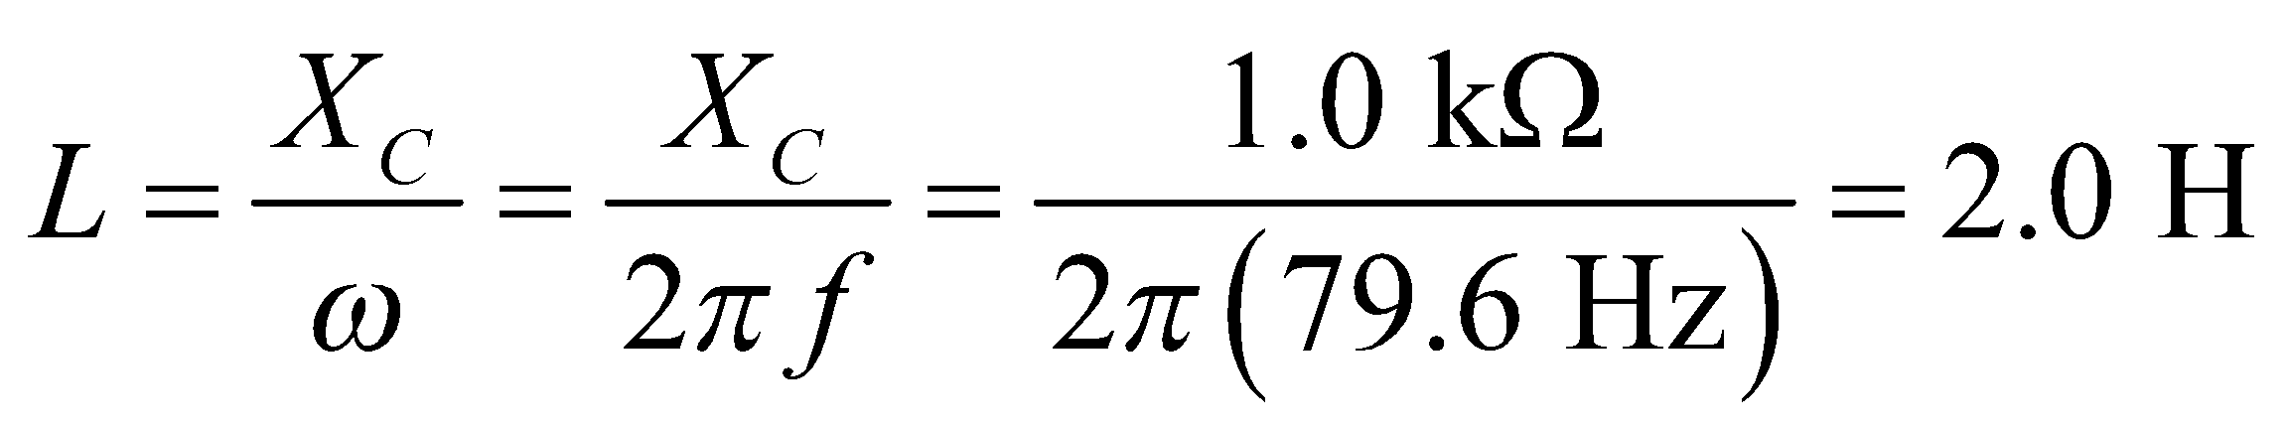

**(c)** Doubling *ω* doubles 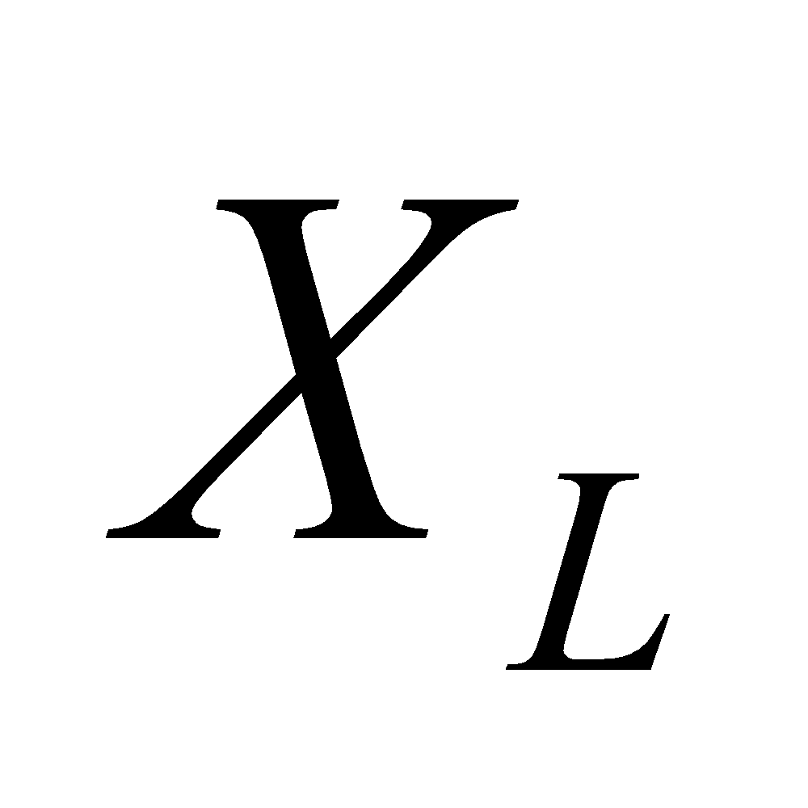 and halves 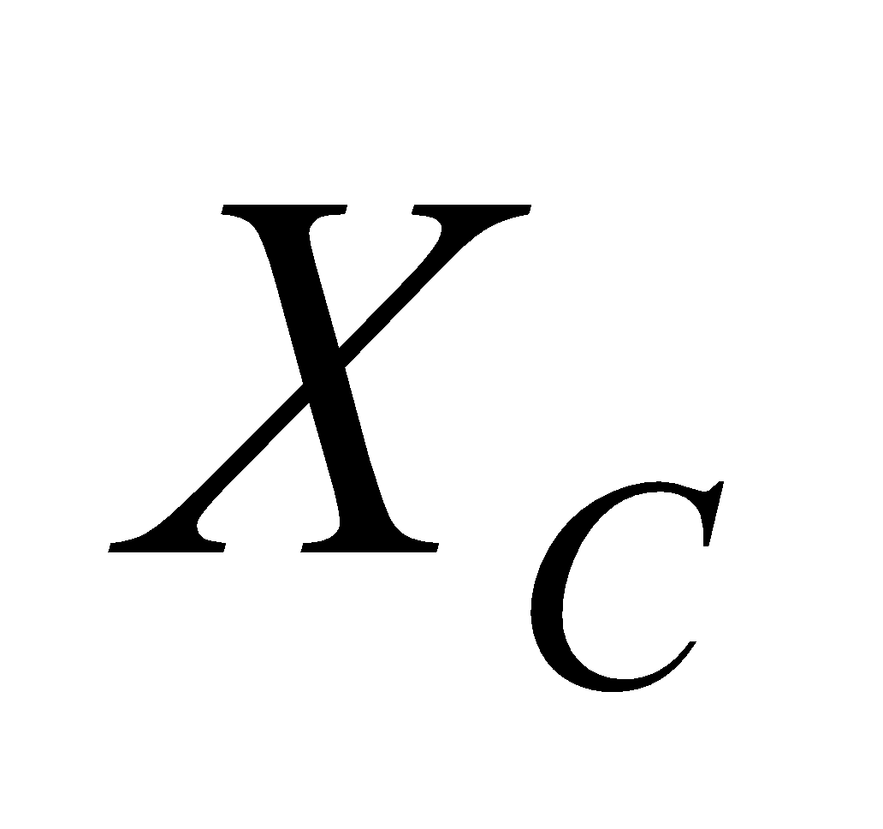, so  would be four times  at 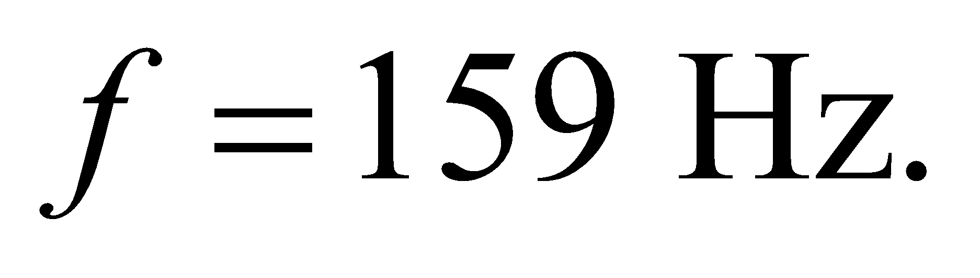

**Assess** Capacitive reactance  is inversely proportional to *ω*, whereas the inductive reactance  is proportional to *ω*. A larger capacitor has lower reactance and a larger inductor has higher reactance.

**40.** **Interpret** This is an exercise in dimensional analysis. We are to show that the units of capacitive and inductive reactance are ohms.

**Develop** Inductance is defined as the ratio of flux to current (Equations 27.3), and capacitance as that of charge to potential difference (Equation 23.1).

**Evaluate** Thus, the units of inductive reactance 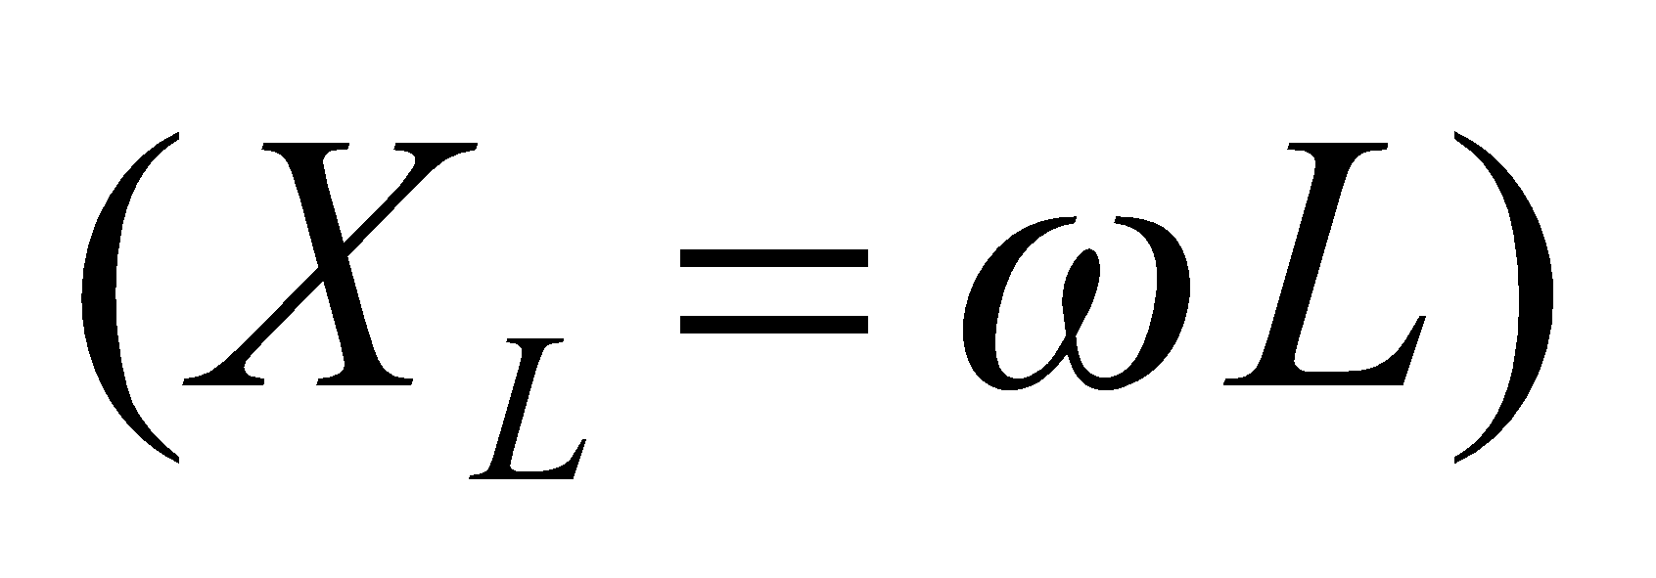 are 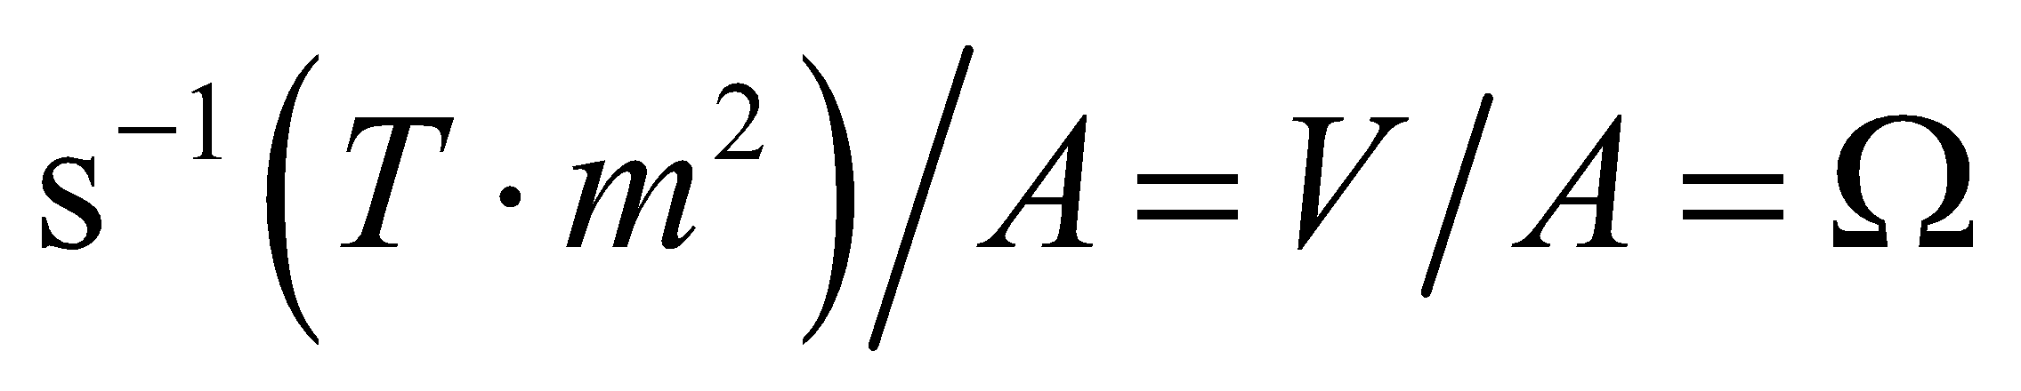(the middle step follows from Faraday’s law), and for capacitive reactance 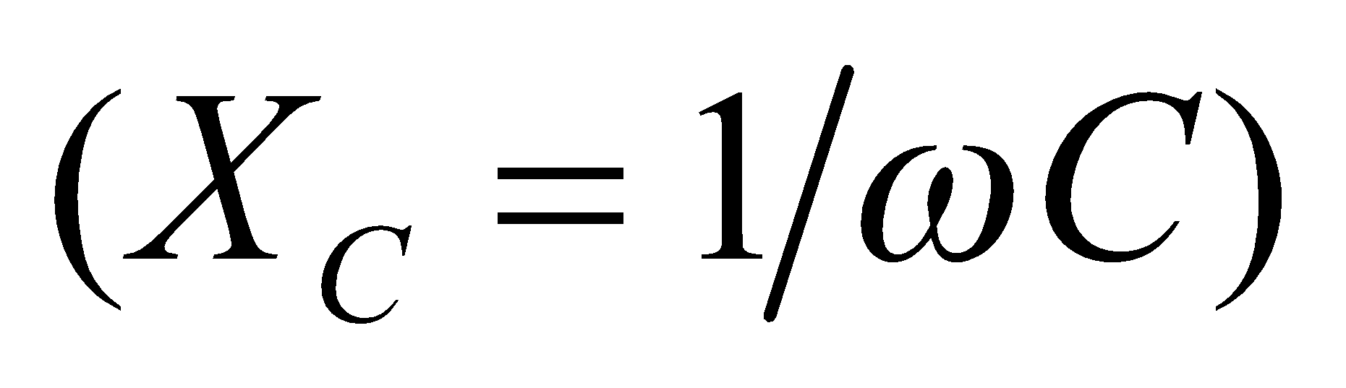 the units are 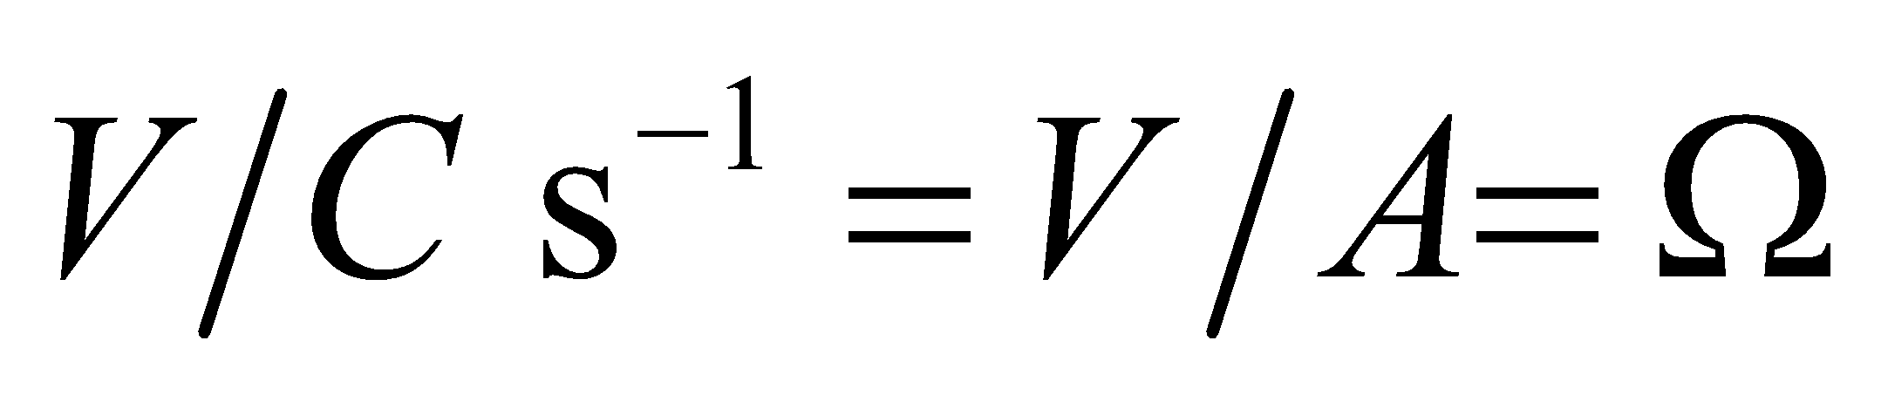 (the middle step following from the definition of current).

**Assess** The units work out as expected.

**41.** **Interpret** We're asked to express the time-varying potential of an alpha wave in the human brain.

**Develop**To use Equation 28.3, 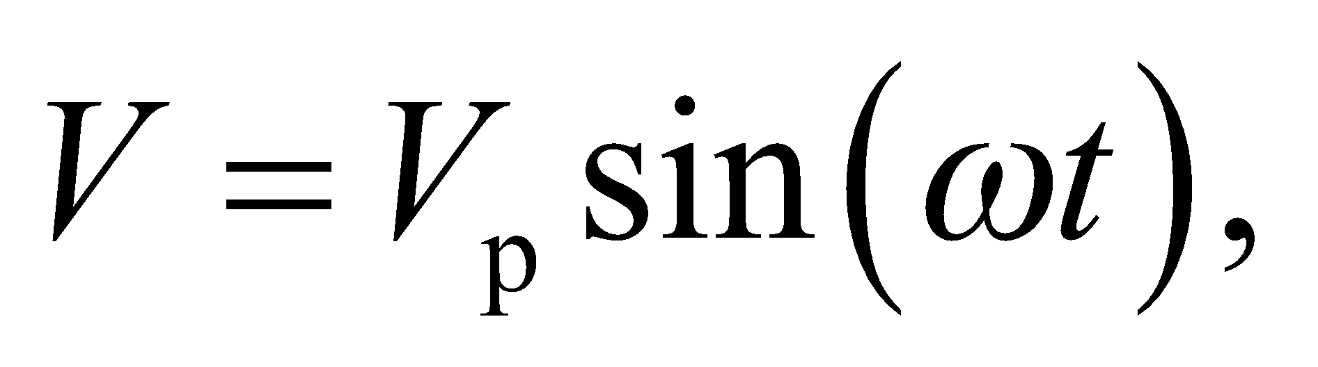we need to convert the rms voltage to the voltage amplitude, as well as the frequency to the angular frequency:

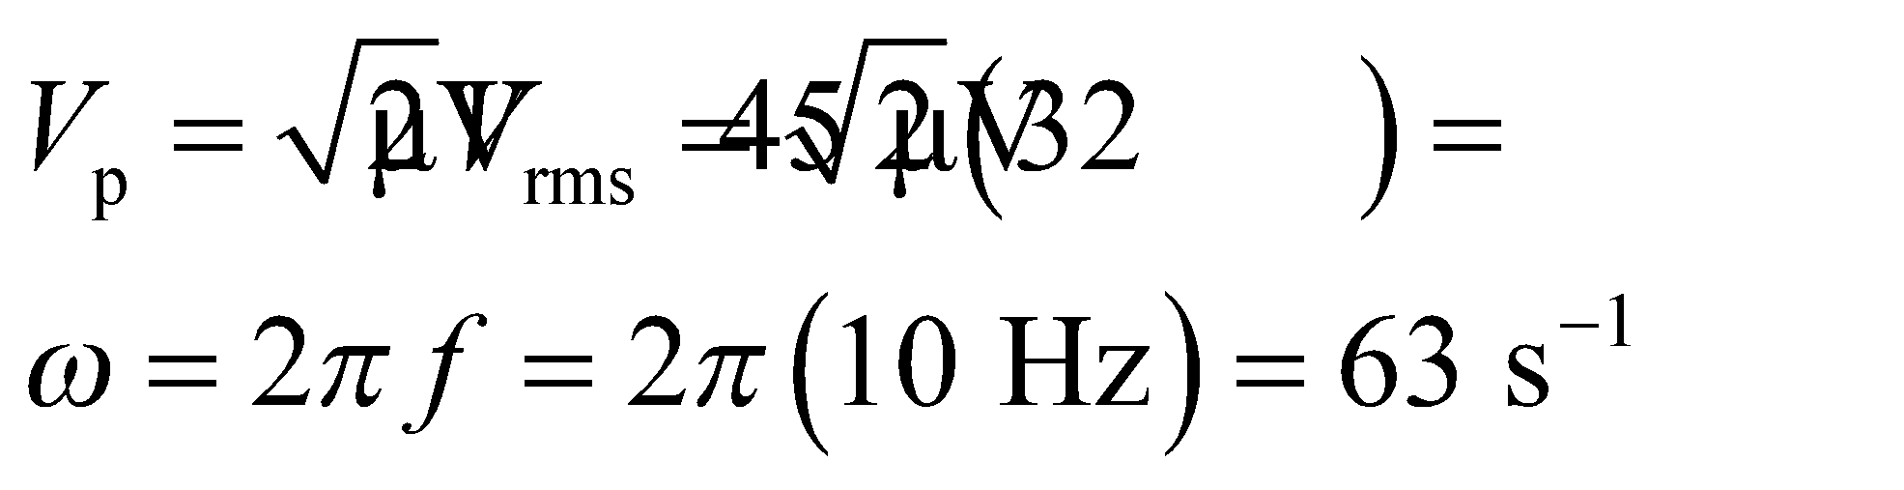

**Evaluate**Plugging the given values into the voltage equation gives

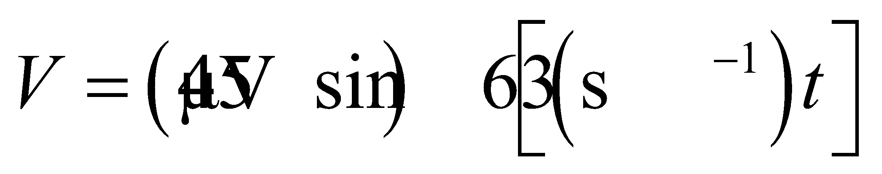

**Assess**We may also write the angular frequency as rad/s, but radians are dimensionless, so it's not obligatory.

**42. Interpret** In this problem a capacitor is connected across an AC generator. We are given the AC voltage function and asked to find the peak current across the capacitor and the voltage and current at a specified time.

**Develop** The current across the capacitor is given by Equation 28.4:

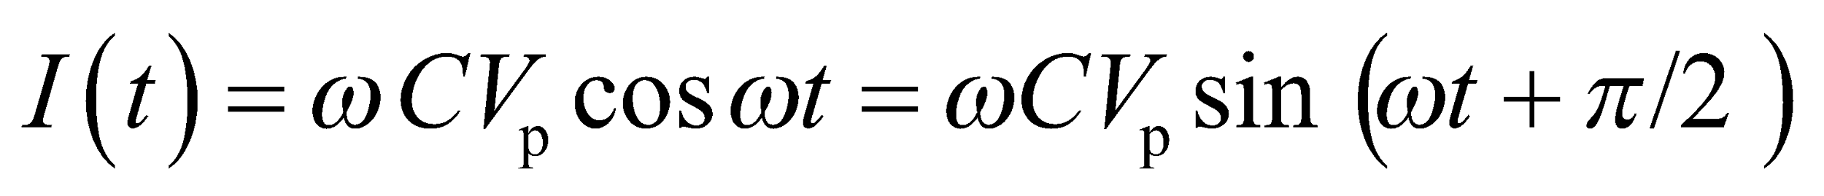

from which we can find the peak current and the current and voltage at any given time. The voltage across the capacitor is just that supplied by the emf source, so

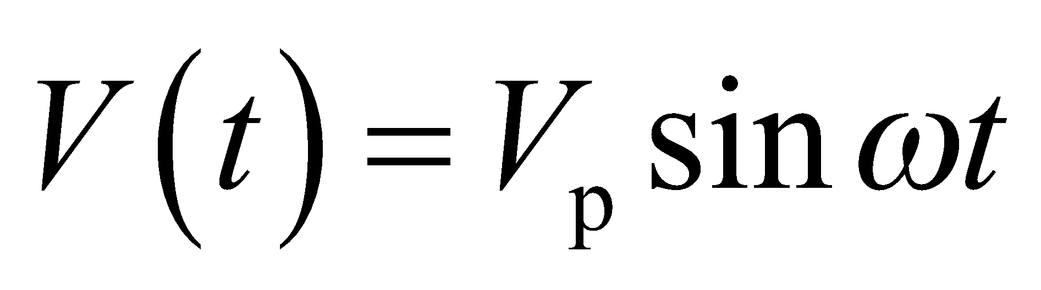

where we have used Equation 28.2, *ω* = 2*πf*.

**Evaluate** **(a)** The above equation shows that the peak current is

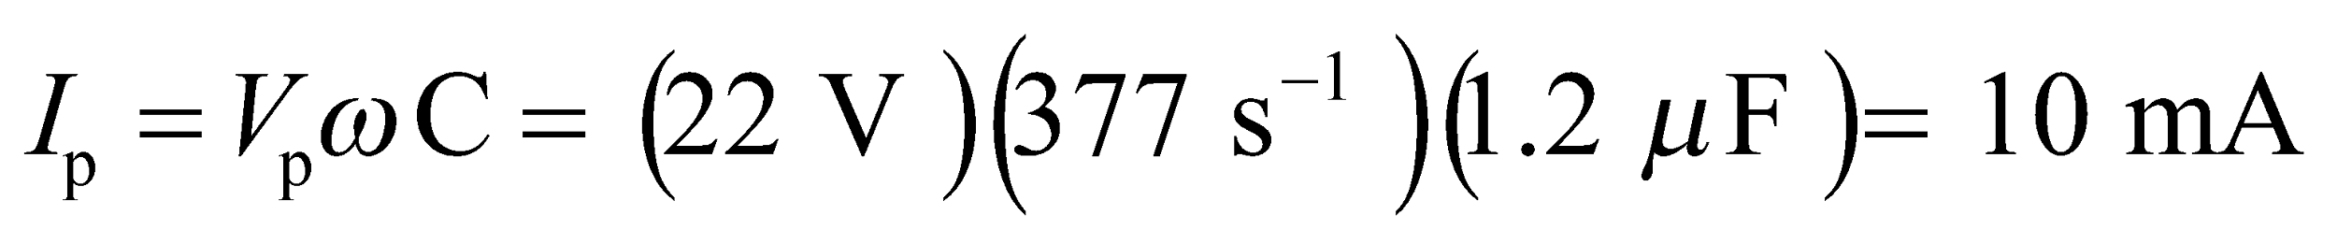

**(b)** The voltage at *t* = 6.5 ms is (remember that 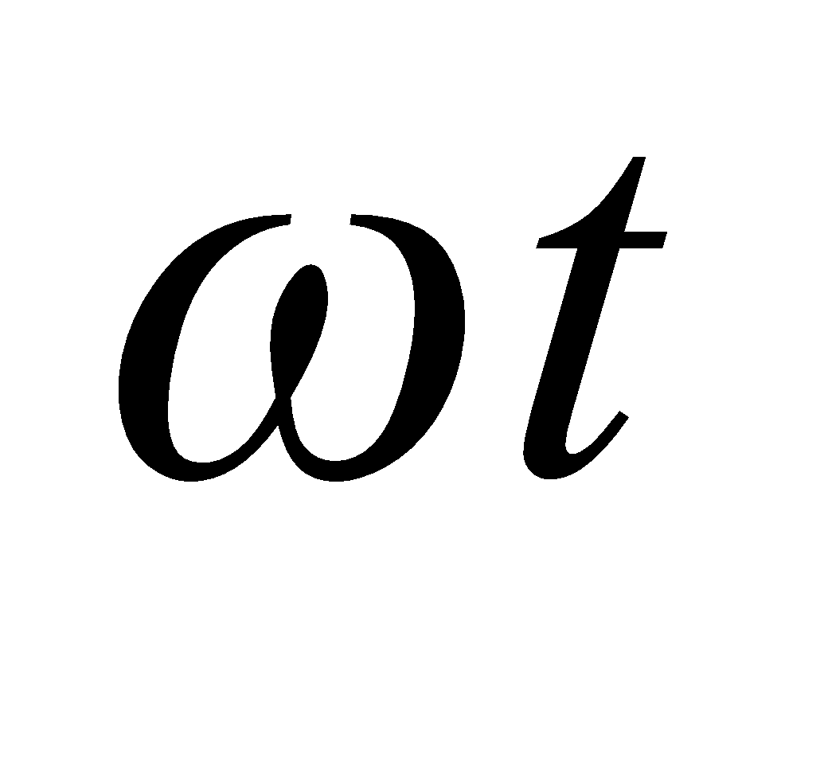 is in radians)



**(c)** Similarly, the current is



The magnitude of the current is 7.7 mA.

**Assess** In a capacitor, the current leads the voltage by 90°.

**43.** **Interpret** We are to find the frequency at which the given inductor and capacitor will have the same reactance given that at 10 kHz the reactance of the inductor is ten times that of the capacitor.

**Develop** From Equations 28.5 and 28.7, the capacitive and inductive reactances are

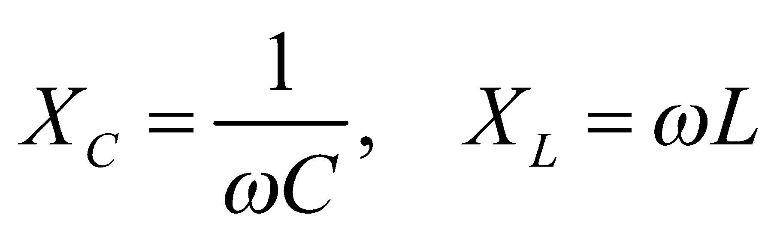

respectively. We are given that 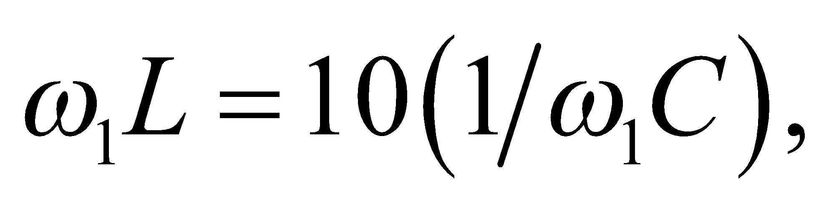 or 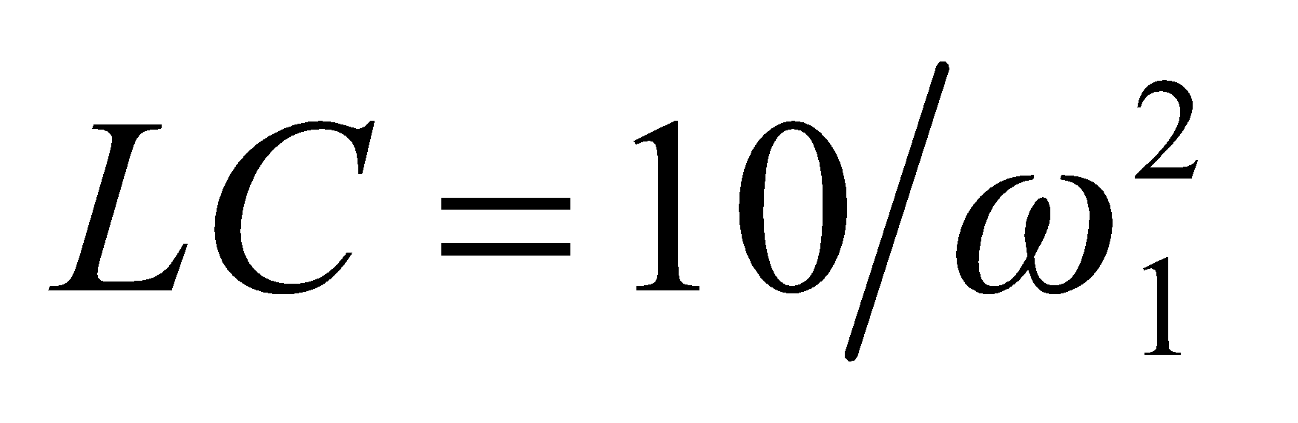. The reactances are equal when 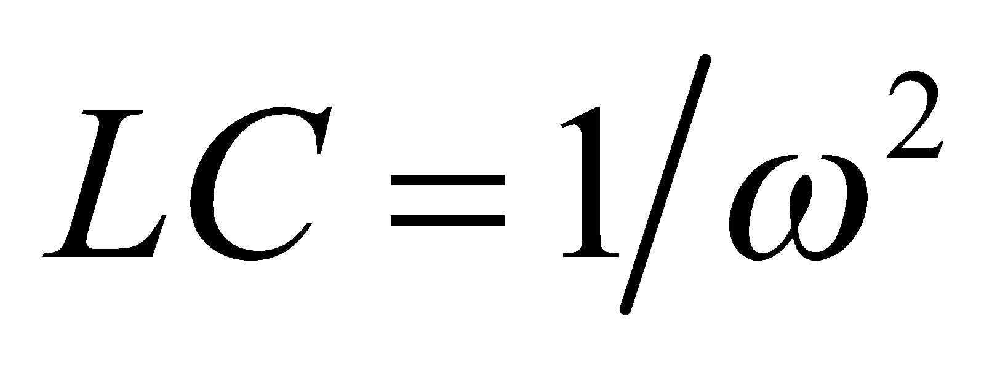, so we can solve for *ω* in terms of *ω*1.

**Evaluate** The frequency at which the reactances are equal is

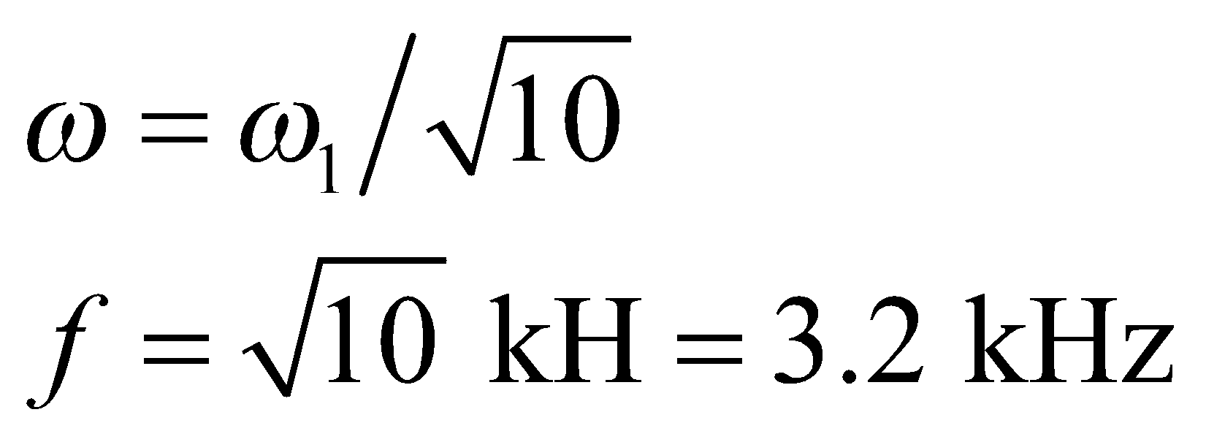

**Assess** Reducing the frequency increases the capacitive reactance and decreases the inductive reactance.

**44. Interpret** In this problem an inductor and a lamp are connected across an AC emf source. We are given the AC voltage and asked to find the rms current across the lamp.

**Develop** In a series circuit, the same current flows through the inductor and lamp. Since the ratio of the rms quantities for a given circuit element equals that of the peak values, Equation 28.7 gives

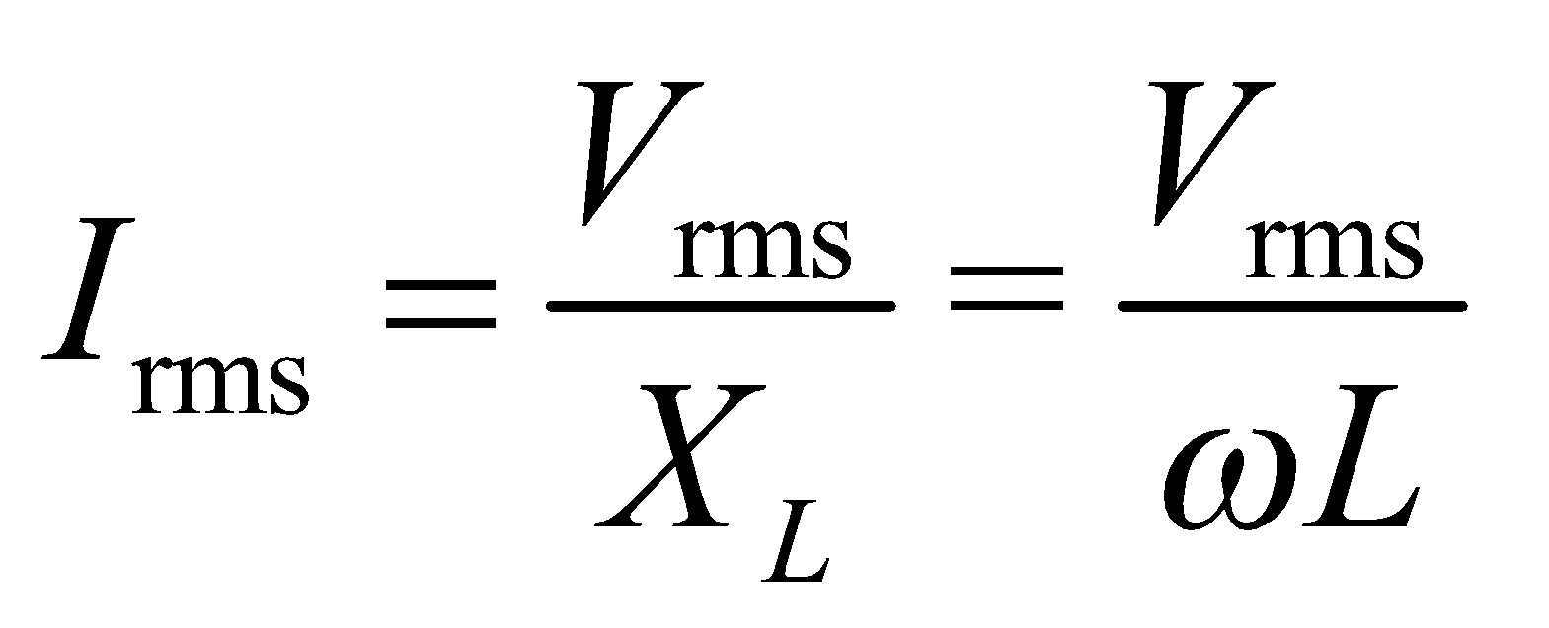

**Evaluate** Substituting the values given, we find the rms current to be

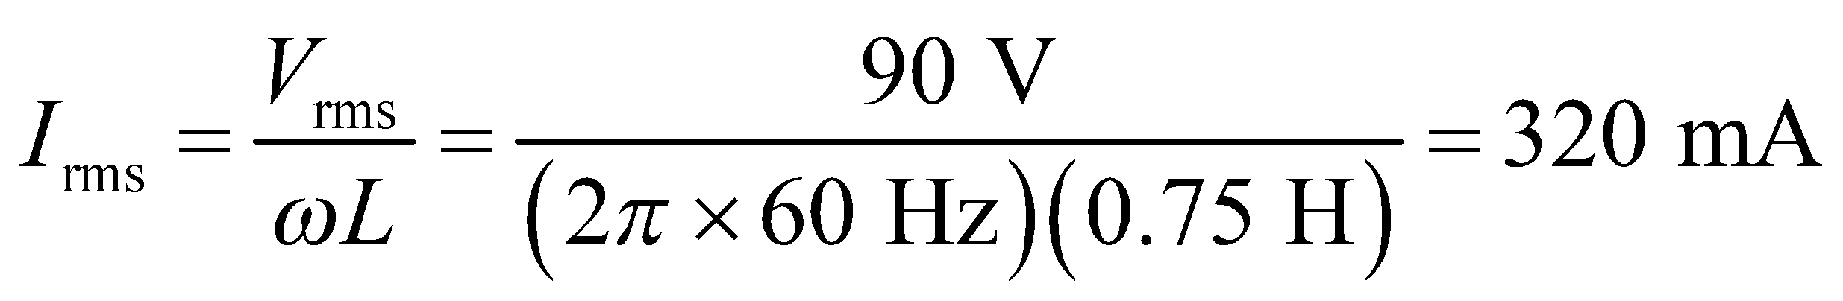

to two significant figures.

**Assess** The current in the inductor and the lamp lags the voltage by 90°.

**45.** **Interpret** This problem involves a capacitive circuit consisting of two capacitors connected in parallel across a emf source. We are given one capacitance and are asked to find the other, and we are also asked to find frequency at which the rms current decreases to the given value.

**Develop** Capacitors in parallel add, so the reactance of the combination is

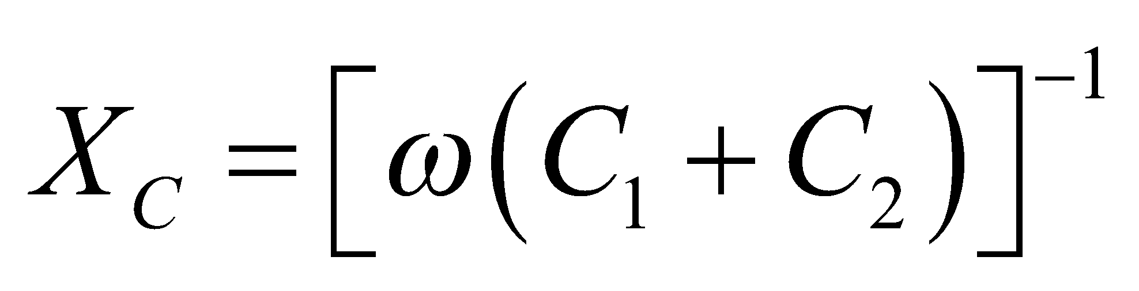

and, from the generalized version of Ohm’s law (Equation 28.12 with *Z* = *X*C) the rms current is 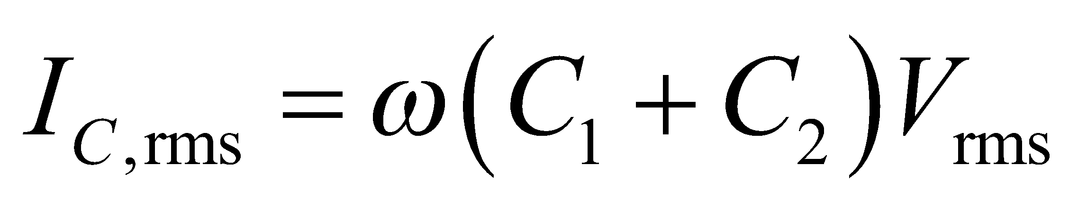, which allows us to find *C*2 (*C*1 = 2.2 nF).

**Evaluate** (**a)** At a frequency of 1.0 kHz,

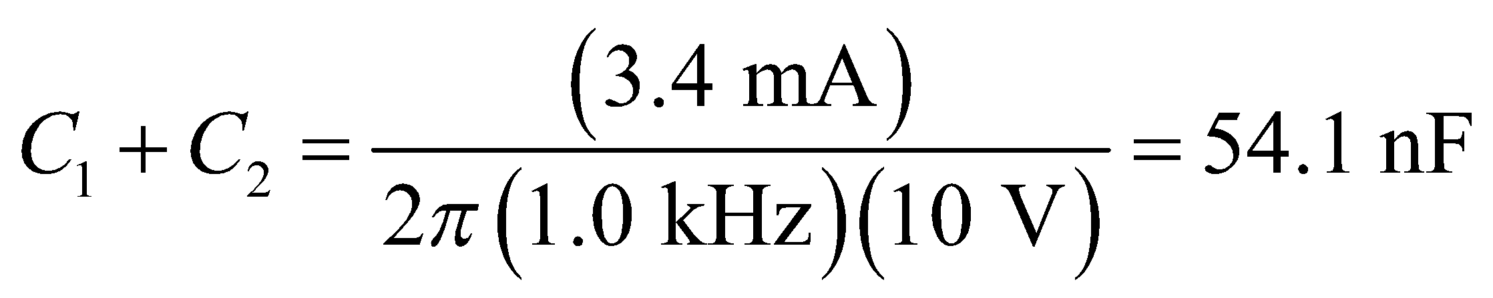

Thus,

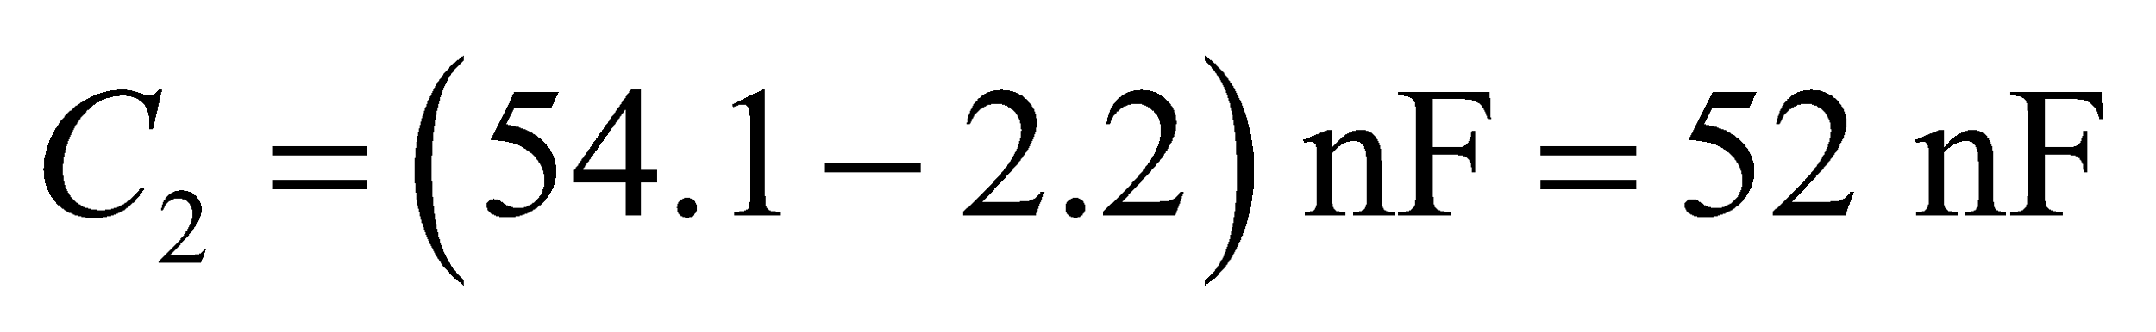

**(b)** Dividing the rms currents at the two frequencies, we get 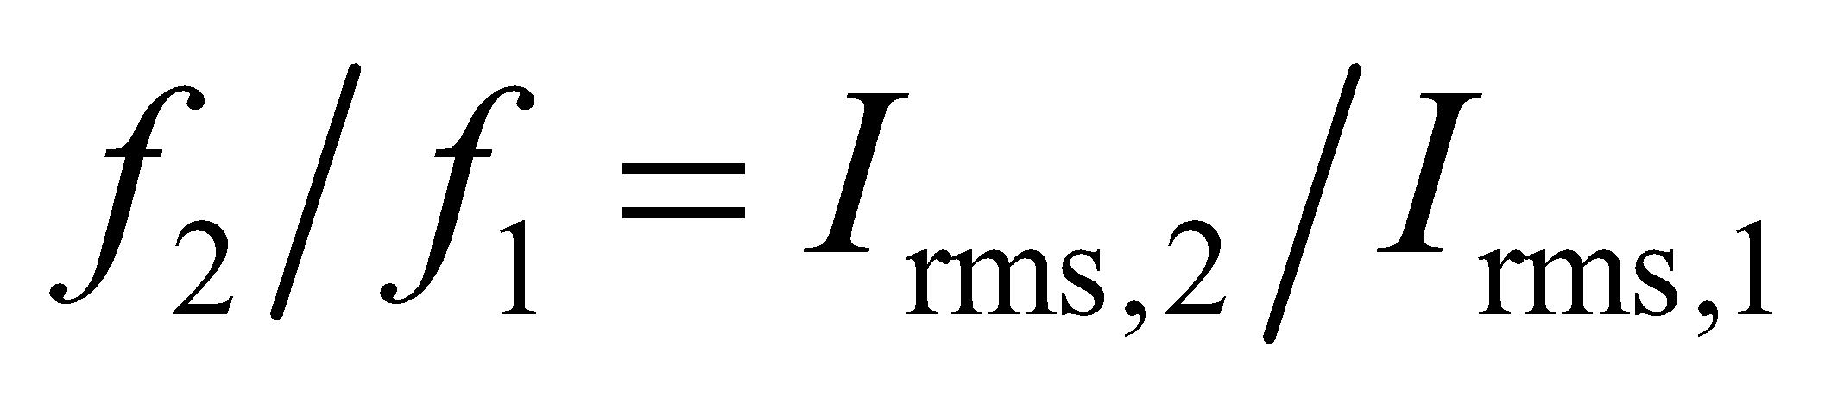, or

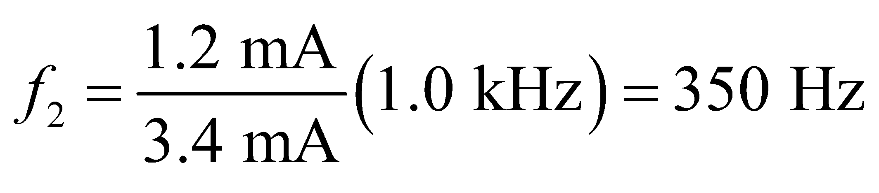

**Assess** The results are reported to two significant figures, as warranted by the data.

**46.** **Interpret** The problem concerns a device that uses capacitors to measure electric signals in the body. We want to know what's the minimum capacitance needed to measure beta waves in the brain.

**Develop**The reactance is inversely proportional to the capacitance: 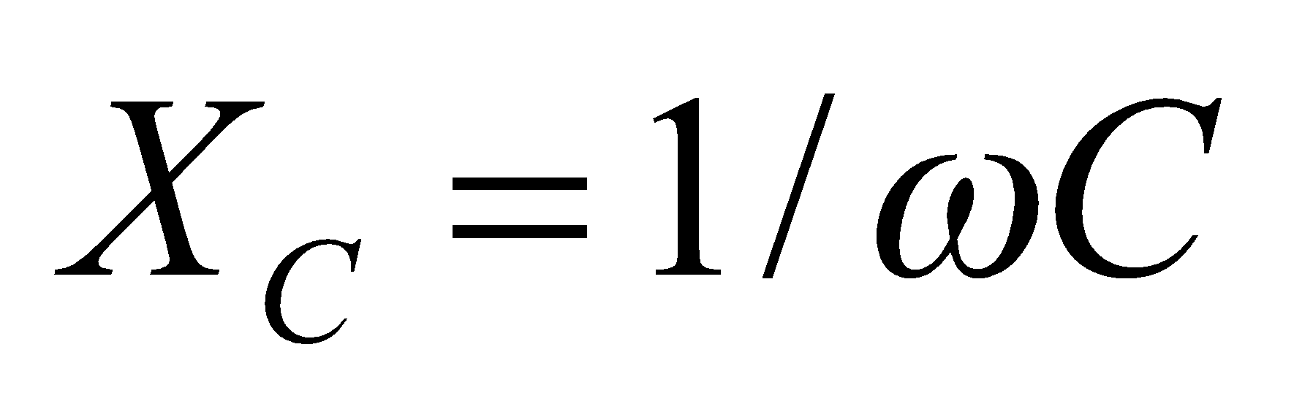 (Equation 28.5). We have to remember to convert the frequency to angular frequency.

**Evaluate**Given the maximum reactance for a certain frequency, the minimum capacitance for the electrode is

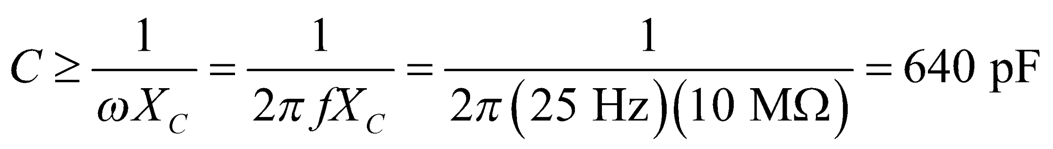

**Assess**We can check if this makes sense. Imagine the electrodes are placed over 1-mm-thick cotton fabric with a dielectric constant of near unity 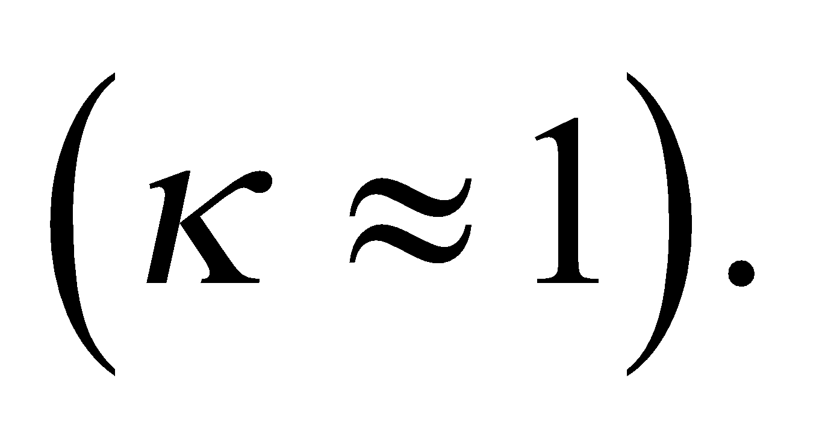Then by Equation 23.4, the area of the electrodes would roughly be

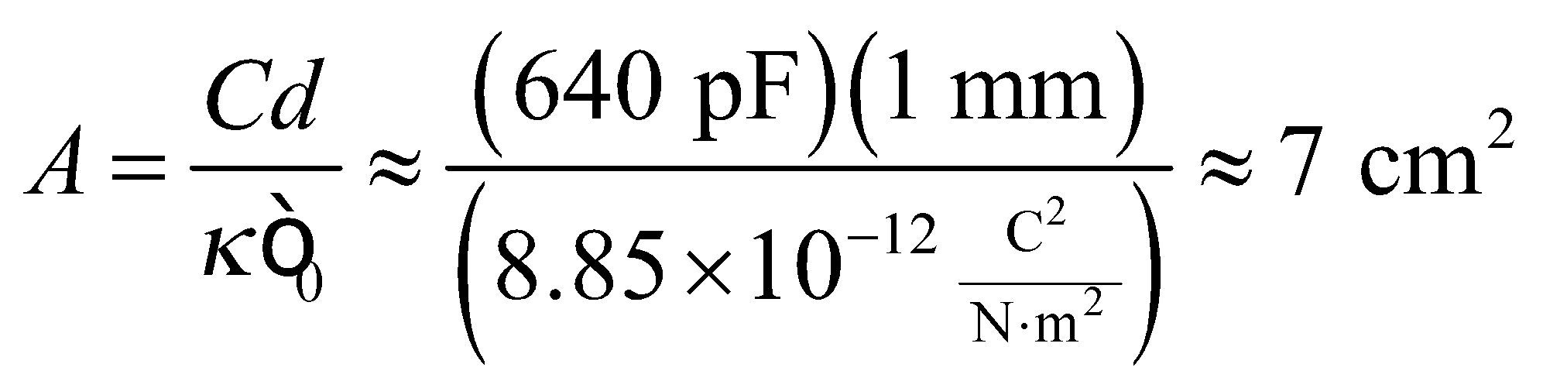

This seems reasonable for the size of an electrode, so the capacitance we found is plausible.

**47. Interpret** This problem asks for the inductance that satisfies the resonance condition for a given range of capacitances and frequencies.

**Develop** Using Equations 28.2 and 28.10, the resonant frequency can be written as



which can be solved to give

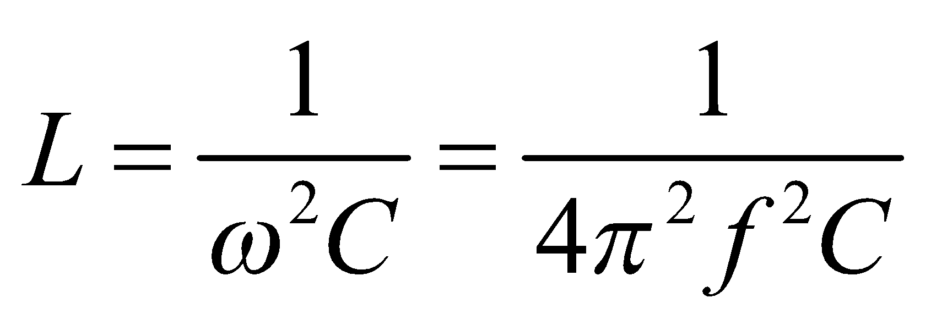

**Evaluate** Using either condition, 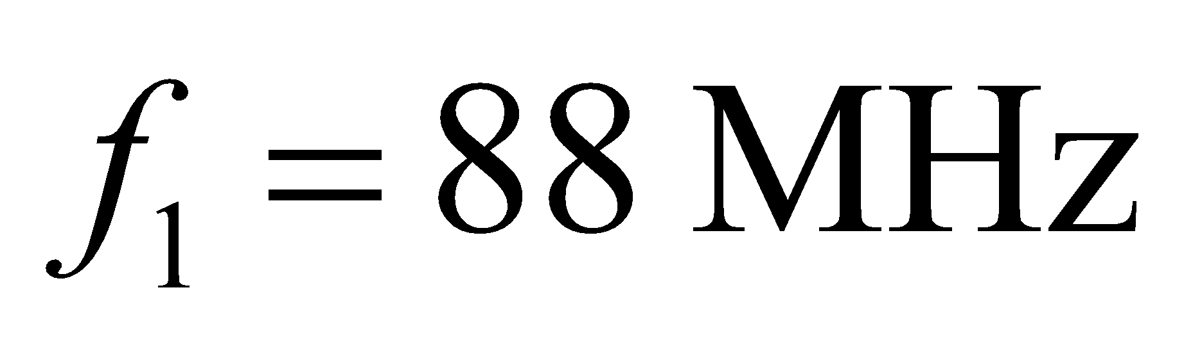 with 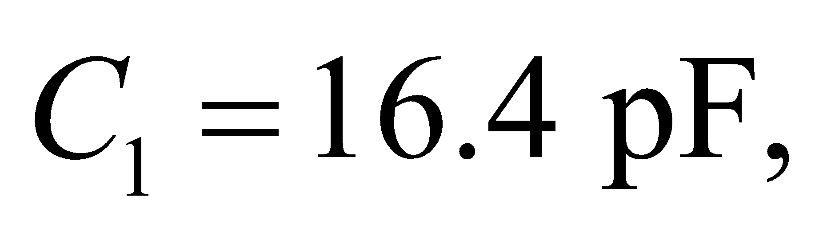 or 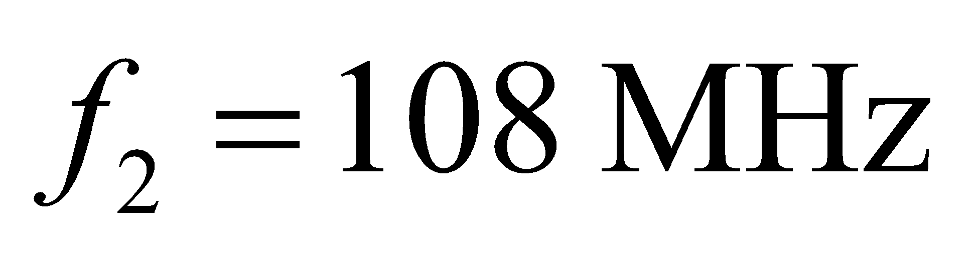 with 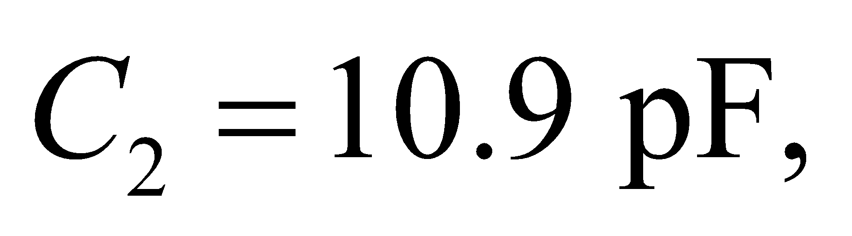 we find the inductance to be

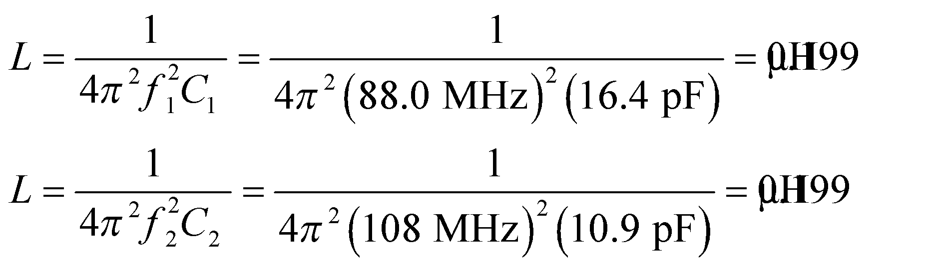

**Assess** For a given inductance *L*, the capacitance is inversely proportional to 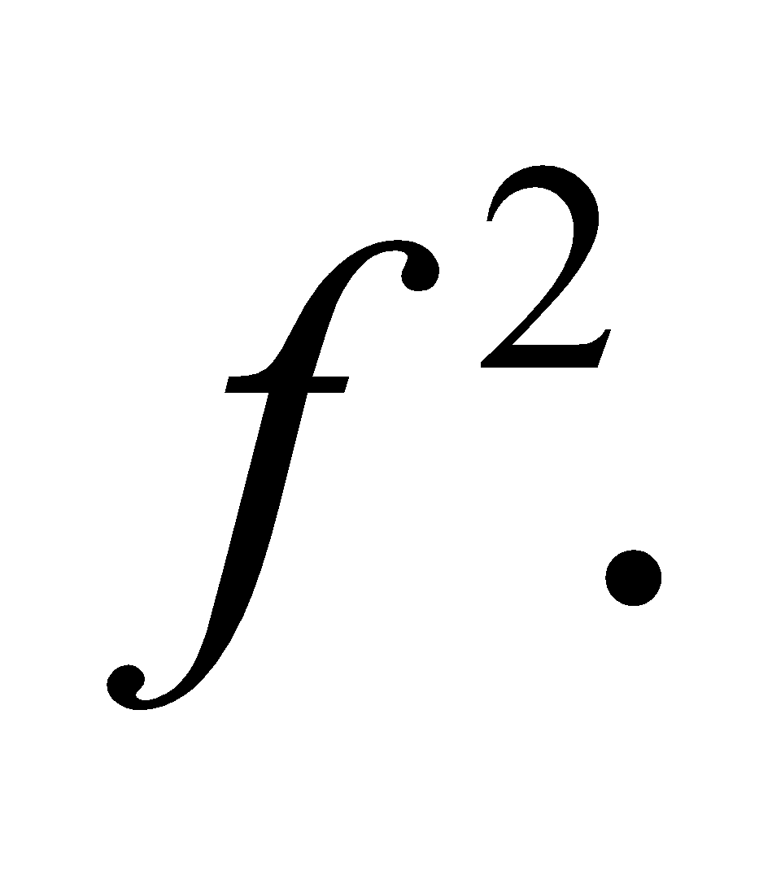 Thus, lower capacitance covers the higher end of the frequency band.

**48.** **Interpret** This problem involves an LC circuit for which we are to find the peak inductor current given the peak capacitor voltage. We are also to find the delay between the peak voltage and peak current.

**Develop** From Example 28.3, we find that the peak current and voltage in an *LC* circuit are related by

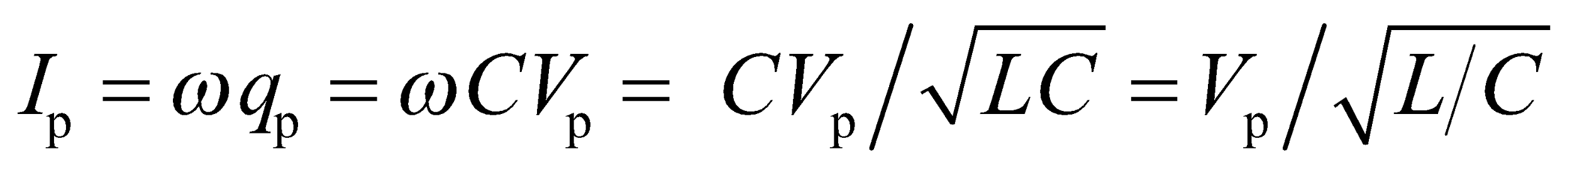

From the discussion accompanying Equation 28.6, we find that the voltage peak across an inductor precedes the current peak by *ωΔt* = 90° = *π*/2.

**Evaluate** (**a**) Inserting the given values into the expression for peak current gives

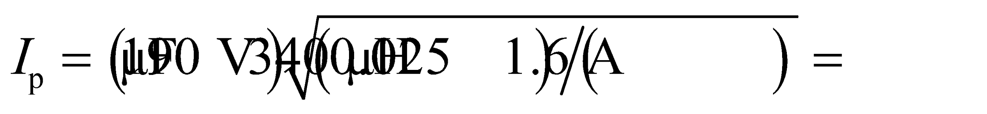

(**b**) Solving for *Δt*, we find that the voltage peaks

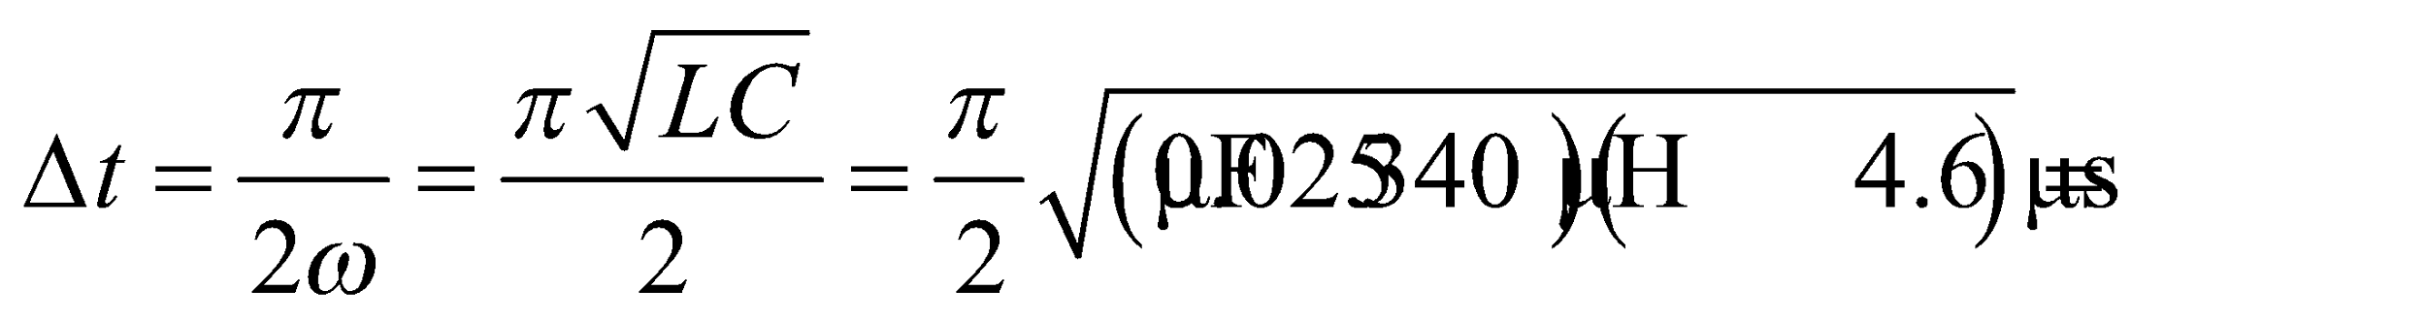

before the current peaks, where we have used Equation 28.10, .

**Assess** The period of the voltage waveform is 4*Δt* = 18 μs.

**49. Interpret** This problem involves an LC circuit in which an oscillation occurs that transfers energy back and forth between electric and magnetic fields. One eighth of a cycle after the capacitor is charged, we are to find the fraction of their peak values of the capacitor charge, energy, and the inductor current and energy.

**Develop** The electric energy stored in the capacitor is given by 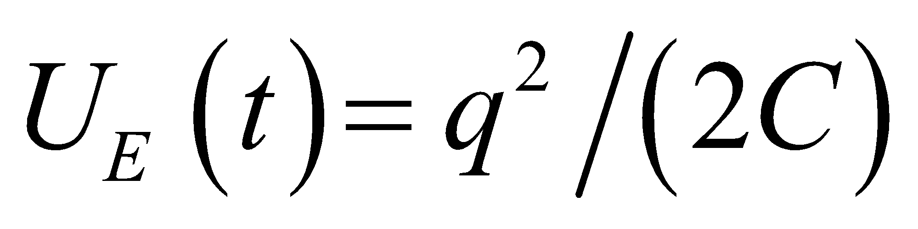 where 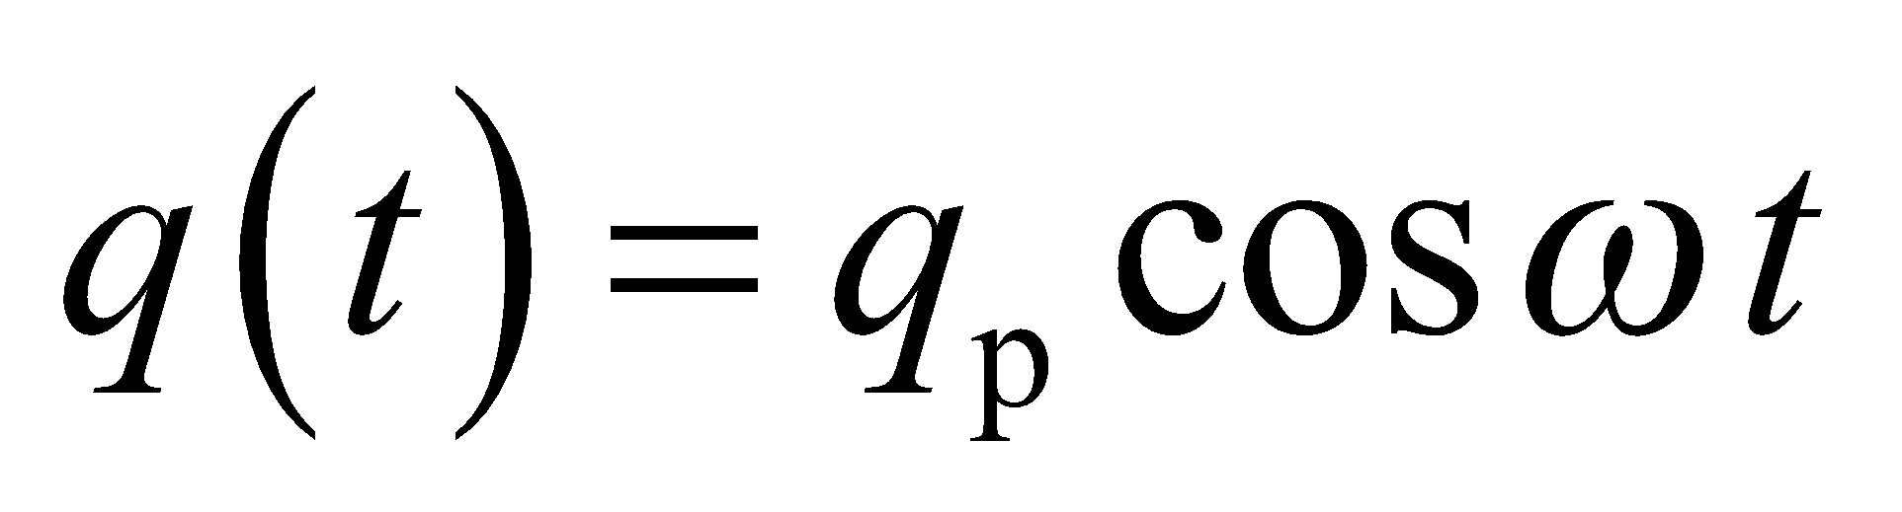 (see Equation 28.9). Similarly, the magnetic energy stored in the inductor is 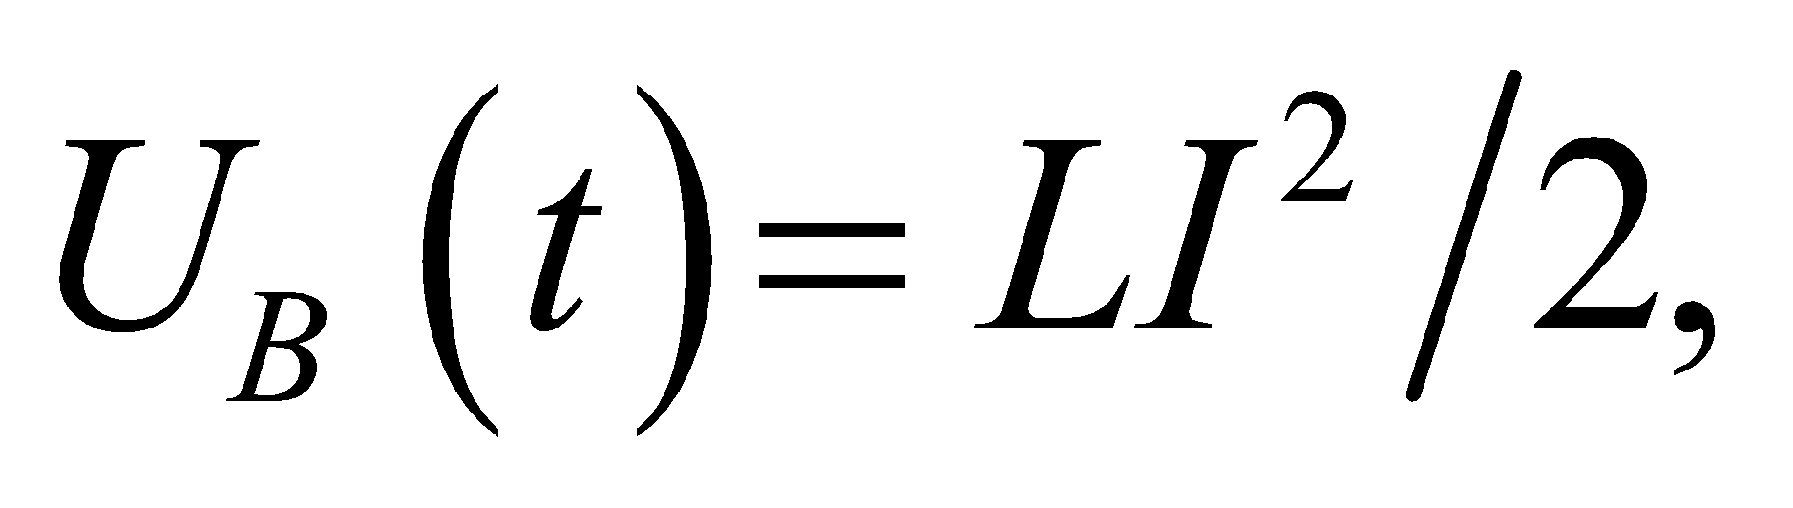 where



The quantities are to be evaluated at 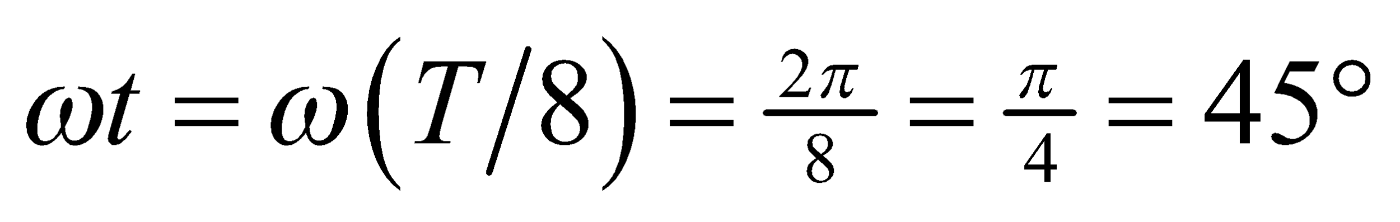 (i.e., at 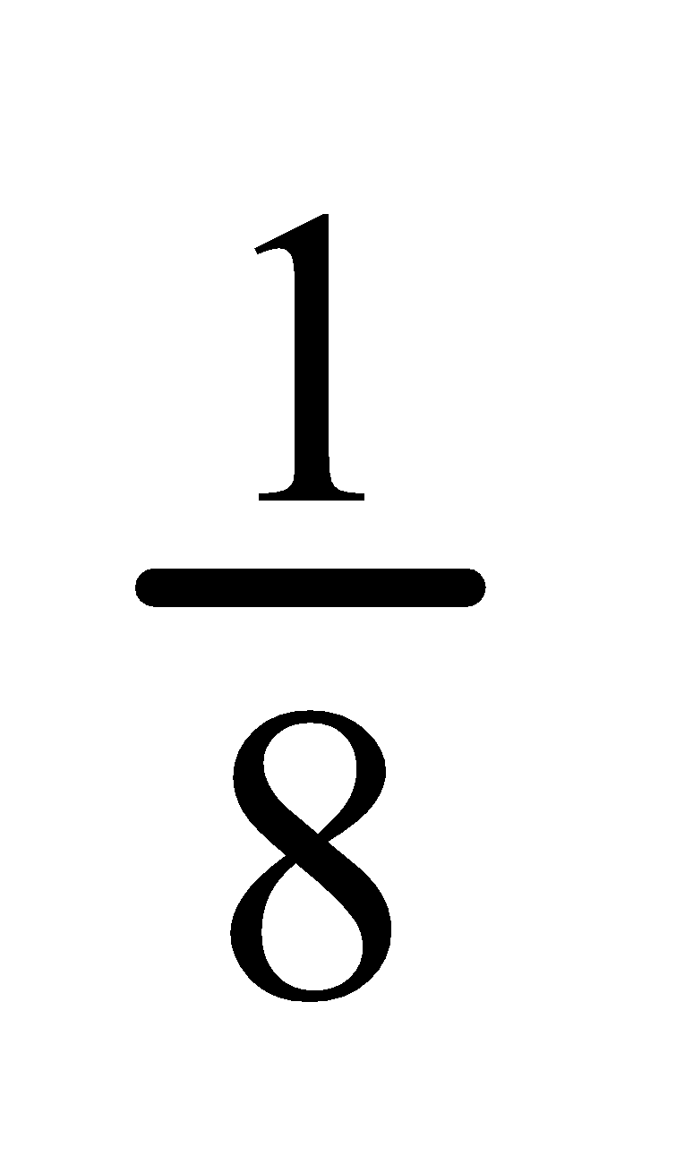 of a cycle). Note that phase constant zero corresponds to a fully charged capacitor at *t* = 0.

**Evaluate**  **(a)** From Equation 28.9, we obtain 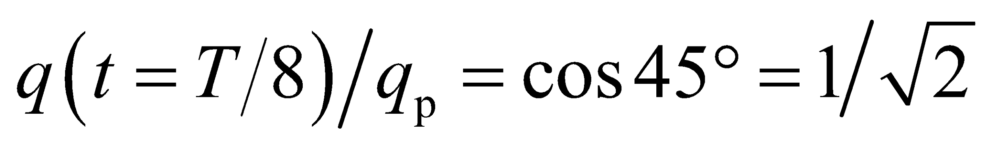

**(b)** From the equation for electric energy, the ratio is

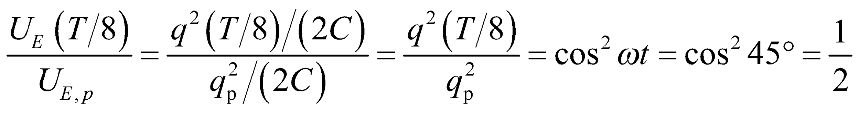

**(c)** The ratio of the current is 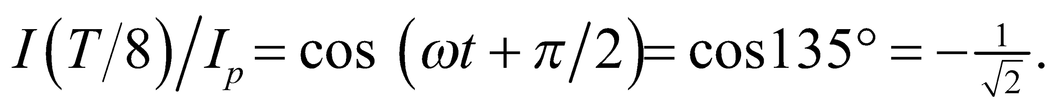 The direction of the current is away from the positive capacitor plate at *t* = 0.

**(d)** From the equation for magnetic energy, 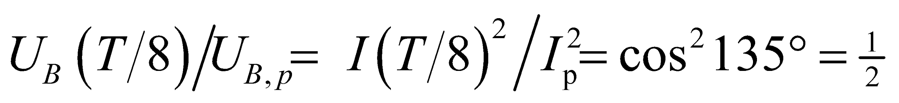

**Assess** At one-eighth of a cycle, half of the total energy is magnetic and half is electric. This is illustrated in Figure 28.11.

**50.** **Interpret** This problem involves an LC circuit with one capacitor charged to 200 V and which is initially in an open-circuit state. We are to manipulate the two switches shown in Figure 28.25 to transfer all the energy to the other capacitor. To do this, we will need to store the energy temporarily in the intermediate inductor.

**Develop** The energy in the inductor is proportional to the current squared, whereas that in the capacitor is proportional to the voltage squared (see Table 28.2). The energy initially stored in the first capacitor is 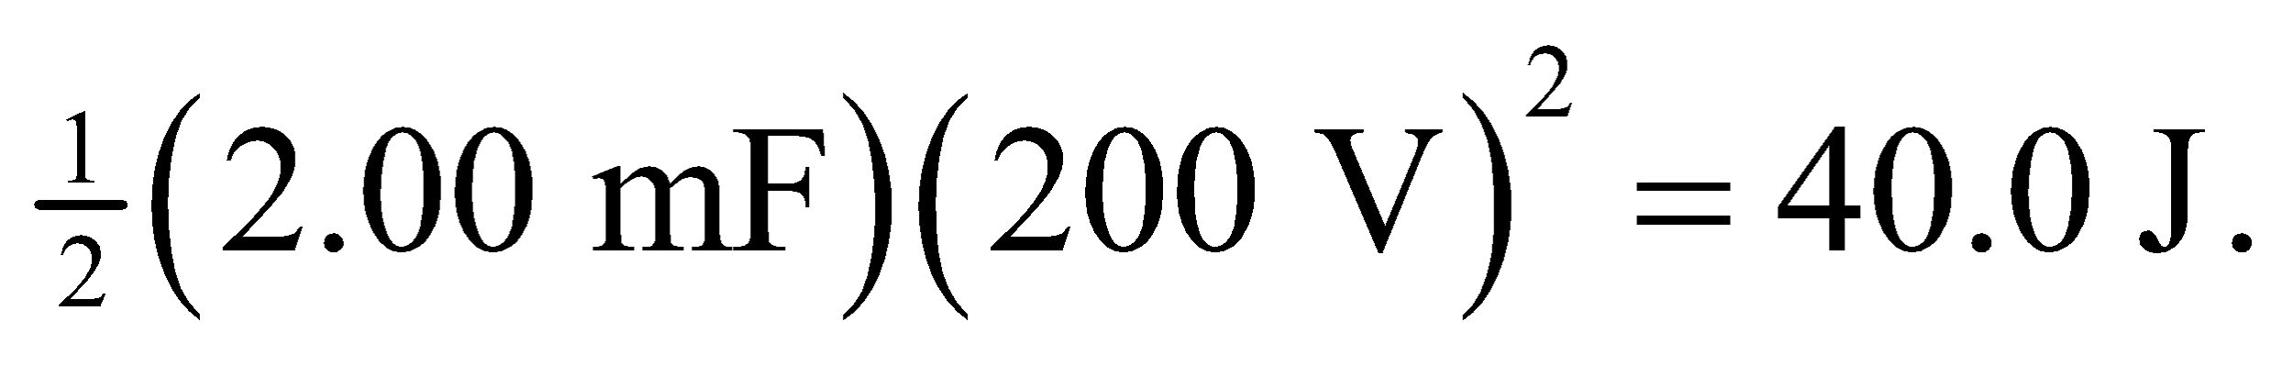 In an LC circuit, the current peaks 1/4 cycle after the voltage peaks, so we need to close switch B for 1/4 cycle to transfer all the energy from the 2000-μF capacitor to the inductor. Next, we can open switch B and close switch A for another 1/4 cycle to transfer the energy from the inductor to the 500-μF capacitor.

**Evaluate** (**a)** As explained above, we first close switch *B* for one quarter of a period of the *LC* circuit containing the 2000-μF capacitor, or



This transfers 40 J to the inductor. Then open switch *B* and close switch *A* for one quarter of a period of the *LC* circuit containing the 500-μF capacitor, or

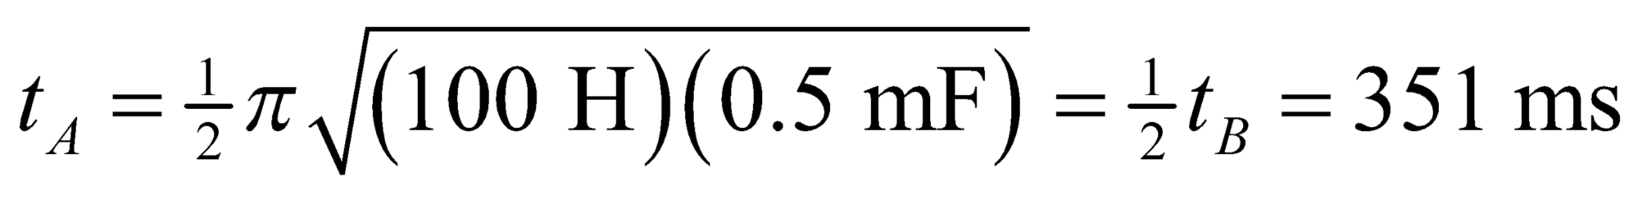

This transfers 40 J to the second capacitor from the inductor. Finally, open switch *A* to maintain the charge on the 500-μF capacitor.

**(b)** When the second capacitor has 40 J of stored energy, its voltage is

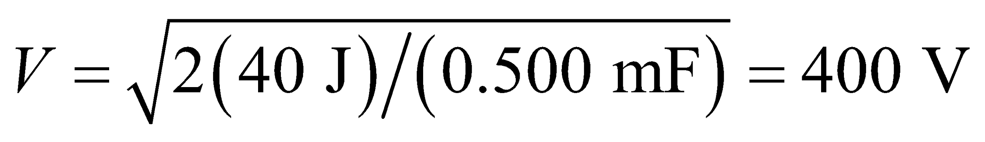

**Assess** The time to transfer the energy from the inductor to the second (smaller) capacitor is ½ that it takes to transfer the energy from the large capacitor to the inductor. This illustrates the more rapid response of smaller capacitors.

**51. Interpret** This problem is about an *LC* circuit with damping due to the resistance. We want to find the number of oscillations the circuit completes before the peak voltage is reduced by half.

**Develop** For a damped *LC* circuit, Equation 28.11 gives the charge as a function of time. Because 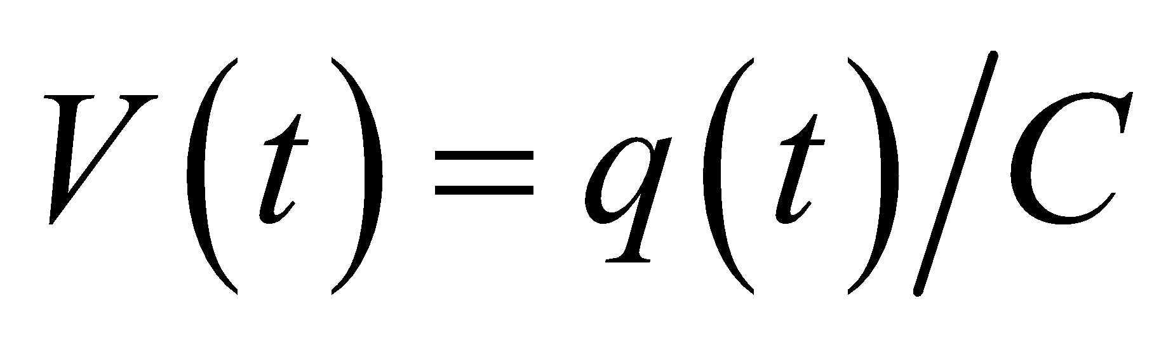, the voltage as a function of time can be written as

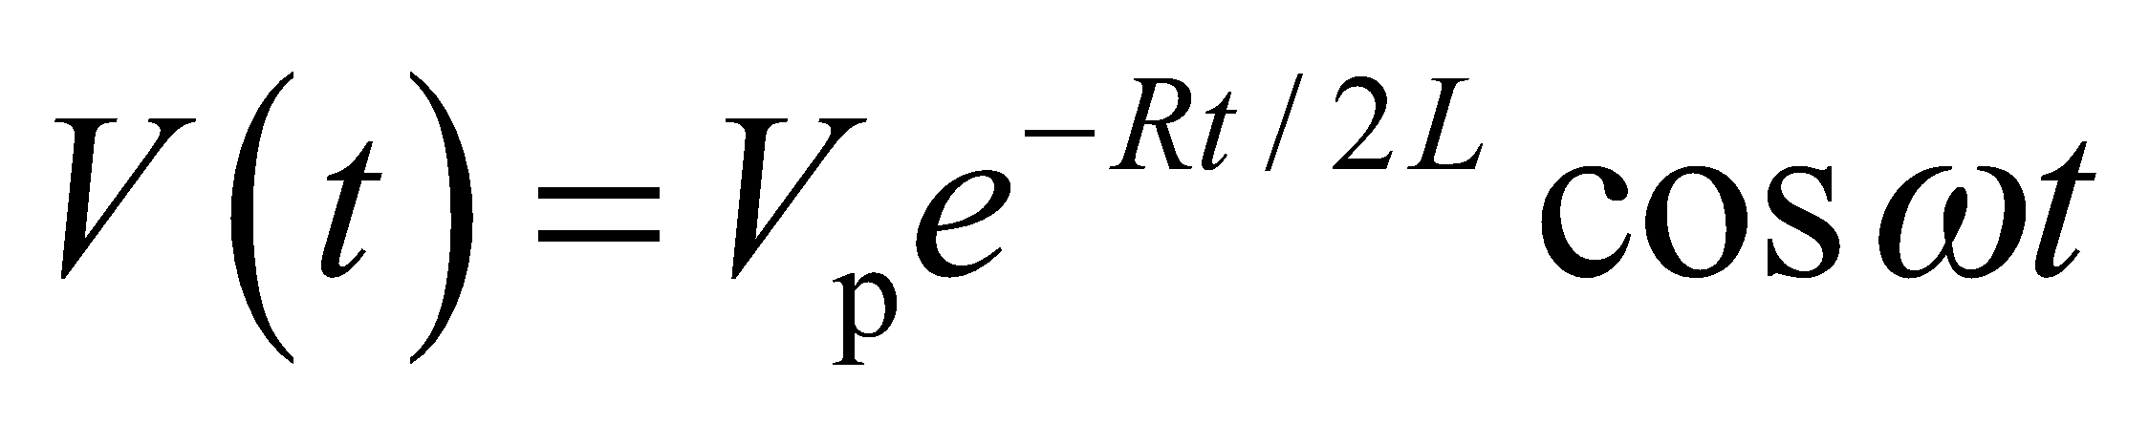

The peak voltage decays with time constant 2*L*/*R*. Half the initial peak value is reached after a time 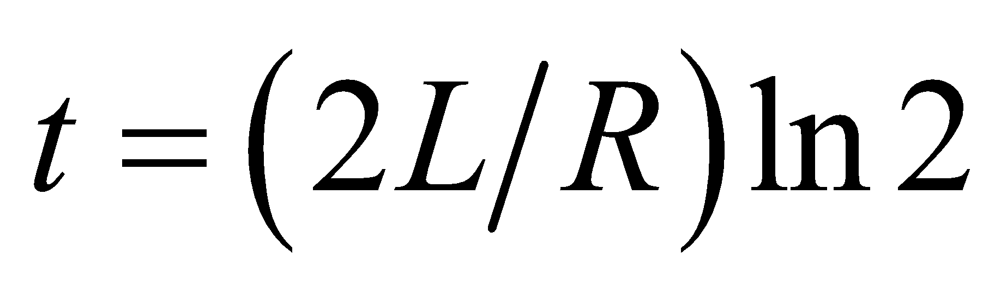 (when 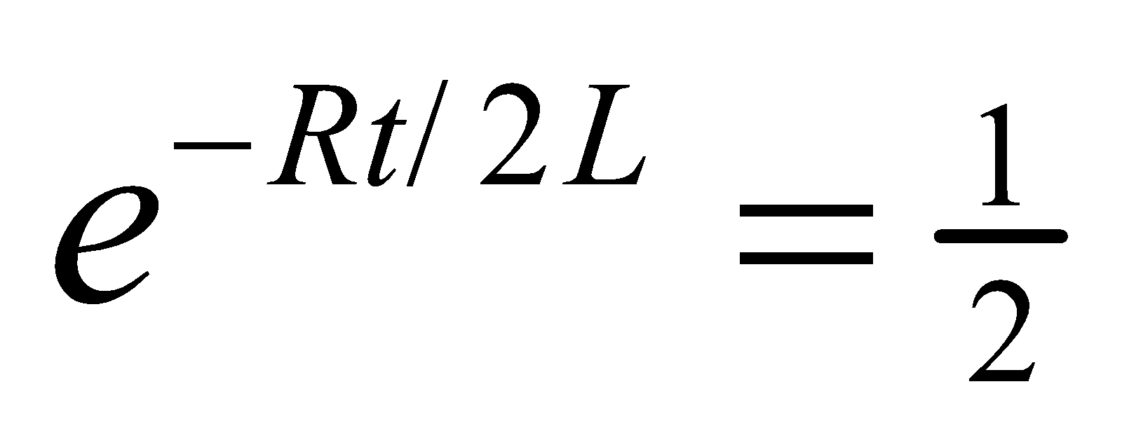).

**Evaluate** Since the period of oscillation is 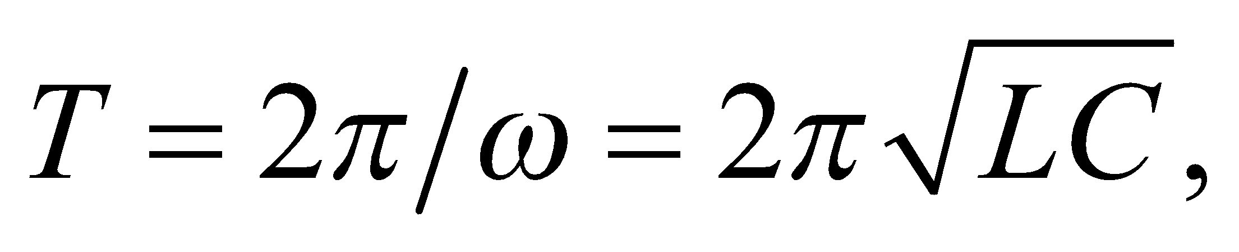 the number of cycles that occur within time *t* is

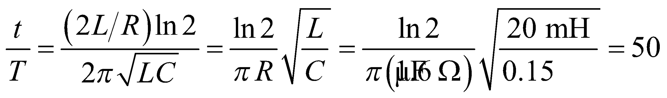

**Assess** This oscillation is underdamped. The larger the resistance, the more rapidly the oscillation decays.

**52.** **Interpret** This problem involves a damped *LC* circuit. Given the resistance, the inductance, and the time it takes for the circuit to dissipate half its energy, we are to find the capacitance.

**Develop** If only half the energy is lost after 15 cycles, the damping is small and the energy varies like the square of Equation 28.11, namely

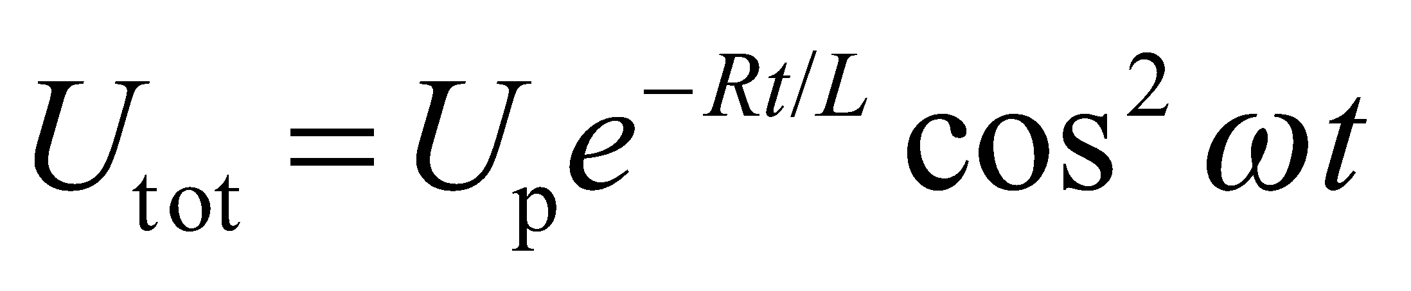

The energy time constant iswhich is one half the charging time constant. After 15 cycles, 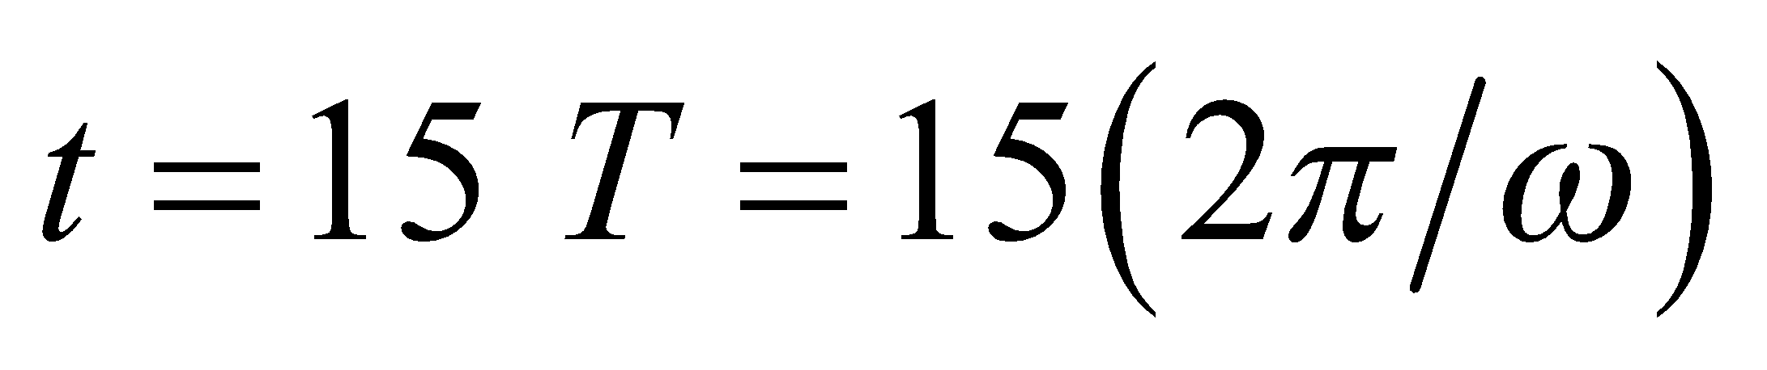 and the fraction of energy remaining is

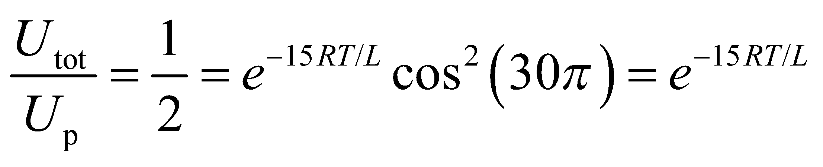

Solve this for the capacitance *C* using Equation 28.2 .

**Evaluate** Take logarithms to get

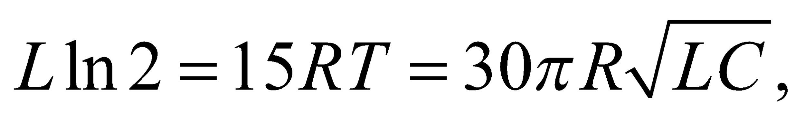

from which we find

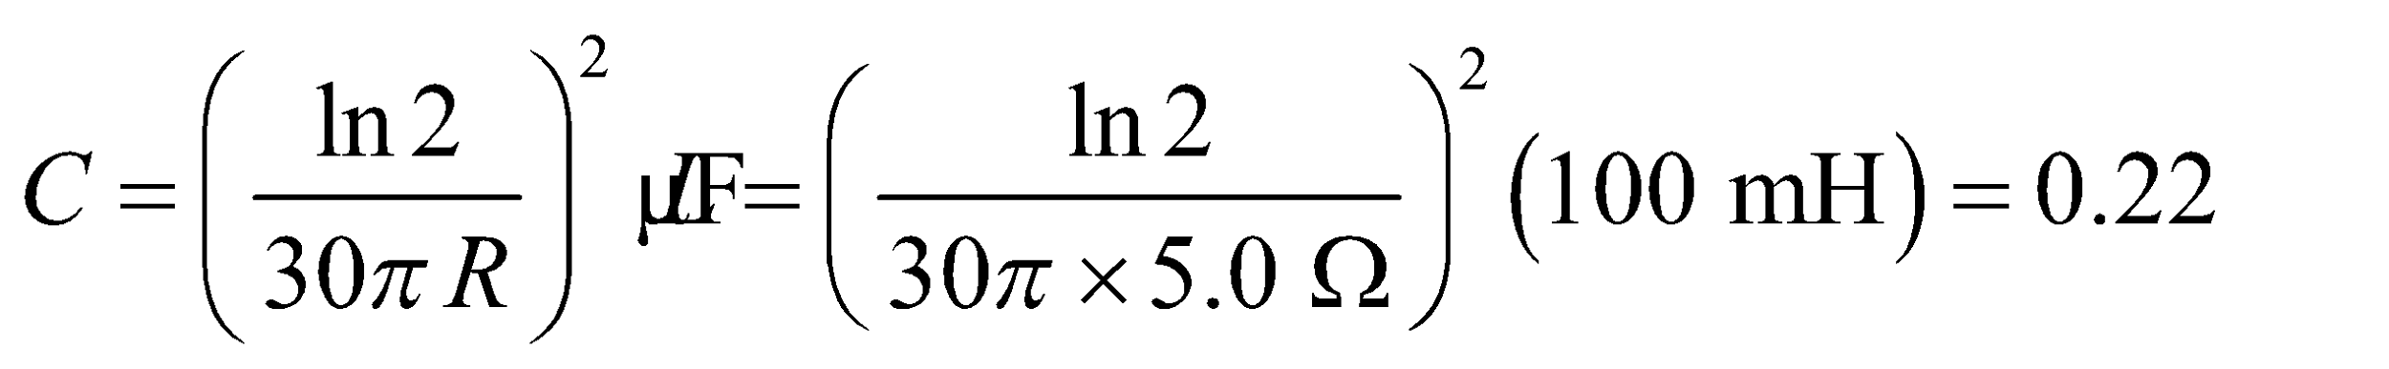

**Assess** This is a typical capacitance for a damped LC circuit.

**53. Interpret** This problem is about a series *RLC* circuit at resonance. We want to find the smallest resistance that still keeps the capacitor voltage under its rated value when the circuit is at resonance.

**Develop** In a series *RLC* circuit at resonance, the peak capacitor voltage is

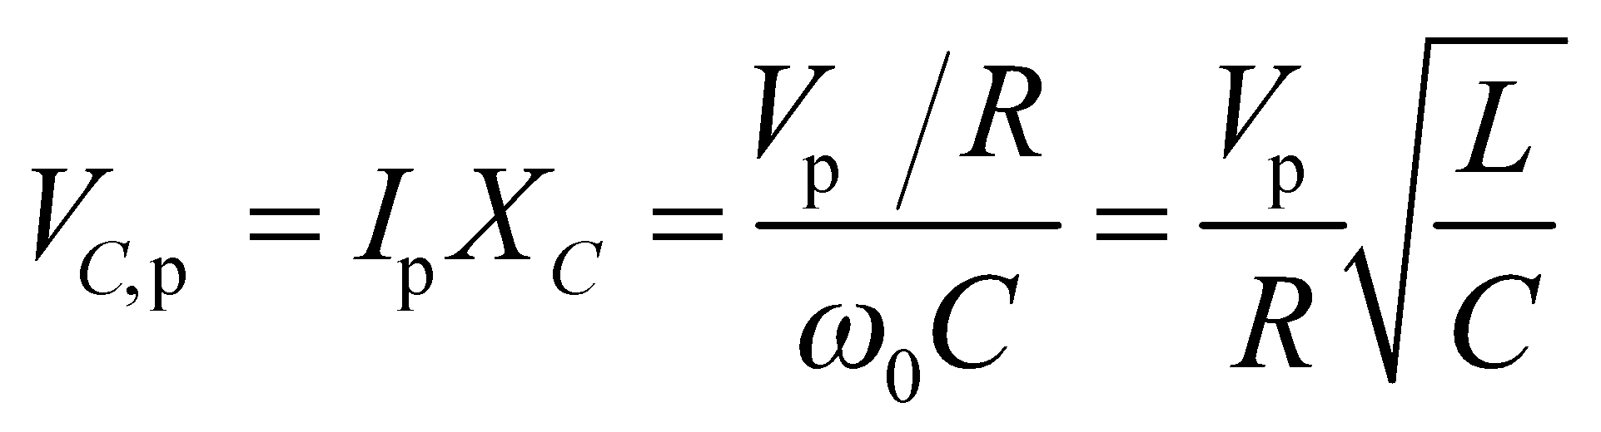

where 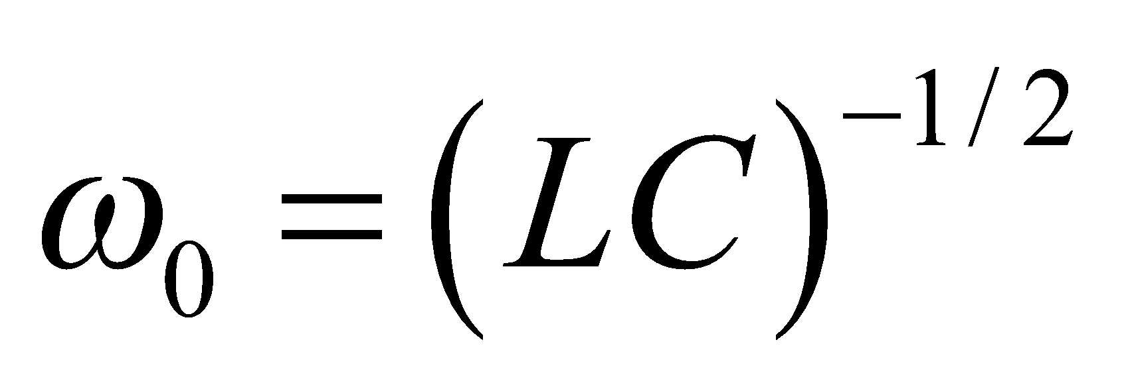 is the resonant angular frequency.

**Evaluate** The condition that 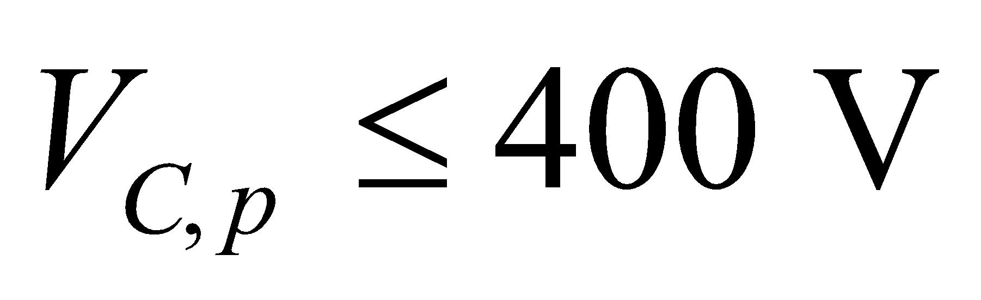 implies

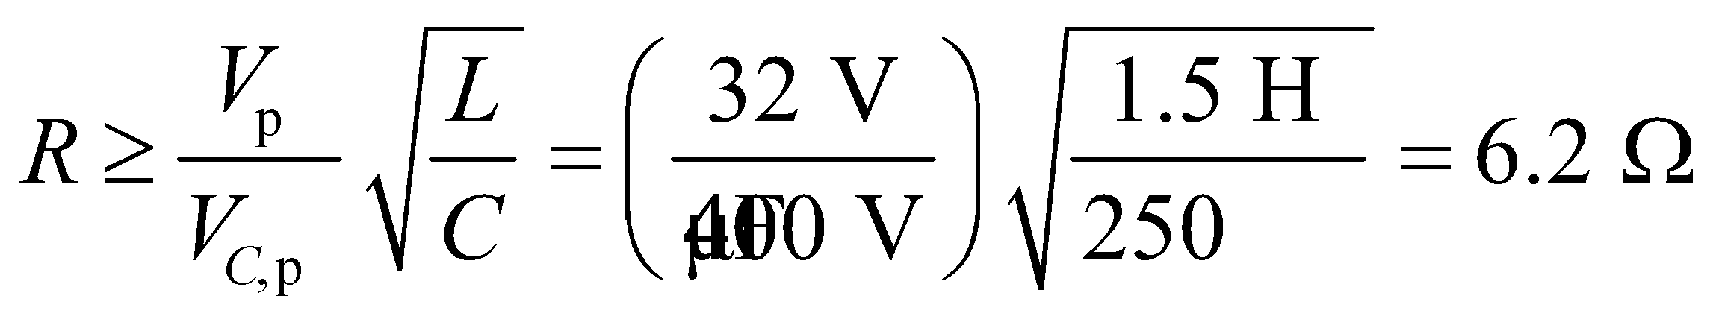

**Assess** Our results shows that 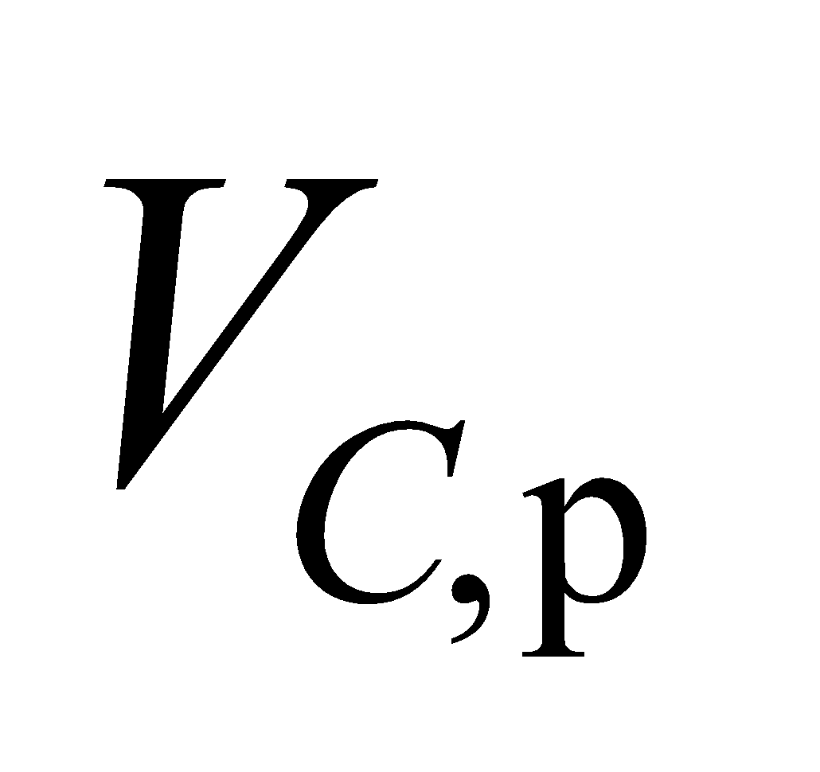 is inversely proportional to *R*. This means that a larger resistor would be required if the capacitor has a lower voltage rating.

**54.** **Interpret** We're asked to plot the voltage across a capacitor in an *RLC* circuit.

**Develop**The peak voltage across the capacitor is the peak current times the capacitive reactance: 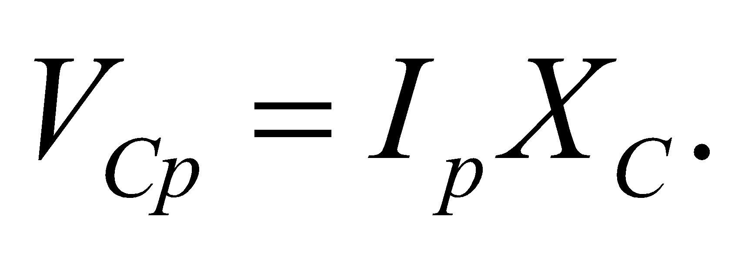 Combining this with Equation 28.12 for the *RLC* current gives

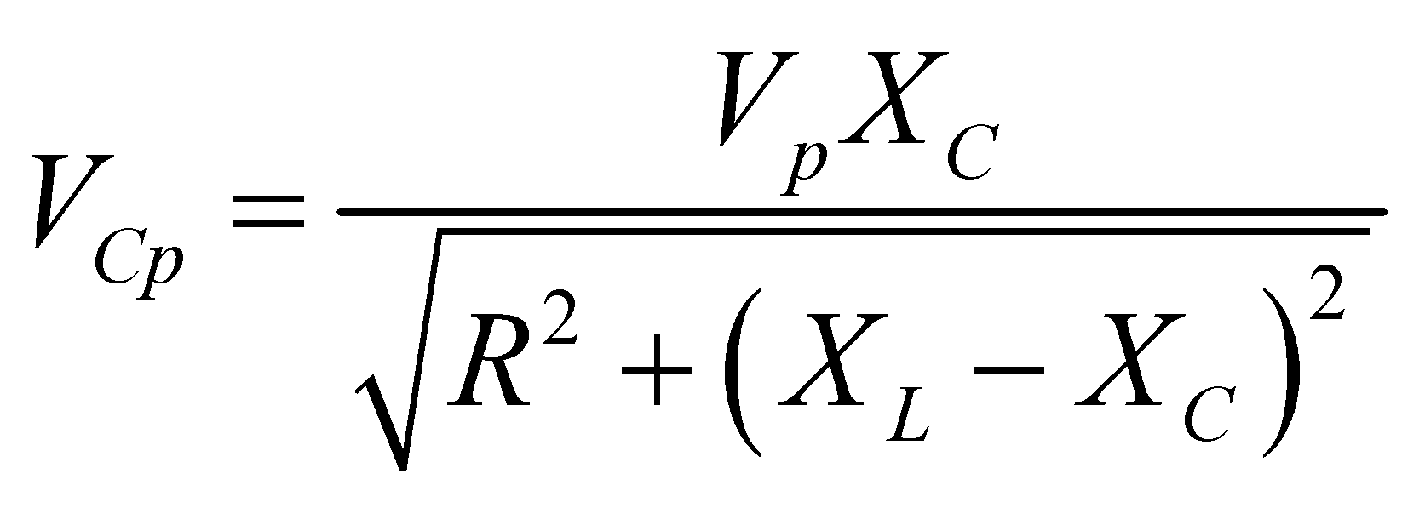

where  and 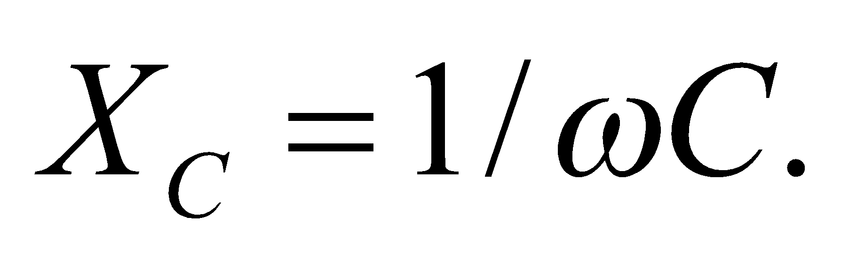 The resonant frequency of the circuit is

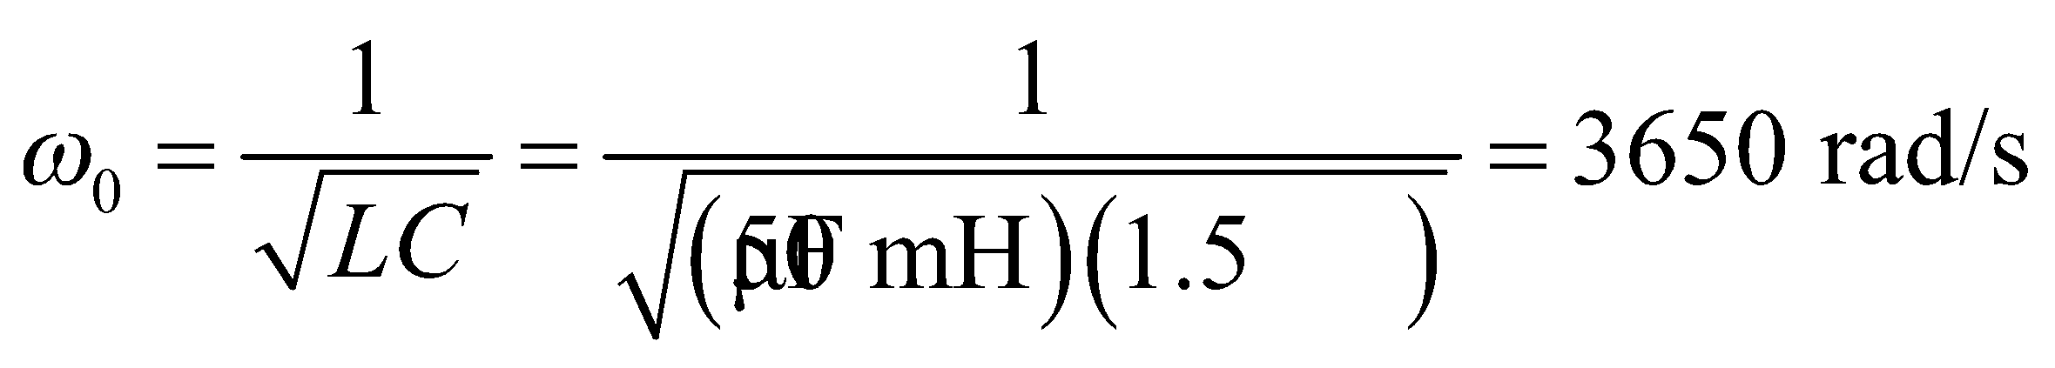

In terms of frequency, this is 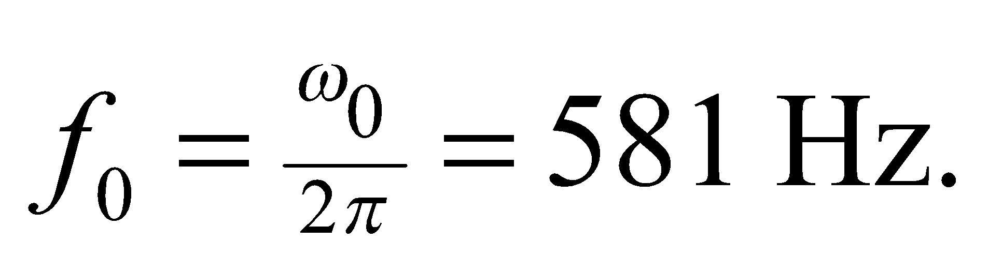

**Evaluate**Below we plot the peak voltage across the capacitor over the range 3200 to 4000 rad/s.



It's clear that the voltage across the capacitor can exceed its rated voltage of 1200 V. The angular frequency range to avoid is 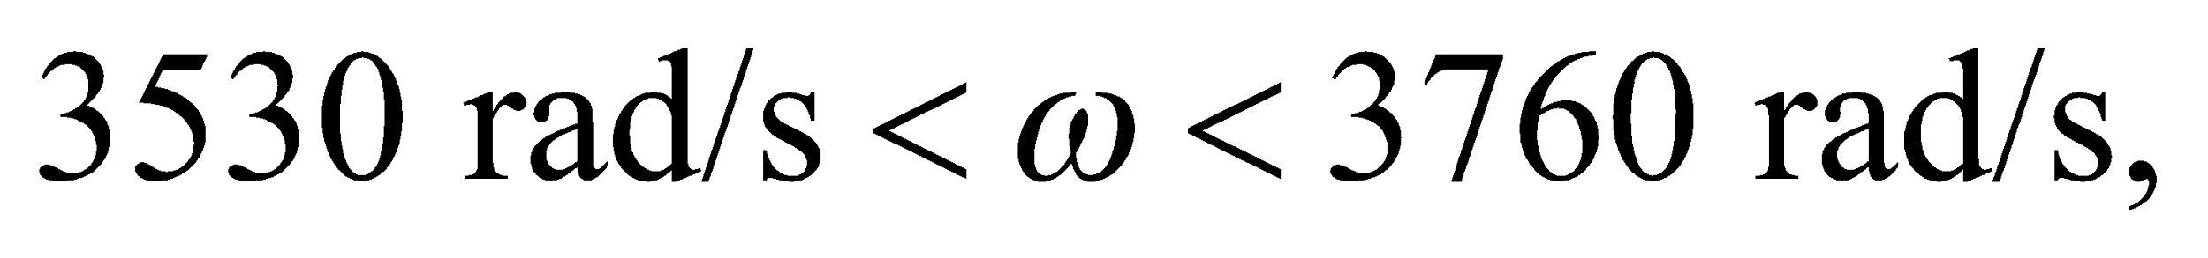 or in frequency 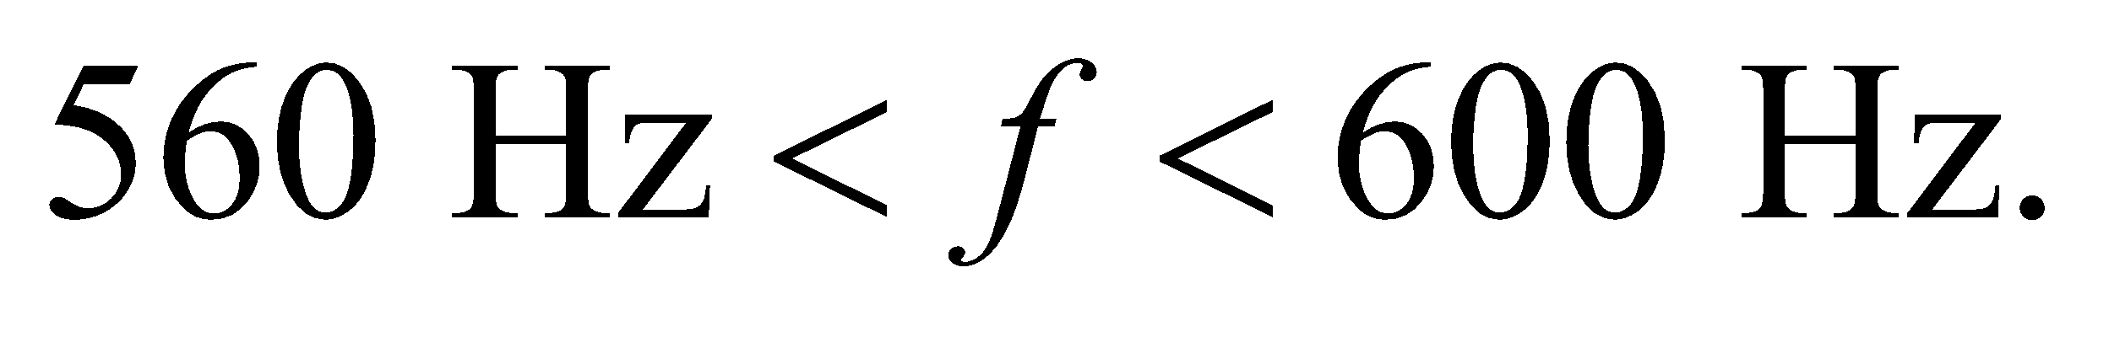

**Assess**At resonance, a system can oscillate with a much higher amplitude than the source that's driving it. We can verify the range of frequencies we found by solving algebraically where 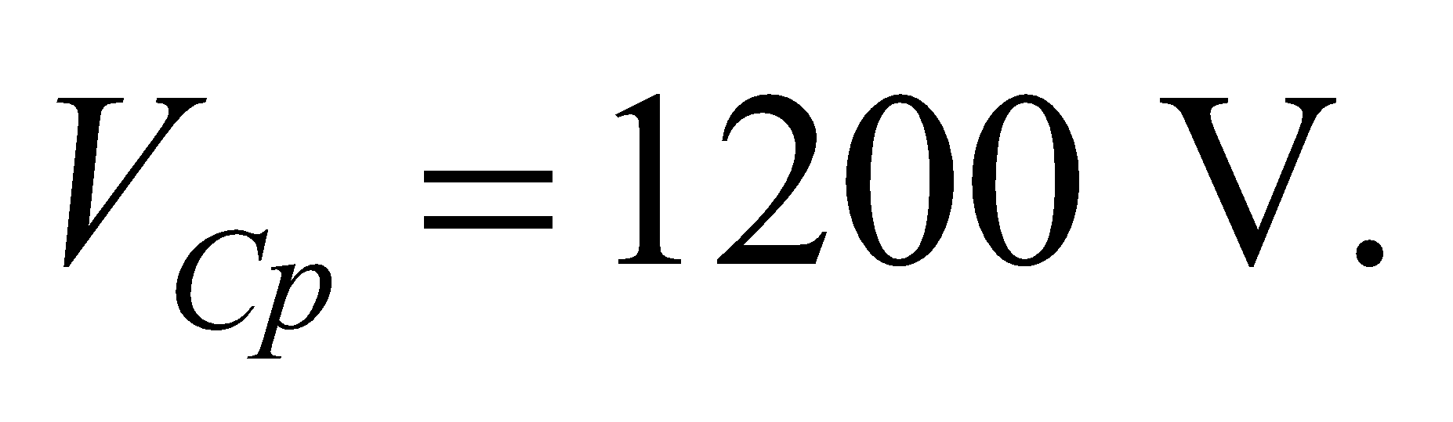 Let 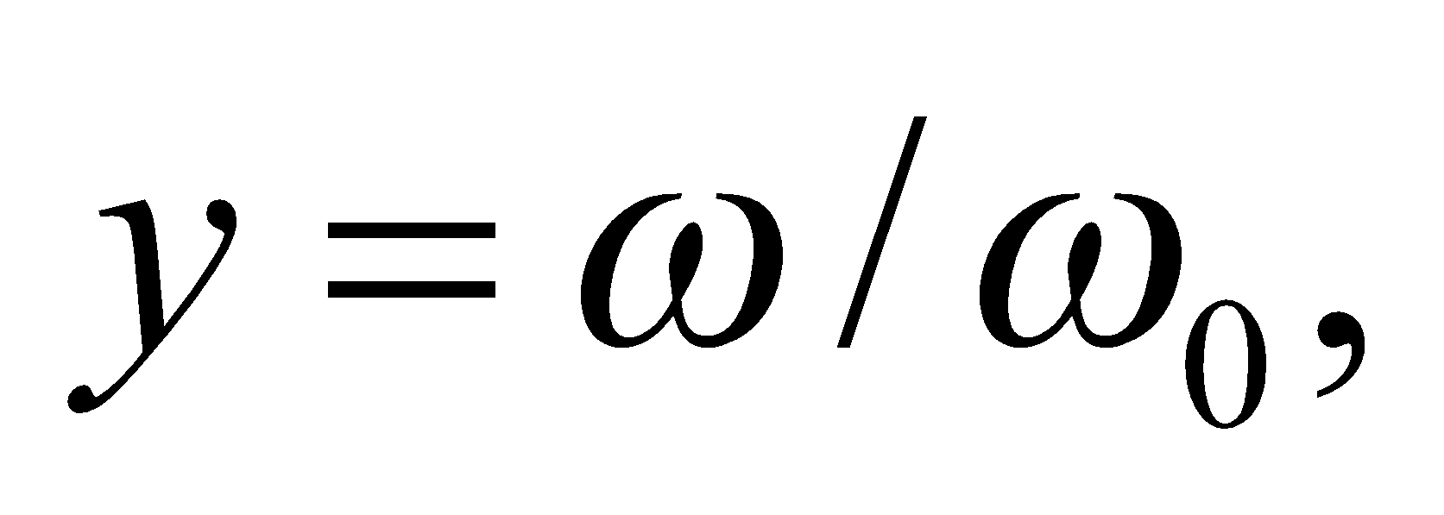and 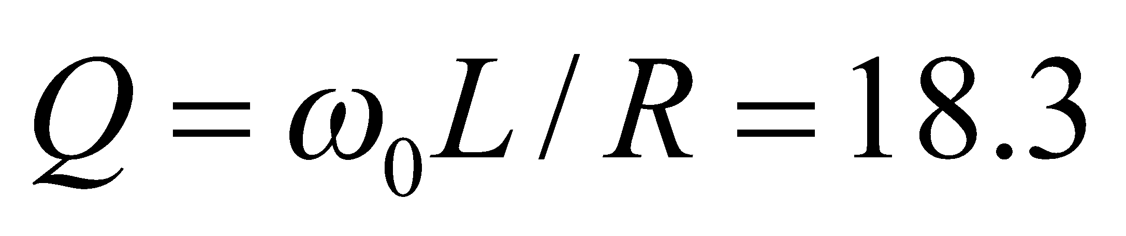 (see Problem 28.73), so the peak voltage across the capacitor can be written as

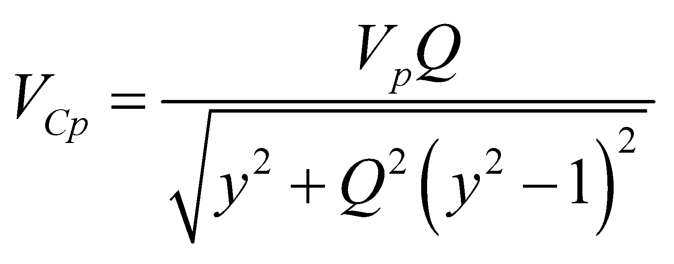

Setting this equal to 1200 V and using the quadratic formula, we get

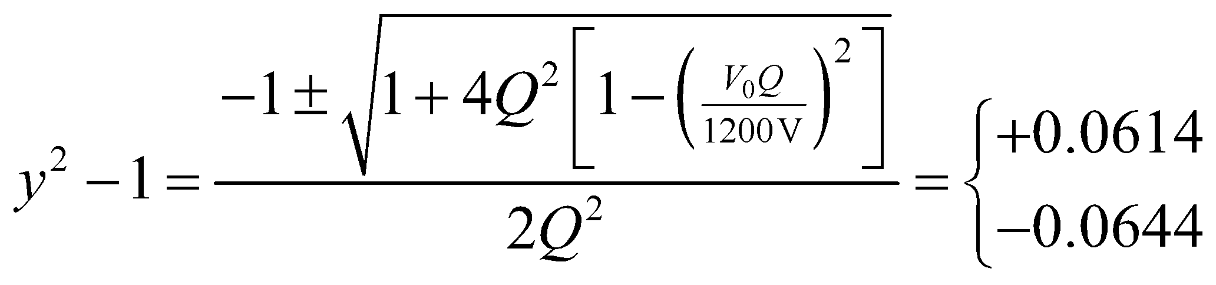

This means the limits of the frequency range to be avoided are 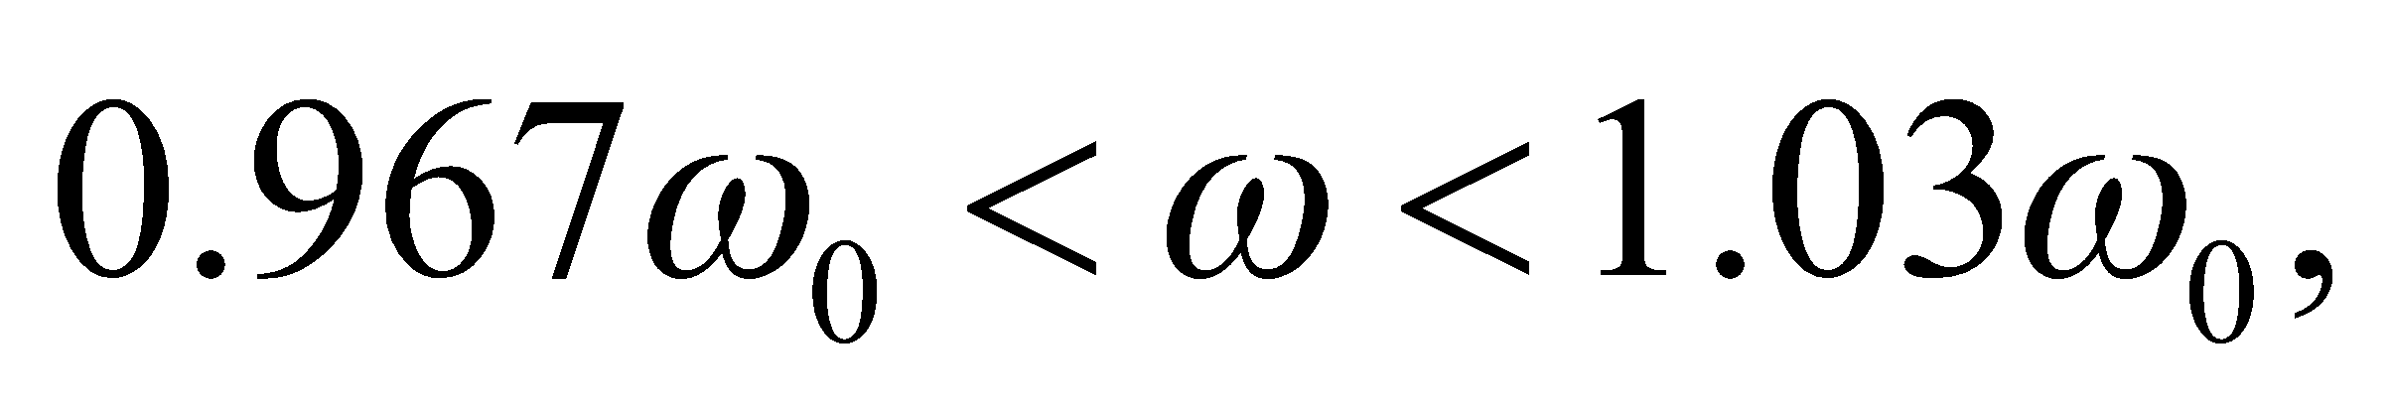which agrees with what we found above.

**55. Interpret** This problem involves analyzing a phasor diagram for a driven *RLC* circuit to find if the driving frequency is above or below resonance. We are also to complete the diagram and use it to find the phase difference between the applied voltage and current.

**Develop** Our diagram has three phasors, 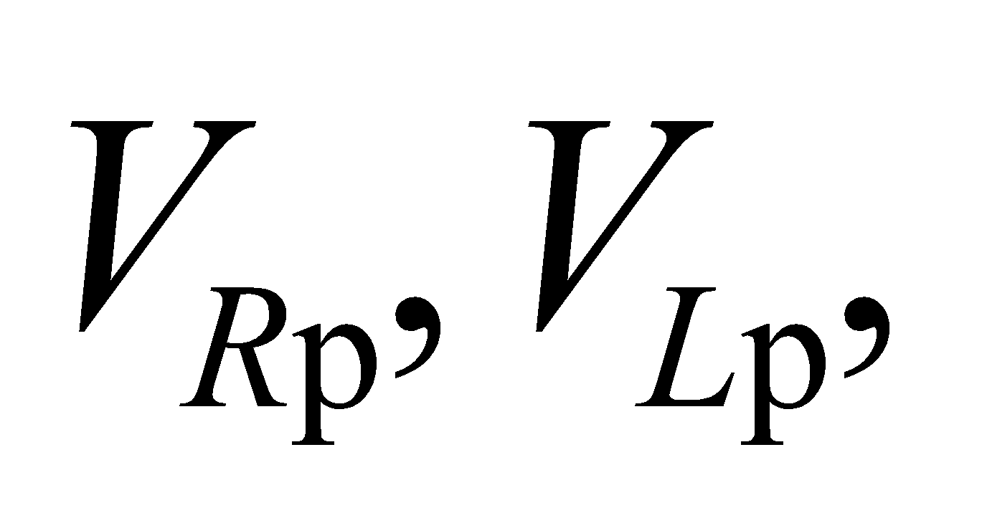 and 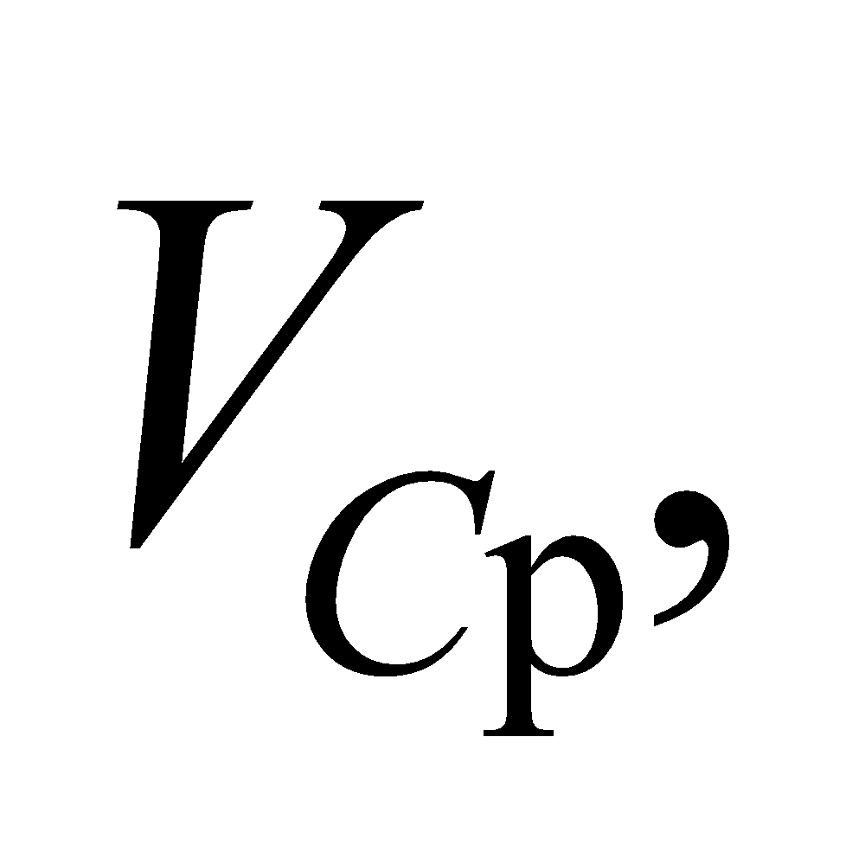 representing the voltages across the resistor, the inductor, and the capacitor, respectively. Because the resistor voltage is in phase with the current, 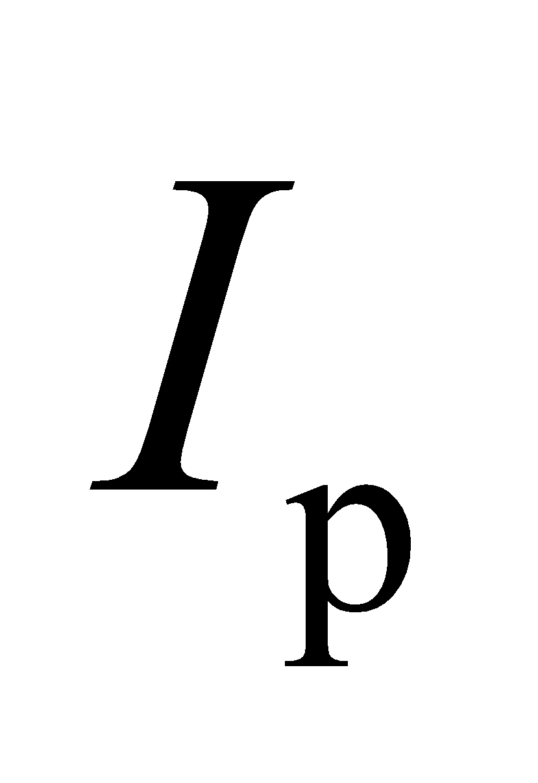 is in the same direction as 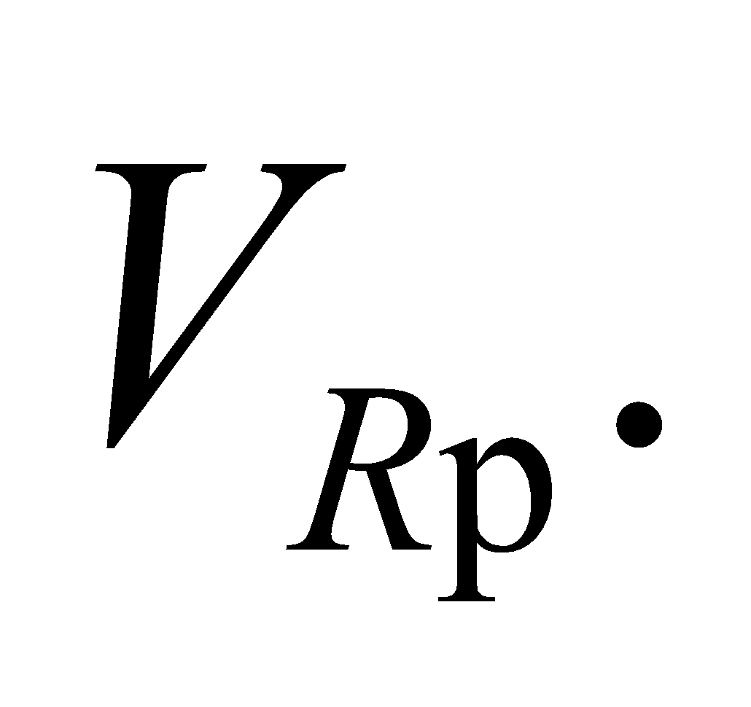 The resonant frequency is .

**Evaluate**  **(a)** From the observation that 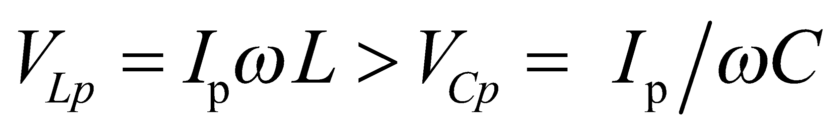, we conclude that 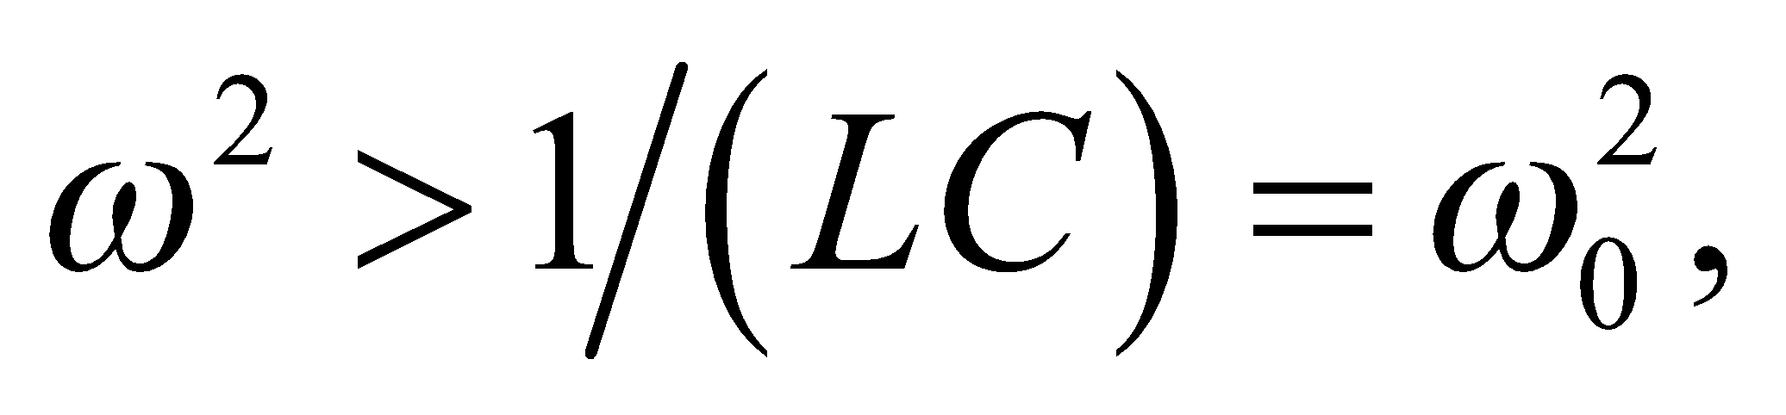which means the frequency is above resonance.

**(b)** The applied voltage phasor is the vector sum of the resistor, capacitor, and inductor voltage phasors, as shown below. The current is in phase with the voltage across the resistor, which in this case is lagging the applied voltage because

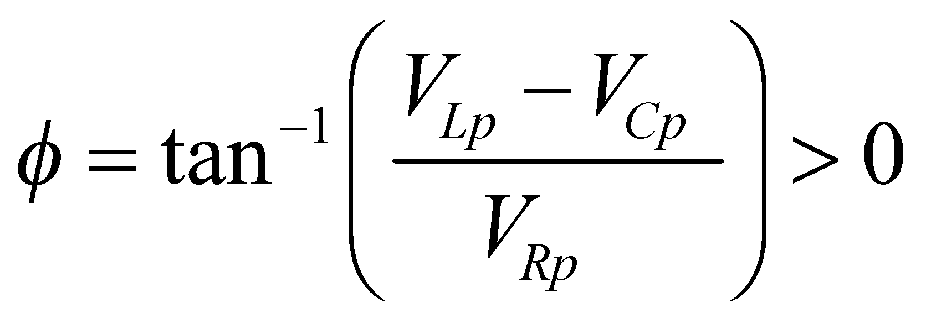

by approximately 50° (as estimated from the figure).

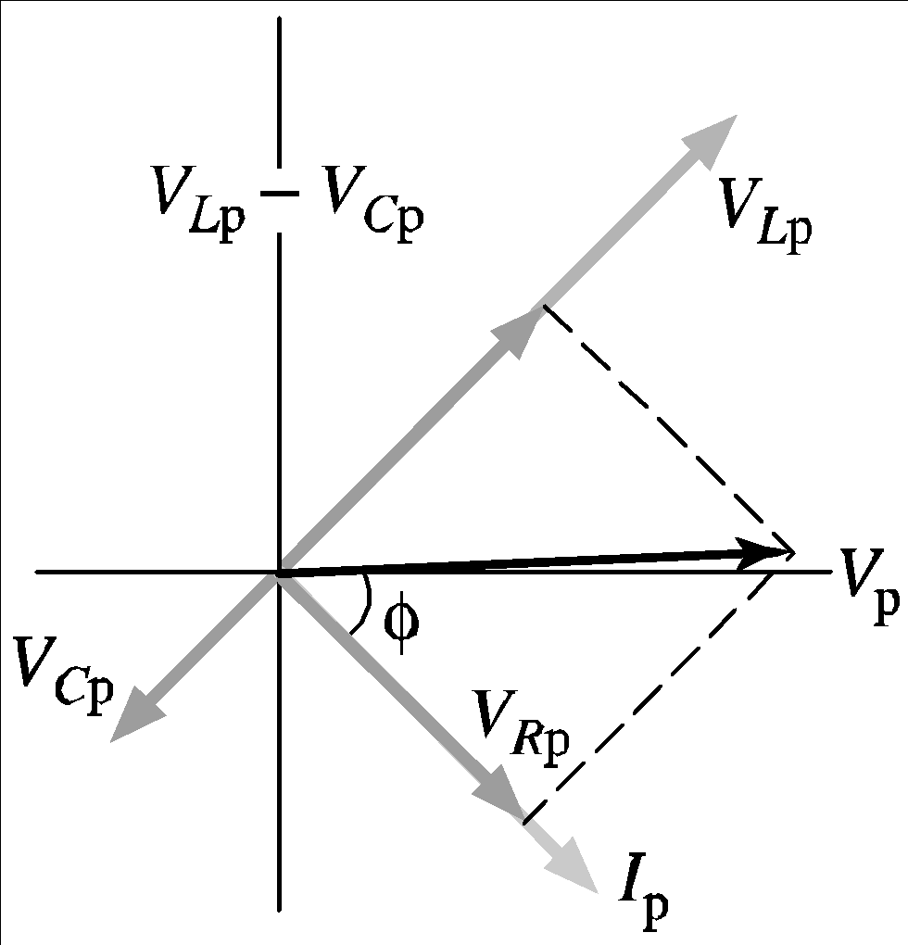

**Assess** Our circuit is inductive since 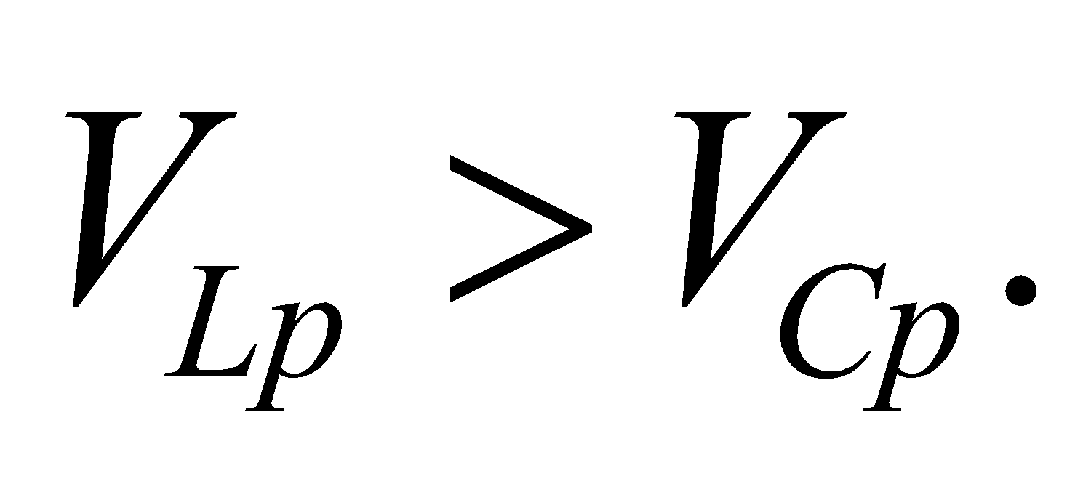 Note that a positive *φ* means that voltage leads current, and a negative *φ* means voltage lags current. At resonance,  and *φ* = 0.

**56.** **Interpret** We are to show that the current in an *RLC* circuit at twice the resonance frequency is the same as the current at half the resonance frequency, provided these are half the current at resonance.

**Develop** At resonance, *XL* = *XC*, and Equation 28.12 takes the form

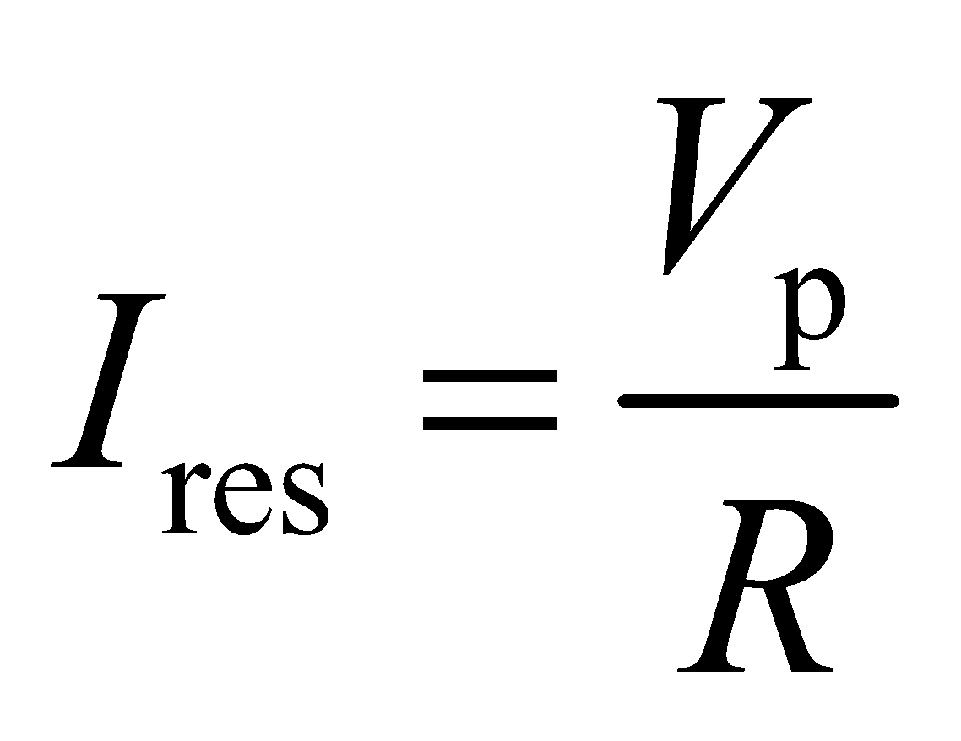

Taking the ratio of the peak current to the current at resonance gives

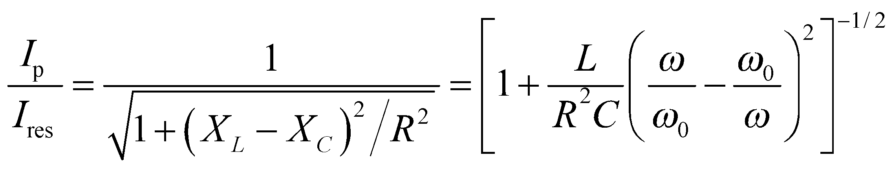

where  is the resonance frequency.

**Evaluate** Since this expression does not change when 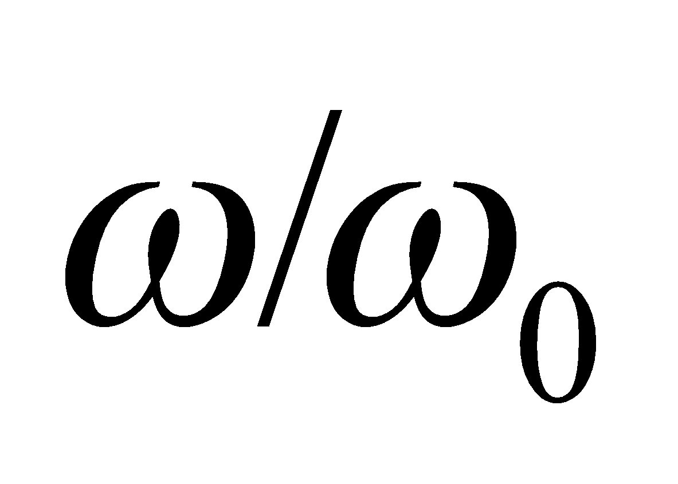 is replaced by its reciprocal, the assertion in this problem is true. (That is, 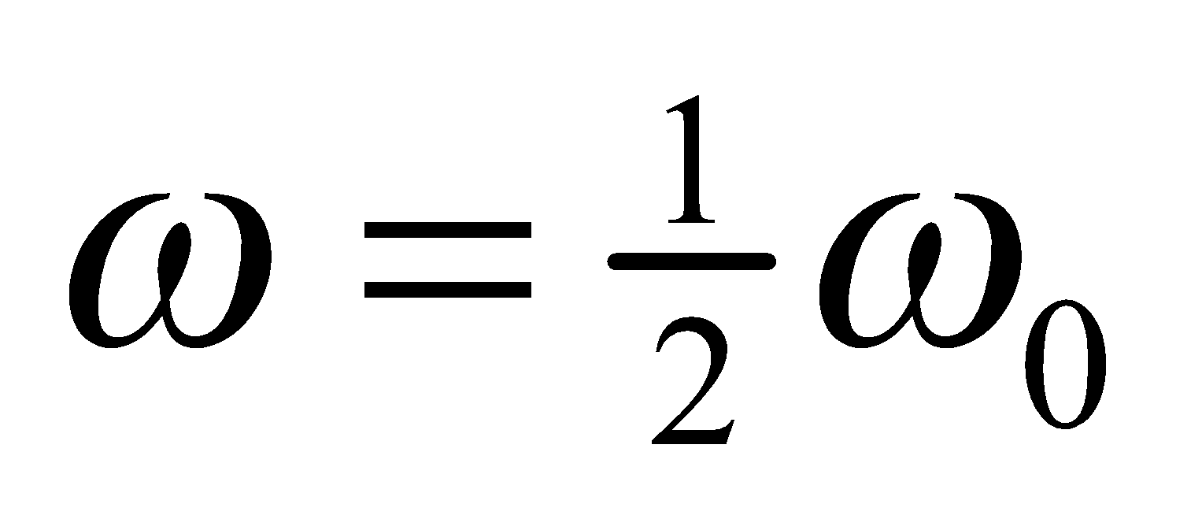 and 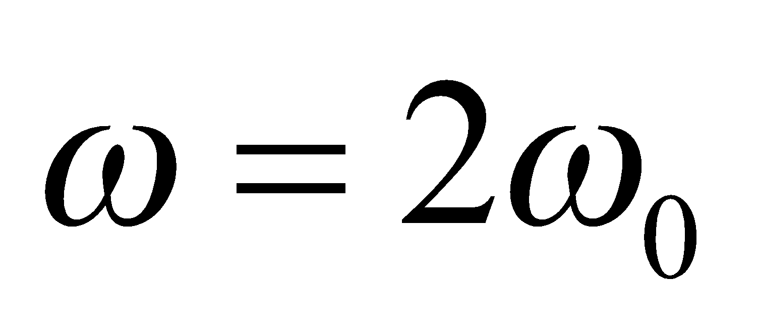 give the same 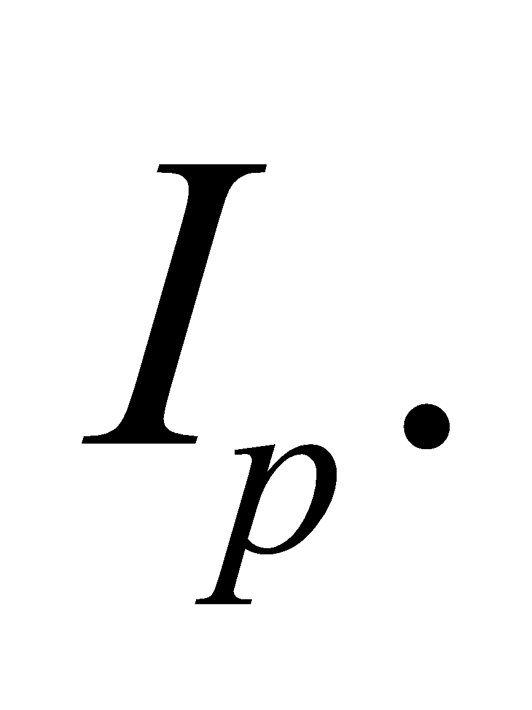)

**Assess** Thus, we have found that if

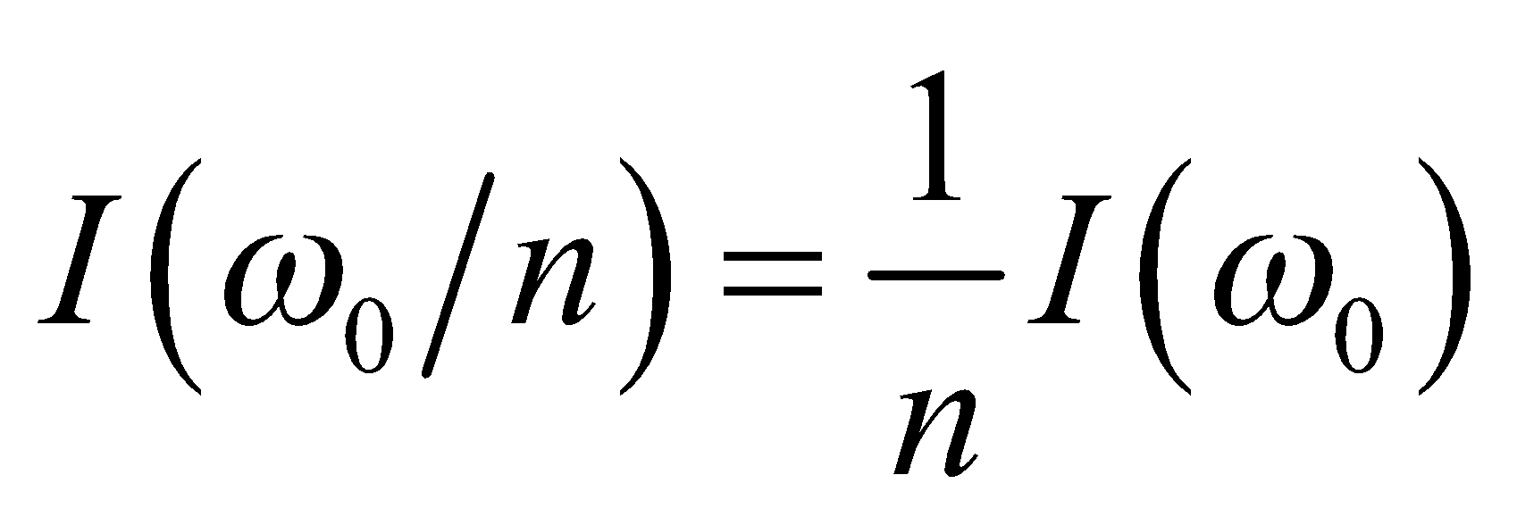

then

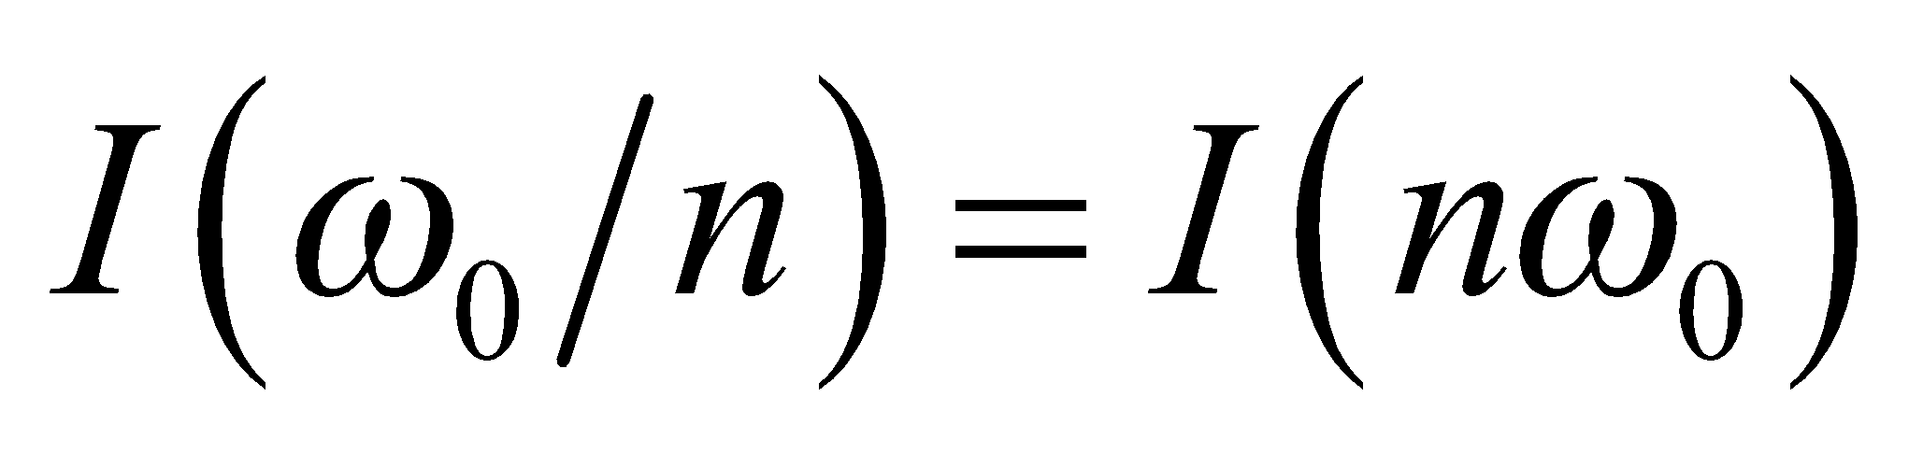

**57. Interpret** We are to find the power factor and the power dissipation in a series *RLC* circuit.

**Develop** From the geometry of Figure 28.16, we find that the power factor of the circuit is

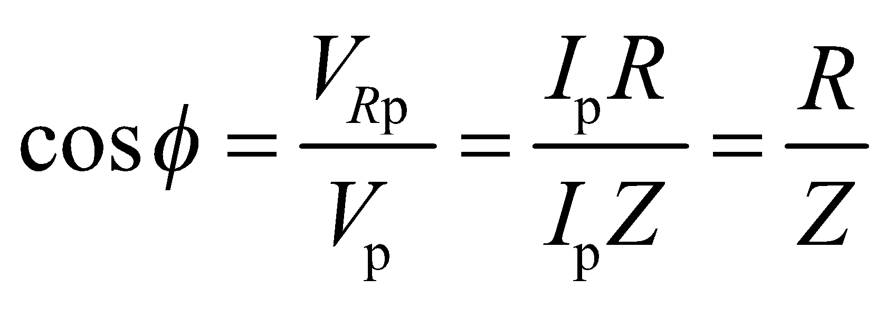

The average power in the circuit is given by Equation 28.14:

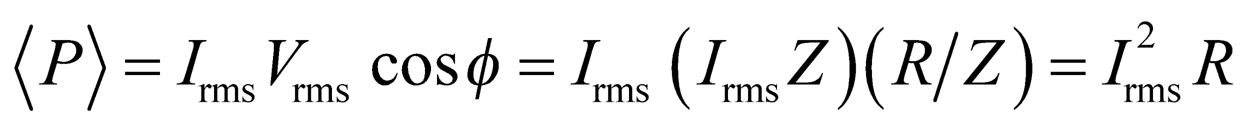

**Evaluate** **(a)** Substituting the values given, we find the power factor is

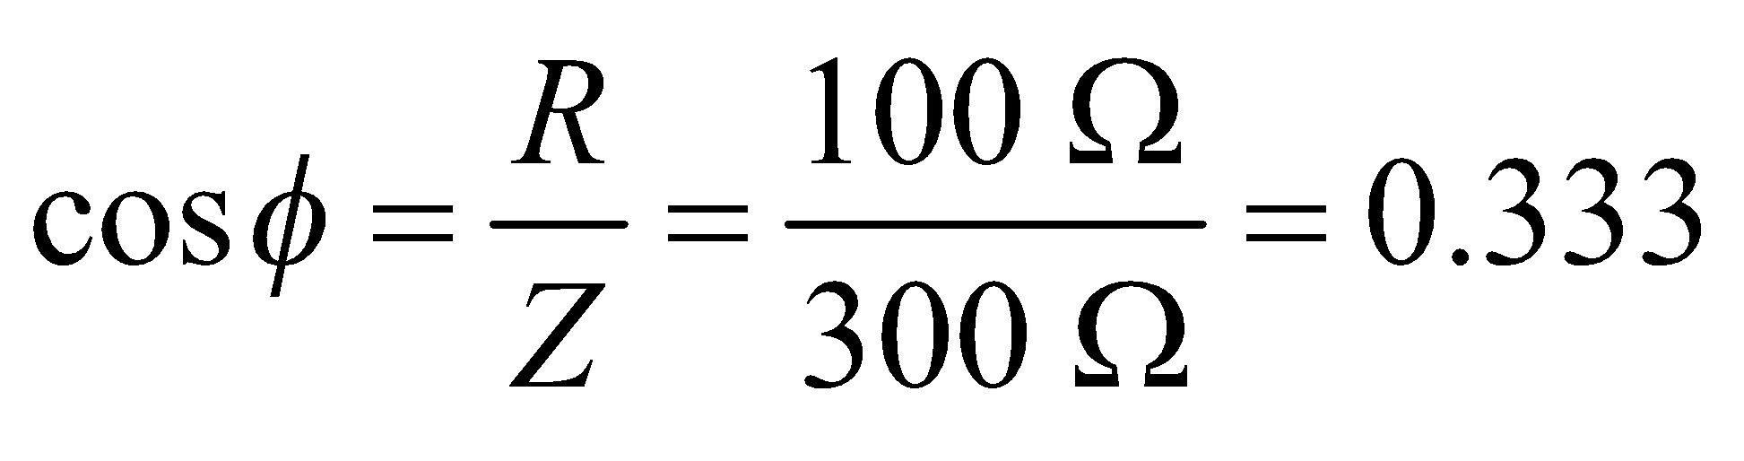

**(b)** The above equation gives 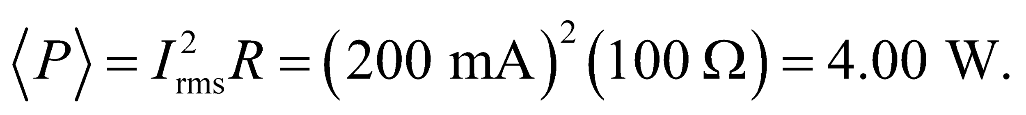

**Assess**  Note that the average AC power is given by the same expression as the DC power if the rms current is used. The power factor must be between zero and 1. A purely resistive circuit has a power factor of 1, while a circuit with only capacitance or inductance has a power factor of zero.

**58.** **Interpret** We are to find the resistance and the resonant frequency of a series *RLC* circuit given the power factor and the impedance at 60 Hz.

**Develop**  From the geometry of Figure 28.16, we find that the power factor of the circuit is



from which we can find the resistance *R*. The reactance of the circuit can be expressed in terms of the inductance, the resonant frequency, and the given values by using Equation 28.12:

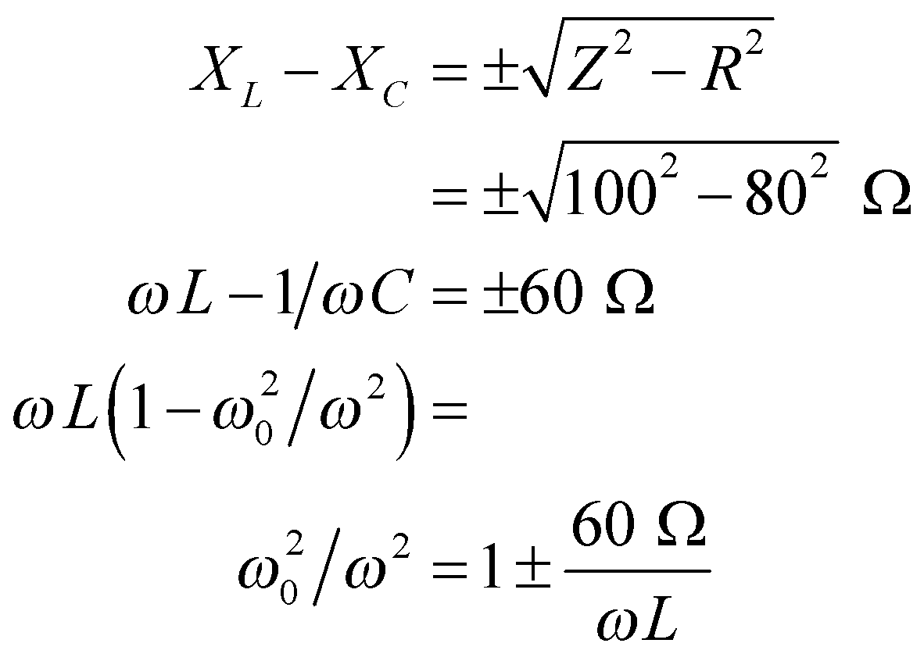

**Evaluate** (**a**) Solving for *R* gives

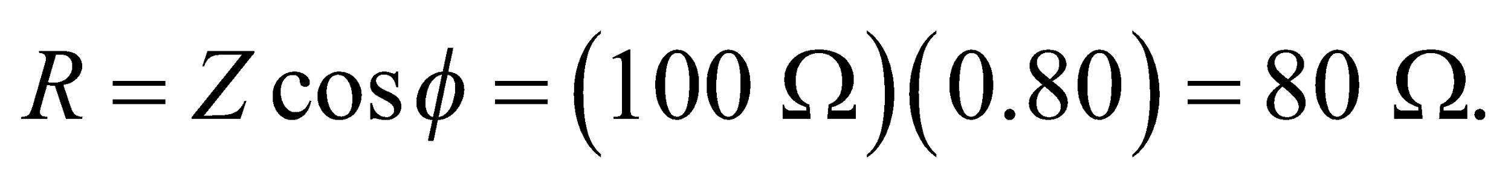

(**b**) Since  we can discard the unphysical solution (with 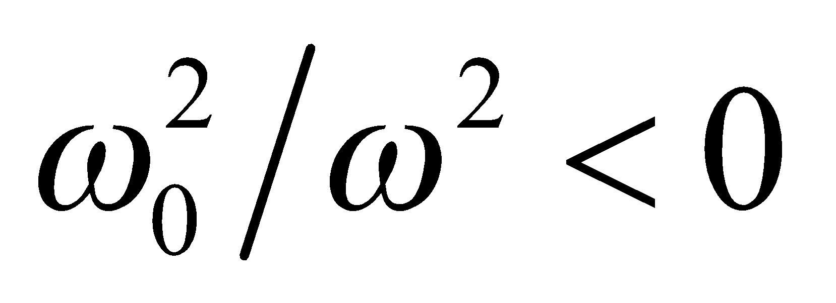) to find 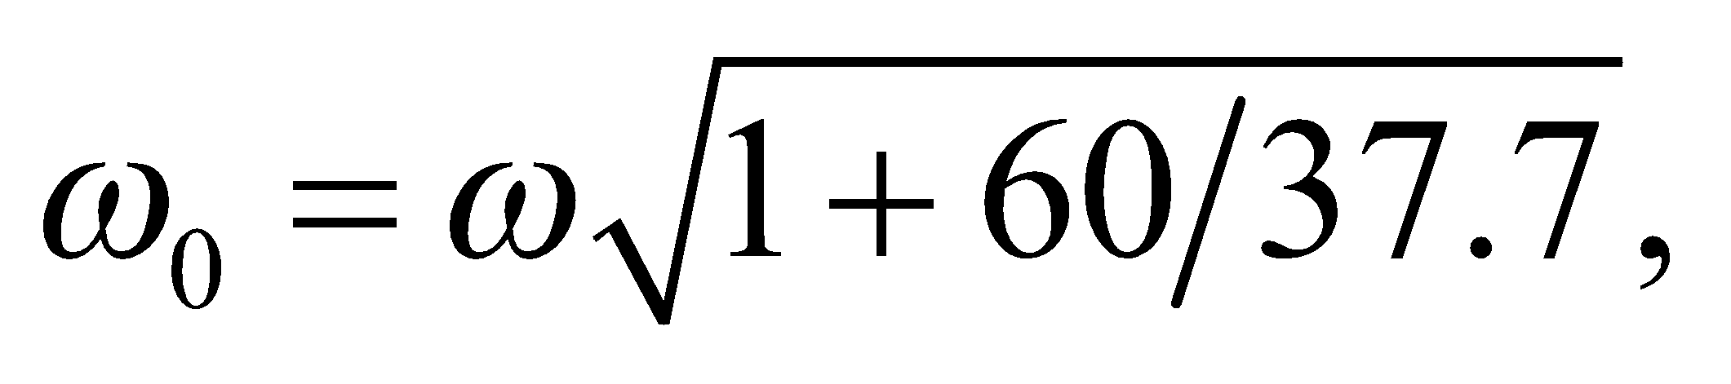 or 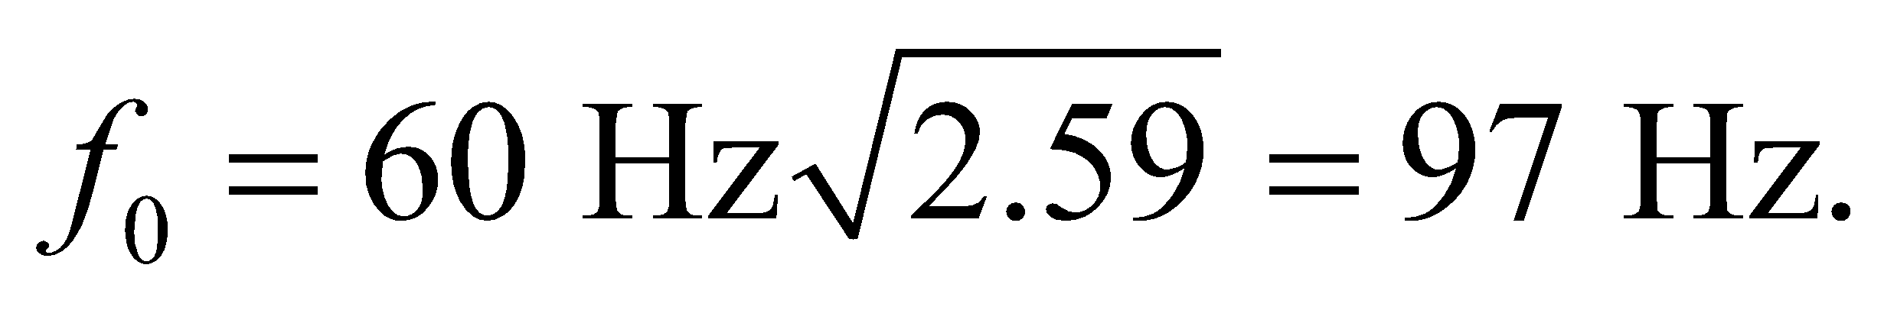

**Assess** An alternative way to show the relationship between the power factor and the impedance and resistance is to use Equations 28.12 and 28.13 and the trigonometric identity 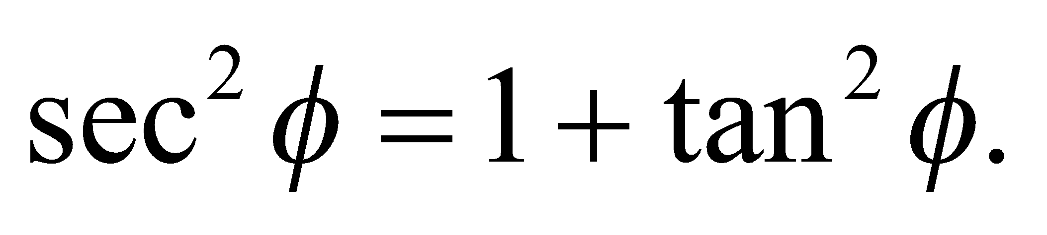

**59.** **Interpret** You want to know the percentage of power your company loses during transmission over its electric lines.

**Develop**For AC circuits, the average power produced is given in Equation 28.14: 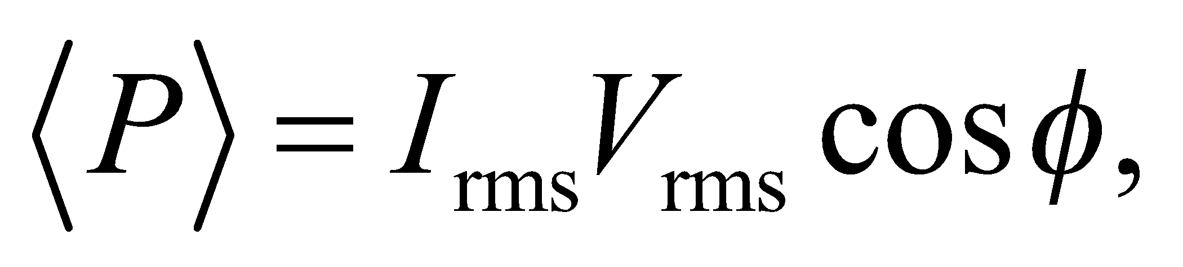 where 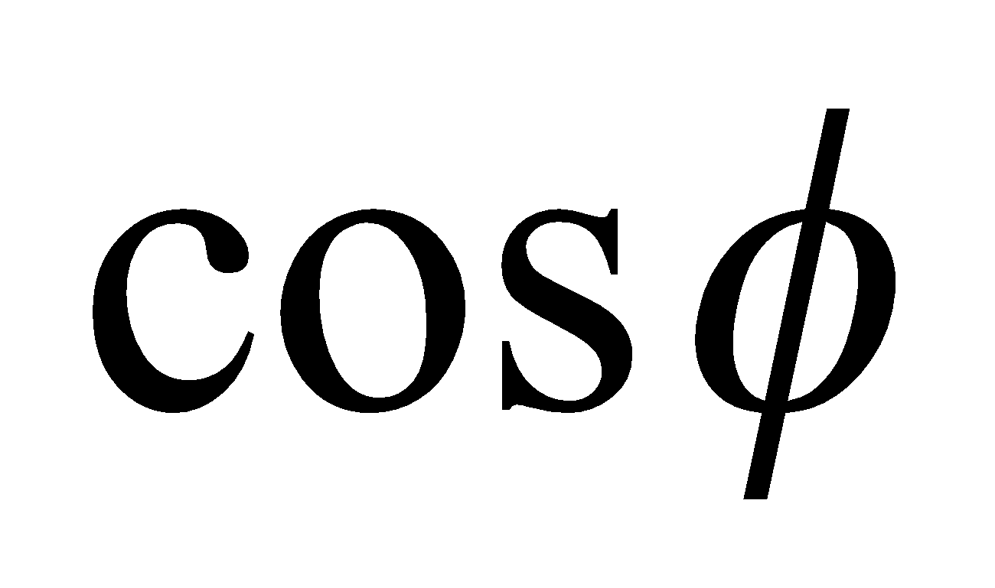is the power factor. The power lost in the transmission lines is 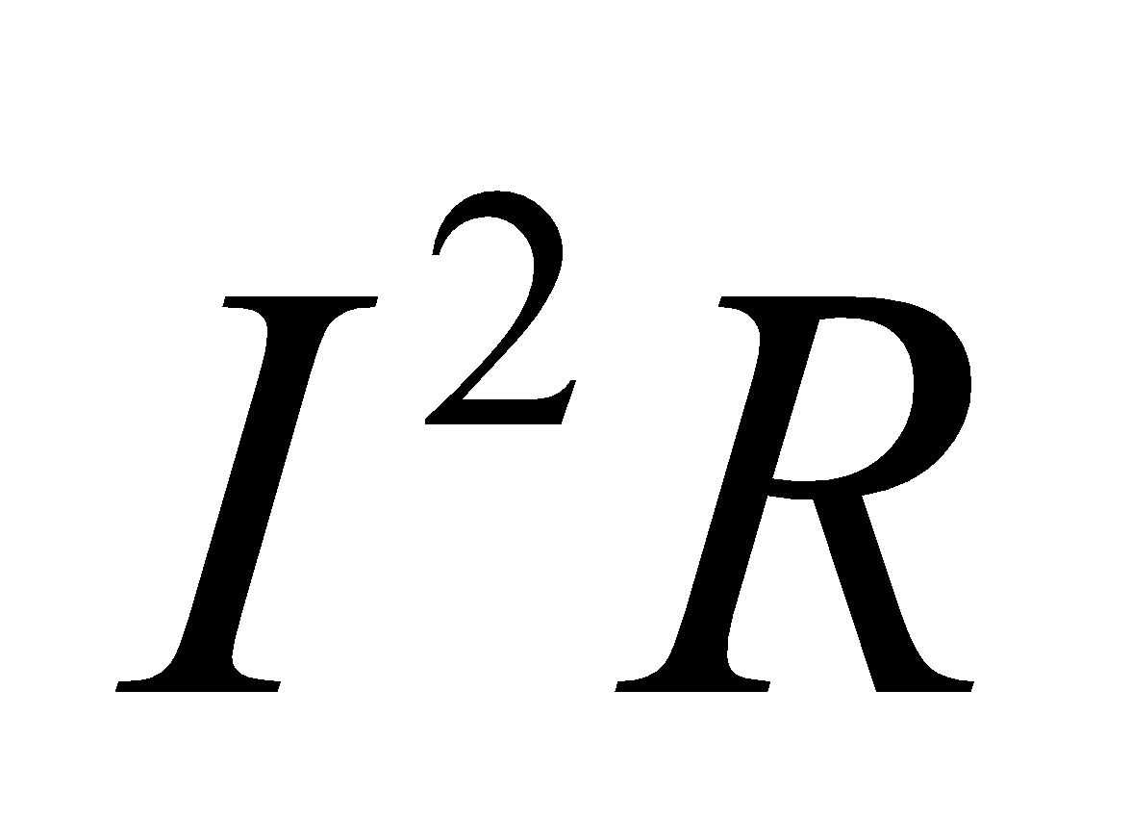at any given time, but the average power lost will be

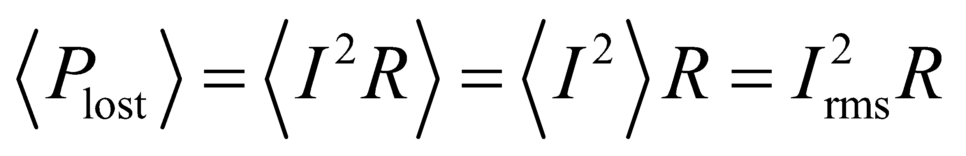

where we have used the fact that the resistance is constant over time, as well as the definition of root-mean-squared: 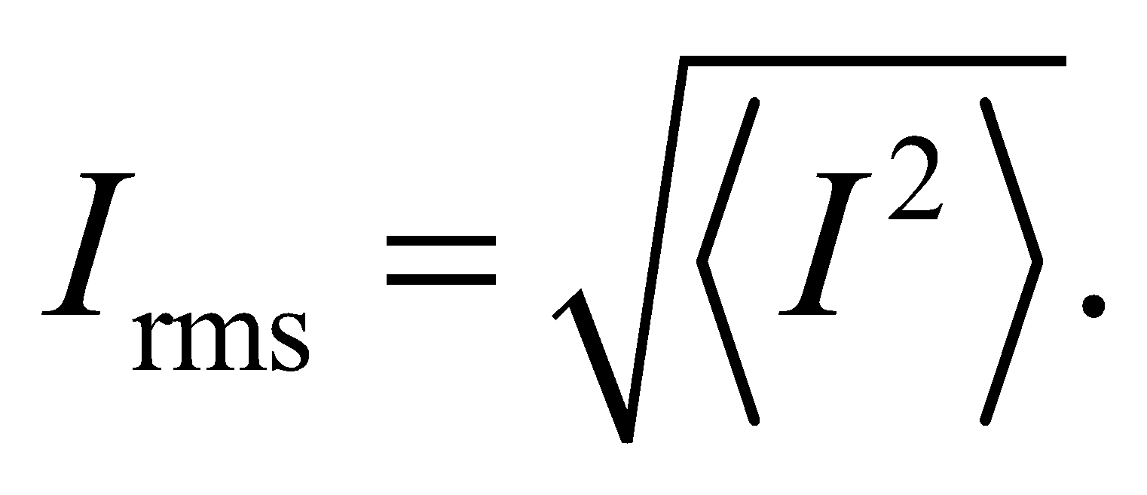

**Evaluate**(a) For a power factor of 1.0, the percentage of power lost in the transmission lines is

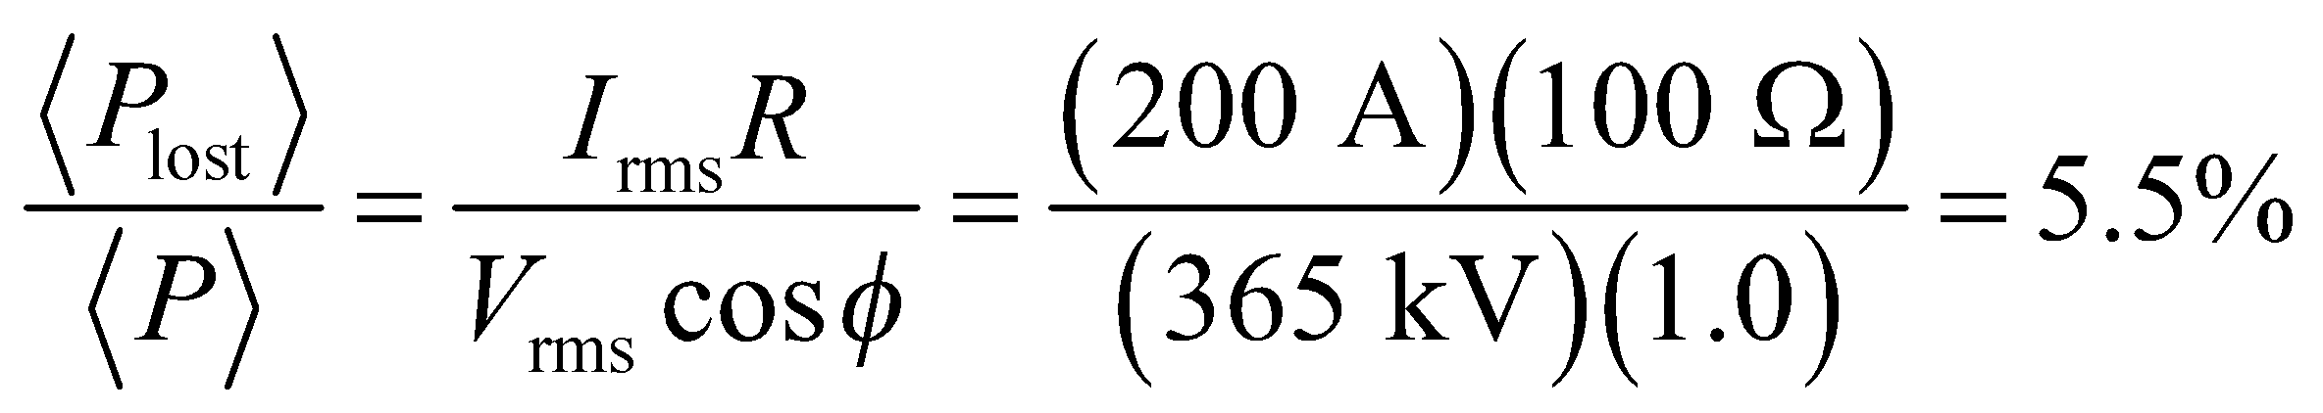

(b) For a power factor of 0.60, the same percentage is

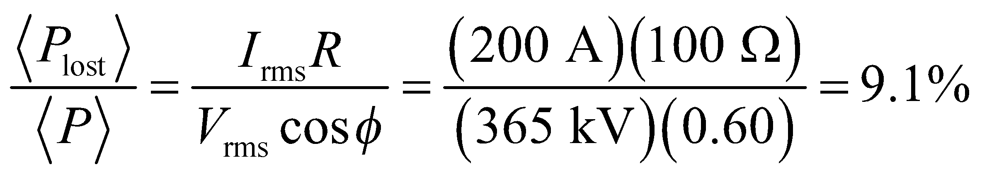

**Assess**In this problem, the current is constant, so the power lost will be the same in both cases. What does change is the amount of AC power produced at the plant. For a power factor of 1.0, the current and voltage are in phase, and the power in the circuit is maximized. But for a lower power factor, the current and voltage are out of phase, so the plant is producing less power for its end-users, while still losing the same amount in the transmission lines.

**60.** **Interpret** We are to find the AC current drawn by the given AC-to-DC converter and the cost to run this converter for 10 hours given a power factor of unity.

**Develop** The DC power output,

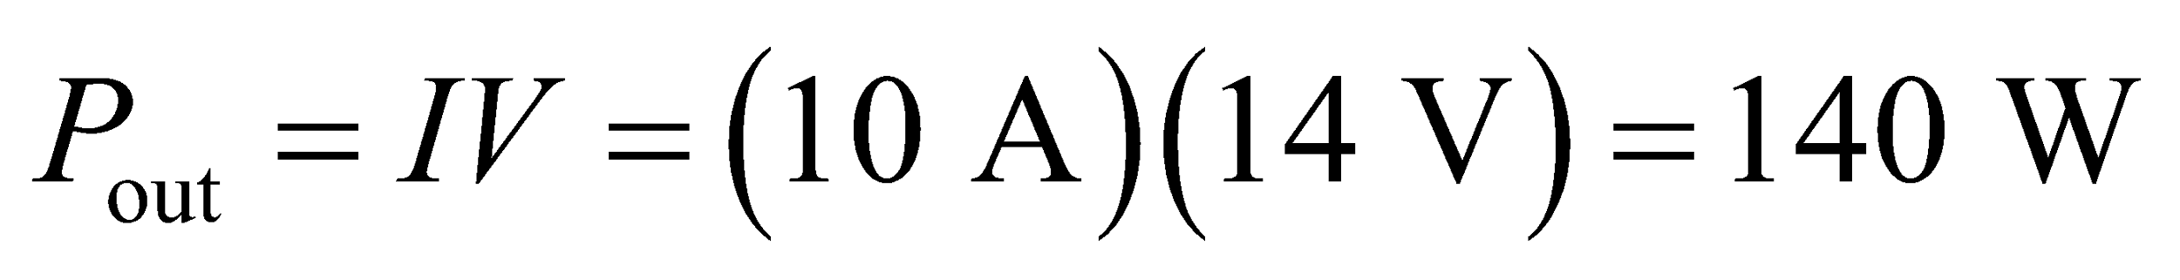

is 80% of the average AC power input which is

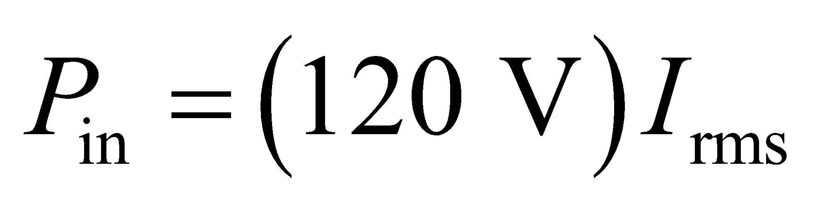

(where cos*φ* = 1 is assumed for the charger).

**Evaluate** **(a)** Thus,

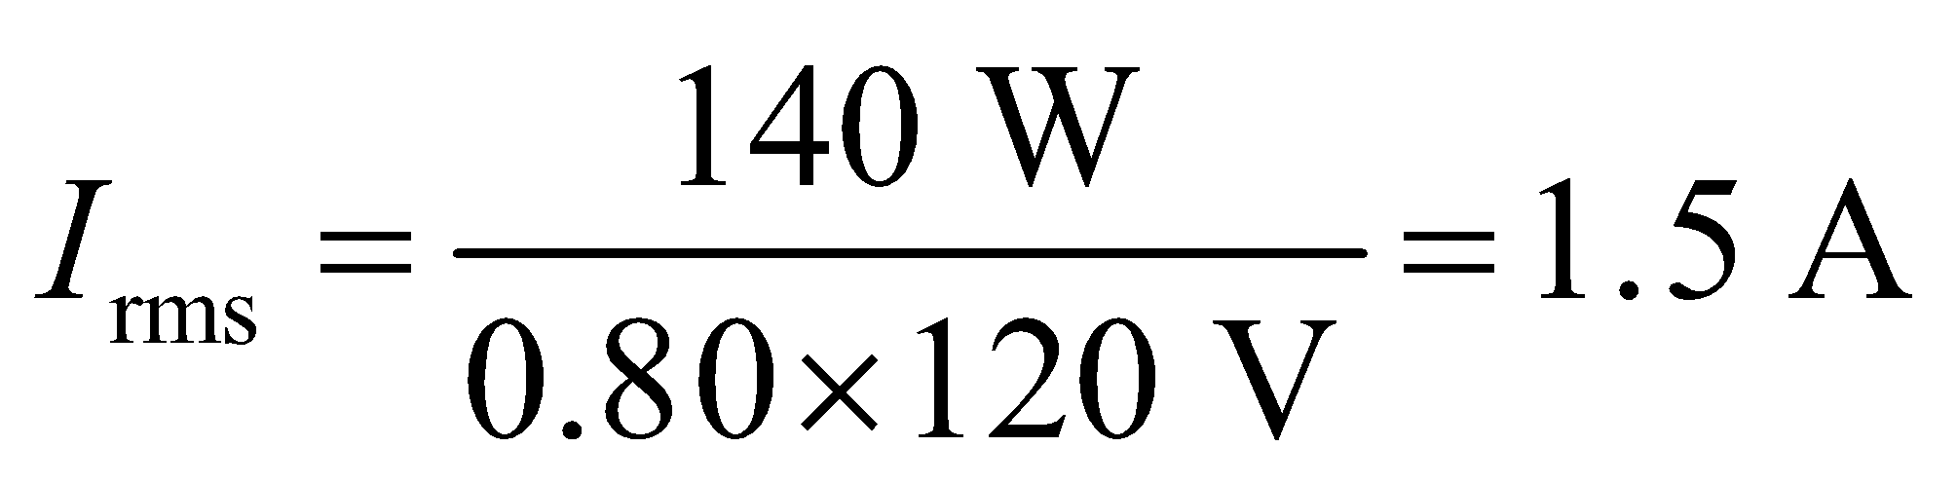

**(b)** The cost for 10 h of operation is

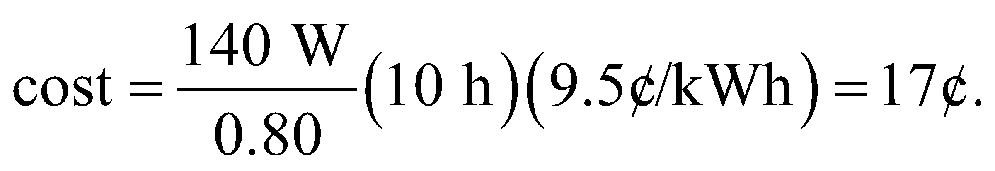

**Assess** For DC power, the rms is not necessary because the power does not fluctuate.

**61. Interpret** This problem deals with DC power supplies. If the time constant *RC* is long enough, the capacitor voltage will only decrease slightly before the AC voltage from the transformer rises again to fully charge the capacitor.

**Develop** The scenario is depicted in Figure 28.23. From the given DC output, we find the load resistance to be 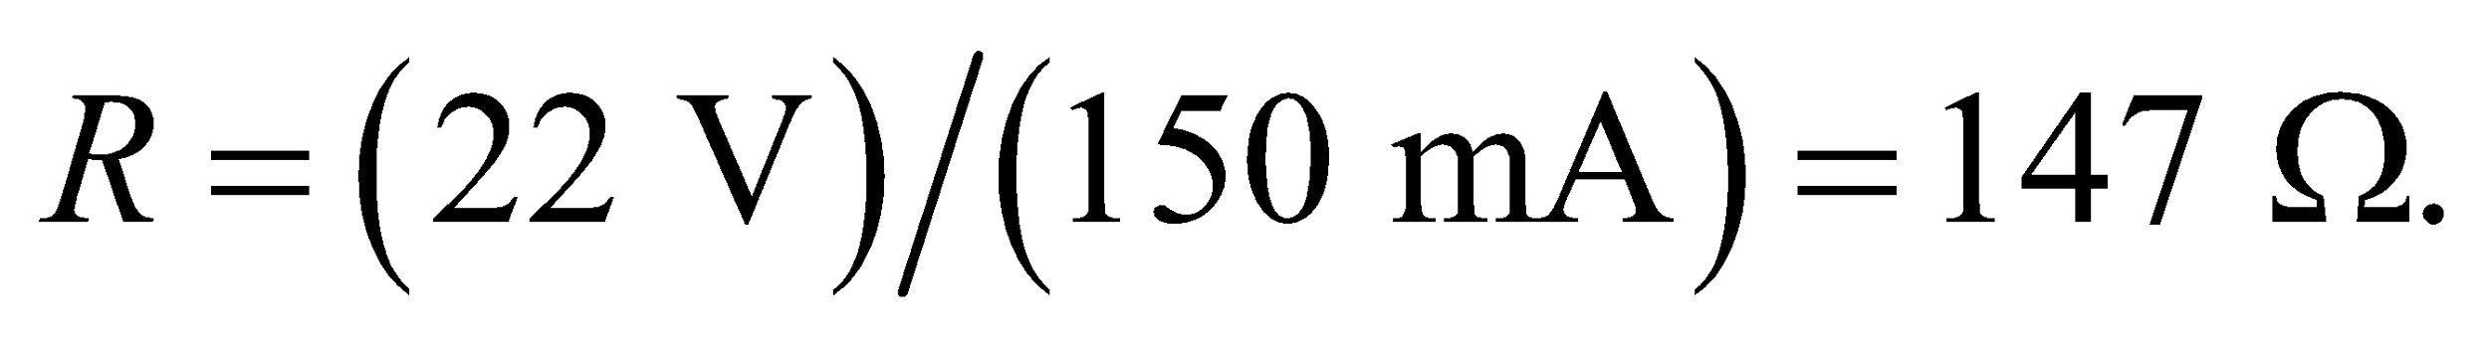 In one period of the input AC (*T* = 1/*f*), the capacitor voltage must decay by less than 3%, or 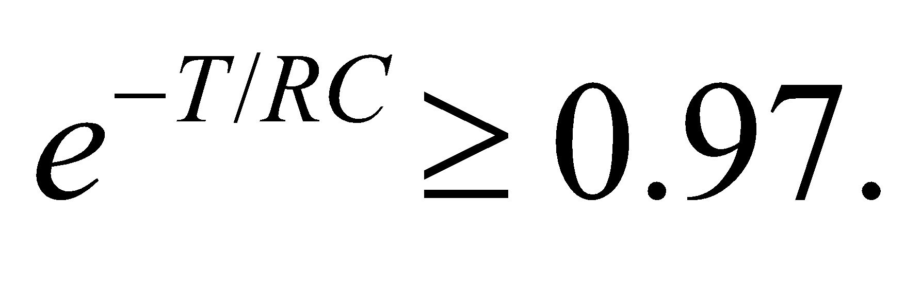

**Evaluate** The above condition implies that

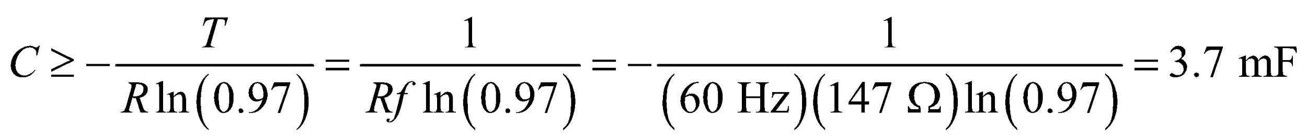

**Assess** If the capacitance is large enough, the load current and voltage can be made arbitrarily smooth with negligible decay.

**62.** **Interpret** This problem involves a damped RLC circuit whose peak voltage across the capacitor decays as given. We are to find the resistance of this circuit.

**Develop** For the damped oscillations of an *RLC* circuit, the voltage decays according to Equation 28.11,

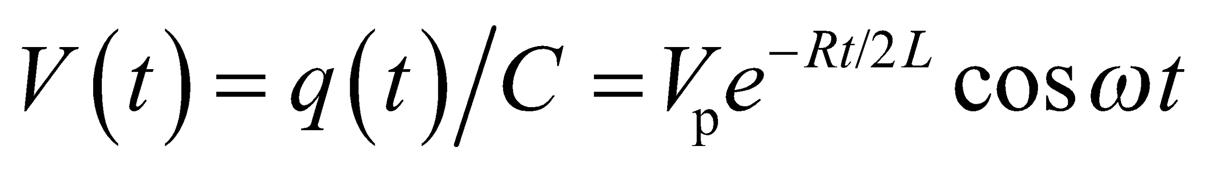

with frequency given by Equation 28.10. If in ten cycles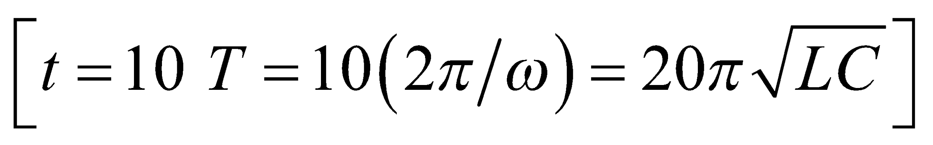the

peak voltage has decayed from 35 V to 28 V, which gives

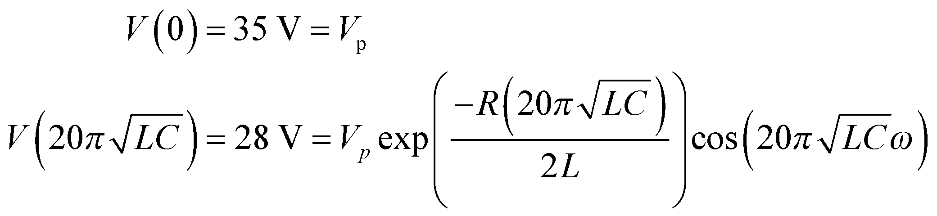

Take the ratio and solve for R.

**Evaluate**  The resistance is

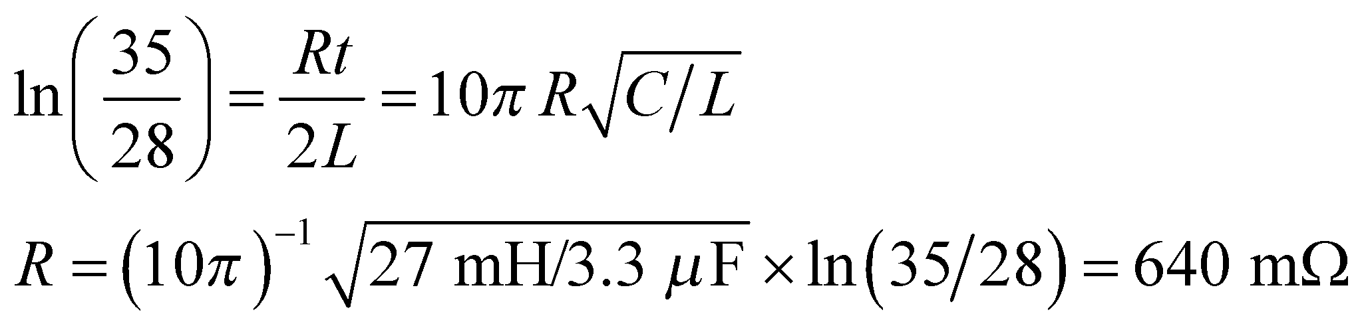

**Assess** The result is given to two significant figures, as warranted by the data.

**63. Interpret** We have an AC generator connected to a series *RLC* circuit, and we want to know its maximum peak voltage when the circuit is at resonance.

**Develop** The peak capacitor voltage is 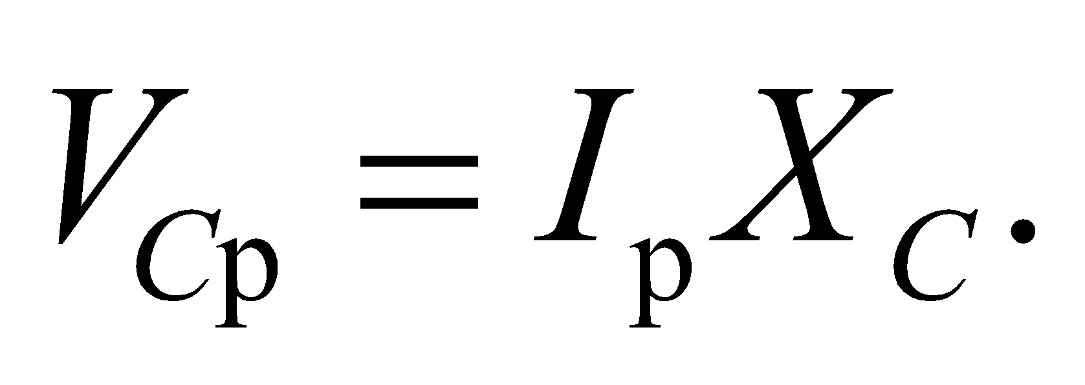 At resonance, the impedance is *Z* = *R* and 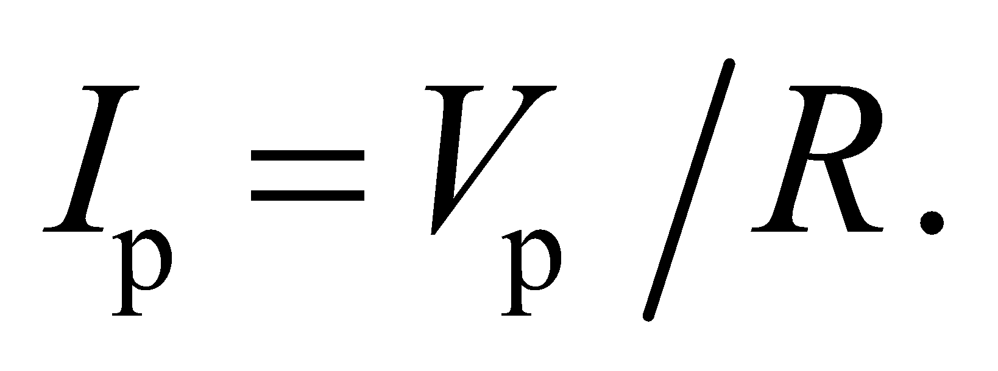 The capacitive reactance is 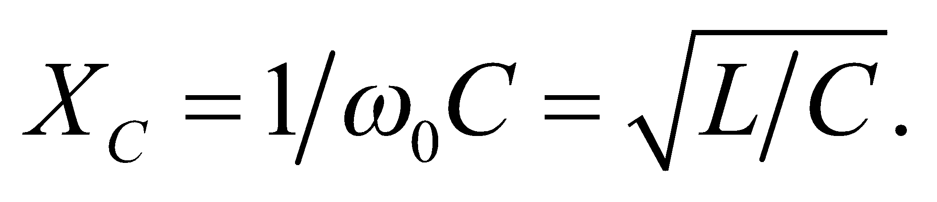

**Evaluate** The condition that 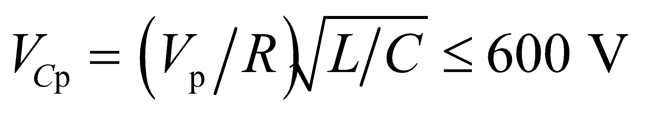 implies

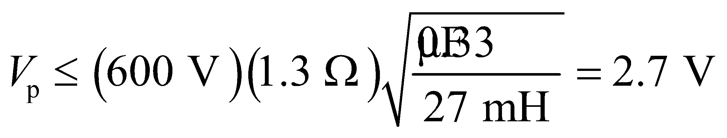

**Assess** The inductor voltage at resonance is

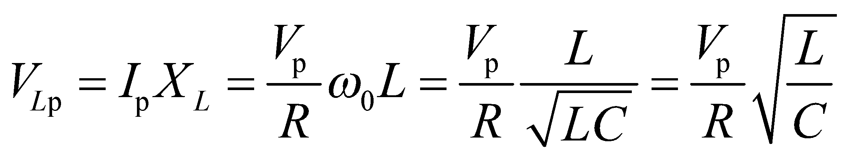

which is the same as 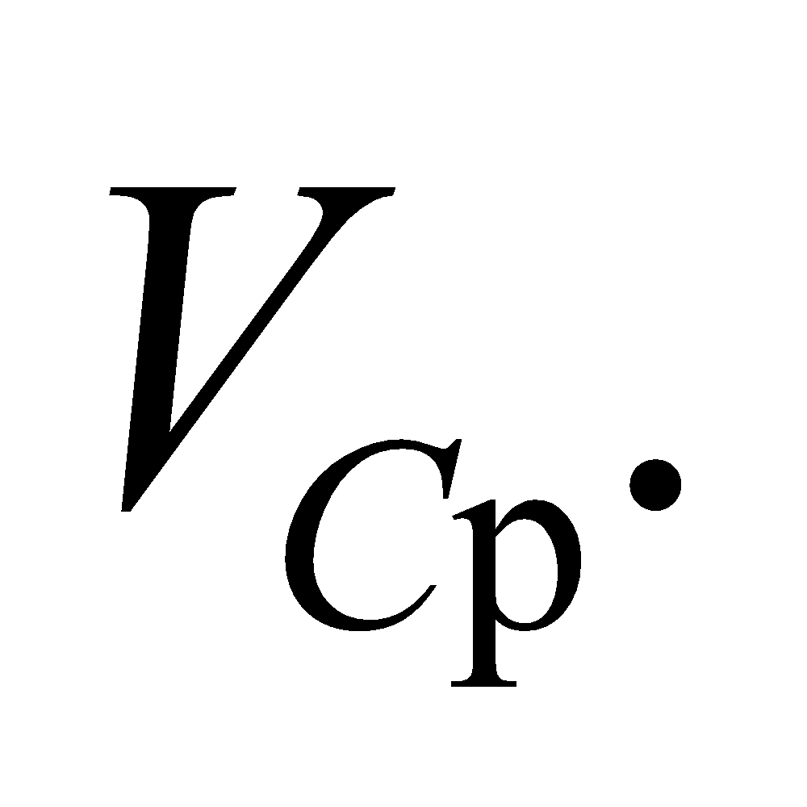 The two voltages cancel exactly at resonance. Note that 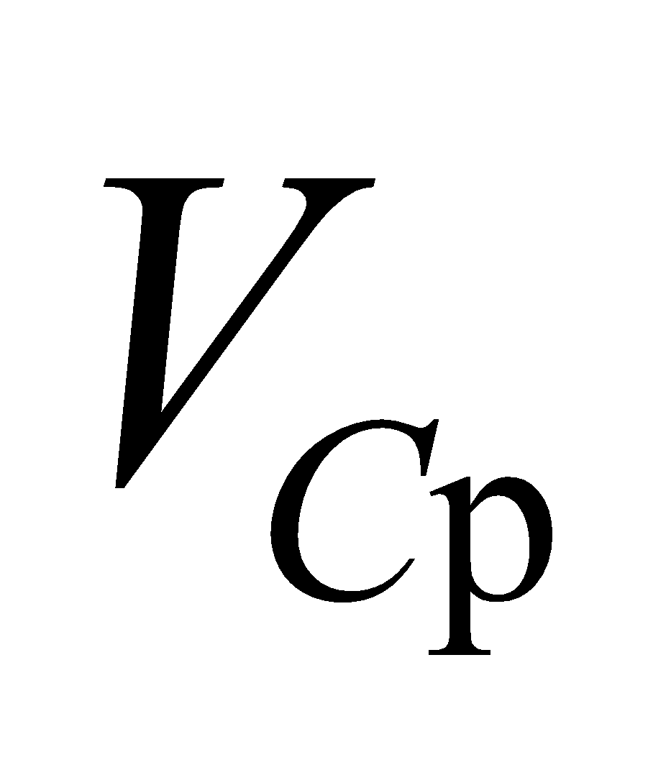 and 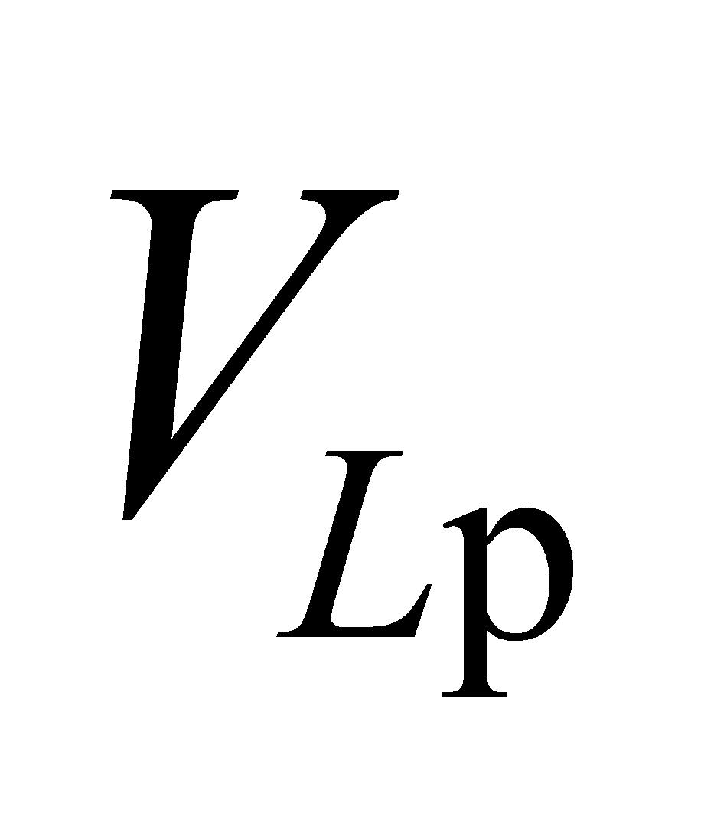 are both higher than 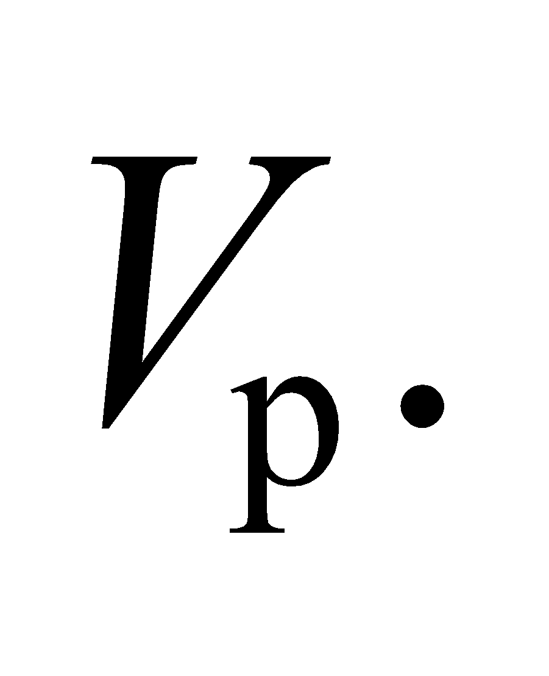

**64. Interpret** Starting with the charge on the capacitor in an *LC* circuit, we are to find the current and the voltage, then the energy stored in the capacitor and in the inductor. We are to sum the two to find the total energy and show that it’s constant.

**Develop** We start with 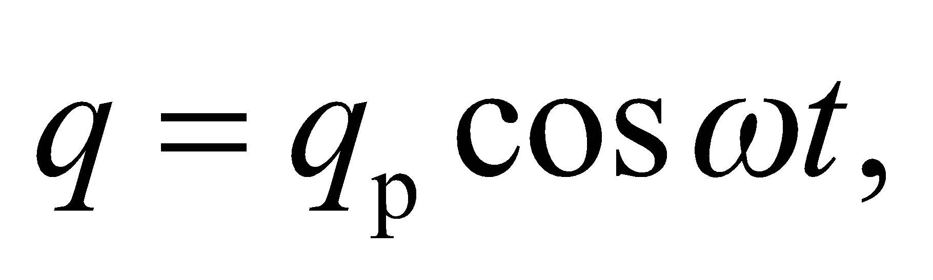 and differentiate with respect to time to find the current. We also use

*q* = *CV* to find the voltage. The energy stored in the electric field of the capacitor is 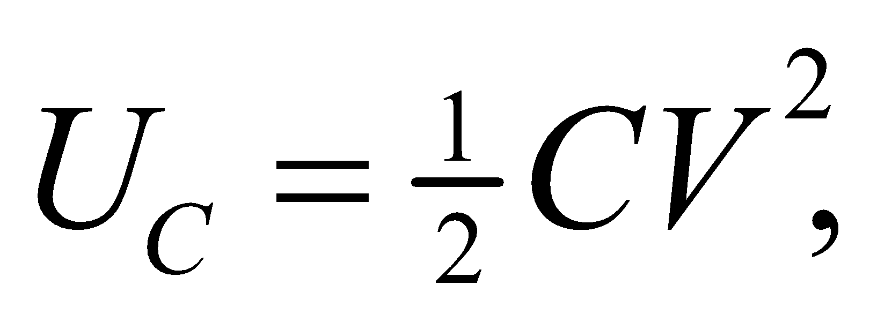 and the energy

stored in the magnetic field of the inductor is 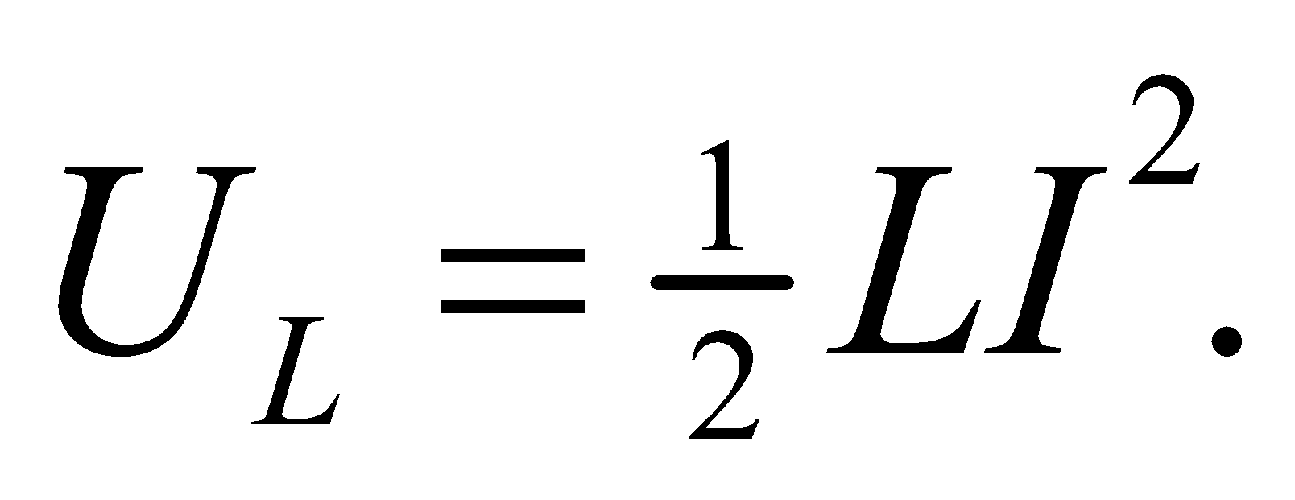

**Evaluate** The current in the *LC* circuit is

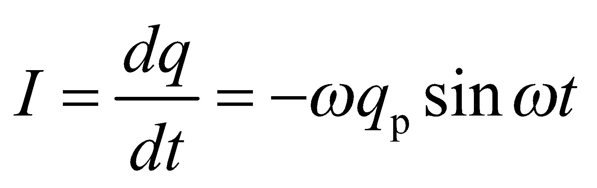

The voltage across the capacitance is

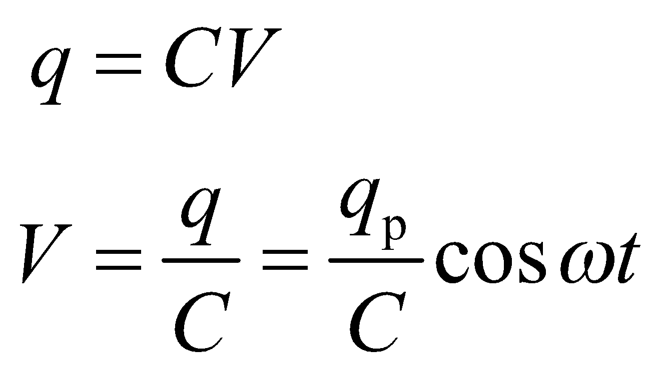

The electric energy in the capacitor is

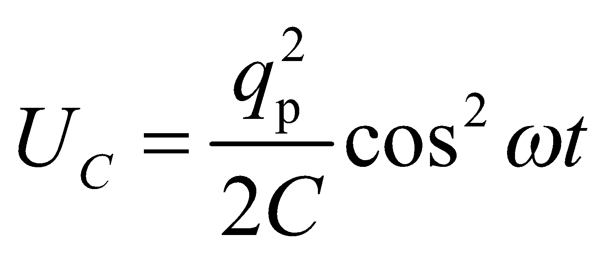

The magnetic energy in the inductor is

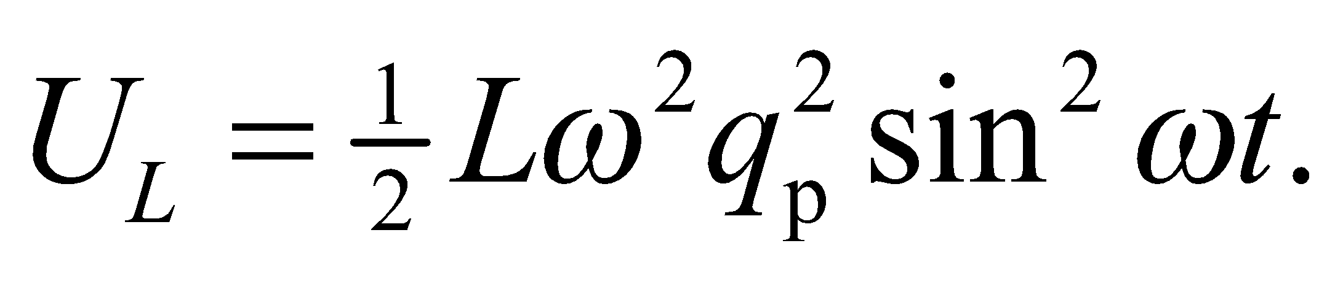

The total energy is

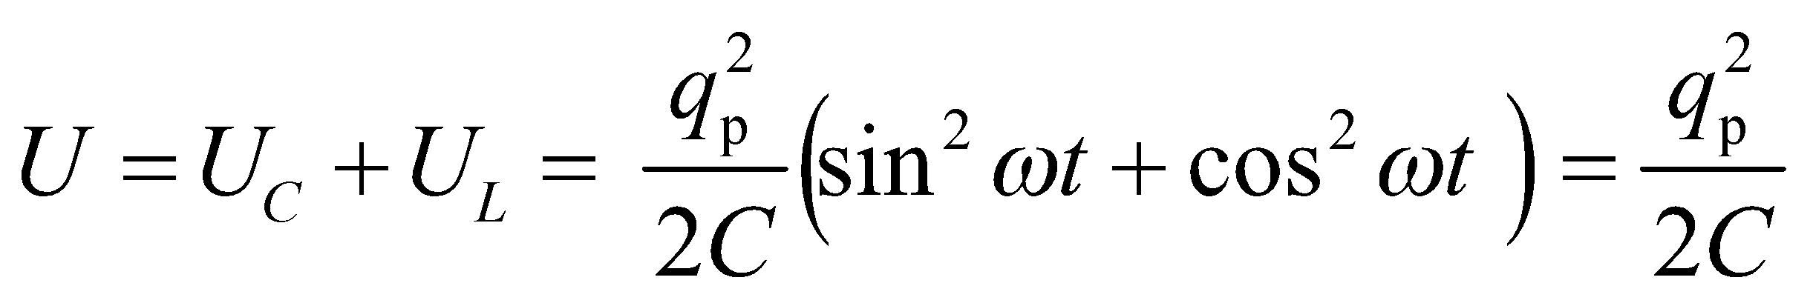

**Assess** We have shown that the energy in this circuit is a constant.

**65. Interpret** In Example 28.4, we found a frequency at which the current in an *RLC* circuit is half its maximum value. Here, we are to find a second frequency at which the current will be half the maximum. We shall use Equation 28.12 for *Z*.

**Develop** From Example 28.4, we have *C* = 11.5 μF, *R* = 8.0 Ω, and *L* = 22 mH. We also know that 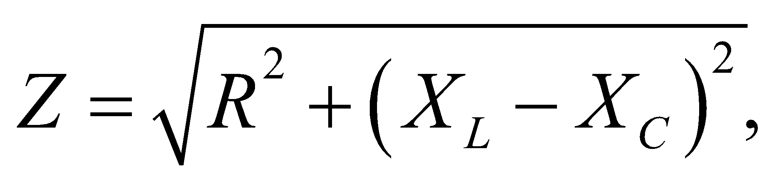 where  and  The current is given by Ohm’s law (Equation 28.12), *I* = *V*/*Z*, and we are looking for a value of *ω* such that *Z* = 2*R*.

**Evaluate**Solving for *ω* gives

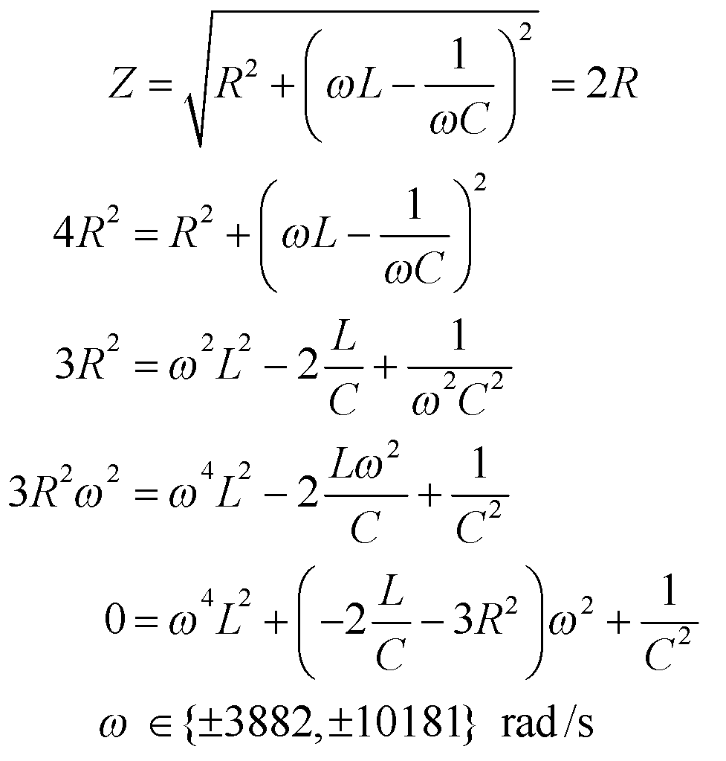

The sign of *ω* is irrelevant. We need to convert to frequency using *f* = 2*π*/*ω*, so 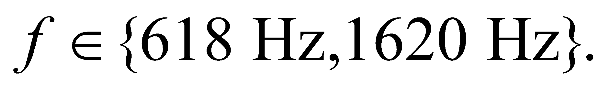

**Assess** The 618-Hz answer was given in the example, so the solution we need is *f* = 1620 Hz.

**66.** **Interpret** This problem involves a pair of capacitors that are connected in parallel and in series across a sine-wave generator that produces a peak voltage that is independent of frequency. We are to find the frequency for the series-connected capacitors such that the peak current is the same as that for the parallel-connected capacitors.

**Develop** For constant 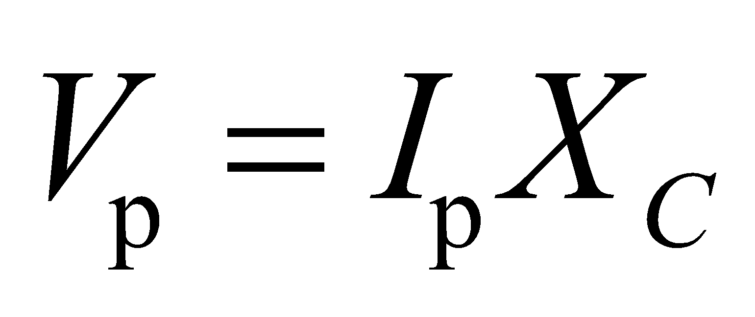 (i.e., independent of frequency), the same peak current will be supplied if the capacitive reactances for the two connections are equal (i.e., 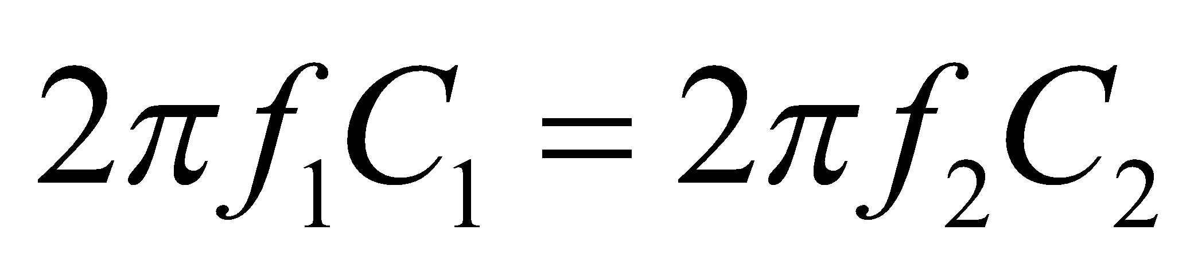). Recall from Chapter 23 that capacitors in series sum directly (CT = C1 + C2), whereas capacitors in parallel sum as reciprocals (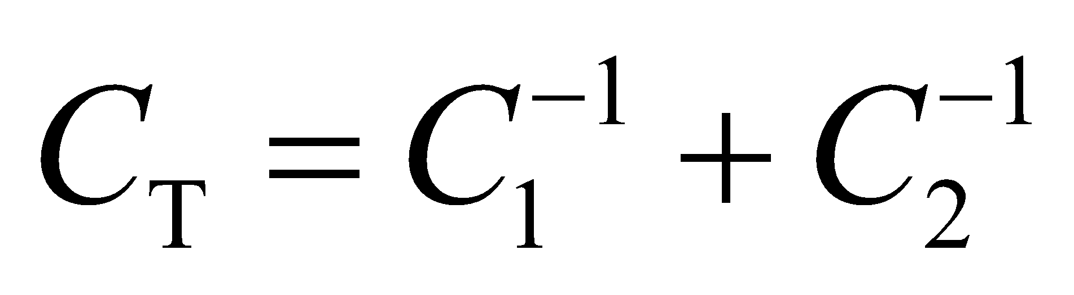).

Thus,

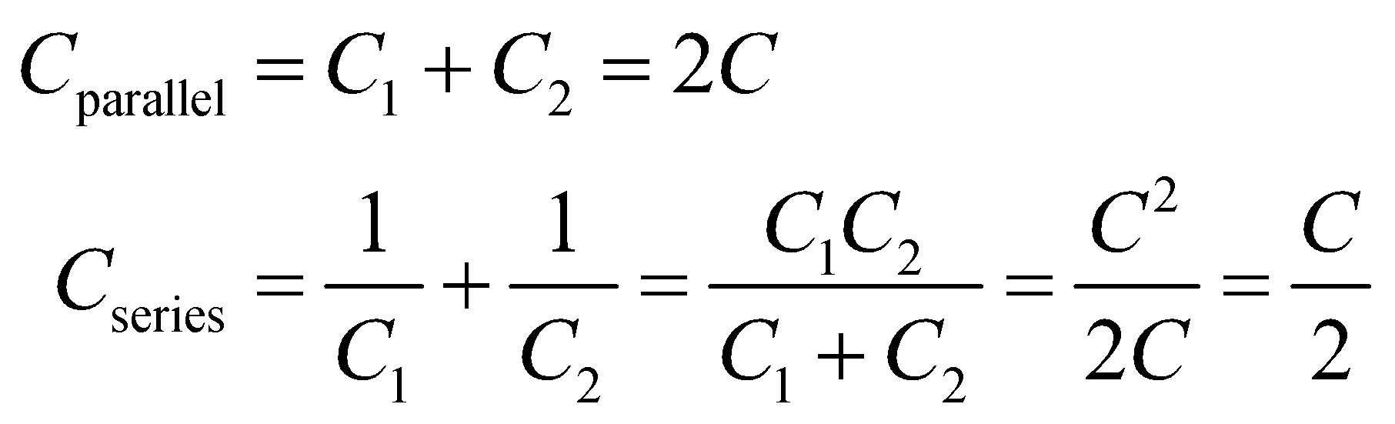

**Evaluate** Thus, for parallel and series combinations of two equal capacitors,

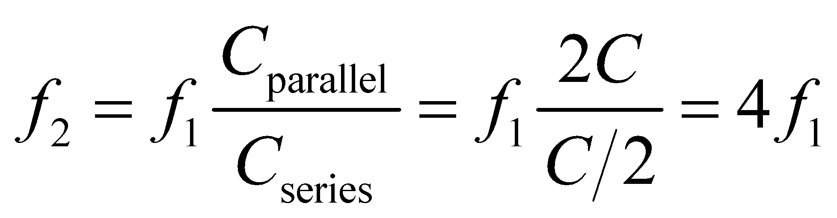

**Assess** Connecting the capacitors in series creates total capacitance four times smaller than connecting them in parallel, so the frequency must be four times higher to have the same reactance.

**67. Interpret** We have two capacitors connected first in series and then in parallel with an AC generator, and we want to know their capacitances given that the current drops from 30 mA to 5.5 mA upon going from parallel to series connections.

**Develop** Equation 28.5 gives the rms current when capacitors are connected to an AC generator,

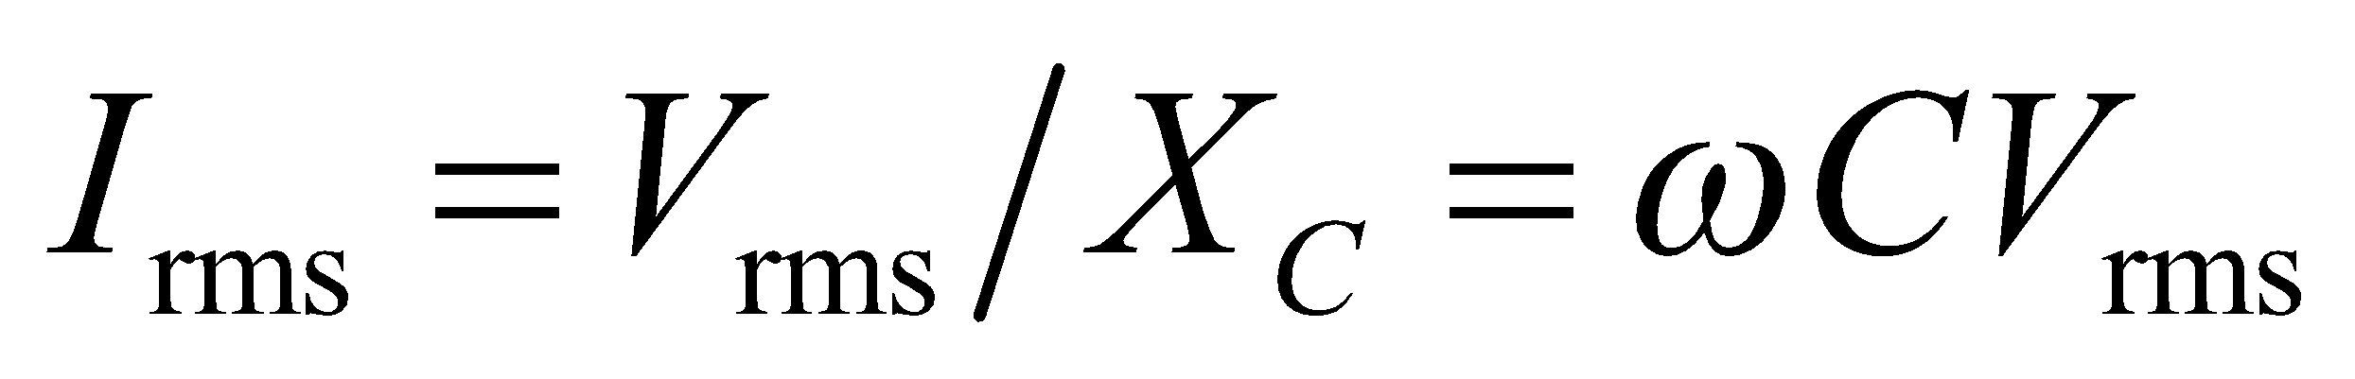

For the parallel connection, 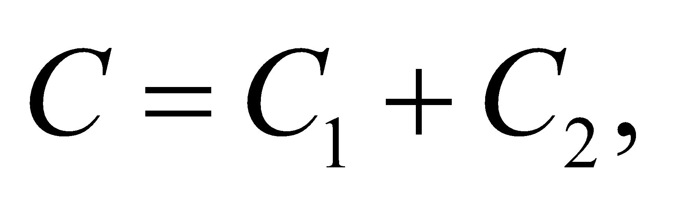(see Chapter 23), so

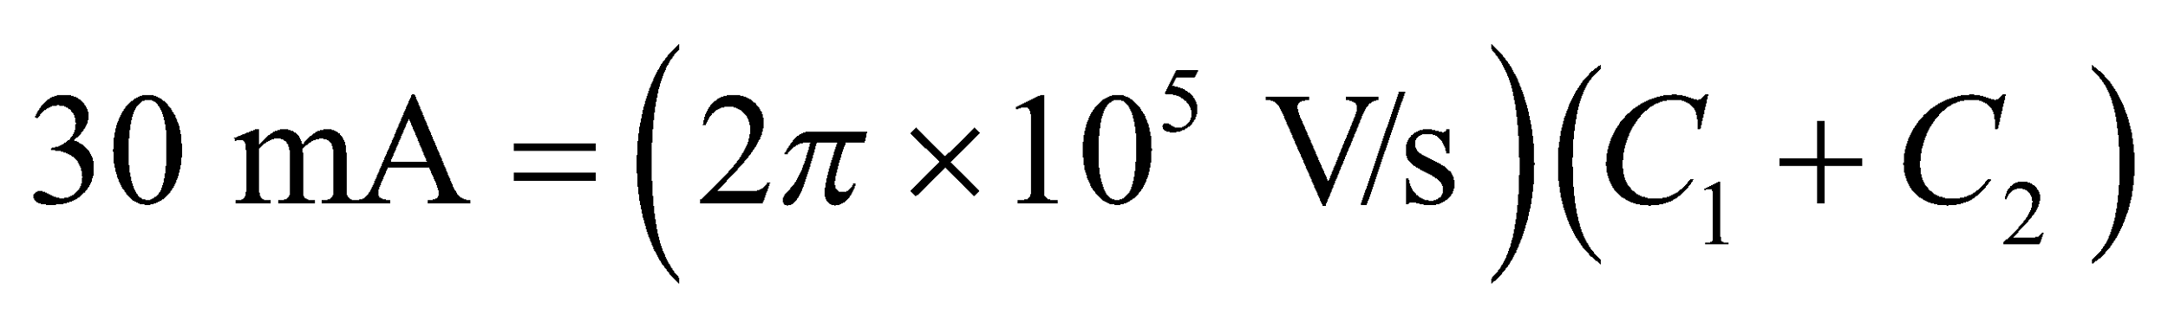

For the series connection, 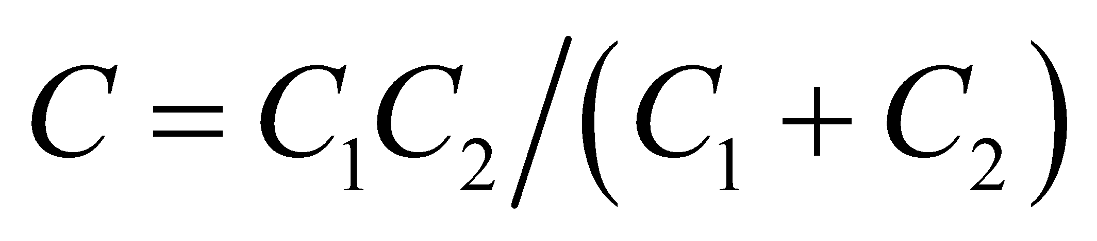, so Equation 28.5 gives

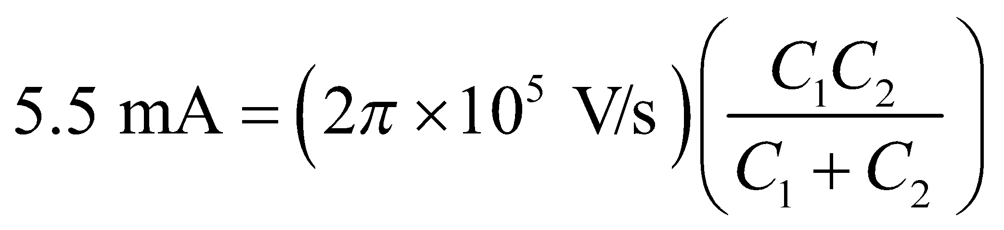

The two equations can be used to solve for *C*1 and *C*2.

**Evaluate** Simplifying the above two equations leads to 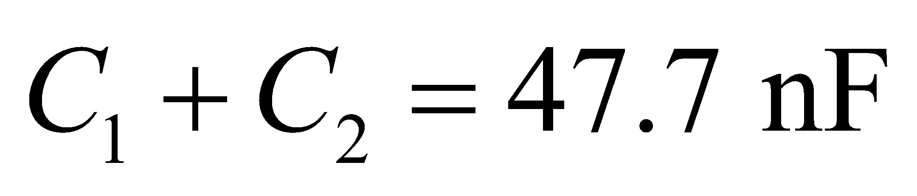 and 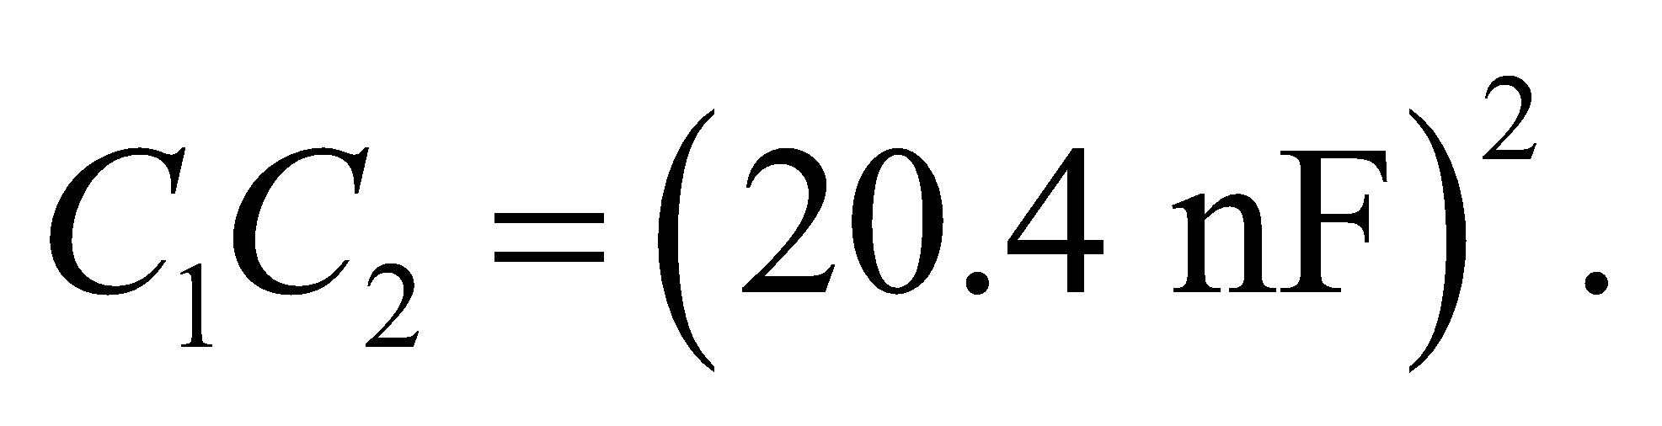 Eliminating *C*1 from the second equation and substituting into the first equation, we obtain the following quadratic equation:

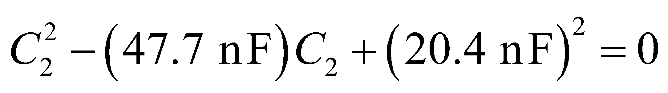

Since the initial two equations are symmetric in *C*1 and *C*2, eliminating *C*2 gives the same equation as the above, but with *C*2 replaced by *C*1. Thus, the solutions for *C*1 and *C*2 are

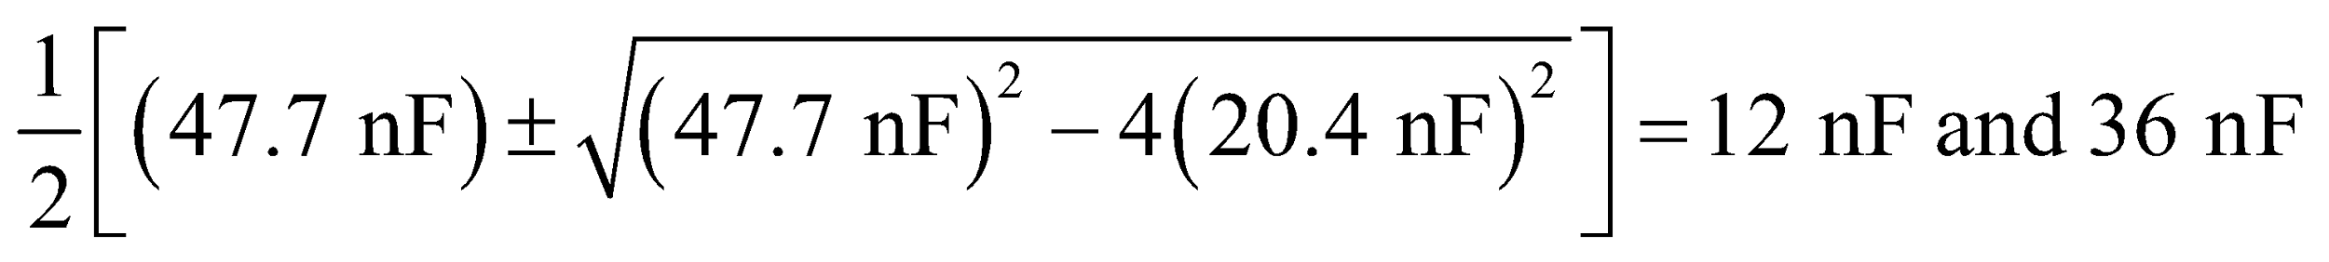

**Assess** The parallel connection yields a greater capacitance, and hence a larger current compared to the series combination. The results are reported to two significant figures, as warranted by the data.

**68.** **Interpret** This problem concerns the time behavior of a simple *LC* circuit.

**Develop**The charge on the capacitor as a function of time is given by Equation 28.9: 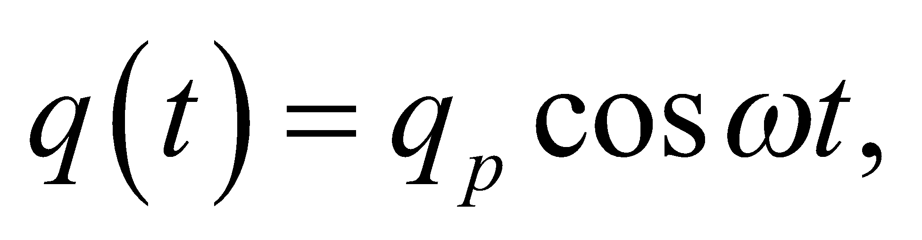 where 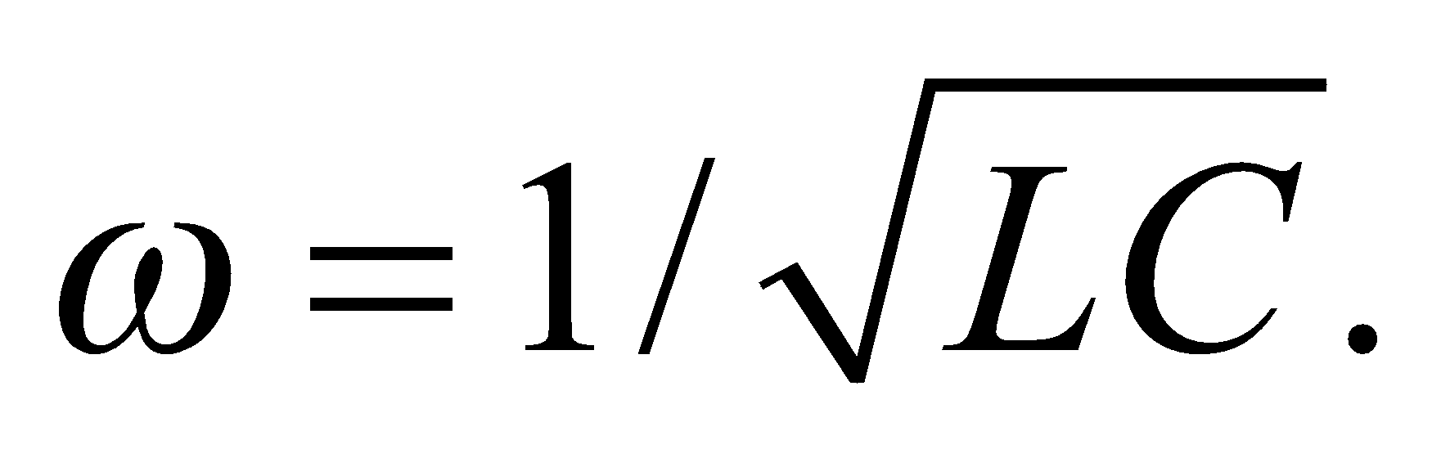 The voltage on the capacitor is the charge divided by the capacitance:

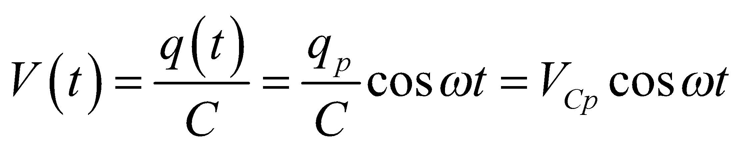

This form of the equation gives the peak voltage at 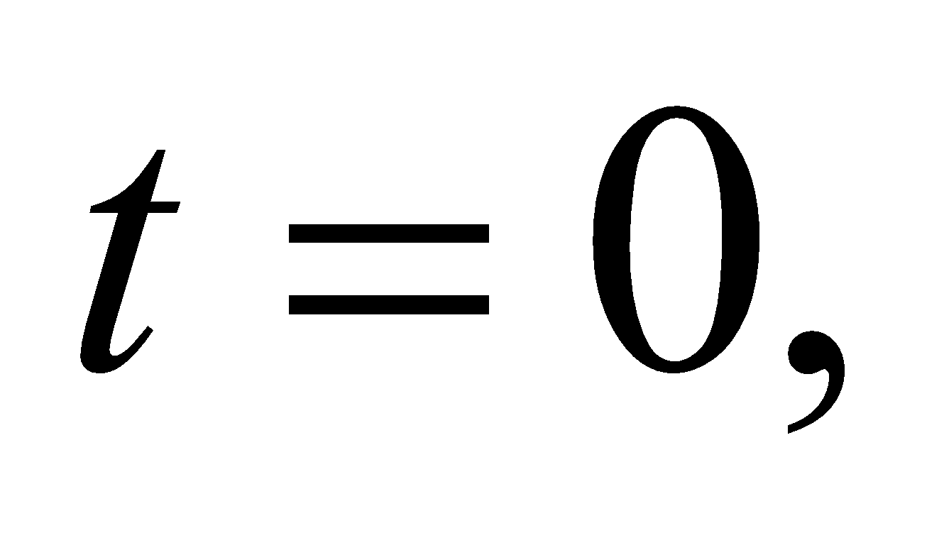 as it should. We can use the capacitor voltage at 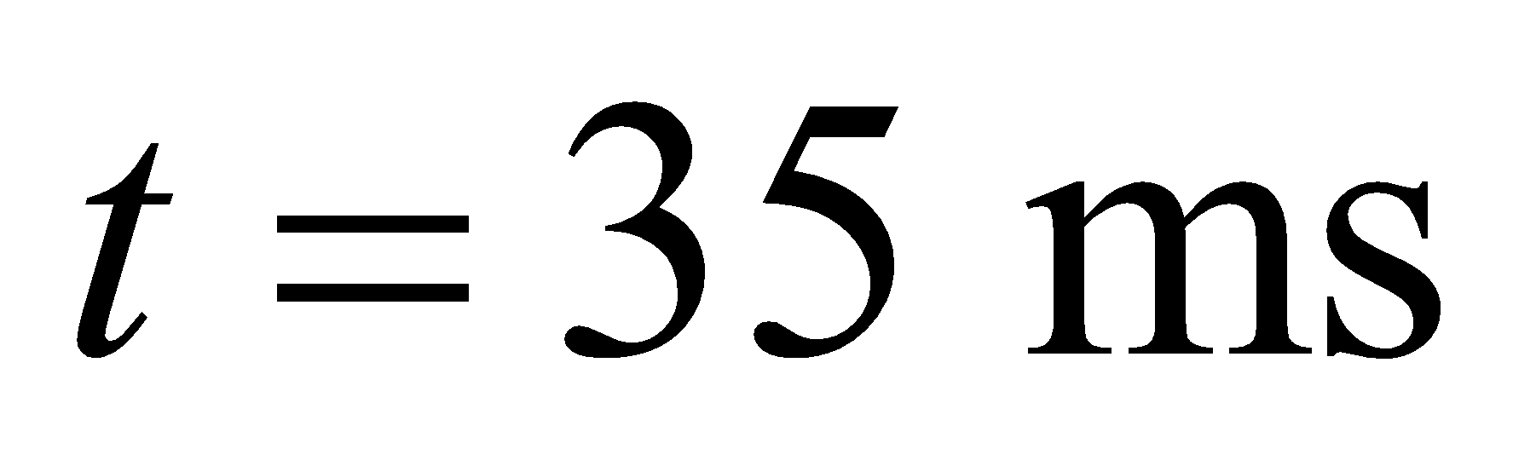 to find the angular frequency, *ω*:

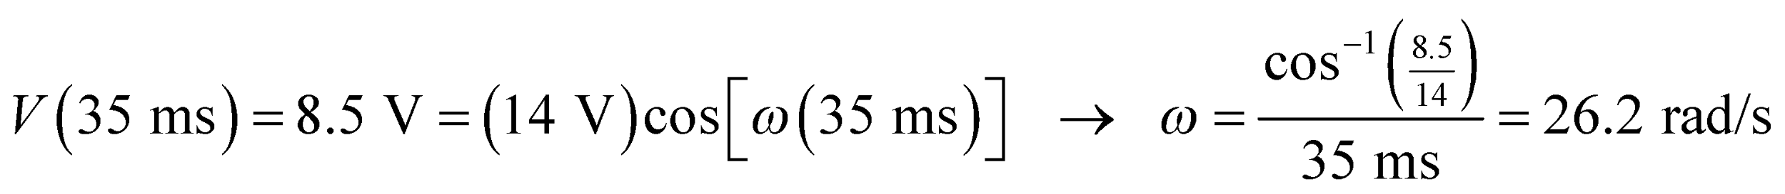

With this information, we will be able to determine the time-dependence of the current in the circuit:

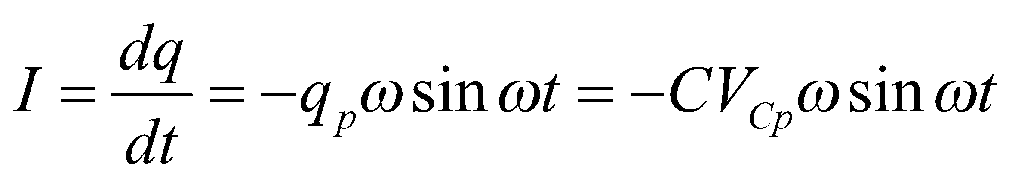

We'll neglect the minus sign here, since we're not concerned with the direction the current flows.

**Evaluate**(a) The peak current is the amplitude in the current equation:

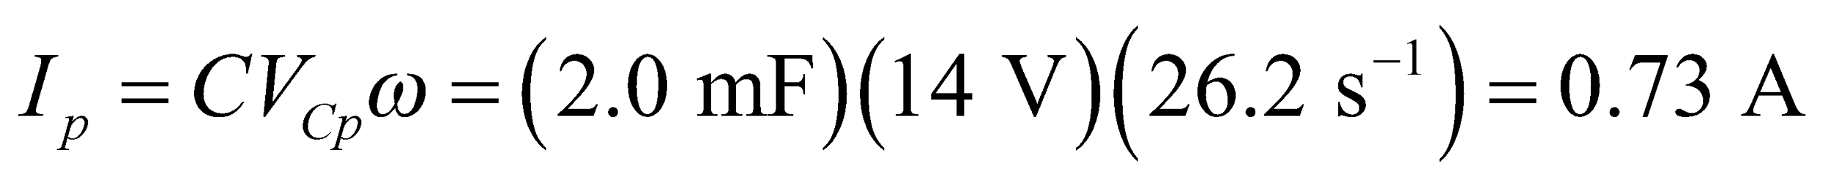

(b) The peak occurs when 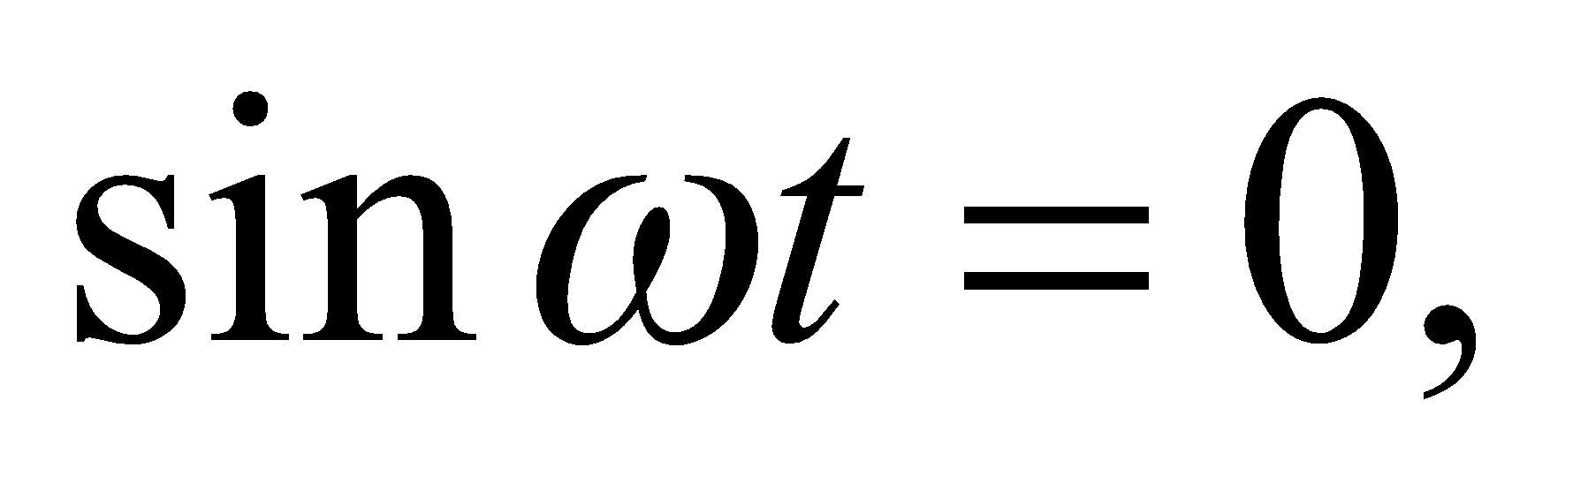or when

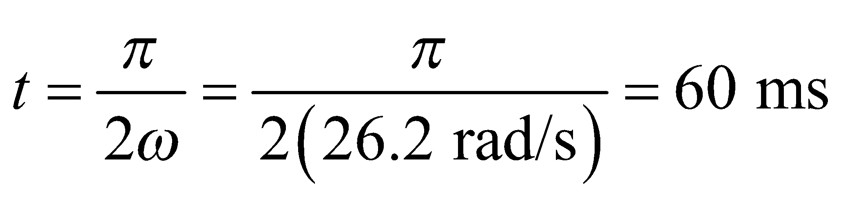

**Assess**These values seem reasonable. Recall that the voltage and the current in an LC circuit are 90° out of phase with each other (see Figure 28.9).

**69. Interpret** This problem involves designing a circuit that gives the desired response to the given input signal.

**Develop** We want the output voltage to lead the input voltage (by 45°). By inspecting Figure 28.16, we notice that the voltage across a resistor leads the voltage across a capacitor with which it is in series. Similarly, the voltage across an inductor leads the voltage across a resistor with which it is in series. Both circuits can be adapted to the criteria of the black box in this problem.

**Evaluate** Case (1): *RC* circuit with an AC input. In this circuit, 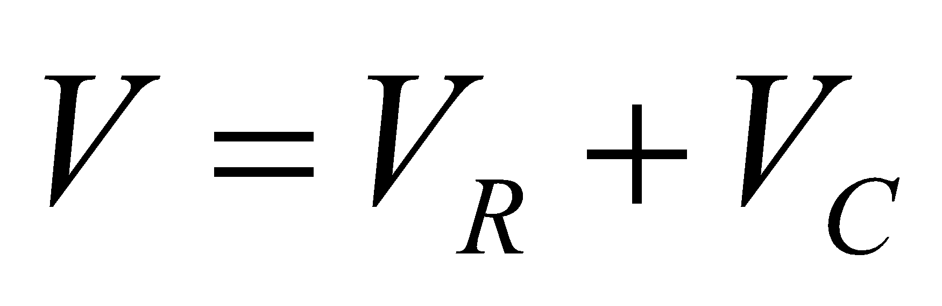 and 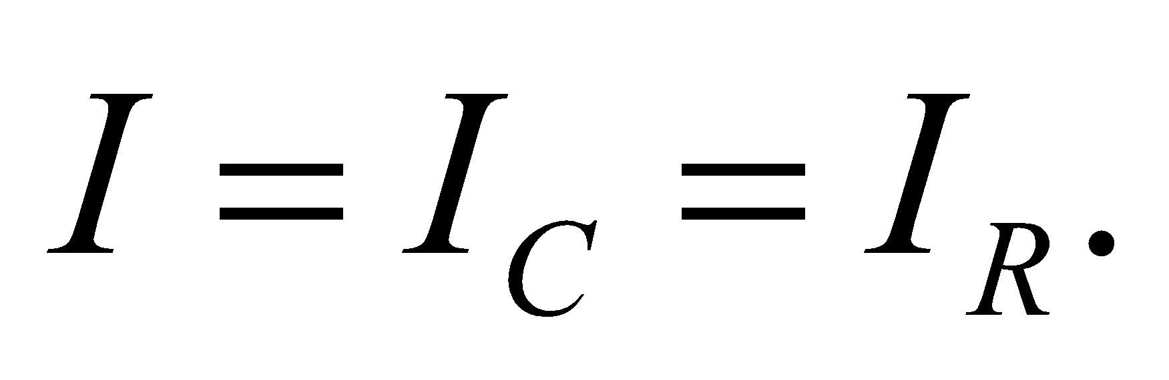 In the corresponding phasor diagram shown below, 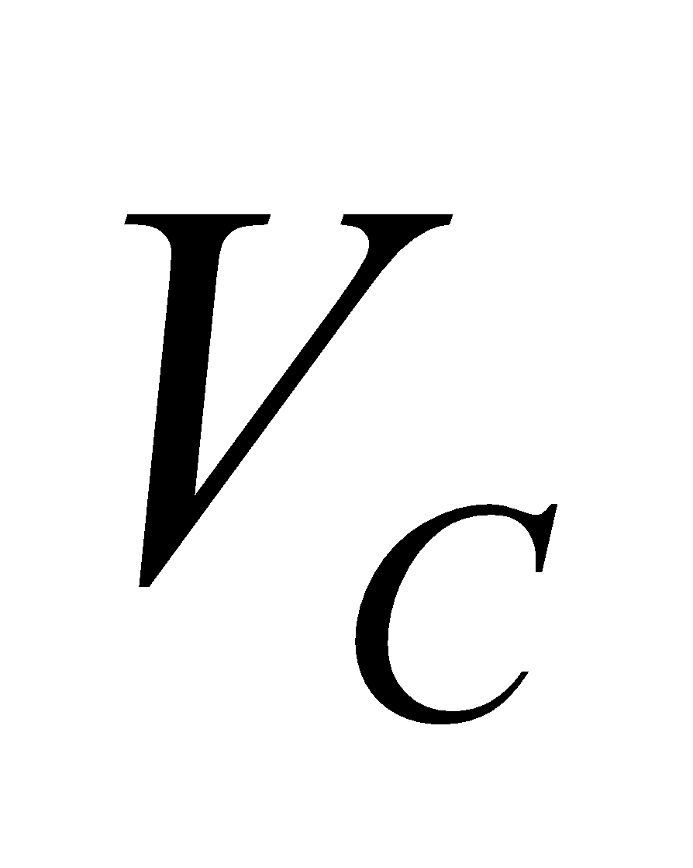 lags *I* by 90°, 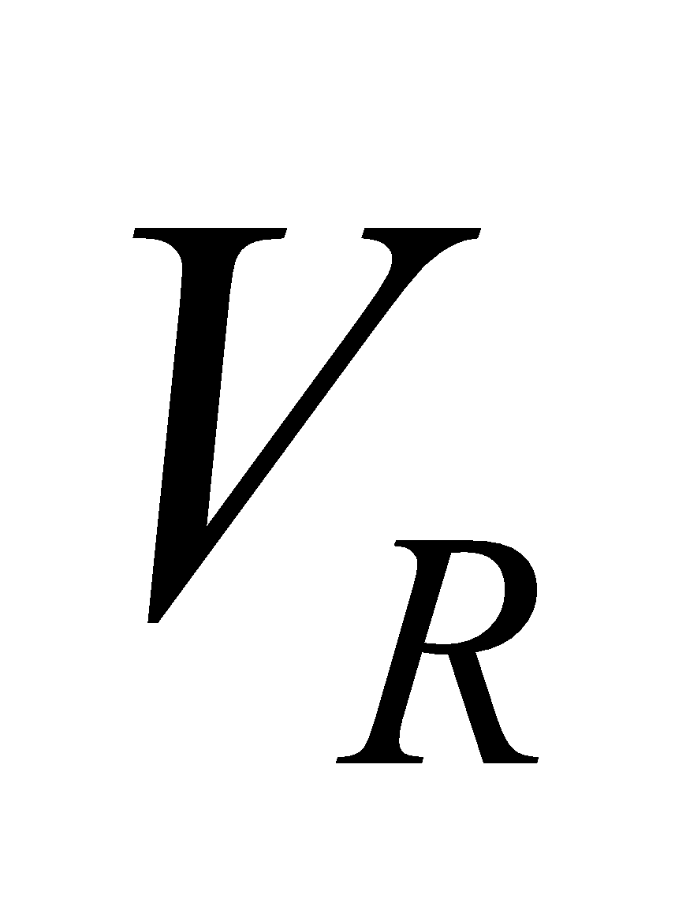 and *I* are in phase, and *V* is the vector sum of these (see Table 28.1). We drew *I* horizontally for convenience in the figure below. The impedance is thus

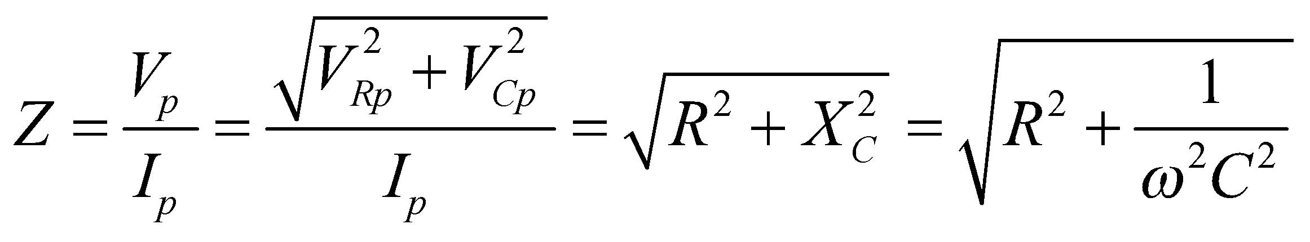

and the phase angle is

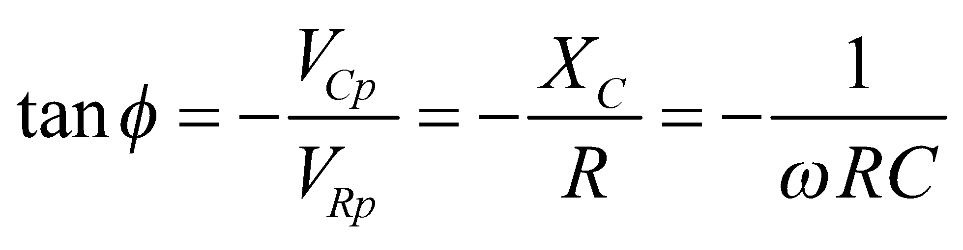



The current *I* always leads *V*, because 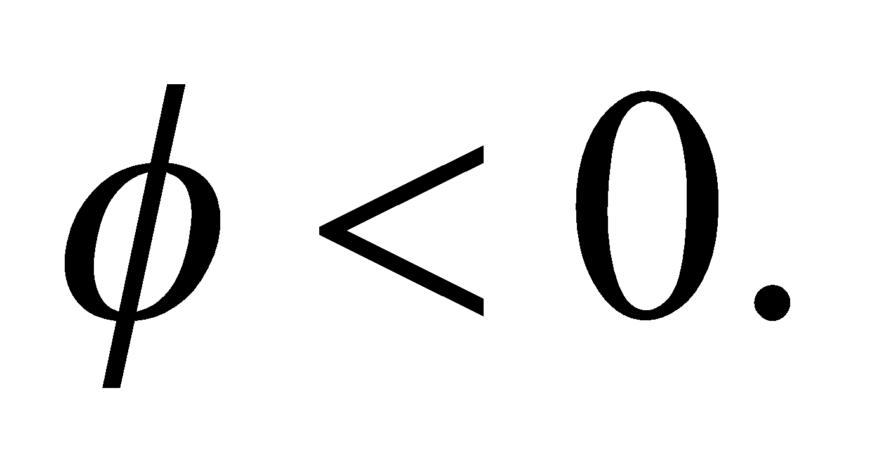 Recall that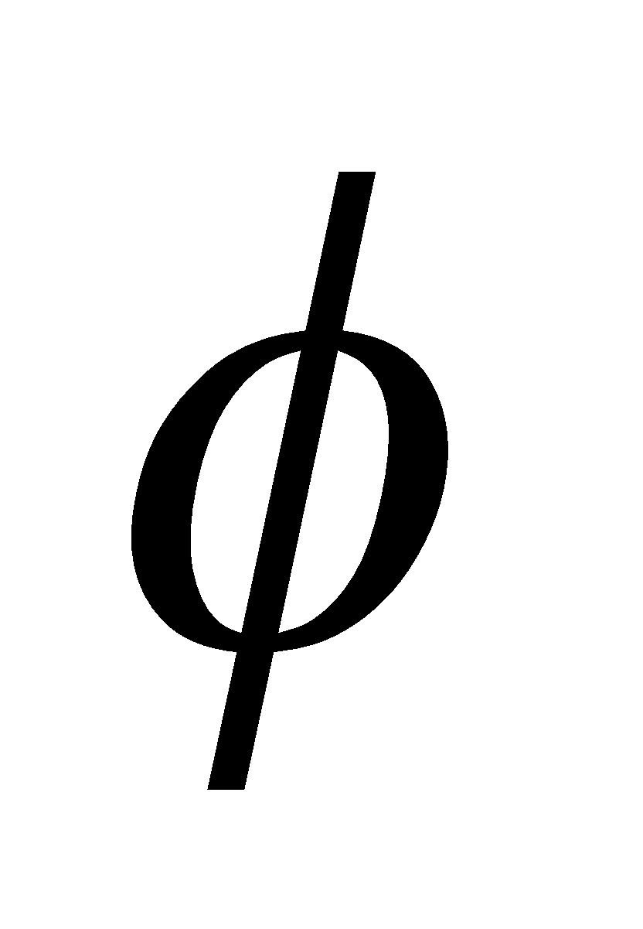is defined by 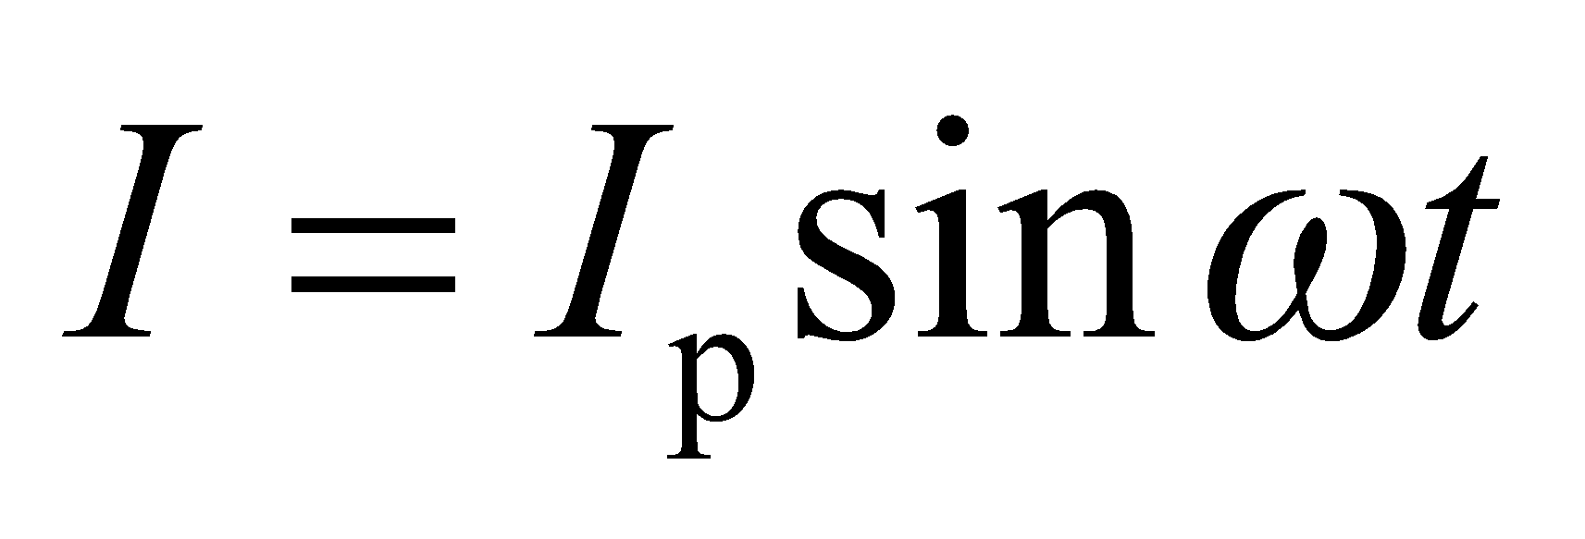 when 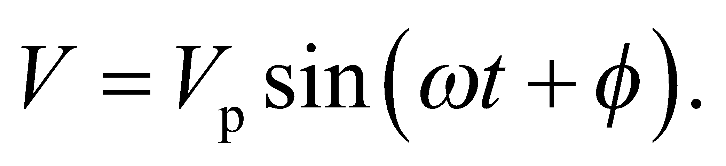

The result implies that, in a series *RC* circuit,  leads the applied voltage, *V* by an angle 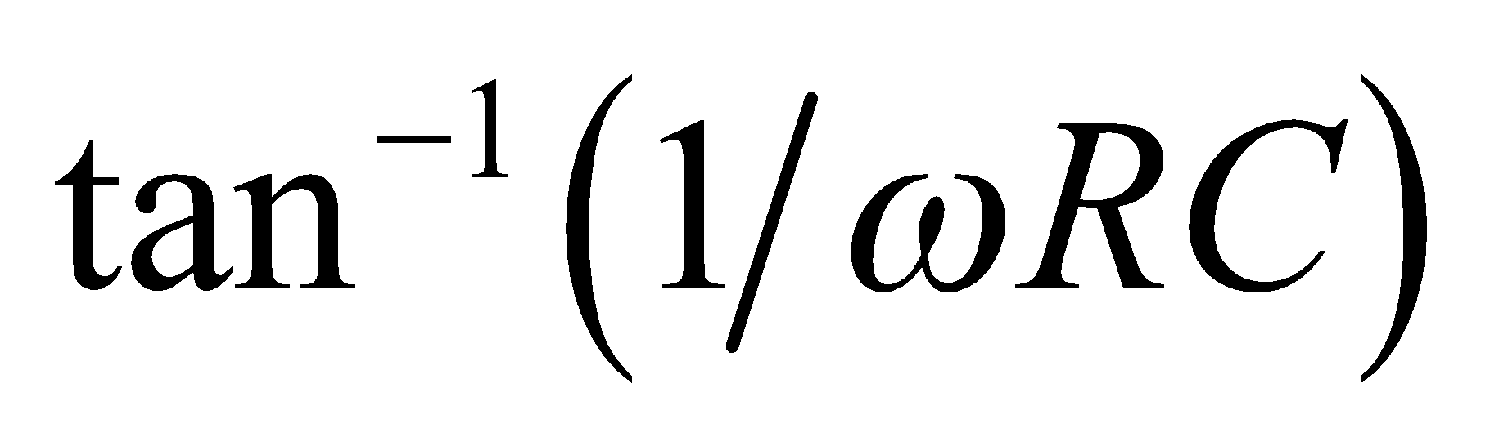, which may be adjusted to 45° if 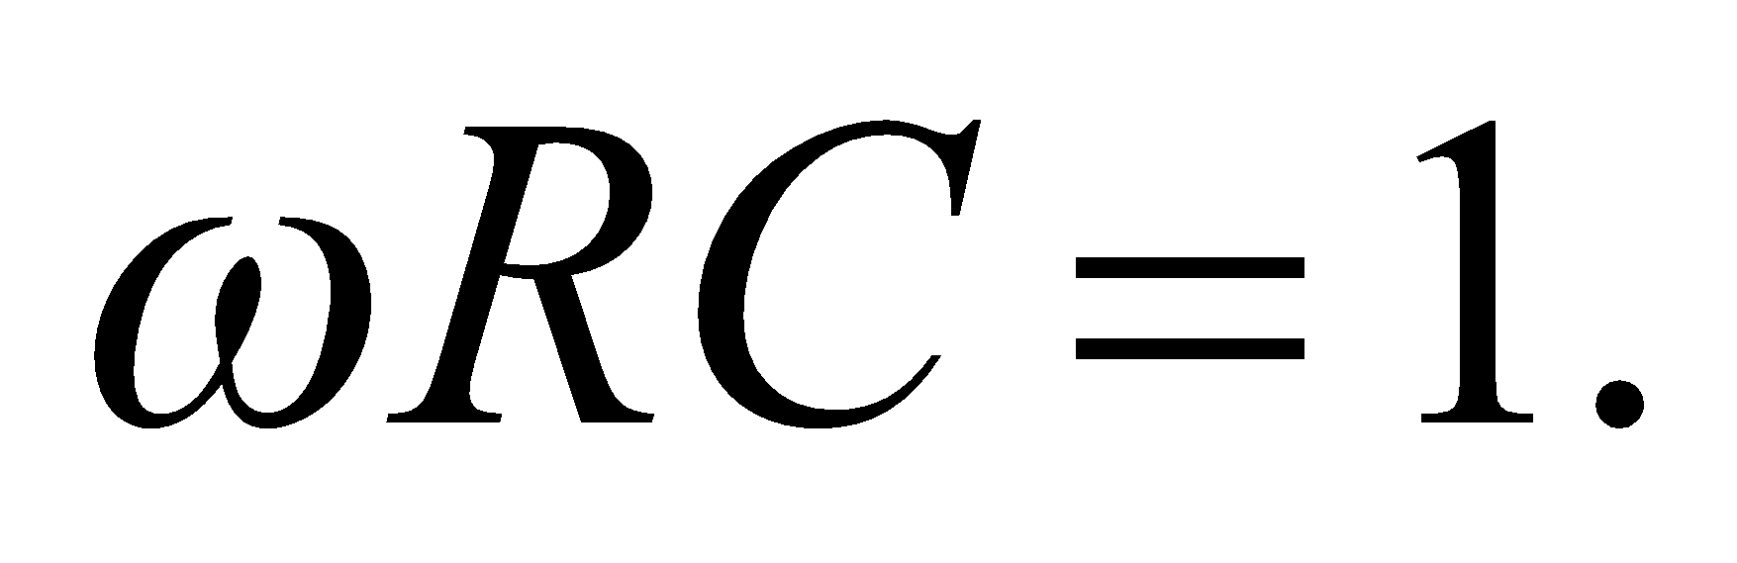 The peak voltage across the entire resistance is 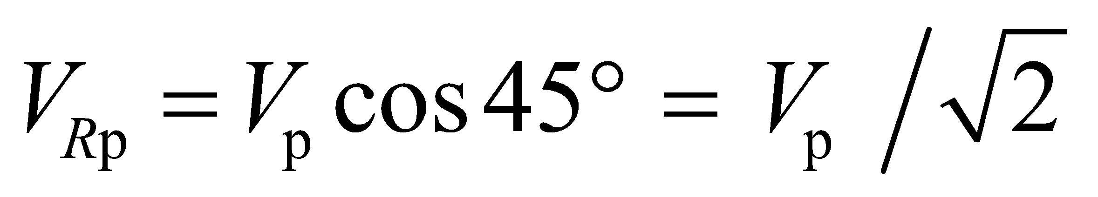, so if we divide the resistance into two parts, 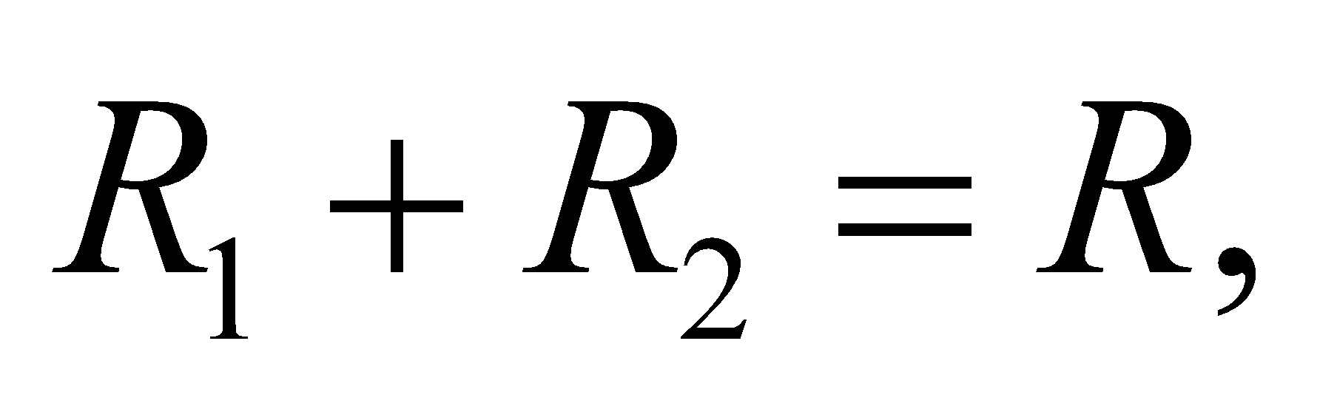 with 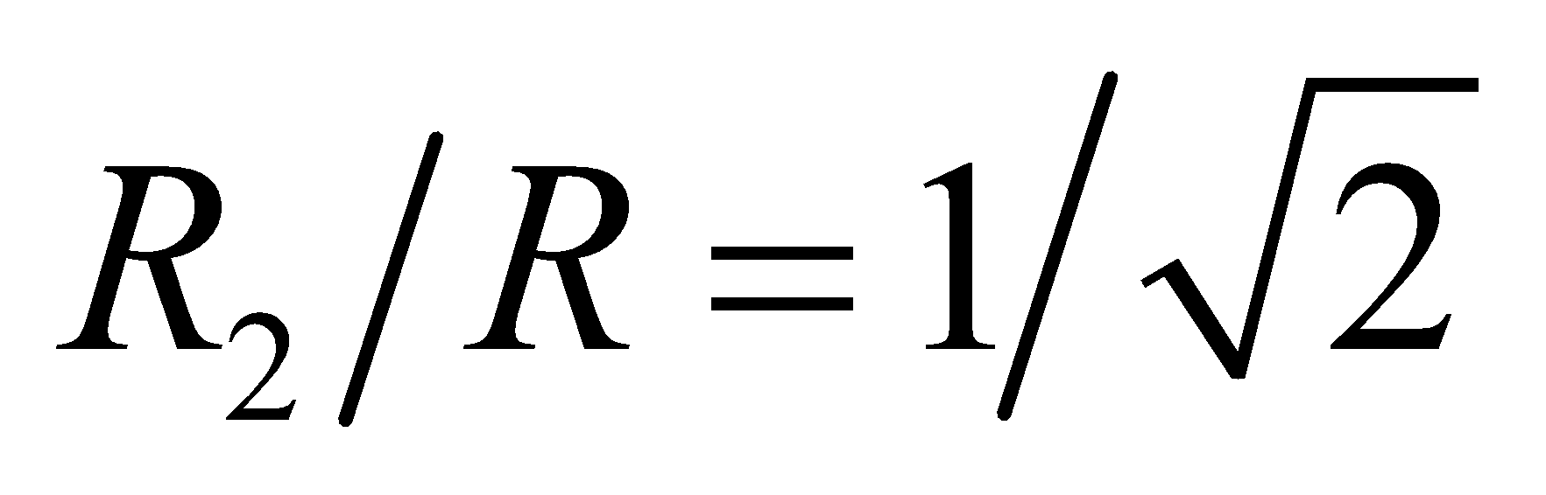, then the peak voltage across 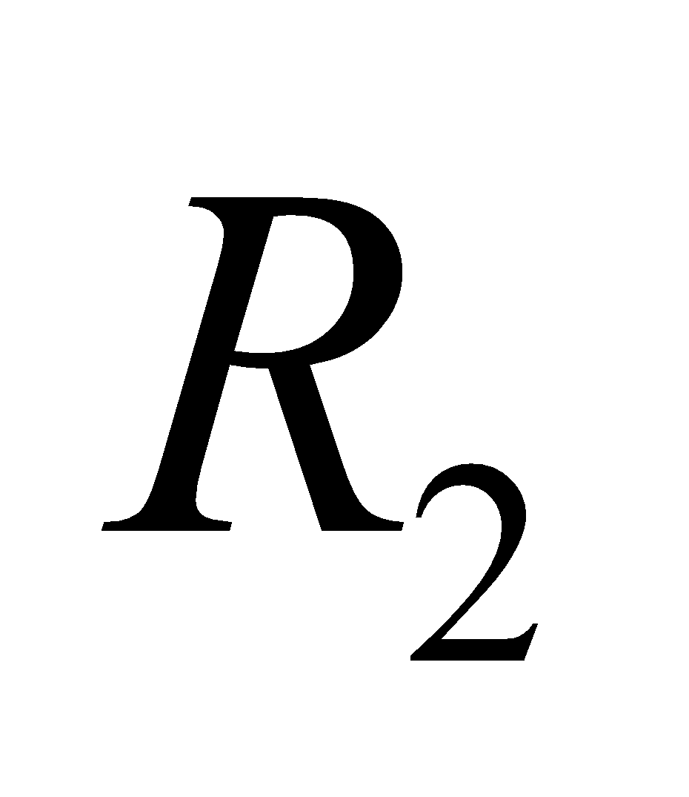 will be 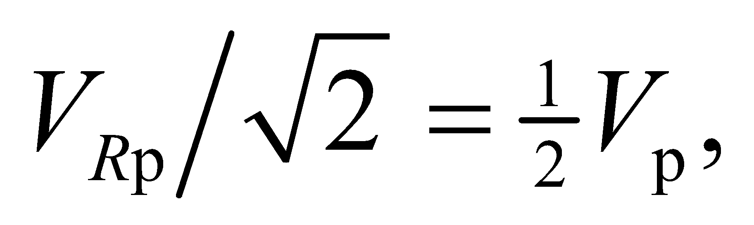 as desired (rms voltages have the same ratio as peak voltages).

Case (2): *RL* circuit with an AC input. When a capacitor is replaced with an inductor, the phasors for  and *I* are still parallel, but 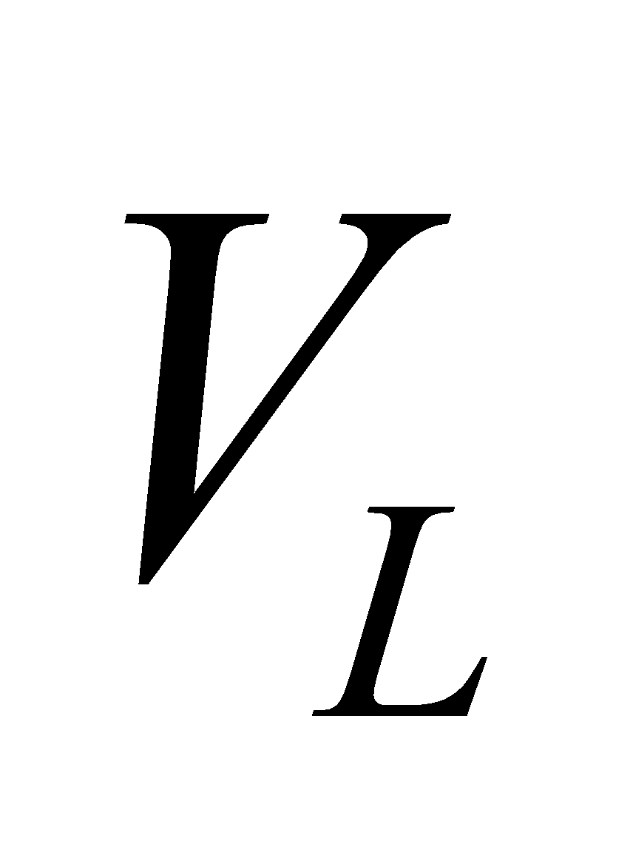 leads *I* by 90°. The voltage *V* is the vector sum of  and 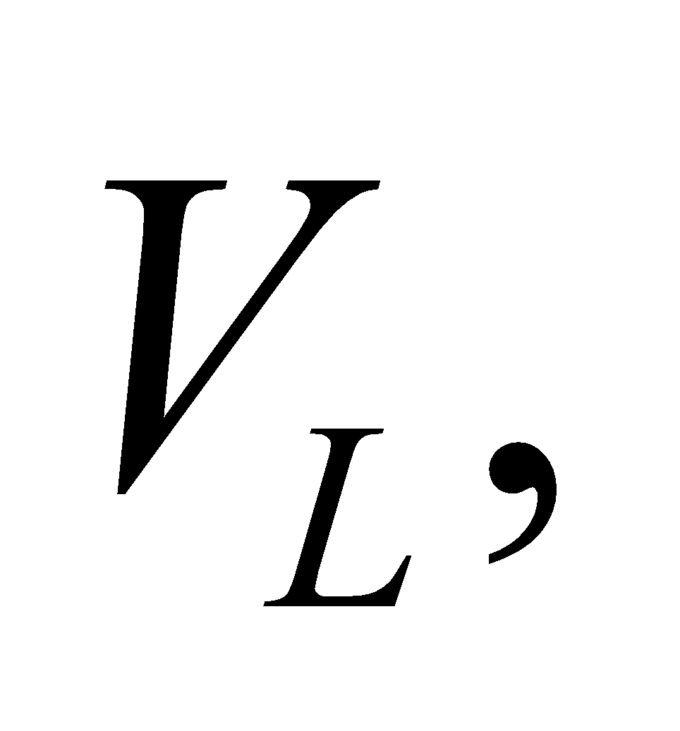 so the impedance is

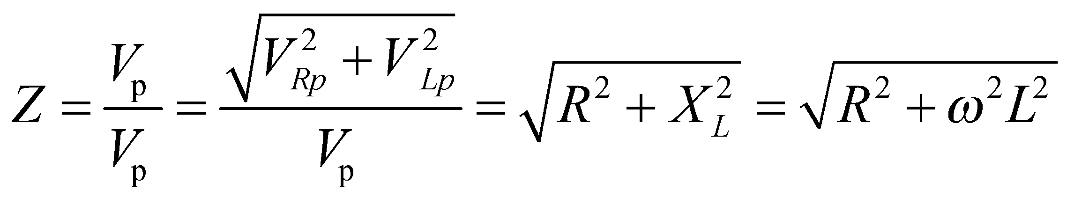

and the phase angle is

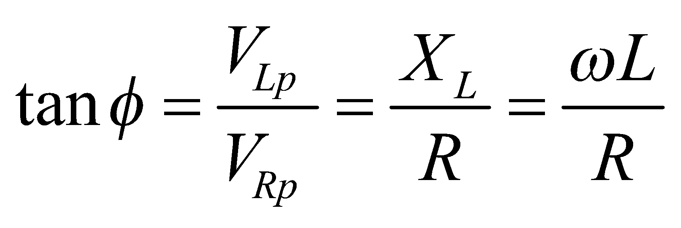



In this case, *I* always lags *V*, because *φ* > 0 Negative *φ* is in the same sense as; measured from *V*.

In a series *RL* circuit,leads *V* by 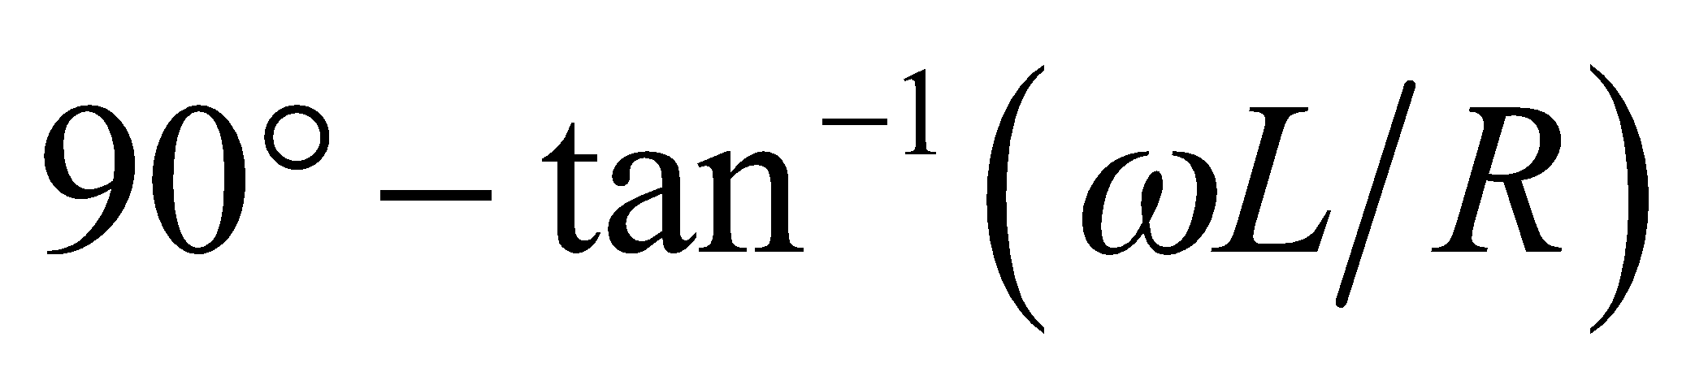 which equals 45° if 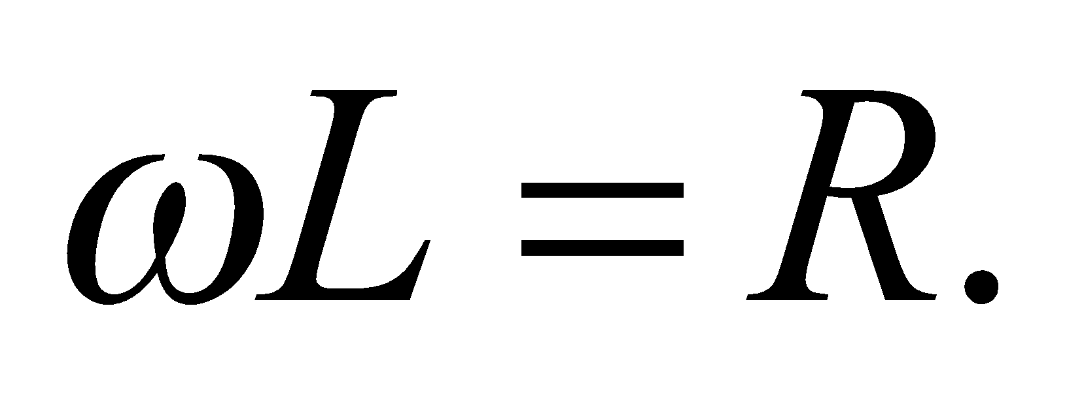 Again, , so if we divide *L* into 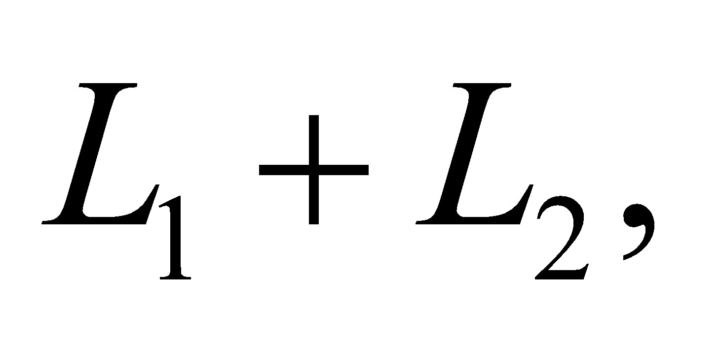 with 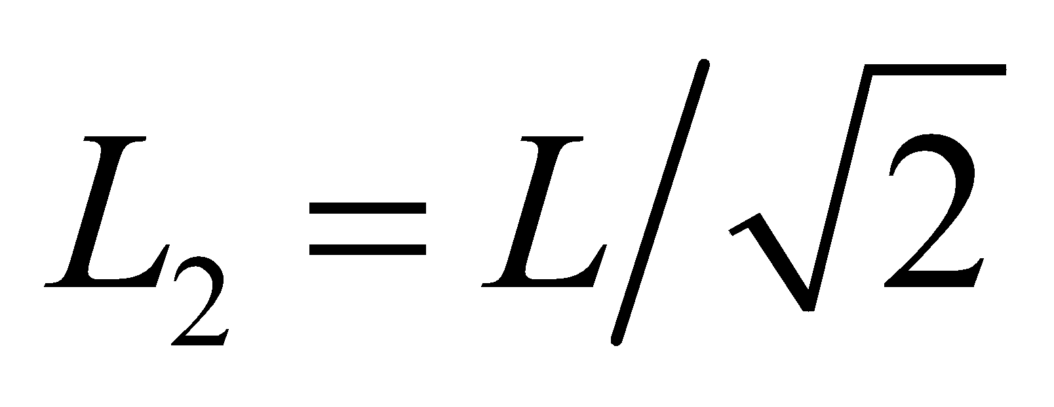, the peak voltage across 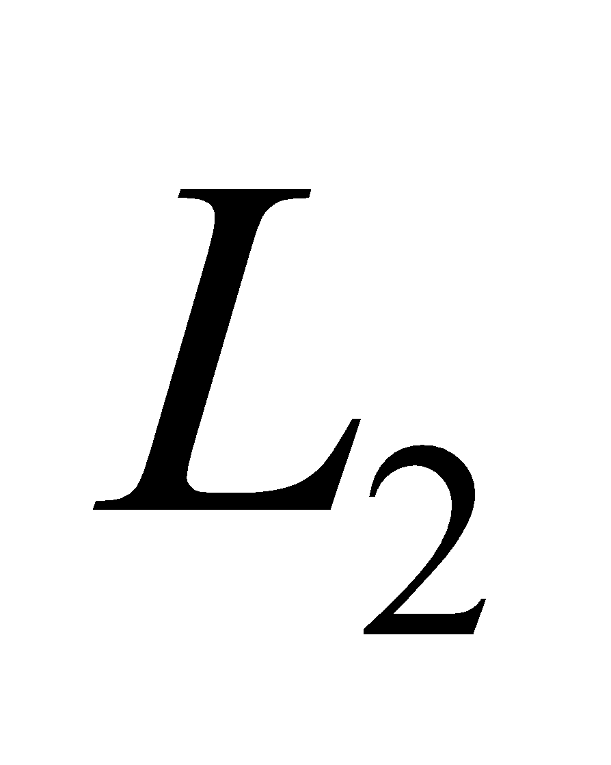 is 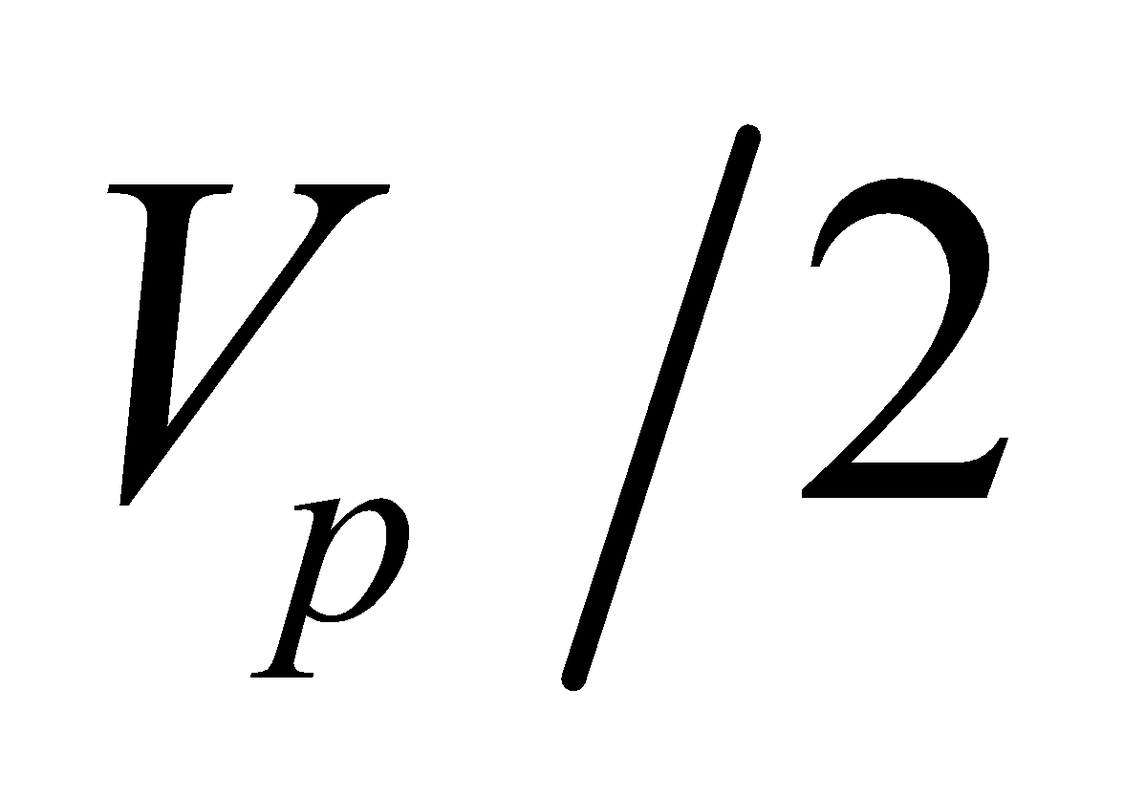. Both circuits are sketched below.



**Assess** We have shown how the circuit can be designed in two different ways to adapt to the criteria of the black box. Our circuit conditions can be verified explicitly. Note that 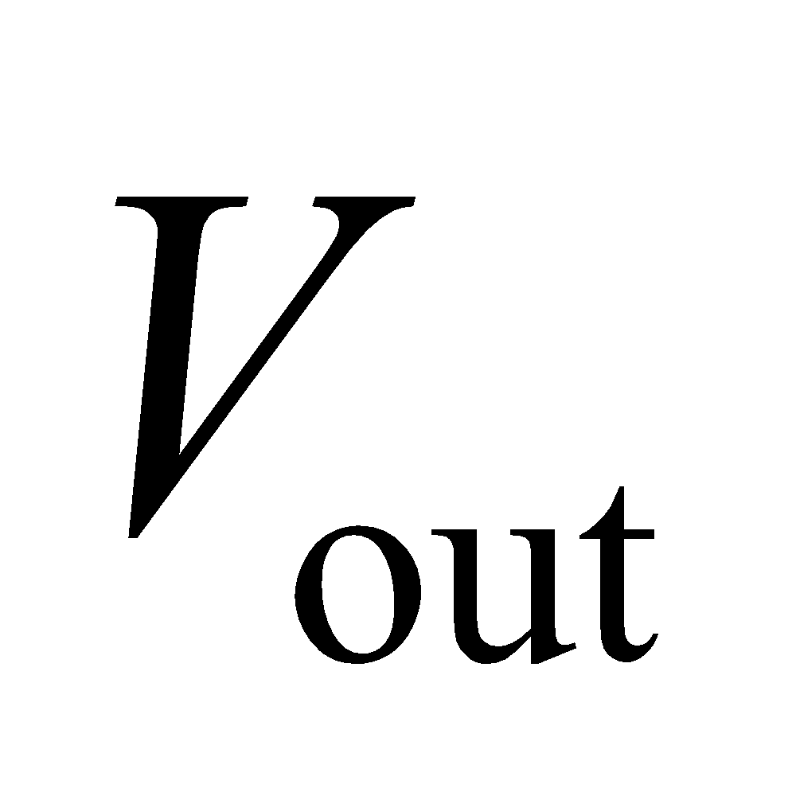 is the open-circuit output voltage. If a

load is connected across the output terminals, the magnitude and the phase of the voltage will be changed accordingly.

**70.** **Interpret** We're asked to find the range of frequencies at which the current in an RLC circuit is half of the maximum current at resonance.

**Develop**The peak current in general is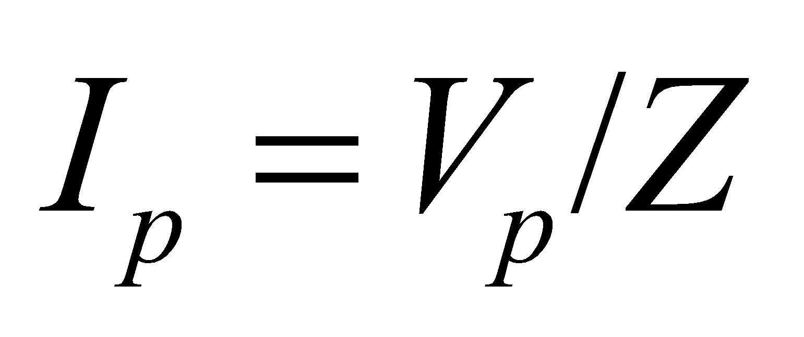 (Equation 28.12), while at resonance, 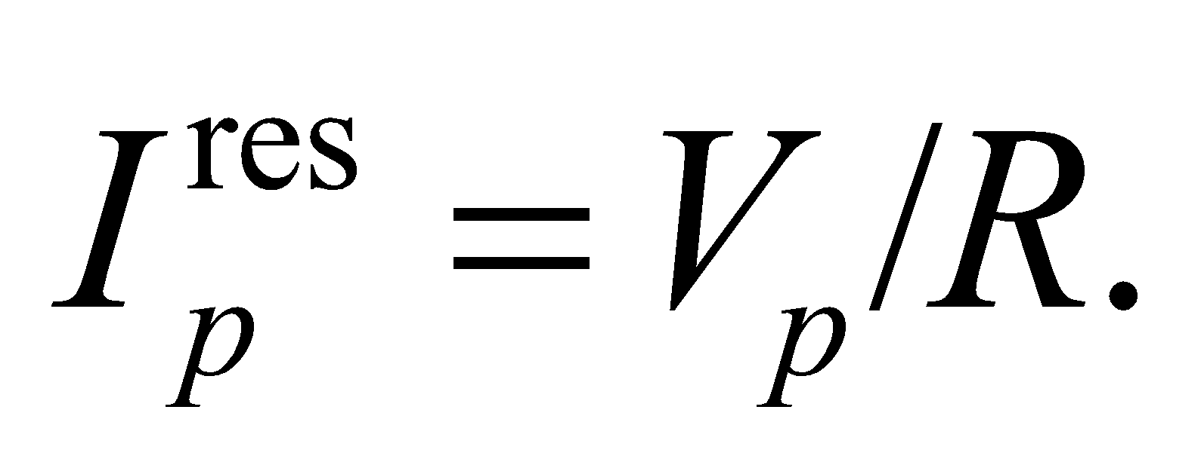 Therefore, 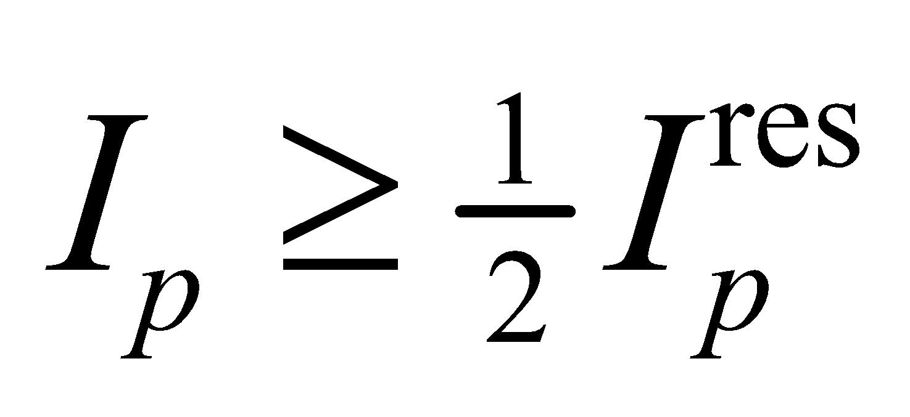 implies 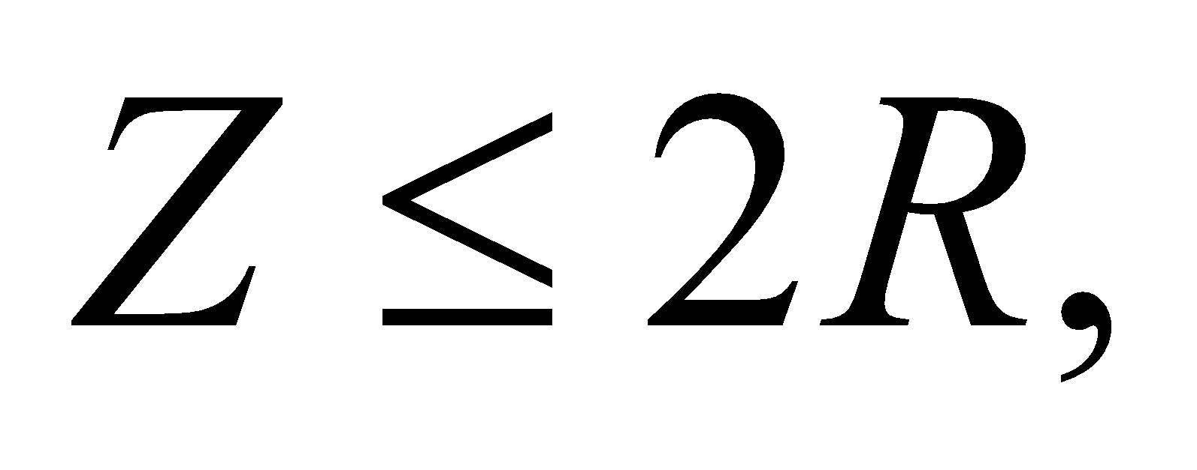 which reduces to

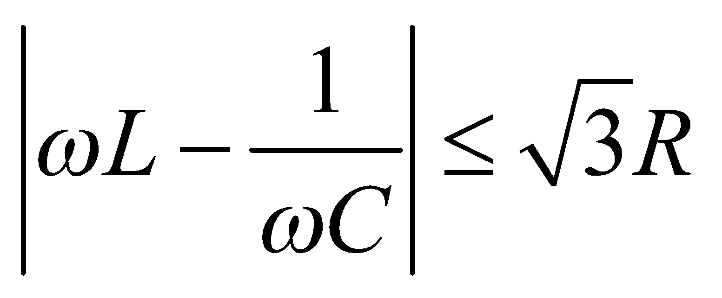

The maximum frequency in this range occurs when the left-hand side of the inequality equals 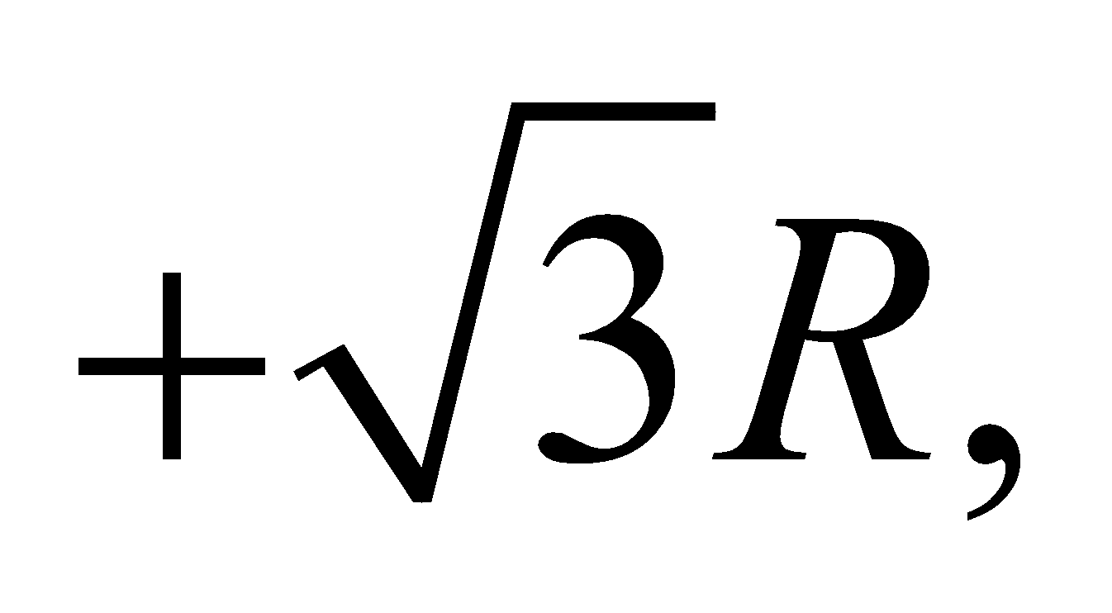 whereas the minimum frequency occurs when the left-hand side of the inequality equals 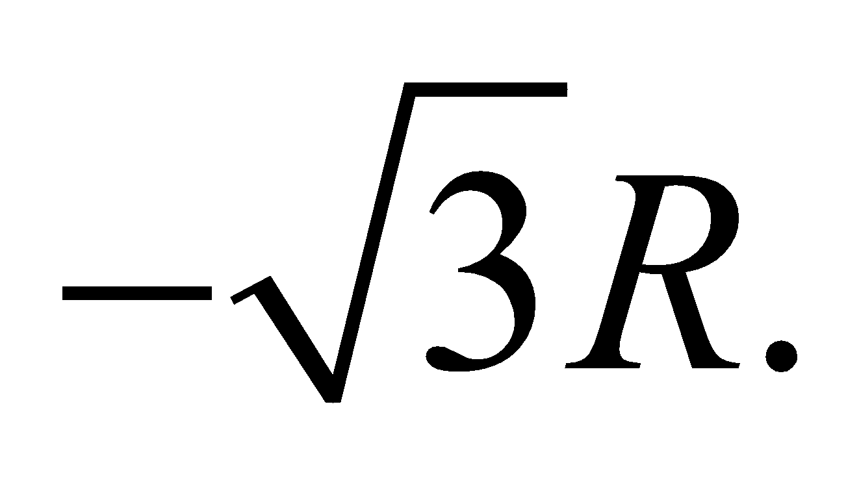

**Evaluate**We can solve for both the maximum and minimum frequencies at the same time by solving for the roots of the equation

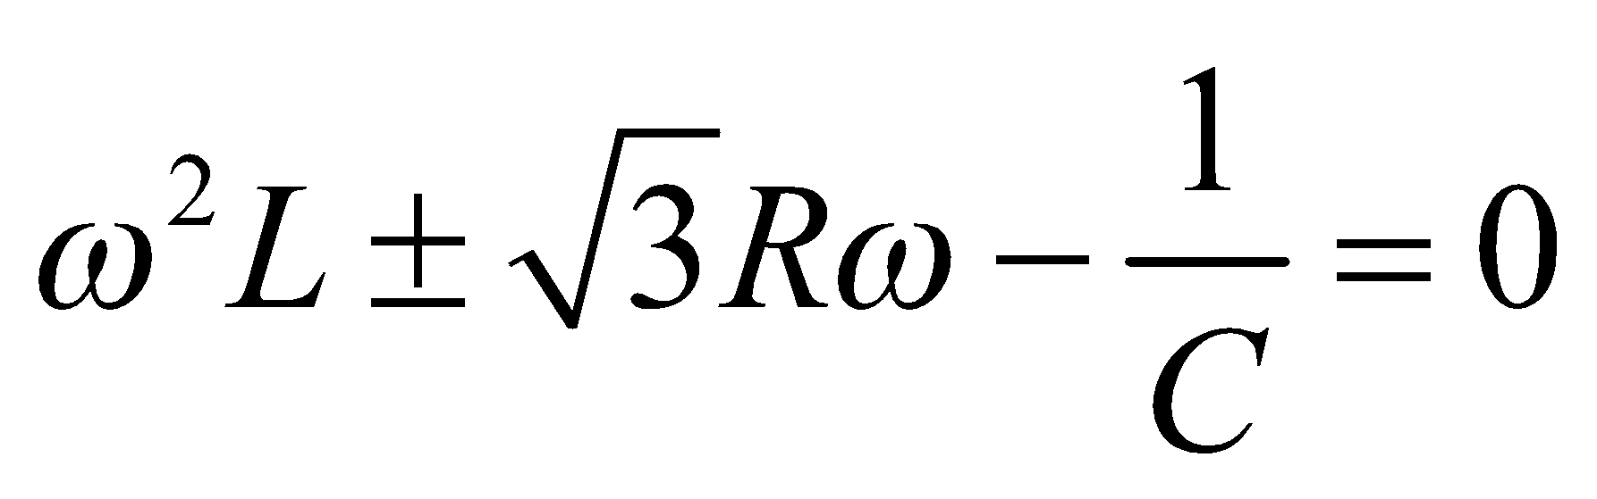

Using the quadratic formula, we have



Since the frequency is inherently positive, we'll disregard the two negative solutions to the above equation. Notice that the last term in the square root is the resonant frequency squared, and the repeated term is inversely proportional to the decay time constant in Equation 28.11:



Using these values, the maximum and minimum frequencies are



**Assess**In terms of frequency, *f*, the range is 135 to 190 Hz. Notice that the peak in the current is not symmetric around the resonance, since 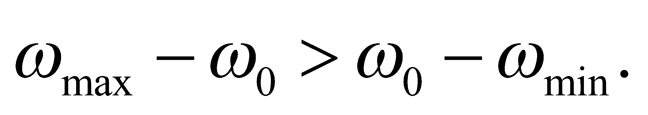

**71. Interpret** This problem involves a series *RLC* circuit for which we are given the current at resonance and at half the resonant frequency. We are asked to find the resistance, the inductance, and the capacitance.

**Develop** At resonance, the impedance is *Z* = *R* and the current is  and 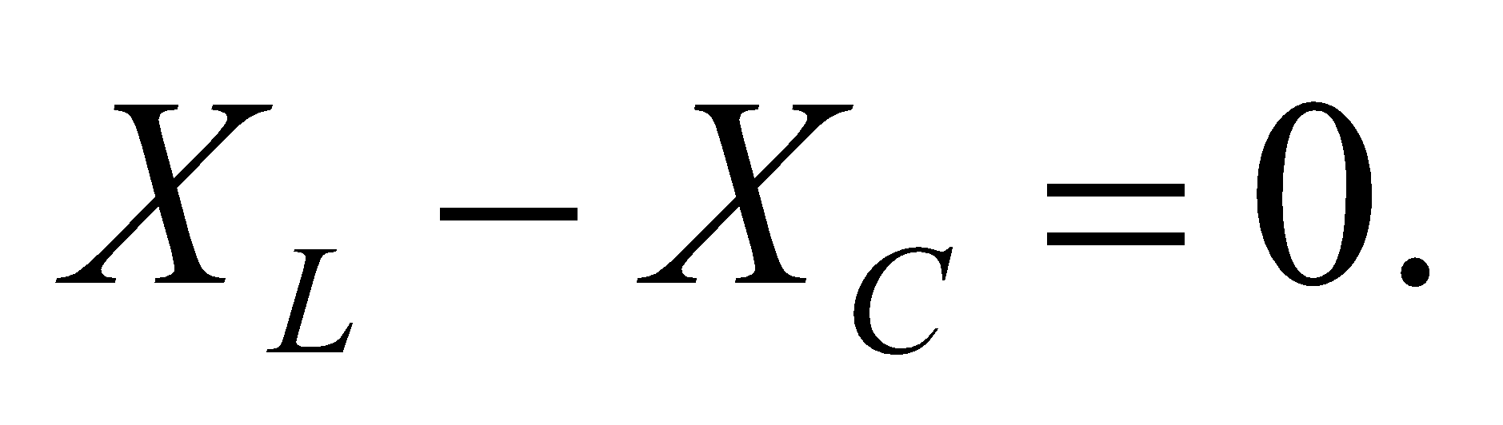 Away from resonance,  and 

**Evaluate** The resonance condition gives



On the other hand, at half the resonant frequency,  the impedance is



which gives



With  and , we obtain the following conditions:



These equations can be solved for *C* and *L*, with the following result:



**Assess** Below resonance, capacitive reactance dominates, with 

**72.** **Interpret** This problem involves using a phasor diagram to derive the impedance of the given *RLC* circuit.

**Develop** In the parallel *RLC* circuit, the currents in each element add to give the total current, so we apply phasor currents to the mode law, . As illustrated in the phasor diagram below,  is in phase with *V* (which is the same across each element, i.e.,  leads *V* by 90°, and  lags *V* by 90°. The peak values are 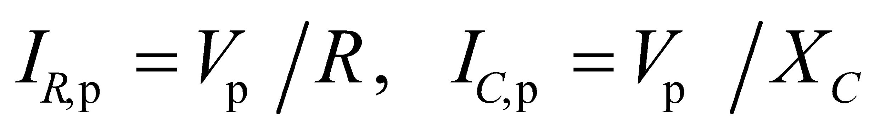 and  The peak total current is 



**Evaluate** The Pythagorean theorem applied to the phasor diagram gives



or



**Assess** The phasor diagram facilitates the analysis of this circuit.

**73. Interpret** In this problem we are asked to derive the *Q* factor of an *RLC* circuit that satisfies the criteria given in the problem statement.

**Develop** To derive the expression for *Q*, we first need to know the power in the circuit. From Equations 28.12 and 28.14 (with rms values), and



from Figure 28.16, the average power in a series *RLC* circuit can be written as



The above expression shows the power falls to half its resonance value  when  or when 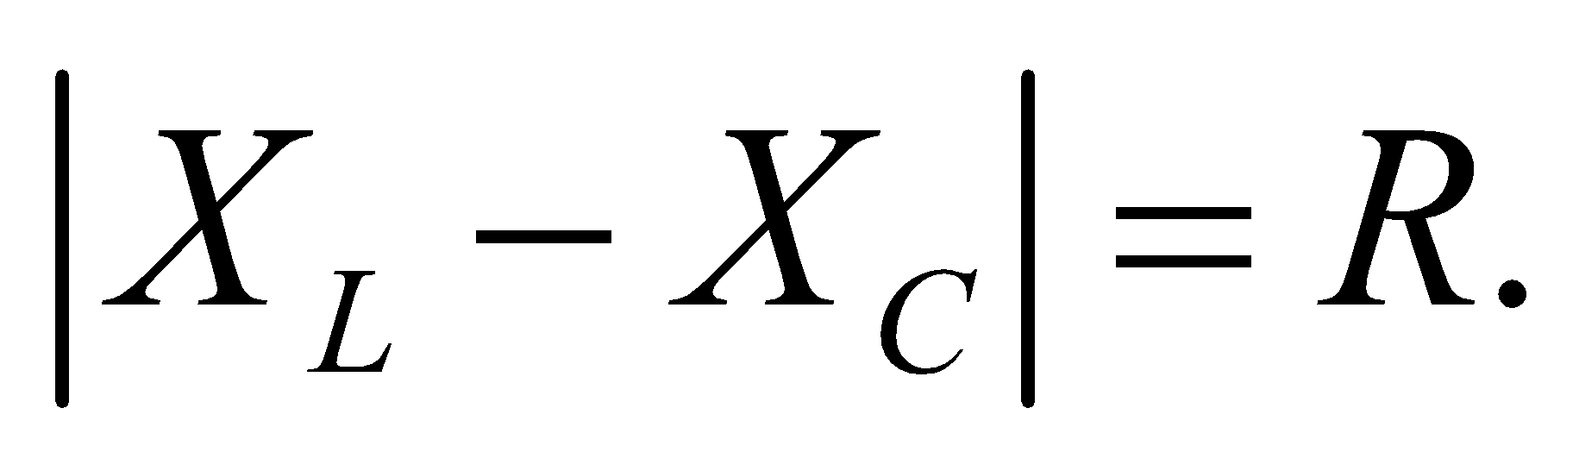 In terms of the resonant frequency  this condition becomes



The solutions of these quadratics, with  are



The *Q* factor is then equal to , where 

**Evaluate** If  (or ), we can neglect the first term under the square root sign compared to the second, which gives  The difference between these two values of *ω* is  from which we obtain 

**Assess** The *Q* factor measures the “quality” of oscillation. The smaller the resistance, the higher the *Q*-factor. In the absence of resistance  the *LC* circuit can oscillate indefinitely.

**74.** **Interpret** We want the rms voltage for a triangle wave.

**Develop**We draw the corresponding triangle wave in the figure below. For simplicity, we've chosen to make the graph symmetric around the  axis. Each cycle takes the time of one period, *T*.



The voltage change over half a period is so the slope of the line alternates between  and  We can characterize the cycle centered at the origin by



**Evaluate**To find the rms value, we square the voltage and take the average over one period:



Taking the square root gives  as was expected.

**Assess**One can certainly simplify the calculation by just doing half a cycle, since the triangle wave is symmetric around its midpoint.

**75. Interpret** We are to use the equation for charge on a capacitor in an *RLC* circuit and the differential equation for an *RLC* circuit from Kirchhoff’s laws to find an expression for *ω*.

**Develop** The given equations are 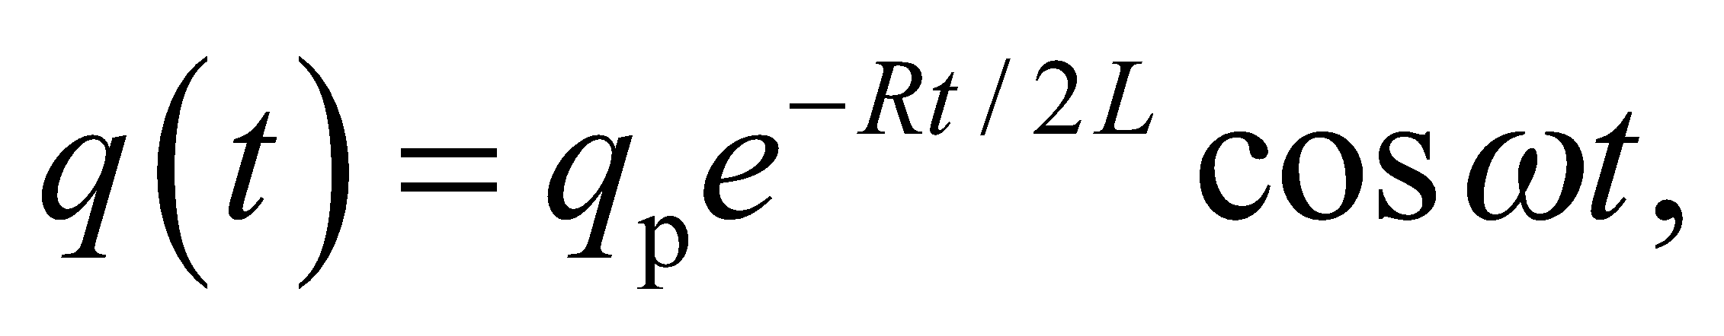 and  We take the derivatives of *q*, substitute it into the differential equation, and solve the resulting equation for *ω*.

**Evaluate**We first calculate the derivatives of *q*(*t*):



Substituting these into the differential equation gives us, after some algebraic steps,



For this equation to be true for all values of *t*, the term in parentheses must be zero.



**Assess** This reduces to  if *R* = 0.

**76. Interpret** We are to find the frequency at which the voltage across a capacitor is maximized, and also the value of that maximum voltage. We shall use both the impedance of the *RLC* circuit and the impedance of the capacitor alone.

**Develop** We are given, in Example 28.4, the component values 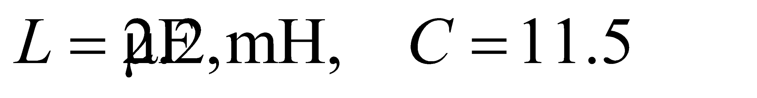 and . The peak voltage is  The peak voltage across the capacitor will be  where  and  We want to find the maximum value of  and the frequency at which it occurs.

**Evaluate**



so we set the derivative equal to zero and solve for *ω*:



to two significant figures. We substitute this value of *ω* into the equation for  to find the peak voltage across the capacitor, 

**Assess** Although the peak voltage on the capacitor is higher than the peak supply voltage, that’s ok: the voltage across the inductor will be negative when the capacitor hits this voltage so Kirchhoff’s loop law is not violated.

**77. Interpret** We are to find the maximum current in an *RLC* circuit at resonance.

**Develop** At resonance, the impedance *Z* is just the resistance *R*, and the current is the same in all series-circuit elements, so the maximum current in the inductor is just  The maximum voltage is  The resistance is  and we really don’t care what the inductor and capacitor values are.

**Evaluate** The maximum current is



**Assess** This current is within the safe limit.

**78. Interpret** We are to design an *LC* oscillator that has the same frequency as a spring-mass system by using our knowledge of the frequency of an *LC* oscillator.

**Develop** For a spring-mass oscillator  and for an *LC* oscillator  The mass is *m* = 5 kg, the spring constant is  and *L* =2.5 H. We set the two angular frequencies equal to each other and solve for *C*.

**Evaluate** The capacitance is



**Assess** In either case, the angular frequency is 

**79.** **Interpret** We are analyzing a filter consisting of an *RC* circuit.

**Develop**To determine which frequencies can pass through the filter, we consider the voltage across the capacitor, which will be equal to the output voltage,  For a given frequency, the peak current through the *RC* circuit is given by Equation 28.12:  where in this case  The peak voltage across the capacitor will be  Using  and defining we can write the capacitor voltage as



**Evaluate**If then which implies that Therefore, low frequencies are passed from the input to the output. By contrast, for we have  This means there is no output at high frequencies. This, then, is a low-pass filter.

The answer is (a).

**Assess**Another way to arrive at this is to recall the short-term and long-term behavior of *RC* circuits from Chapter 25. Over short-times (or equivalently 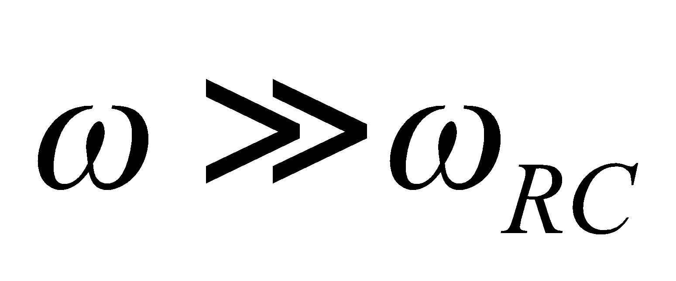), the capacitor acts like a short-circuit, so current will flow through the capacitor, and there will be no voltage at the output. Over long-times (or equivalently ), the capacitor acts like an open circuit, so no current flows in the capacitor, which means the input and output have the same voltage. One might have wrongly guessed that the presence of the capacitor implies a high-pass filter, judging from the Application on loudspeakers in the text. But in that case the capacitor is in series with the output, whereas in this case it is in parallel.

**80.** **Interpret** We are analyzing a filter consisting of an *RC* circuit.

**Develop**In the previous problem, we argued that the output voltage is the same as the voltage across the capacitor, which has a peak value of



**Evaluate**If the capacitor's reactance is equal to the resistance then and the output voltage will be 

The answer is (c).

**Assess**Notice that setting the reactance equal to resistance is the same as setting  or  as defined in the previous problem. This frequency corresponds to a time in between the short-and long-term behavior of the capacitor, so the input is only partially passed to the output.

**81.** **Interpret** We are analyzing a filter consisting of an *RC* circuit.

**Develop**Since there is no inductance, there is technically no resonance in this circuit. The maximum output voltage is the input voltage  which occurs when the reactance goes to infinity. This corresponds to zero frequency, or essentially a DC signal.

**Evaluate**The output voltage gradually decreases from its maximum at  to  at very high frequencies. Thus, there is no resonant peak at nor at  but the latter actually has the wrong dimensions for frequency. Since the output voltage is the same as the voltage across the capacitor, it should have the same frequency as the input, but not necessarily the same phase. Indeed, the capacitor voltage lags behind the current by 90° (see Table 28.1), and the current and input voltage have a phase difference given by Equation 28.13, which in this case is  So the input and output voltages will differ in phase by 

The answer is (d).

**Assess**Specifically, the phase difference between the input and the output is  where 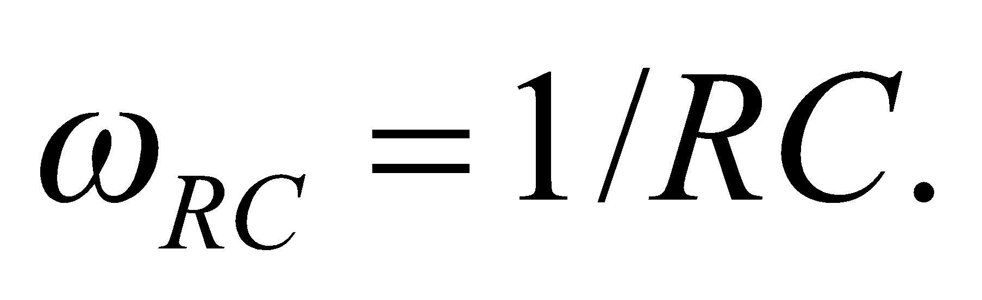 As the two voltages approach 90° out of phase. Conversely, as  the two voltages become more and more in phase.

**82.** **Interpret** We are analyzing a filter consisting of an *RC* circuit.

**Develop**If the capacitor is replaced by an inductor, the output voltage will now be equal to the voltage across the inductor, which peaks according to



where we have introduced the term 

**Evaluate**If then and there's no output voltage. At the other end of the spectrum, we have which means So as opposed to the *RC* circuit, the *LC* circuit is a high-pass filter.

The answer is (b).

**Assess**Recall the short-term and long-term behavior of *RL* circuits from Chapter 27. At short times (or equivalently 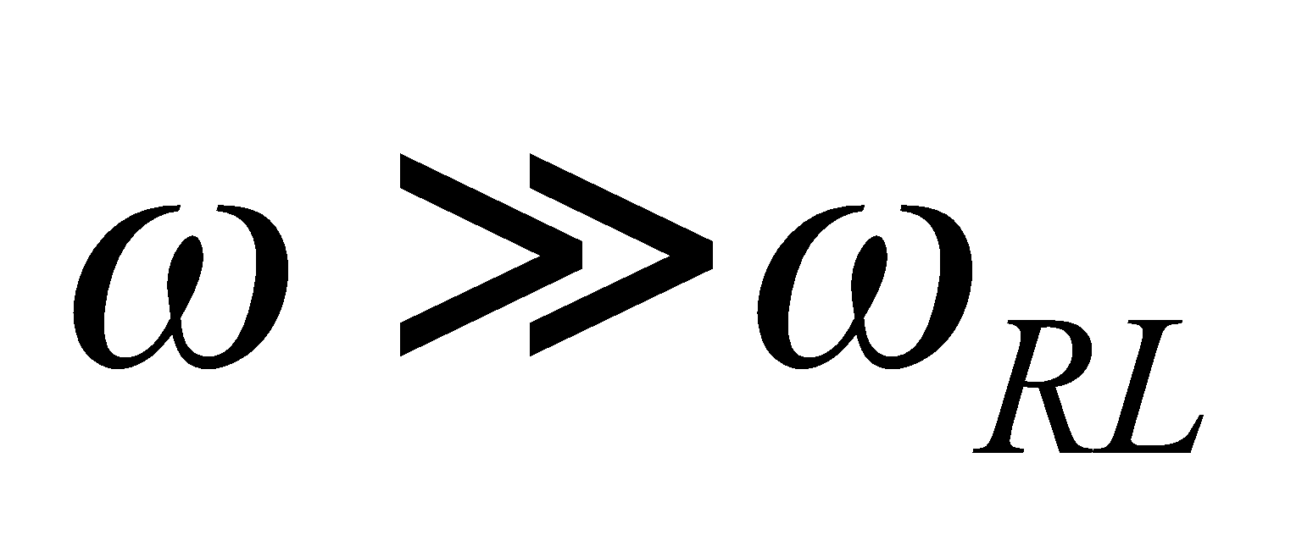), the inductor acts like an open circuit, so the input and output terminals are at equal voltage. But over long times (or equivalently ), the inductor begins to behave like a short circuit, so current will flow through the inductor, and there will be no voltage at the output.